  Year 6 · Add, subtract, multiply and divide · Step 8  Multiplication problems | 
  Year 6 · Add, subtract, multiply and divide · Step 8
  Multiplication problems
  1 | Use the bar model to work out the multiplication.  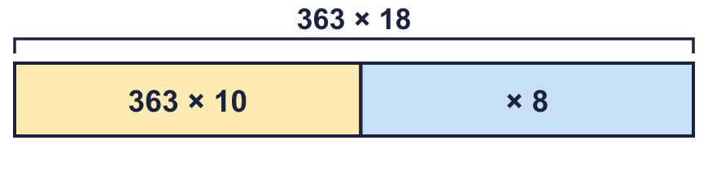  a) 363 × 10 =  b) 363 × 8 =  c) 363 × 18 =
  1 | Use the bar model to work out the multiplication.  a) 363 × 10 =  b) 363 × 8 =  c) 363 × 18 =
  2 | Use the rounding method to work out 32 × 39. Complete the number sentence.
    32 × 39 = 32 × 40 − |  | =
  2 | Use the rounding method to work out 32 × 39. Complete the number sentence.
    32 × 39 = 32 × 40 − |  | =
  3 | Multiply by 5. Use the times 10, then halve method.  a) 27 × 5 =  b) 157 × 5 =  c) 290 × 5 =  d) 1,399 × 5 =
  3 | Multiply by 5. Use the times 10, then halve method.  a) 27 × 5 =  b) 157 × 5 =  c) 290 × 5 =  d) 1,399 × 5 =
  4 | Fill in the missing numbers.
    a) | 36 × 4 = 12 × |  | so
    36 × 4 =
    b) | 16 × 6 = 8 × |  | so | 16 × 6 =
  4 | Fill in the missing numbers.
    a) | 36 × 4 = 12 × |  | so
    36 × 4 =
    b) | 16 × 6 = 8 × |  | so | 16 × 6 =
  5 | Use factors to help you multiply.  a) 9 × 14 =  b) 6 × 24 =
  5 | Use factors to help you multiply.  a) 9 × 14 =  b) 6 × 24 =
  6 | Multiply by 25. Use the times 100, then divide by 4 method.  a) 24 × 25 =  b) 16 × 25 =
  6 | Multiply by 25. Use the times 100, then divide by 4 method.  a) 24 × 25 =  b) 16 × 25 =
  7 | There are 56 seats on a coach. A school hires 9 coaches.  How many seats are there altogether?
  7 | There are 56 seats on a coach. A school hires 9 coaches.  How many seats are there altogether?
  8 | A laptop costs £99.99. A shop buys 4 laptops.  How much do they cost?
  8 | A laptop costs £99.99. A shop buys 4 laptops.  How much do they cost?

  9 | a) How many boxes can the factory pack in one day?  b) How many in 5 days?
     | 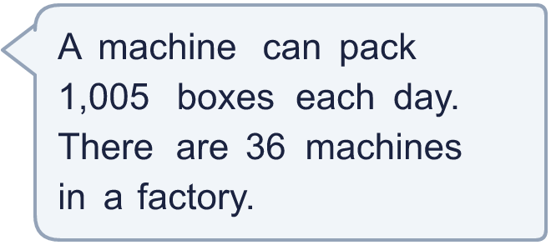
  9 | a) How many boxes can the factory pack in one day?  b) How many in 5 days?
  10 | 29 children go on a school trip by train. A train ticket costs £19.  What is the total cost of the tickets?
  10 | 29 children go on a school trip by train. A train ticket costs £19.  What is the total cost of the tickets?
  11 | Is Boba correct? Circle yes or no.  Yes / No  Explain how you know.
     | 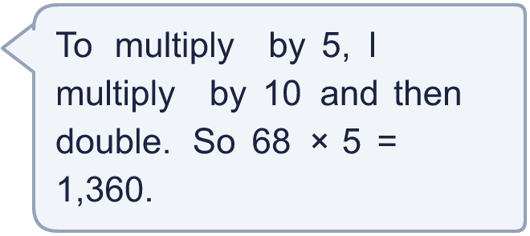
  11 | Is Boba correct? Circle yes or no.  Yes / No  Explain how you know.
  12 | How many different ways can you work out 34 × 21? Write two different calculations that give the answer.
  12 | How many different ways can you work out 34 × 21? Write two different calculations that give the answer.
  13 | Complete the multiplication in two different ways: ___ × ___ = 756
  13 | Complete the multiplication in two different ways: ___ × ___ = 756
  14 | Pencils are sold in packs of 48. Class A buys 26 packs. Class B buys 29 packs.  How many pencils do the two classes buy altogether?
  14 | Pencils are sold in packs of 48. Class A buys 26 packs. Class B buys 29 packs.  How many pencils do the two classes buy altogether?

Year 6 · Add, subtract, multiply and divide · Step 8
Multiplication problems
Answers (teacher copy)

  1 | Use the bar model to work out the multiplication.  a) 363 × 10 = 3,630  b) 363 × 8 = 2,904  c) 363 × 18 = 6,534
  2 | Use the rounding method to work out 32 × 39. Complete the number sentence.  32 × 39 = 32 × 40 − 32 = 1,248
  3 | Multiply by 5. Use the times 10, then halve method.  a) 27 × 5 = 135  b) 157 × 5 = 785  c) 290 × 5 = 1,450  d) 1,399 × 5 = 6,995
  4 | Fill in the missing numbers.  a) 36 × 4 = 12 × 12 so 36 × 4 = 144  b) 16 × 6 = 8 × 12 so 16 × 6 = 96
  5 | Use factors to help you multiply.  a) 9 × 14 = 126  b) 6 × 24 = 144
  6 | Multiply by 25. Use the times 100, then divide by 4 method.  a) 24 × 25 = 600  b) 16 × 25 = 400
  7 | There are 56 seats on a coach. A school hires 9 coaches.  How many seats are there altogether? 504
  8 | A laptop costs £99.99. A shop buys 4 laptops.  How much do they cost? £399.96
  9 | a) How many boxes can the factory pack in one day? 36,180  b) How many in 5 days? 180,900
  10 | 29 children go on a school trip by train. A train ticket costs £19.  What is the total cost of the tickets? £551
  11 | Is Boba correct? Circle yes or no.  Yes / No  Explain how you know.  × 5 is × 10 and then HALVE, not double. 68 × 10 = 680, and half of 680 is 340. So 68 × 5 = 340.
  12 | How many different ways can you work out 34 × 21? Write two different calculations that give the answer.  Any two correct methods for 34 × 21, for example 34 × 20 + 34 × 1 or 30 × 21 + 4 × 21
  13 | Complete the multiplication in two different ways: ___ × ___ = 756  Any two pairs of whole numbers that multiply to 756, for example 2 × 378 or 3 × 252
  14 | Pencils are sold in packs of 48. Class A buys 26 packs. Class B buys 29 packs.  How many pencils do the two classes buy altogether? 2,640

