  Year 6 · Add, subtract, multiply and divide · Step 14  Multi-step problems | 
  Year 6 · Add, subtract, multiply and divide · Step 14
  Multi-step problems
  1 | There are 12 sweets in a bag. A group of friends has 14 bags.  a) They eat 12 sweets. How many sweets are left?  b) They eat 8 bags of sweets. How many sweets are left?  Hint: a) First find the total number of sweets. Then take away the sweets eaten. b) First find how many bags are left. Then multiply.
  1 | There are 12 sweets in a bag. A group of friends has 14 bags.  a) They eat 12 sweets. How many sweets are left?  b) They eat 8 bags of sweets. How many sweets are left?  Hint: a) First find the total number of sweets. Then take away the sweets eaten. b) First find how many bags are left. Then multiply.
  2 | Ron saves £3 every week. Mo saves £6 every week.  a) How many pounds have they saved altogether after 12 weeks?  b) A games console costs £387. How many weeks will it take them to save enough?  Hint: a) Add what they save each week, then multiply by the weeks. b) Divide the cost by what they save together each week.
  2 | Ron saves £3 every week. Mo saves £6 every week.  a) How many pounds have they saved altogether after 12 weeks?  b) A games console costs £387. How many weeks will it take them to save enough?  Hint: a) Add what they save each week, then multiply by the weeks. b) Divide the cost by what they save together each week.
  3 | A school buys textbooks in boxes of 12. It has 595 textbooks. 73 textbooks are given out.  How many full boxes of textbooks are left?  Hint: First find how many textbooks are left. Then divide by the number in a box. Only whole boxes count.
  3 | A school buys textbooks in boxes of 12. It has 595 textbooks. 73 textbooks are given out.  How many full boxes of textbooks are left?  Hint: First find how many textbooks are left. Then divide by the number in a box. Only whole boxes count.
  4 | A car travels 17 miles in 20 minutes. It keeps the same speed.  Hint: 4 hours is 240 minutes. How many lots of 20 minutes fit in 240 minutes? Multiply that by 17.
    How far does it travel in 4 hours?
    miles
  4 | A car travels 17 miles in 20 minutes. It keeps the same speed.  Hint: 4 hours is 240 minutes. How many lots of 20 minutes fit in 240 minutes? Multiply that by 17.
    How far does it travel in 4 hours?
    miles
  5 | Nijah plays with 8 friends. They have 5 bags of marbles. Each bag has 63 marbles. They share all the marbles equally between everyone playing.  How many marbles does each person get?  Hint: Find the total number of marbles first. Then count how many people there are: Nijah AND 8 friends.
  5 | Nijah plays with 8 friends. They have 5 bags of marbles. Each bag has 63 marbles. They share all the marbles equally between everyone playing.  How many marbles does each person get?  Hint: Find the total number of marbles first. Then count how many people there are: Nijah AND 8 friends.
  6 | Sticker book A has 7 pages with 10 rows of 8 stickers on each page. Sticker book B has 7 pages with 12 rows of 6 stickers on each page.  When both books are full, how many more stickers does the bigger book hold?  Hint: Work out the stickers on one page, then on the whole book, for A and for B. Then find the difference.
  6 | Sticker book A has 7 pages with 10 rows of 8 stickers on each page. Sticker book B has 7 pages with 12 rows of 6 stickers on each page.  When both books are full, how many more stickers does the bigger book hold?  Hint: Work out the stickers on one page, then on the whole book, for A and for B. Then find the difference.
  7 | A school needs water for 272 pupils on Sports Day: one bottle each. Packs of 6 cost £4.00. Packs of 9 cost £5.00.  a) What is the cost of enough packs of 6?  b) What is the cost of enough packs of 9?  c) Which is cheaper?  Hint: Divide the pupils by the pack size. Round UP if there is a remainder, because you cannot buy part of a pack. Then multiply by the price.
  7 | A school needs water for 272 pupils on Sports Day: one bottle each. Packs of 6 cost £4.00. Packs of 9 cost £5.00.  a) What is the cost of enough packs of 6?  b) What is the cost of enough packs of 9?  c) Which is cheaper?  Hint: Divide the pupils by the pack size. Round UP if there is a remainder, because you cannot buy part of a pack. Then multiply by the price.
  8 | A pack of 6 pens costs £1.80.  How much do 54 pens cost?  Hint: How many packs is that? 54 ÷ 6. Then multiply by the price of one pack.
  8 | A pack of 6 pens costs £1.80.  How much do 54 pens cost?  Hint: How many packs is that? 54 ÷ 6. Then multiply by the price of one pack.

  9 | 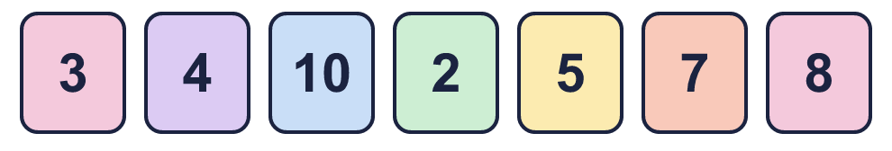  Hint: Think of factors of 120: 4 × 5 × 6 = 120. Look for cards that multiply to 120, or two cards that multiply to a number you can divide.
    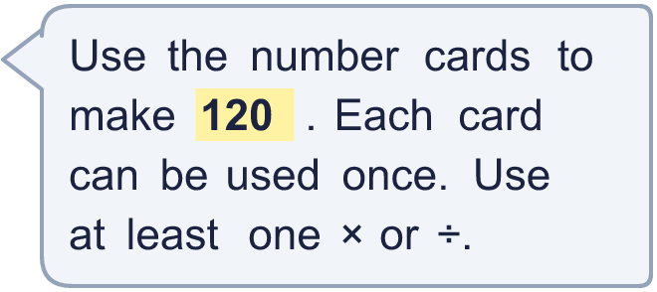
  9 | Hint: Think of factors of 120: 4 × 5 × 6 = 120. Look for cards that multiply to 120, or two cards that multiply to a number you can divide.
  10 | A baker has 403 eggs. Each cake needs 5 eggs. She sells each cake for £6.00.  a) How many cakes can she make?  b) How much money does she get if she sells them all?  Hint: a) Divide the eggs by the eggs for one cake: ignore any remainder. b) Multiply the cakes by the price.
  10 | A baker has 403 eggs. Each cake needs 5 eggs. She sells each cake for £6.00.  a) How many cakes can she make?  b) How much money does she get if she sells them all?  Hint: a) Divide the eggs by the eggs for one cake: ignore any remainder. b) Multiply the cakes by the price.
  11 | A warehouse has 7 boxes with 18 cans in each box. Each shop gets 6 cans.  How many shops can be given cans?  Hint: Find the total number of cans, then divide by the cans for each shop.
  11 | A warehouse has 7 boxes with 18 cans in each box. Each shop gets 6 cans.  How many shops can be given cans?  Hint: Find the total number of cans, then divide by the cans for each shop.
  12 | Is Boba correct? Circle yes or no.  Yes / No  Explain how you know.  Hint: Work out the total cost first. Then take it away from the money paid.
     | 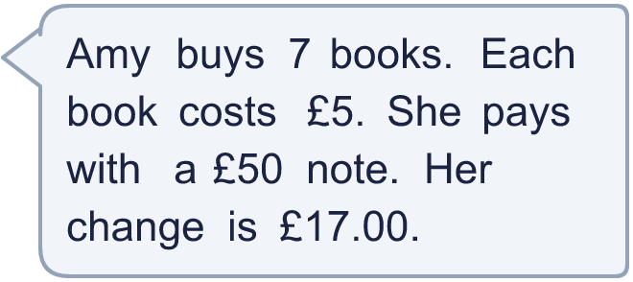
  12 | Is Boba correct? Circle yes or no.  Yes / No  Explain how you know.  Hint: Work out the total cost first. Then take it away from the money paid.
  13 | Zara has 2 times as many stickers as Ben. Together they have 180 stickers.  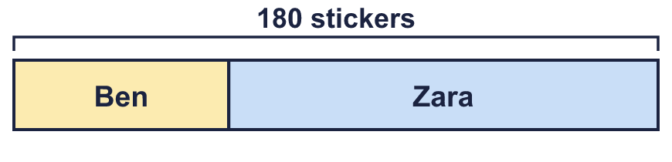  a) How many stickers does Ben have?  b) How many stickers does Zara have?  Hint: The bar model has 3 equal parts. Divide the total by 3 to find one part.
  13 | Zara has 2 times as many stickers as Ben. Together they have 180 stickers.  a) How many stickers does Ben have?  b) How many stickers does Zara have?  Hint: The bar model has 3 equal parts. Divide the total by 3 to find one part.
  14 | A rectangle has an area of 180 cm². Its sides are whole numbers of centimetres. Write two different pairs of side lengths it could have.  Hint: The two sides multiply to make 180. Find numbers that divide into 180 exactly.
  14 | A rectangle has an area of 180 cm². Its sides are whole numbers of centimetres. Write two different pairs of side lengths it could have.  Hint: The two sides multiply to make 180. Find numbers that divide into 180 exactly.

Year 6 · Add, subtract, multiply and divide · Step 14
Multi-step problems
Answers (teacher copy)

  1 | There are 12 sweets in a bag. A group of friends has 14 bags.  a) They eat 12 sweets. How many sweets are left? 156  b) They eat 8 bags of sweets. How many sweets are left? 72  Hint: a) First find the total number of sweets. Then take away the sweets eaten. b) First find how many bags are left. Then multiply.
  2 | Ron saves £3 every week. Mo saves £6 every week.  a) How many pounds have they saved altogether after 12 weeks? 108  b) A games console costs £387. How many weeks will it take them to save enough? 43  Hint: a) Add what they save each week, then multiply by the weeks. b) Divide the cost by what they save together each week.
  3 | A school buys textbooks in boxes of 12. It has 595 textbooks. 73 textbooks are given out.  How many full boxes of textbooks are left? 43  Hint: First find how many textbooks are left. Then divide by the number in a box. Only whole boxes count.
  4 | A car travels 17 miles in 20 minutes. It keeps the same speed.  How far does it travel in 4 hours? 204 miles  Hint: 4 hours is 240 minutes. How many lots of 20 minutes fit in 240 minutes? Multiply that by 17.
  5 | Nijah plays with 8 friends. They have 5 bags of marbles. Each bag has 63 marbles. They share all the marbles equally between everyone playing.  How many marbles does each person get? 35  Hint: Find the total number of marbles first. Then count how many people there are: Nijah AND 8 friends.
  6 | Sticker book A has 7 pages with 10 rows of 8 stickers on each page. Sticker book B has 7 pages with 12 rows of 6 stickers on each page.  When both books are full, how many more stickers does the bigger book hold? 56  Hint: Work out the stickers on one page, then on the whole book, for A and for B. Then find the difference.
  7 | A school needs water for 272 pupils on Sports Day: one bottle each. Packs of 6 cost £4.00. Packs of 9 cost £5.00.  a) What is the cost of enough packs of 6? £184.00  b) What is the cost of enough packs of 9? £155.00  c) Which is cheaper? Packs of 9  Hint: Divide the pupils by the pack size. Round UP if there is a remainder, because you cannot buy part of a pack. Then multiply by the price.
  8 | A pack of 6 pens costs £1.80.  How much do 54 pens cost? £16.20  Hint: How many packs is that? 54 ÷ 6. Then multiply by the price of one pack.
  9 | Any calculation that uses each card at most once and makes 120, for example 3 × 4 × 10 or 3 × 5 × 8  Hint: Think of factors of 120: 4 × 5 × 6 = 120. Look for cards that multiply to 120, or two cards that multiply to a number you can divide.
  10 | A baker has 403 eggs. Each cake needs 5 eggs. She sells each cake for £6.00.  a) How many cakes can she make? 80  b) How much money does she get if she sells them all? £480.00  Hint: a) Divide the eggs by the eggs for one cake: ignore any remainder. b) Multiply the cakes by the price.
  11 | A warehouse has 7 boxes with 18 cans in each box. Each shop gets 6 cans.  How many shops can be given cans? 21  Hint: Find the total number of cans, then divide by the cans for each shop.
  12 | Is Boba correct? Circle yes or no.  Yes / No  Explain how you know.  7 × £5 = £35. £50 − £35 = £15, so the change is £15.00, not £17.00.  Hint: Work out the total cost first. Then take it away from the money paid.
  13 | Zara has 2 times as many stickers as Ben. Together they have 180 stickers.  a) How many stickers does Ben have? 60  b) How many stickers does Zara have? 120  Hint: The bar model has 3 equal parts. Divide the total by 3 to find one part.
  14 | A rectangle has an area of 180 cm². Its sides are whole numbers of centimetres. Write two different pairs of side lengths it could have.  Any two pairs of whole numbers that multiply to 180, for example 3 × 60 or 4 × 45  Hint: The two sides multiply to make 180. Find numbers that divide into 180 exactly.

