  Year 6 · Add, subtract, multiply and divide · Step 14  Multi-step problems | 
  Year 6 · Add, subtract, multiply and divide · Step 14
  Multi-step problems
  1 | There are 12 sweets in a bag. A group of friends has 14 bags.  a) They eat 12 sweets. How many sweets are left?  b) They eat 8 bags of sweets. How many sweets are left?
  1 | There are 12 sweets in a bag. A group of friends has 14 bags.  a) They eat 12 sweets. How many sweets are left?  b) They eat 8 bags of sweets. How many sweets are left?
  2 | Ron saves £3 every week. Mo saves £6 every week.  a) How many pounds have they saved altogether after 12 weeks?  b) A games console costs £387. How many weeks will it take them to save enough?
  2 | Ron saves £3 every week. Mo saves £6 every week.  a) How many pounds have they saved altogether after 12 weeks?  b) A games console costs £387. How many weeks will it take them to save enough?
  3 | A school buys textbooks in boxes of 12. It has 595 textbooks. 73 textbooks are given out.  How many full boxes of textbooks are left?
  3 | A school buys textbooks in boxes of 12. It has 595 textbooks. 73 textbooks are given out.  How many full boxes of textbooks are left?
  4 | A car travels 17 miles in 20 minutes. It keeps the same speed.
    How far does it travel in 4 hours?
    miles
  4 | A car travels 17 miles in 20 minutes. It keeps the same speed.
    How far does it travel in 4 hours?
    miles
  5 | Nijah plays with 8 friends. They have 5 bags of marbles. Each bag has 63 marbles. They share all the marbles equally between everyone playing.  How many marbles does each person get?
  5 | Nijah plays with 8 friends. They have 5 bags of marbles. Each bag has 63 marbles. They share all the marbles equally between everyone playing.  How many marbles does each person get?
  6 | Sticker book A has 7 pages with 10 rows of 8 stickers on each page. Sticker book B has 7 pages with 12 rows of 6 stickers on each page.  When both books are full, how many more stickers does the bigger book hold?
  6 | Sticker book A has 7 pages with 10 rows of 8 stickers on each page. Sticker book B has 7 pages with 12 rows of 6 stickers on each page.  When both books are full, how many more stickers does the bigger book hold?
  7 | A school needs water for 272 pupils on Sports Day: one bottle each. Packs of 6 cost £4.00. Packs of 9 cost £5.00.  a) What is the cost of enough packs of 6?  b) What is the cost of enough packs of 9?  c) Which is cheaper?
  7 | A school needs water for 272 pupils on Sports Day: one bottle each. Packs of 6 cost £4.00. Packs of 9 cost £5.00.  a) What is the cost of enough packs of 6?  b) What is the cost of enough packs of 9?  c) Which is cheaper?
  8 | A pack of 6 pens costs £1.80.  How much do 54 pens cost?
  8 | A pack of 6 pens costs £1.80.  How much do 54 pens cost?

  9 | 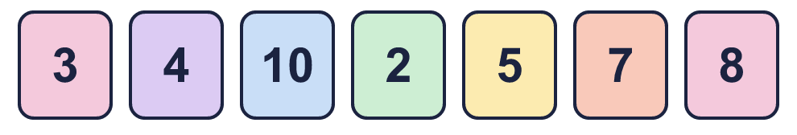
    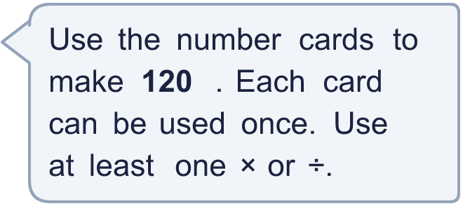
  9
  10 | A baker has 403 eggs. Each cake needs 5 eggs. She sells each cake for £6.00.  a) How many cakes can she make?  b) How much money does she get if she sells them all?
  10 | A baker has 403 eggs. Each cake needs 5 eggs. She sells each cake for £6.00.  a) How many cakes can she make?  b) How much money does she get if she sells them all?
  11 | A warehouse has 7 boxes with 18 cans in each box. Each shop gets 6 cans.  How many shops can be given cans?
  11 | A warehouse has 7 boxes with 18 cans in each box. Each shop gets 6 cans.  How many shops can be given cans?
  12 | Is Boba correct? Circle yes or no.  Yes / No  Explain how you know.
     | 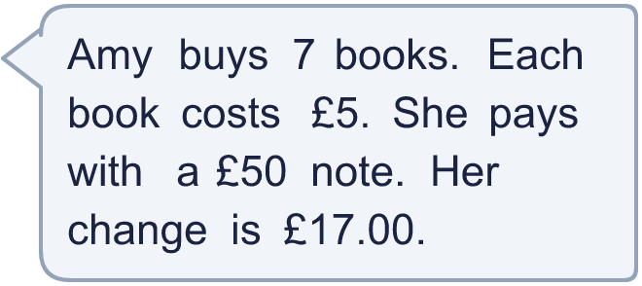
  12 | Is Boba correct? Circle yes or no.  Yes / No  Explain how you know.
  13 | Zara has 2 times as many stickers as Ben. Together they have 180 stickers.  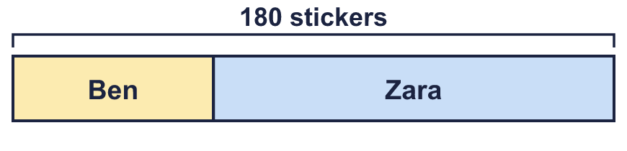  a) How many stickers does Ben have?  b) How many stickers does Zara have?
  13 | Zara has 2 times as many stickers as Ben. Together they have 180 stickers.  a) How many stickers does Ben have?  b) How many stickers does Zara have?
  14 | A rectangle has an area of 180 cm². Its sides are whole numbers of centimetres. Write two different pairs of side lengths it could have.
  14 | A rectangle has an area of 180 cm². Its sides are whole numbers of centimetres. Write two different pairs of side lengths it could have.

Year 6 · Add, subtract, multiply and divide · Step 14
Multi-step problems
Answers (teacher copy)

  1 | There are 12 sweets in a bag. A group of friends has 14 bags.  a) They eat 12 sweets. How many sweets are left? 156  b) They eat 8 bags of sweets. How many sweets are left? 72
  2 | Ron saves £3 every week. Mo saves £6 every week.  a) How many pounds have they saved altogether after 12 weeks? 108  b) A games console costs £387. How many weeks will it take them to save enough? 43
  3 | A school buys textbooks in boxes of 12. It has 595 textbooks. 73 textbooks are given out.  How many full boxes of textbooks are left? 43
  4 | A car travels 17 miles in 20 minutes. It keeps the same speed.  How far does it travel in 4 hours? 204 miles
  5 | Nijah plays with 8 friends. They have 5 bags of marbles. Each bag has 63 marbles. They share all the marbles equally between everyone playing.  How many marbles does each person get? 35
  6 | Sticker book A has 7 pages with 10 rows of 8 stickers on each page. Sticker book B has 7 pages with 12 rows of 6 stickers on each page.  When both books are full, how many more stickers does the bigger book hold? 56
  7 | A school needs water for 272 pupils on Sports Day: one bottle each. Packs of 6 cost £4.00. Packs of 9 cost £5.00.  a) What is the cost of enough packs of 6? £184.00  b) What is the cost of enough packs of 9? £155.00  c) Which is cheaper? Packs of 9
  8 | A pack of 6 pens costs £1.80.  How much do 54 pens cost? £16.20
  9 | Any calculation that uses each card at most once and makes 120, for example 3 × 4 × 10 or 3 × 5 × 8
  10 | A baker has 403 eggs. Each cake needs 5 eggs. She sells each cake for £6.00.  a) How many cakes can she make? 80  b) How much money does she get if she sells them all? £480.00
  11 | A warehouse has 7 boxes with 18 cans in each box. Each shop gets 6 cans.  How many shops can be given cans? 21
  12 | Is Boba correct? Circle yes or no.  Yes / No  Explain how you know.  7 × £5 = £35. £50 − £35 = £15, so the change is £15.00, not £17.00.
  13 | Zara has 2 times as many stickers as Ben. Together they have 180 stickers.  a) How many stickers does Ben have? 60  b) How many stickers does Zara have? 120
  14 | A rectangle has an area of 180 cm². Its sides are whole numbers of centimetres. Write two different pairs of side lengths it could have.  Any two pairs of whole numbers that multiply to 180, for example 3 × 60 or 4 × 45

