Divisibility rules to help you:  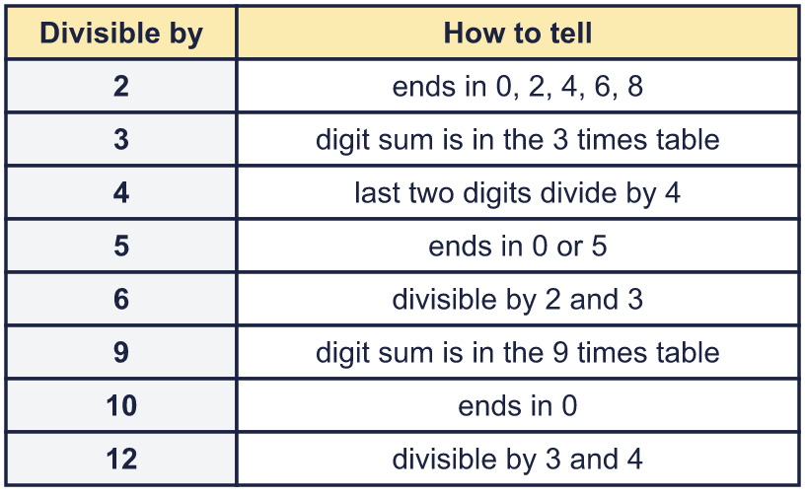 |  | Divisibility rules to help you:
  Year 6 · Add, subtract, multiply and divide · Step 4  Divisibility rules | 
  Year 6 · Add, subtract, multiply and divide · Step 4
  Divisibility rules
  1 | Sort the numbers. Write each group.  9,620 2,575 85,003 11,335 2,200 93,533  Divisible by 5 and 10:  Divisible by 5 only:  Not divisible by 5 or 10:  Hint: Look at the ones digit. A 0 means divisible by 10 (and by 5). A 5 means divisible by 5 only.
  1 | Sort the numbers. Write each group.  9,620 2,575 85,003 11,335 2,200 93,533  Divisible by 5 and 10:  Divisible by 5 only:  Not divisible by 5 or 10:  Hint: Look at the ones digit. A 0 means divisible by 10 (and by 5). A 5 means divisible by 5 only.
  2 | Find the digit sum of each number. Is the number divisible by the number shown?  Hint: Add up all the digits. If the digit sum is in the 3 times table (or the 9 times table) the number is divisible by 3 (or 9).
    a) | 63: digit sum
    divisible by 3?
    b) | 509: digit sum
    divisible by 3?
    c) | 876: digit sum
    divisible by 9?
  2 | Find the digit sum of each number. Is the number divisible by the number shown?  Hint: Add up all the digits. If the digit sum is in the 3 times table (or the 9 times table) the number is divisible by 3 (or 9).
    a) | 63: digit sum
    divisible by 3?
    b) | 509: digit sum
    divisible by 3?
    c) | 876: digit sum
    divisible by 9?
  3 | Which numbers are divisible by 9? Write them.  2,364 5,112 8,991 4,563 5,236 8,216  Hint: Add up the digits of each number. Is the digit sum in the 9 times table?
  3 | Which numbers are divisible by 9? Write them.  2,364 5,112 8,991 4,563 5,236 8,216  Hint: Add up the digits of each number. Is the digit sum in the 9 times table?
  4 | Write which of the numbers 3, 4 and 12 each number is divisible by. Write none if there are none.  a) 69:  b) 56:  c) 24:  Hint: Check the rule for 3 (digit sum), then the rule for 4 (last two digits), then 12 (both 3 and 4).
  4 | Write which of the numbers 3, 4 and 12 each number is divisible by. Write none if there are none.  a) 69:  b) 56:  c) 24:  Hint: Check the rule for 3 (digit sum), then the rule for 4 (last two digits), then 12 (both 3 and 4).
  5 | Which numbers are divisible by 4? Write them.  664 34,763 12,192 7,695 635 8,076  Hint: Only look at the last two digits. Is that 2-digit number in the 4 times table?
  5 | Which numbers are divisible by 4? Write them.  664 34,763 12,192 7,695 635 8,076  Hint: Only look at the last two digits. Is that 2-digit number in the 4 times table?
  6 | Is each number divisible by 6? Write yes or no.  a) 8,004:  b) 7,094:  c) 1,275:  Hint: A number is divisible by 6 if it is divisible by BOTH 2 and 3.
  6 | Is each number divisible by 6? Write yes or no.  a) 8,004:  b) 7,094:  c) 1,275:  Hint: A number is divisible by 6 if it is divisible by BOTH 2 and 3.
  7 | Which numbers are divisible by 18? Use the rules for 2 and 9. Write them.  189 306 459 648 936 18,018  Hint: A number is divisible by 18 if it is divisible by 2 AND by 9: check the ones digit is even, then add the digits.
  7 | Which numbers are divisible by 18? Use the rules for 2 and 9. Write them.  189 306 459 648 936 18,018  Hint: A number is divisible by 18 if it is divisible by 2 AND by 9: check the ones digit is even, then add the digits.
  8 | The number 7_41 has a digit missing. Write every digit that makes it divisible by 9.  Hint: Add the digits you can see. Then work out which digit, 0 to 9, makes the digit sum divisible by 9.
  8 | The number 7_41 has a digit missing. Write every digit that makes it divisible by 9.  Hint: Add the digits you can see. Then work out which digit, 0 to 9, makes the digit sum divisible by 9.

  9 | Which box sizes can be used with no books left over?  Hint: A box size works if the number of books is divisible by it. Use the divisibility rules, then check the ones you are not sure about.
     | 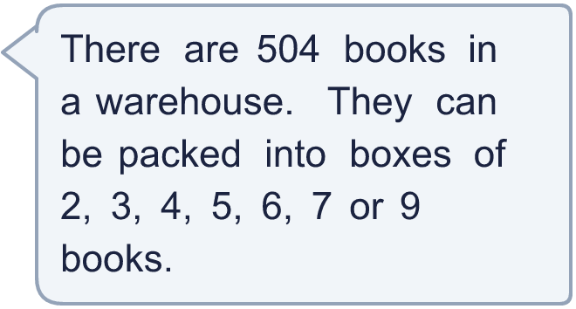
  9 | Which box sizes can be used with no books left over?  Hint: A box size works if the number of books is divisible by it. Use the divisibility rules, then check the ones you are not sure about.
  10 | Is Boba correct? Circle yes or no.  Yes / No  Explain how you know. Use an example.  Hint: Try an example. Pick a number in the 4 times table and check it against the rule for 2.
     | 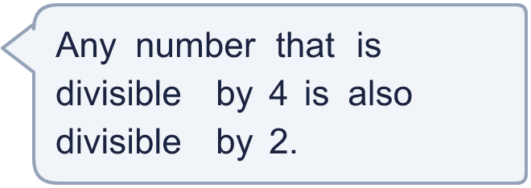
  10 | Is Boba correct? Circle yes or no.  Yes / No  Explain how you know. Use an example.  Hint: Try an example. Pick a number in the 4 times table and check it against the rule for 2.
  11 | Is Boba correct? Circle yes or no.  Yes / No  Explain how you know.  Hint: Use two rules: one for 5 (the ones digit) and one for 3 (the digit sum).
     | 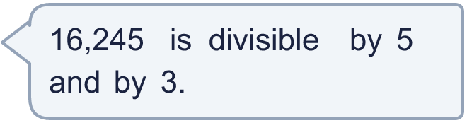
  11 | Is Boba correct? Circle yes or no.  Yes / No  Explain how you know.  Hint: Use two rules: one for 5 (the ones digit) and one for 3 (the digit sum).
  12 | 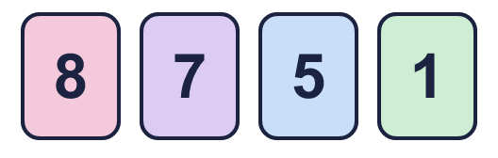  What is the greatest number you can make?  Hint: Use the rule for 3. Try the biggest digits first, then check the rule.
    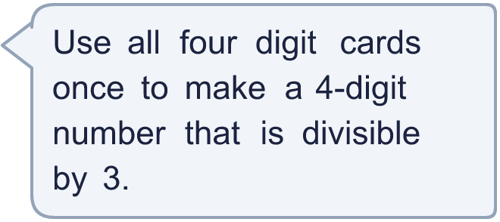
  12 | What is the greatest number you can make?  Hint: Use the rule for 3. Try the biggest digits first, then check the rule.
  13 | • It is divisible by 5.  • It is divisible by 6.  • The digits add up to 9.  • It is greater than 99 and less than 201.  What is my number?  Hint: Use the rules to cross numbers out. Start with the clue that has the biggest number.
    
  13 | • It is divisible by 5.  • It is divisible by 6.  • The digits add up to 9.  • It is greater than 99 and less than 201.  What is my number?  Hint: Use the rules to cross numbers out. Start with the clue that has the biggest number.
  14 | Write three different 4-digit numbers that are divisible by both 4 and 5.  Hint: A number divisible by both 4 and 5 is in the 20 times table. Pick a 4-digit number and check both rules.
  14 | Write three different 4-digit numbers that are divisible by both 4 and 5.  Hint: A number divisible by both 4 and 5 is in the 20 times table. Pick a 4-digit number and check both rules.

Year 6 · Add, subtract, multiply and divide · Step 4
Divisibility rules
Answers (teacher copy)

Divisibility rules to help you:
  1 | Sort the numbers. Write each group.  9,620 2,575 85,003 11,335 2,200 93,533  Divisible by 5 and 10: 9,620, 2,200  Divisible by 5 only: 2,575, 11,335  Not divisible by 5 or 10: 85,003, 93,533  Hint: Look at the ones digit. A 0 means divisible by 10 (and by 5). A 5 means divisible by 5 only.
  2 | Find the digit sum of each number. Is the number divisible by the number shown?  a) 63: digit sum 9 divisible by 3? Yes  b) 509: digit sum 14 divisible by 3? No  c) 876: digit sum 21 divisible by 9? No  Hint: Add up all the digits. If the digit sum is in the 3 times table (or the 9 times table) the number is divisible by 3 (or 9).
  3 | Which numbers are divisible by 9? Write them.  2,364 5,112 8,991 4,563 5,236 8,216  5,112, 8,991, 4,563  Hint: Add up the digits of each number. Is the digit sum in the 9 times table?
  4 | Write which of the numbers 3, 4 and 12 each number is divisible by. Write none if there are none.  a) 69: 3  b) 56: 4  c) 24: 3, 4, 12  Hint: Check the rule for 3 (digit sum), then the rule for 4 (last two digits), then 12 (both 3 and 4).
  5 | Which numbers are divisible by 4? Write them.  664 34,763 12,192 7,695 635 8,076  664, 12,192, 8,076  Hint: Only look at the last two digits. Is that 2-digit number in the 4 times table?
  6 | Is each number divisible by 6? Write yes or no.  a) 8,004: Yes  b) 7,094: No  c) 1,275: No  Hint: A number is divisible by 6 if it is divisible by BOTH 2 and 3.
  7 | Which numbers are divisible by 18? Use the rules for 2 and 9. Write them.  189 306 459 648 936 18,018  306, 648, 936, 18,018  Hint: A number is divisible by 18 if it is divisible by 2 AND by 9: check the ones digit is even, then add the digits.
  8 | The number 7_41 has a digit missing. Write every digit that makes it divisible by 9.  6  Hint: Add the digits you can see. Then work out which digit, 0 to 9, makes the digit sum divisible by 9.
  9 | Which box sizes can be used with no books left over? 2, 3, 4, 6, 7, 9  Hint: A box size works if the number of books is divisible by it. Use the divisibility rules, then check the ones you are not sure about.
  10 | Is Boba correct? Circle yes or no.  Yes / No  Explain how you know. Use an example.  4 is a multiple of 2, so any number divisible by 4 is divisible by 2. For example 12 ÷ 4 = 3 and 12 ÷ 2 = 6.  Hint: Try an example. Pick a number in the 4 times table and check it against the rule for 2.
  11 | Is Boba correct? Circle yes or no.  Yes / No  Explain how you know.  16,245 ends in 5, so it is divisible by 5. The digit sum is 18, which is in the 3 times table, so it is divisible by 3.  Hint: Use two rules: one for 5 (the ones digit) and one for 3 (the digit sum).
  12 | What is the greatest number you can make? 8,751  Hint: Use the rule for 3. Try the biggest digits first, then check the rule.
  13 | • It is divisible by 5.  • It is divisible by 6.  • The digits add up to 9.  • It is greater than 99 and less than 201.  What is my number? 180  Hint: Use the rules to cross numbers out. Start with the clue that has the biggest number.
  14 | Write three different 4-digit numbers that are divisible by both 4 and 5.  Any three 4-digit numbers divisible by 4 and 5, for example 1,000, 1,140, 1,280  Hint: A number divisible by both 4 and 5 is in the 20 times table. Pick a 4-digit number and check both rules.

