  Year 6 · Add, subtract, multiply and divide · Step 4  Divisibility rules | 
  Year 6 · Add, subtract, multiply and divide · Step 4
  Divisibility rules
  1 | Sort the numbers. Write each group.  9,620 2,575 85,003 11,335 2,200 93,533  Divisible by 5 and 10:  Divisible by 5 only:  Not divisible by 5 or 10:
  1 | Sort the numbers. Write each group.  9,620 2,575 85,003 11,335 2,200 93,533  Divisible by 5 and 10:  Divisible by 5 only:  Not divisible by 5 or 10:
  2 | Find the digit sum of each number. Is the number divisible by the number shown?
    a) | 63: digit sum
    divisible by 3?
    b) | 509: digit sum
    divisible by 3?
    c) | 876: digit sum
    divisible by 9?
  2 | Find the digit sum of each number. Is the number divisible by the number shown?
    a) | 63: digit sum
    divisible by 3?
    b) | 509: digit sum
    divisible by 3?
    c) | 876: digit sum
    divisible by 9?
  3 | Which numbers are divisible by 9? Write them.  2,364 5,112 8,991 4,563 5,236 8,216
  3 | Which numbers are divisible by 9? Write them.  2,364 5,112 8,991 4,563 5,236 8,216
  4 | Write which of the numbers 3, 4 and 12 each number is divisible by. Write none if there are none.  a) 69:  b) 56:  c) 24:
  4 | Write which of the numbers 3, 4 and 12 each number is divisible by. Write none if there are none.  a) 69:  b) 56:  c) 24:
  5 | Which numbers are divisible by 4? Write them.  664 34,763 12,192 7,695 635 8,076
  5 | Which numbers are divisible by 4? Write them.  664 34,763 12,192 7,695 635 8,076
  6 | Is each number divisible by 6? Write yes or no.  a) 8,004:  b) 7,094:  c) 1,275:
  6 | Is each number divisible by 6? Write yes or no.  a) 8,004:  b) 7,094:  c) 1,275:
  7 | Which numbers are divisible by 18? Use the rules for 2 and 9. Write them.  189 306 459 648 936 18,018
  7 | Which numbers are divisible by 18? Use the rules for 2 and 9. Write them.  189 306 459 648 936 18,018
  8 | The number 7_41 has a digit missing. Write every digit that makes it divisible by 9.
  8 | The number 7_41 has a digit missing. Write every digit that makes it divisible by 9.

  9 | Which box sizes can be used with no books left over?
     | 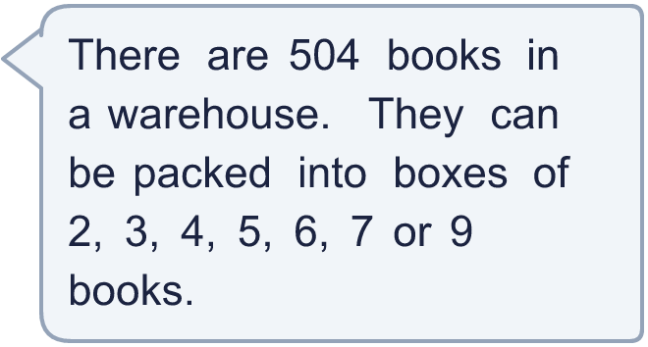
  9 | Which box sizes can be used with no books left over?
  10 | Is Boba correct? Circle yes or no.  Yes / No  Explain how you know. Use an example.
     | 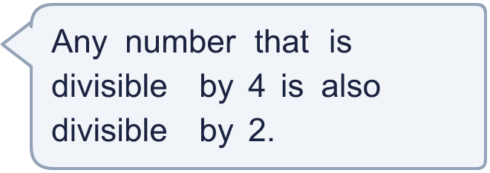
  10 | Is Boba correct? Circle yes or no.  Yes / No  Explain how you know. Use an example.
  11 | Is Boba correct? Circle yes or no.  Yes / No  Explain how you know.
     | 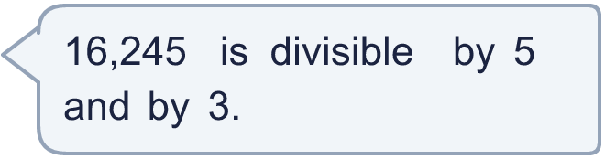
  11 | Is Boba correct? Circle yes or no.  Yes / No  Explain how you know.
  12 | 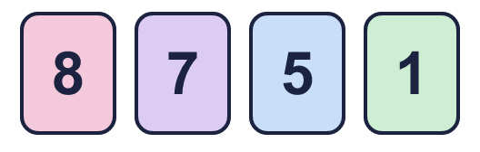  What is the greatest number you can make?
    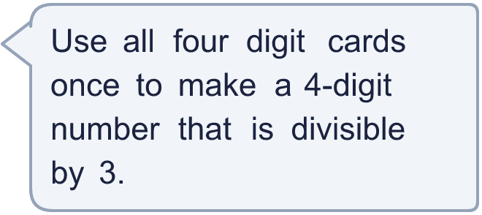
  12 | What is the greatest number you can make?
  13 | • It is divisible by 5.  • It is divisible by 6.  • The digits add up to 9.  • It is greater than 99 and less than 201.  What is my number?
    
  13 | • It is divisible by 5.  • It is divisible by 6.  • The digits add up to 9.  • It is greater than 99 and less than 201.  What is my number?
  14 | Write three different 4-digit numbers that are divisible by both 4 and 5.
  14 | Write three different 4-digit numbers that are divisible by both 4 and 5.

Year 6 · Add, subtract, multiply and divide · Step 4
Divisibility rules
Answers (teacher copy)

  1 | Sort the numbers. Write each group.  9,620 2,575 85,003 11,335 2,200 93,533  Divisible by 5 and 10: 9,620, 2,200  Divisible by 5 only: 2,575, 11,335  Not divisible by 5 or 10: 85,003, 93,533
  2 | Find the digit sum of each number. Is the number divisible by the number shown?  a) 63: digit sum 9 divisible by 3? Yes  b) 509: digit sum 14 divisible by 3? No  c) 876: digit sum 21 divisible by 9? No
  3 | Which numbers are divisible by 9? Write them.  2,364 5,112 8,991 4,563 5,236 8,216  5,112, 8,991, 4,563
  4 | Write which of the numbers 3, 4 and 12 each number is divisible by. Write none if there are none.  a) 69: 3  b) 56: 4  c) 24: 3, 4, 12
  5 | Which numbers are divisible by 4? Write them.  664 34,763 12,192 7,695 635 8,076  664, 12,192, 8,076
  6 | Is each number divisible by 6? Write yes or no.  a) 8,004: Yes  b) 7,094: No  c) 1,275: No
  7 | Which numbers are divisible by 18? Use the rules for 2 and 9. Write them.  189 306 459 648 936 18,018  306, 648, 936, 18,018
  8 | The number 7_41 has a digit missing. Write every digit that makes it divisible by 9.  6
  9 | Which box sizes can be used with no books left over? 2, 3, 4, 6, 7, 9
  10 | Is Boba correct? Circle yes or no.  Yes / No  Explain how you know. Use an example.  4 is a multiple of 2, so any number divisible by 4 is divisible by 2. For example 12 ÷ 4 = 3 and 12 ÷ 2 = 6.
  11 | Is Boba correct? Circle yes or no.  Yes / No  Explain how you know.  16,245 ends in 5, so it is divisible by 5. The digit sum is 18, which is in the 3 times table, so it is divisible by 3.
  12 | What is the greatest number you can make? 8,751
  13 | • It is divisible by 5.  • It is divisible by 6.  • The digits add up to 9.  • It is greater than 99 and less than 201.  What is my number? 180
  14 | Write three different 4-digit numbers that are divisible by both 4 and 5.  Any three 4-digit numbers divisible by 4 and 5, for example 1,000, 1,140, 1,280

