  Year 6 · Add, subtract, multiply and divide · Step 2  Common factors | 
  Year 6 · Add, subtract, multiply and divide · Step 2
  Common factors
  1 | Write all the factors of each number.  a) 18:  b) 48:  Hint: Factors come in pairs. Try 1 × the number, then 2, then 3, ... Stop when the pairs repeat.  Arrays show the factor pairs of 12:  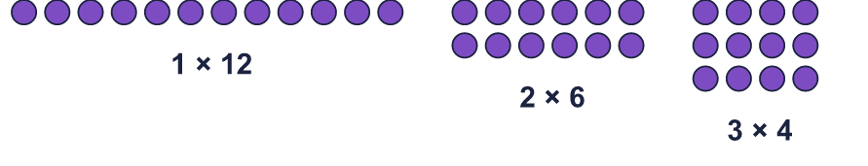
  1 | Write all the factors of each number.  a) 18:  b) 48:  Hint: Factors come in pairs. Try 1 × the number, then 2, then 3, ... Stop when the pairs repeat.  Arrays show the factor pairs of 12:
  2 | Complete the factor pairs of 36.  Hint: Divide 36 by the first number to find its partner.  Arrays show the factor pairs of 18:  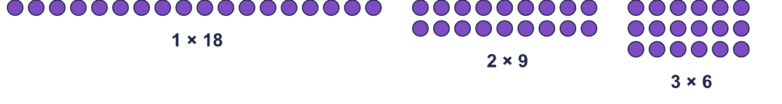
    a) | 1 × |  | = 36
    b) | 2 × |  | = 36
    c) | 3 × |  | = 36
    d) | 4 × |  | = 36
  2 | Complete the factor pairs of 36.  Hint: Divide 36 by the first number to find its partner.  Arrays show the factor pairs of 18:
    a) | 1 × |  | = 36
    b) | 2 × |  | = 36
    c) | 3 × |  | = 36
    d) | 4 × |  | = 36
  3 | Sort the numbers into the diagram. Write each group.  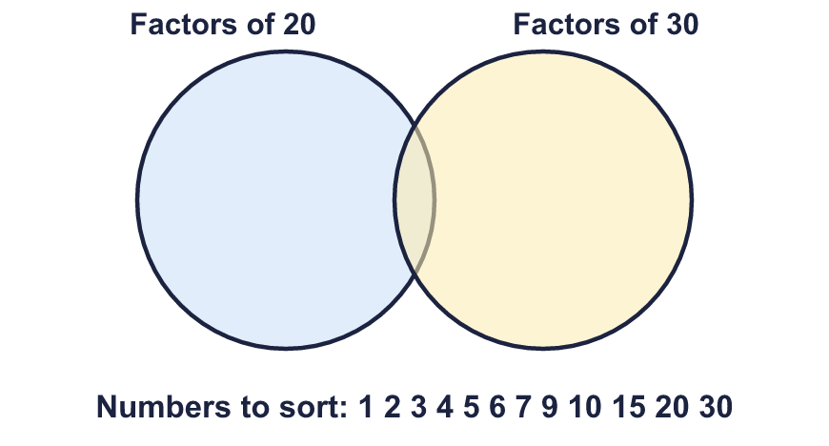  Factors of 20 only:  Factors of both:  Factors of 30 only:  Neither:  Hint: Write the factors of 20, then the factors of 30. A number in both lists goes in the middle. A number in neither list goes outside.
  3 | Sort the numbers into the diagram. Write each group.  Factors of 20 only:  Factors of both:  Factors of 30 only:  Neither:  Hint: Write the factors of 20, then the factors of 30. A number in both lists goes in the middle. A number in neither list goes outside.
  4 | Find the common factors of each pair of numbers.  a) 18 and 27:  b) 20 and 60:  c) 16 and 25:  Hint: List all the factors of each number. Then find the ones that are in BOTH lists.
  4 | Find the common factors of each pair of numbers.  a) 18 and 27:  b) 20 and 60:  c) 16 and 25:  Hint: List all the factors of each number. Then find the ones that are in BOTH lists.
  5 | Find the greatest common factor of each pair.  a) 27 and 45:  b) 40 and 60:  Hint: The greatest common factor is the biggest number that is a factor of both. List the common factors, then pick the biggest.
  5 | Find the greatest common factor of each pair.  a) 27 and 45:  b) 40 and 60:  Hint: The greatest common factor is the biggest number that is a factor of both. List the common factors, then pick the biggest.
  6 | Find the common factors of all three numbers.  a) 40, 60, 80:  b) 18, 27, 45:  Hint: Find the common factors of the first two numbers. Then check which of those are also factors of the third.
  6 | Find the common factors of all three numbers.  a) 40, 60, 80:  b) 18, 27, 45:  Hint: Find the common factors of the first two numbers. Then check which of those are also factors of the third.
  7 | List the common factors of 360 and 180 that are greater than 50.  Hint: First find the greatest common factor of 360 and 180. Every common factor is a factor of that number.
  7 | List the common factors of 360 and 180 that are greater than 50.  Hint: First find the greatest common factor of 360 and 180. Every common factor is a factor of that number.
  8 | Circle the numbers that are common factors of 18 and 30. Write them below.  2 3 4 5 6 8 9 12  Hint: A common factor divides both numbers exactly, with nothing left over.
  8 | Circle the numbers that are common factors of 18 and 30. Write them below.  2 3 4 5 6 8 9 12  Hint: A common factor divides both numbers exactly, with nothing left over.

  9 | Is Boba correct? Circle yes or no.  Yes / No  Explain how you know.  What is the greatest number of bags she can make?  Hint: Every bag must have the same number of sweets and the same number of balloons, so the number of bags is a common factor of both numbers.
     | 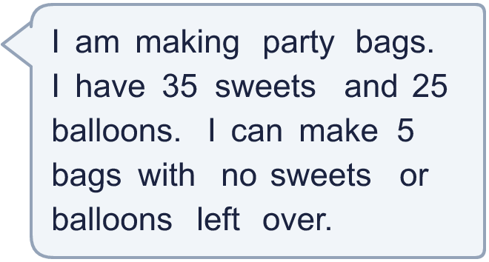
  9 | Is Boba correct? Circle yes or no.  Yes / No  Explain how you know.  What is the greatest number of bags she can make?  Hint: Every bag must have the same number of sweets and the same number of balloons, so the number of bags is a common factor of both numbers.
  10 | • It is a multiple of 11.  • The greatest common factor of my number and 12 is 4.  • It is greater than 79.  What is my number?  Hint: Start with the 2-digit multiples of 11. Cross out the ones that break a clue.
    
  10 | • It is a multiple of 11.  • The greatest common factor of my number and 12 is 4.  • It is greater than 79.  What is my number?  Hint: Start with the 2-digit multiples of 11. Cross out the ones that break a clue.
  11 | Divide the top and bottom of ³⁶⁄₆₀ by their greatest common factor. What fraction do you get?  Hint: First find the greatest common factor of 36 and 60. Then divide both numbers by it.
     | 
  11 | Divide the top and bottom of ³⁶⁄₆₀ by their greatest common factor. What fraction do you get?  Hint: First find the greatest common factor of 36 and 60. Then divide both numbers by it.
  12 | Is Boba correct? Circle yes or no.  Yes / No  Explain how you know.  Hint: List the factors of each number and find the ones in both lists. Count them.
     | 
  12 | Is Boba correct? Circle yes or no.  Yes / No  Explain how you know.  Hint: List the factors of each number and find the ones in both lists. Count them.
  13 | Look at the three pairs of numbers.  a) 16 and 24  b) 10 and 15  c) 9 and 27  Which pair has the most common factors? Write the letter.  Hint: Count the common factors of each pair. The pair with the biggest count wins.
  13 | Look at the three pairs of numbers.  a) 16 and 24  b) 10 and 15  c) 9 and 27  Which pair has the most common factors? Write the letter.  Hint: Count the common factors of each pair. The pair with the biggest count wins.
  14 | Write two different pairs of numbers (each less than 100) whose only common factors are 1 and 3.  Hint: Both numbers must be multiples of 3, but they must not share any other factor. Try 3 × 2 and 3 × 3.
  14 | Write two different pairs of numbers (each less than 100) whose only common factors are 1 and 3.  Hint: Both numbers must be multiples of 3, but they must not share any other factor. Try 3 × 2 and 3 × 3.

Year 6 · Add, subtract, multiply and divide · Step 2
Common factors
Answers (teacher copy)

  1 | Write all the factors of each number.  a) 18: 1, 2, 3, 6, 9, 18  b) 48: 1, 2, 3, 4, 6, 8, 12, 16, 24, 48  Hint: Factors come in pairs. Try 1 × the number, then 2, then 3, ... Stop when the pairs repeat.  Arrays show the factor pairs of 12:
  2 | Complete the factor pairs of 36.  a) 1 × 36 = 36  b) 2 × 18 = 36  c) 3 × 12 = 36  d) 4 × 9 = 36  Hint: Divide 36 by the first number to find its partner.  Arrays show the factor pairs of 18:
  3 | Sort the numbers into the diagram. Write each group.  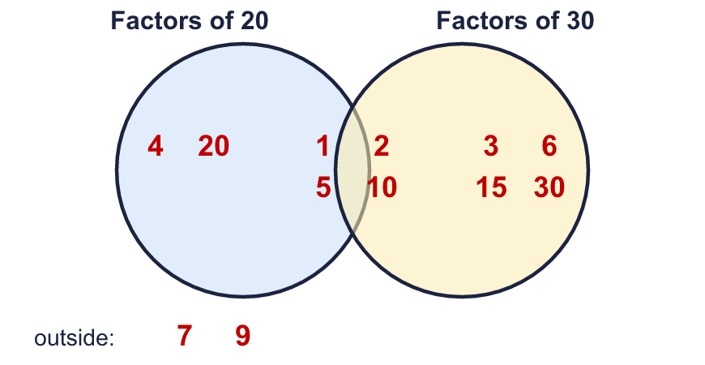  Factors of 20 only: 4, 20  Factors of both: 1, 2, 5, 10  Factors of 30 only: 3, 6, 15, 30  Neither: 7, 9  Hint: Write the factors of 20, then the factors of 30. A number in both lists goes in the middle. A number in neither list goes outside.
  4 | Find the common factors of each pair of numbers.  a) 18 and 27: 1, 3, 9  b) 20 and 60: 1, 2, 4, 5, 10, 20  c) 16 and 25: 1  Hint: List all the factors of each number. Then find the ones that are in BOTH lists.
  5 | Find the greatest common factor of each pair.  a) 27 and 45: 9  b) 40 and 60: 20  Hint: The greatest common factor is the biggest number that is a factor of both. List the common factors, then pick the biggest.
  6 | Find the common factors of all three numbers.  a) 40, 60, 80: 1, 2, 4, 5, 10, 20  b) 18, 27, 45: 1, 3, 9  Hint: Find the common factors of the first two numbers. Then check which of those are also factors of the third.
  7 | List the common factors of 360 and 180 that are greater than 50.  60, 90, 180  Hint: First find the greatest common factor of 360 and 180. Every common factor is a factor of that number.
  8 | Circle the numbers that are common factors of 18 and 30. Write them below.  2 3 4 5 6 8 9 12  2, 3, 6  Hint: A common factor divides both numbers exactly, with nothing left over.
  9 | Is Boba correct? Circle yes or no.  Yes / No  Explain how you know.  5 is a common factor of 35 and 25: 35 ÷ 5 = 7 and 25 ÷ 5 = 5.  What is the greatest number of bags she can make? 5  Hint: Every bag must have the same number of sweets and the same number of balloons, so the number of bags is a common factor of both numbers.
  10 | • It is a multiple of 11.  • The greatest common factor of my number and 12 is 4.  • It is greater than 79.  What is my number? 88  Hint: Start with the 2-digit multiples of 11. Cross out the ones that break a clue.
  11 | Divide the top and bottom of ³⁶⁄₆₀ by their greatest common factor. What fraction do you get? ³⁄₅  Hint: First find the greatest common factor of 36 and 60. Then divide both numbers by it.
  12 | Is Boba correct? Circle yes or no.  Yes / No  Explain how you know.  The common factors of 24 and 36 are 1, 2, 3, 4, 6, 12. That is 6 common factors, not 8.  Hint: List the factors of each number and find the ones in both lists. Count them.
  13 | Look at the three pairs of numbers.  a) 16 and 24  b) 10 and 15  c) 9 and 27  Which pair has the most common factors? Write the letter. a  Hint: Count the common factors of each pair. The pair with the biggest count wins.
  14 | Write two different pairs of numbers (each less than 100) whose only common factors are 1 and 3.  Any pairs with common factors 1 and 3 only, for example 9 and 12 and 15 and 21  Hint: Both numbers must be multiples of 3, but they must not share any other factor. Try 3 × 2 and 3 × 3.

