  Year 6 · Add, subtract, multiply and divide · Step 2  Common factors | 
  Year 6 · Add, subtract, multiply and divide · Step 2
  Common factors
  1 | Write all the factors of each number.  a) 18:  b) 48:
  1 | Write all the factors of each number.  a) 18:  b) 48:
  2 | Complete the factor pairs of 36.
    a) | 1 × |  | = 36
    b) | 2 × |  | = 36
    c) | 3 × |  | = 36
    d) | 4 × |  | = 36
  2 | Complete the factor pairs of 36.
    a) | 1 × |  | = 36
    b) | 2 × |  | = 36
    c) | 3 × |  | = 36
    d) | 4 × |  | = 36
  3 | Sort the numbers into the diagram. Write each group.  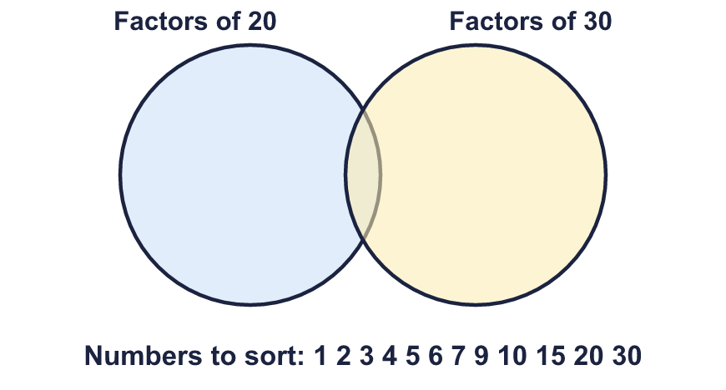  Factors of 20 only:  Factors of both:  Factors of 30 only:  Neither:
  3 | Sort the numbers into the diagram. Write each group.  Factors of 20 only:  Factors of both:  Factors of 30 only:  Neither:
  4 | Find the common factors of each pair of numbers.  a) 18 and 27:  b) 20 and 60:  c) 16 and 25:
  4 | Find the common factors of each pair of numbers.  a) 18 and 27:  b) 20 and 60:  c) 16 and 25:
  5 | Find the greatest common factor of each pair.  a) 27 and 45:  b) 40 and 60:
  5 | Find the greatest common factor of each pair.  a) 27 and 45:  b) 40 and 60:
  6 | Find the common factors of all three numbers.  a) 40, 60, 80:  b) 18, 27, 45:
  6 | Find the common factors of all three numbers.  a) 40, 60, 80:  b) 18, 27, 45:
  7 | List the common factors of 360 and 180 that are greater than 50.
  7 | List the common factors of 360 and 180 that are greater than 50.
  8 | Circle the numbers that are common factors of 18 and 30. Write them below.  2 3 4 5 6 8 9 12
  8 | Circle the numbers that are common factors of 18 and 30. Write them below.  2 3 4 5 6 8 9 12

  9 | Is Boba correct? Circle yes or no.  Yes / No  Explain how you know.  What is the greatest number of bags she can make?
     | 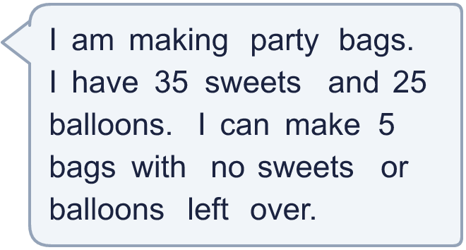
  9 | Is Boba correct? Circle yes or no.  Yes / No  Explain how you know.  What is the greatest number of bags she can make?
  10 | • It is a multiple of 11.  • The greatest common factor of my number and 12 is 4.  • It is greater than 79.  What is my number?
    
  10 | • It is a multiple of 11.  • The greatest common factor of my number and 12 is 4.  • It is greater than 79.  What is my number?
  11 | Divide the top and bottom of ³⁶⁄₆₀ by their greatest common factor. What fraction do you get?
     | 
  11 | Divide the top and bottom of ³⁶⁄₆₀ by their greatest common factor. What fraction do you get?
  12 | Is Boba correct? Circle yes or no.  Yes / No  Explain how you know.
     | 
  12 | Is Boba correct? Circle yes or no.  Yes / No  Explain how you know.
  13 | Look at the three pairs of numbers.  a) 16 and 24  b) 10 and 15  c) 9 and 27  Which pair has the most common factors? Write the letter.
  13 | Look at the three pairs of numbers.  a) 16 and 24  b) 10 and 15  c) 9 and 27  Which pair has the most common factors? Write the letter.
  14 | Write two different pairs of numbers (each less than 100) whose only common factors are 1 and 3.
  14 | Write two different pairs of numbers (each less than 100) whose only common factors are 1 and 3.

Year 6 · Add, subtract, multiply and divide · Step 2
Common factors
Answers (teacher copy)

  1 | Write all the factors of each number.  a) 18: 1, 2, 3, 6, 9, 18  b) 48: 1, 2, 3, 4, 6, 8, 12, 16, 24, 48
  2 | Complete the factor pairs of 36.  a) 1 × 36 = 36  b) 2 × 18 = 36  c) 3 × 12 = 36  d) 4 × 9 = 36
  3 | Sort the numbers into the diagram. Write each group.  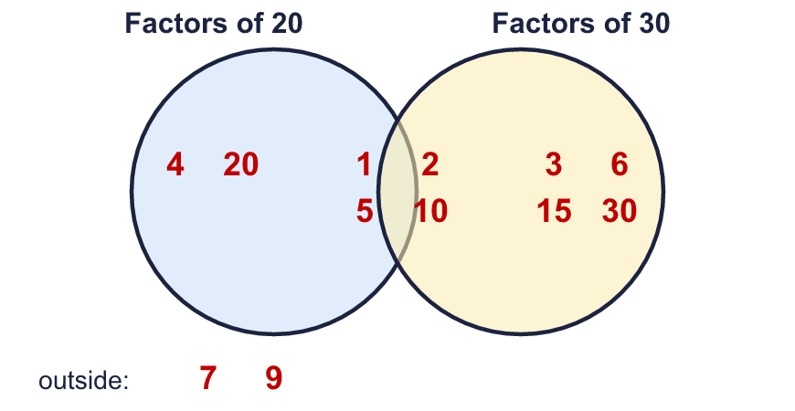  Factors of 20 only: 4, 20  Factors of both: 1, 2, 5, 10  Factors of 30 only: 3, 6, 15, 30  Neither: 7, 9
  4 | Find the common factors of each pair of numbers.  a) 18 and 27: 1, 3, 9  b) 20 and 60: 1, 2, 4, 5, 10, 20  c) 16 and 25: 1
  5 | Find the greatest common factor of each pair.  a) 27 and 45: 9  b) 40 and 60: 20
  6 | Find the common factors of all three numbers.  a) 40, 60, 80: 1, 2, 4, 5, 10, 20  b) 18, 27, 45: 1, 3, 9
  7 | List the common factors of 360 and 180 that are greater than 50.  60, 90, 180
  8 | Circle the numbers that are common factors of 18 and 30. Write them below.  2 3 4 5 6 8 9 12  2, 3, 6
  9 | Is Boba correct? Circle yes or no.  Yes / No  Explain how you know.  5 is a common factor of 35 and 25: 35 ÷ 5 = 7 and 25 ÷ 5 = 5.  What is the greatest number of bags she can make? 5
  10 | • It is a multiple of 11.  • The greatest common factor of my number and 12 is 4.  • It is greater than 79.  What is my number? 88
  11 | Divide the top and bottom of ³⁶⁄₆₀ by their greatest common factor. What fraction do you get? ³⁄₅
  12 | Is Boba correct? Circle yes or no.  Yes / No  Explain how you know.  The common factors of 24 and 36 are 1, 2, 3, 4, 6, 12. That is 6 common factors, not 8.
  13 | Look at the three pairs of numbers.  a) 16 and 24  b) 10 and 15  c) 9 and 27  Which pair has the most common factors? Write the letter. a
  14 | Write two different pairs of numbers (each less than 100) whose only common factors are 1 and 3.  Any pairs with common factors 1 and 3 only, for example 9 and 12 and 15 and 21

