  Year 5 · Volume · Step 4  Estimate capacity | 
  Year 5 · Volume · Step 4
  Estimate capacity
  1 | Write the letter of the most sensible capacity for each container.  a) a fish tank: A: 600 litres B: 6 litres C: 60 litres  b) a bucket: A: 100 litres B: 10 litres C: 1 litre  c) a glass of juice: A: 25 ml B: 2.5 litres C: 250 ml
    The most sensible capacity is
    The most sensible capacity is
    The most sensible capacity is
  1 | Write the letter of the most sensible capacity for each container.  a) a fish tank: A: 600 litres B: 6 litres C: 60 litres  b) a bucket: A: 100 litres B: 10 litres C: 1 litre  c) a glass of juice: A: 25 ml B: 2.5 litres C: 250 ml
    The most sensible capacity is
    The most sensible capacity is
    The most sensible capacity is
  2 | How much water is in the jug?  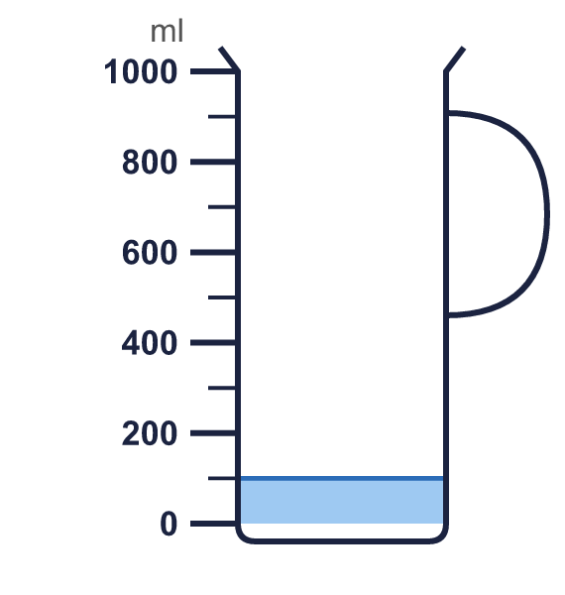
    Water: |  | ml
  2 | How much water is in the jug?
    Water: |  | ml
  3 | Dora pours a full carton of juice into glasses. It fills 4 glasses. Each glass holds 200 ml.
    Estimate of the capacity of the carton:
    ml
  3 | Dora pours a full carton of juice into glasses. It fills 4 glasses. Each glass holds 200 ml.
    Estimate of the capacity of the carton:
    ml
  4 | Dexter pours 5 equal bags of sand into a 1 litre container. The container is full. 1 litre = 1,000 ml.
    Estimate of the capacity of one bag:
    ml
  4 | Dexter pours 5 equal bags of sand into a 1 litre container. The container is full. 1 litre = 1,000 ml.
    Estimate of the capacity of one bag:
    ml
  5 | Whitney fills a fish tank with the water from 9 full bottles. Each bottle holds 500 ml. 1 litre = 1,000 ml.
    Estimate of the capacity of the tank:
    ml
    How many litres is that?
    litres
  5 | Whitney fills a fish tank with the water from 9 full bottles. Each bottle holds 500 ml. 1 litre = 1,000 ml.
    Estimate of the capacity of the tank:
    ml
    How many litres is that?
    litres
  6 | How much juice is in the jug?  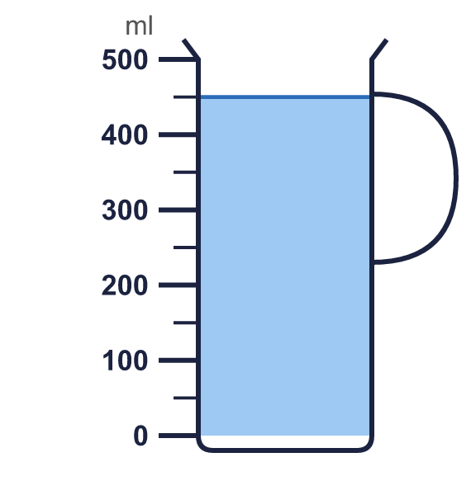
    Juice: |  | ml
  6 | How much juice is in the jug?
    Juice: |  | ml
  7 | A bucket holds about 3 litres of water. 1 litre = 1,000 ml.
    How many millilitres is that?
    ml
  7 | A bucket holds about 3 litres of water. 1 litre = 1,000 ml.
    How many millilitres is that?
    ml
  8 | A jug holds 3 litres of water. Glasses hold 200 ml. 1 litre = 1,000 ml.
    How many glasses can be filled from the jug?
  8 | A jug holds 3 litres of water. Glasses hold 200 ml. 1 litre = 1,000 ml.
    How many glasses can be filled from the jug?

  9 | Whitney fills a fish tank with 8 full bottles of water and 100 ml from one more bottle. Each full bottle holds 600 ml. 1 litre = 1,000 ml.
    Estimate of the capacity of the tank:
    litres
  9 | Whitney fills a fish tank with 8 full bottles of water and 100 ml from one more bottle. Each full bottle holds 600 ml. 1 litre = 1,000 ml.
    Estimate of the capacity of the tank:
    litres
  10 | Write the letter of the most sensible capacity for each container.  a) a bucket: A: 10 litres B: 1 litre C: 100 litres  b) a washing-up bowl: A: 80 litres B: 8 litres C: 800 ml  c) a small bottle of water: A: 500 ml B: 5 litres C: 50 ml  d) a fish tank: A: 6 litres B: 600 litres C: 60 litres
    The most sensible capacity is
    The most sensible capacity is
    The most sensible capacity is
    The most sensible capacity is
  10 | Write the letter of the most sensible capacity for each container.  a) a bucket: A: 10 litres B: 1 litre C: 100 litres  b) a washing-up bowl: A: 80 litres B: 8 litres C: 800 ml  c) a small bottle of water: A: 500 ml B: 5 litres C: 50 ml  d) a fish tank: A: 6 litres B: 600 litres C: 60 litres
    The most sensible capacity is
    The most sensible capacity is
    The most sensible capacity is
    The most sensible capacity is
  11 | A bucket holds 15 litres of lemonade. Glasses hold 250 ml. 1 litre = 1,000 ml.
    How many glasses can be filled from the bucket?
  11 | A bucket holds 15 litres of lemonade. Glasses hold 250 ml. 1 litre = 1,000 ml.
    How many glasses can be filled from the bucket?
  12 | Tom pours 20 litres of juice into glasses that hold 250 ml each. He sells every glass for 40p. 1 litre = 1,000 ml and £1 = 100p.
    How much money does he get in total?
    pounds
  12 | Tom pours 20 litres of juice into glasses that hold 250 ml each. He sells every glass for 40p. 1 litre = 1,000 ml and £1 = 100p.
    How much money does he get in total?
    pounds
  13 | A water tank is 50 cm long, 30 cm wide and 30 cm high. 1 litre = 1,000 cm³.
    What is the capacity of the tank in litres?
    litres
  13 | A water tank is 50 cm long, 30 cm wide and 30 cm high. 1 litre = 1,000 cm³.
    What is the capacity of the tank in litres?
    litres
  14 | It takes about 100 bottles of water to fill a paddling pool. Each bottle holds 500 ml. 1 litre = 1,000 ml.
    Estimate of the capacity of the pool:
    litres
  14 | It takes about 100 bottles of water to fill a paddling pool. Each bottle holds 500 ml. 1 litre = 1,000 ml.
    Estimate of the capacity of the pool:
    litres

Year 5 · Volume · Step 4
Estimate capacity
Answers (teacher copy)

  1 | Write the letter of the most sensible capacity for each container.  a) a fish tank: A: 600 litres B: 6 litres C: 60 litres  The most sensible capacity is C  b) a bucket: A: 100 litres B: 10 litres C: 1 litre  The most sensible capacity is B  c) a glass of juice: A: 25 ml B: 2.5 litres C: 250 ml  The most sensible capacity is C
  2 | How much water is in the jug?  Water: 100 ml
  3 | Dora pours a full carton of juice into glasses. It fills 4 glasses. Each glass holds 200 ml.  Estimate of the capacity of the carton: 800 ml
  4 | Dexter pours 5 equal bags of sand into a 1 litre container. The container is full. 1 litre = 1,000 ml.  Estimate of the capacity of one bag: 200 ml
  5 | Whitney fills a fish tank with the water from 9 full bottles. Each bottle holds 500 ml. 1 litre = 1,000 ml.  Estimate of the capacity of the tank: 4,500 ml  How many litres is that? 4.5 litres
  6 | How much juice is in the jug?  Juice: 450 ml
  7 | A bucket holds about 3 litres of water. 1 litre = 1,000 ml.  How many millilitres is that? 3,000 ml
  8 | A jug holds 3 litres of water. Glasses hold 200 ml. 1 litre = 1,000 ml.  How many glasses can be filled from the jug? 15
  9 | Whitney fills a fish tank with 8 full bottles of water and 100 ml from one more bottle. Each full bottle holds 600 ml. 1 litre = 1,000 ml.  Estimate of the capacity of the tank: 4.9 litres
  10 | Write the letter of the most sensible capacity for each container.  a) a bucket: A: 10 litres B: 1 litre C: 100 litres  The most sensible capacity is A  b) a washing-up bowl: A: 80 litres B: 8 litres C: 800 ml  The most sensible capacity is B  c) a small bottle of water: A: 500 ml B: 5 litres C: 50 ml  The most sensible capacity is A  d) a fish tank: A: 6 litres B: 600 litres C: 60 litres  The most sensible capacity is C
  11 | A bucket holds 15 litres of lemonade. Glasses hold 250 ml. 1 litre = 1,000 ml.  How many glasses can be filled from the bucket? 60
  12 | Tom pours 20 litres of juice into glasses that hold 250 ml each. He sells every glass for 40p. 1 litre = 1,000 ml and £1 = 100p.  How much money does he get in total? 32 pounds
  13 | A water tank is 50 cm long, 30 cm wide and 30 cm high. 1 litre = 1,000 cm³.  What is the capacity of the tank in litres? 45 litres
  14 | It takes about 100 bottles of water to fill a paddling pool. Each bottle holds 500 ml. 1 litre = 1,000 ml.  Estimate of the capacity of the pool: 50 litres

