  Year 5 · Volume · Step 1  Cubic centimetres | 
  Year 5 · Volume · Step 1
  Cubic centimetres
  1 | Dexter has made a 3-D shape from cubes. How many cubes did he use? There are no hidden cubes.  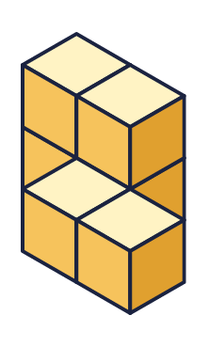
    Number of cubes =
  1 | Dexter has made a 3-D shape from cubes. How many cubes did he use? There are no hidden cubes.
    Number of cubes =
  2 | How many cubes are needed to make each shape? There are no hidden cubes.  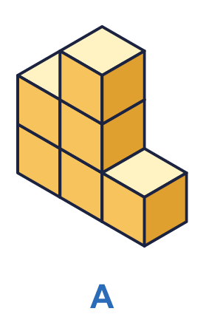  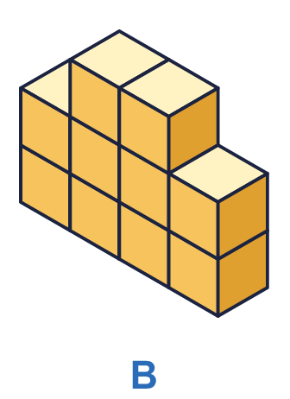
    a) Shape A: |  | cubes
    b) Shape B: |  | cubes
  2 | How many cubes are needed to make each shape? There are no hidden cubes.
    a) Shape A: |  | cubes
    b) Shape B: |  | cubes
  3 | The cuboid is made from cubes. Count the cubes in one layer, then work out the total.  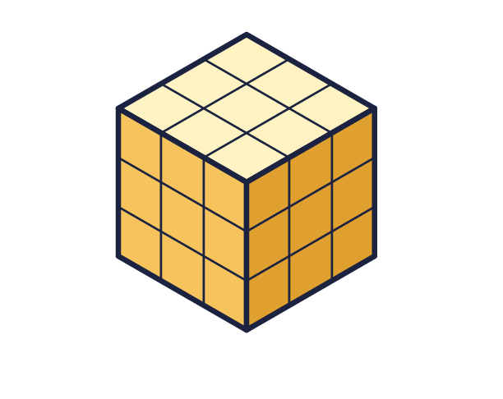
    Cubes in one layer =
    Number of layers =
    Total cubes =
  3 | The cuboid is made from cubes. Count the cubes in one layer, then work out the total.
    Cubes in one layer =
    Number of layers =
    Total cubes =
  4 | Each cube has a volume of 1 cm³. Work out the volume of each cuboid.  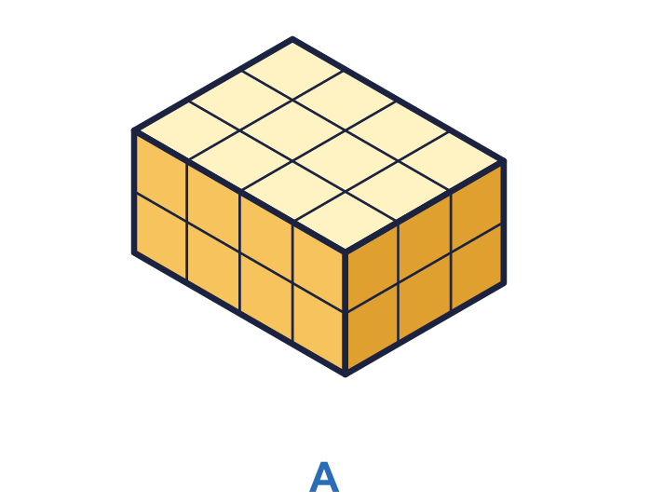  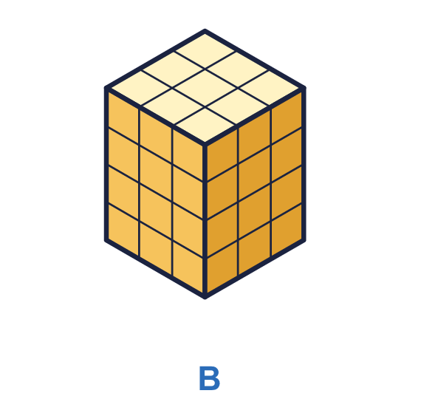
    a) Cuboid A: |  | cm³
    b) Cuboid B: |  | cm³
  4 | Each cube has a volume of 1 cm³. Work out the volume of each cuboid.
    a) Cuboid A: |  | cm³
    b) Cuboid B: |  | cm³
  5 | Each cube has a volume of 1 cm³. What is the volume of each shape?  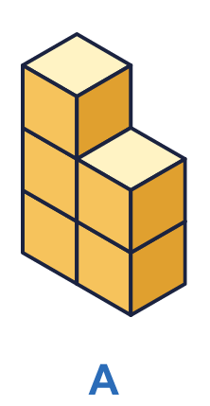  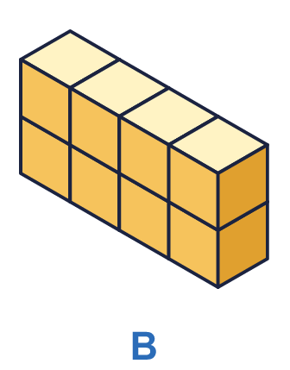
    a) Shape A: |  | cm³
    b) Shape B: |  | cm³
  5 | Each cube has a volume of 1 cm³. What is the volume of each shape?
    a) Shape A: |  | cm³
    b) Shape B: |  | cm³
  6 | A cuboid is made from cubes. It is 6 cubes long, 6 cubes wide and 6 cubes high.
    Number of cubes =
  6 | A cuboid is made from cubes. It is 6 cubes long, 6 cubes wide and 6 cubes high.
    Number of cubes =
  7 | A box is filled with 4 layers of cubes. Each layer has 8 cubes.
    Number of cubes =
  7 | A box is filled with 4 layers of cubes. Each layer has 8 cubes.
    Number of cubes =
  8 | Look at the two shapes. There are no hidden cubes.  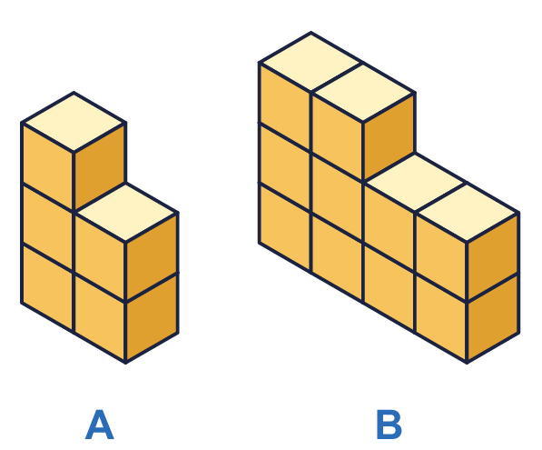
    Shape A: |  | cubes
    Shape B: |  | cubes
    Shape B has
    more cubes than shape A.
  8 | Look at the two shapes. There are no hidden cubes.
    Shape A: |  | cubes
    Shape B: |  | cubes
    Shape B has
    more cubes than shape A.

  9 | Here is a shape made from cubes. There are no hidden cubes.  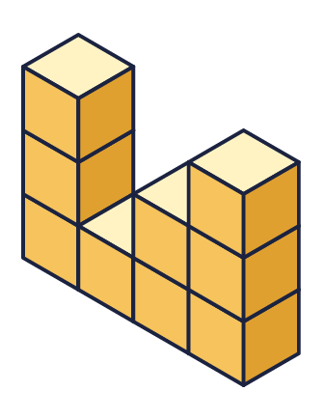  Is Boba correct? Circle yes or no.  Yes / No  Explain how you know.
    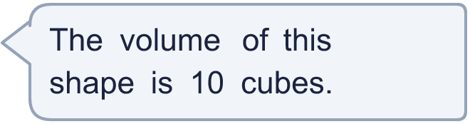
  9 | Here is a shape made from cubes. There are no hidden cubes.  Is Boba correct? Circle yes or no.  Yes / No  Explain how you know.
  10 | Each cube has a volume of 1 cm³. Which cuboid has the greater volume? How much greater?  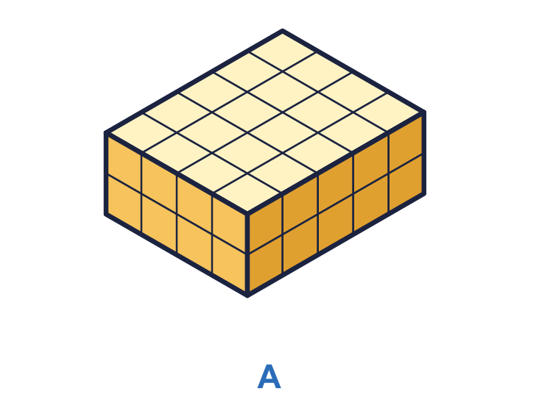  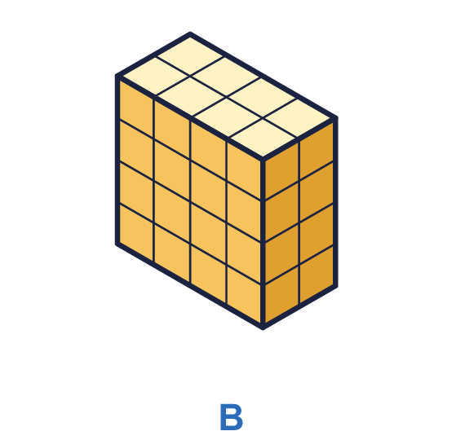
    Greater volume: cuboid
    It is greater by |  | cm³
  10 | Each cube has a volume of 1 cm³. Which cuboid has the greater volume? How much greater?
    Greater volume: cuboid
    It is greater by |  | cm³
  11 | A cuboid is made from 45 cubes. It is 3 cubes long and 3 cubes wide.
    It is |  | cubes high.
  11 | A cuboid is made from 45 cubes. It is 3 cubes long and 3 cubes wide.
    It is |  | cubes high.
  12 | A box holds 30 cubes in 3 equal layers. Each layer is 2 cubes wide.
    Cubes in one layer =
    Each layer is |  | cubes long.
  12 | A box holds 30 cubes in 3 equal layers. Each layer is 2 cubes wide.
    Cubes in one layer =
    Each layer is |  | cubes long.
  13 | Ron has 18 cubes. He uses all of them to make a cuboid. A cuboid that is 1 cube by 2 cubes by 9 cubes is the same as one that is 2 by 9 by 1.
    How many different cuboids can Ron make?
  13 | Ron has 18 cubes. He uses all of them to make a cuboid. A cuboid that is 1 cube by 2 cubes by 9 cubes is the same as one that is 2 by 9 by 1.
    How many different cuboids can Ron make?
  14 | A cube is made from 27 small cubes.
    Each edge of the big cube is
    small cubes long.
  14 | A cube is made from 27 small cubes.
    Each edge of the big cube is
    small cubes long.

Year 5 · Volume · Step 1
Cubic centimetres
Answers (teacher copy)

  1 | Dexter has made a 3-D shape from cubes. How many cubes did he use? There are no hidden cubes.  Number of cubes = 6
  2 | How many cubes are needed to make each shape? There are no hidden cubes.  a) Shape A: 6 cubes  b) Shape B: 10 cubes
  3 | The cuboid is made from cubes. Count the cubes in one layer, then work out the total.  Cubes in one layer = 9  Number of layers = 3  Total cubes = 27
  4 | Each cube has a volume of 1 cm³. Work out the volume of each cuboid.  a) Cuboid A: 24 cm³  b) Cuboid B: 36 cm³
  5 | Each cube has a volume of 1 cm³. What is the volume of each shape?  a) Shape A: 5 cm³  b) Shape B: 8 cm³
  6 | A cuboid is made from cubes. It is 6 cubes long, 6 cubes wide and 6 cubes high.  Number of cubes = 216
  7 | A box is filled with 4 layers of cubes. Each layer has 8 cubes.  Number of cubes = 32
  8 | Look at the two shapes. There are no hidden cubes.  Shape A: 5 cubes  Shape B: 10 cubes  Shape B has 5 more cubes than shape A.
  9 | Here is a shape made from cubes. There are no hidden cubes.  Is Boba correct? Circle yes or no.  Yes / No  Explain how you know.  No. There are 9 cubes in the shape, so its volume is 9 cubes.
  10 | Each cube has a volume of 1 cm³. Which cuboid has the greater volume? How much greater?  Greater volume: cuboid A  It is greater by 8 cm³
  11 | A cuboid is made from 45 cubes. It is 3 cubes long and 3 cubes wide.  It is 5 cubes high.
  12 | A box holds 30 cubes in 3 equal layers. Each layer is 2 cubes wide.  Cubes in one layer = 10  Each layer is 5 cubes long.
  13 | Ron has 18 cubes. He uses all of them to make a cuboid. A cuboid that is 1 cube by 2 cubes by 9 cubes is the same as one that is 2 by 9 by 1.  How many different cuboids can Ron make? 4
  14 | A cube is made from 27 small cubes.  Each edge of the big cube is 3 small cubes long.

