  Year 5 · Volume · Step 2  Compare volume | 
  Year 5 · Volume · Step 2
  Compare volume
  1 | Whitney and Tommy have each made a shape using cubes. Each cube has a volume of 1 cm³. There are no hidden cubes.  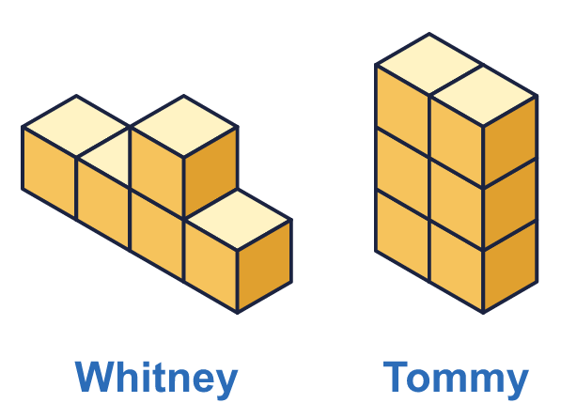
    What is the volume of Whitney's shape?
    cm³
    What is the volume of Tommy's shape?
    cm³
    Whose shape has the greater volume?
  1 | Whitney and Tommy have each made a shape using cubes. Each cube has a volume of 1 cm³. There are no hidden cubes.
    What is the volume of Whitney's shape?
    cm³
    What is the volume of Tommy's shape?
    cm³
    Whose shape has the greater volume?
  2 | Write the letter of the shape with the greater volume in each pair. There are no hidden cubes.  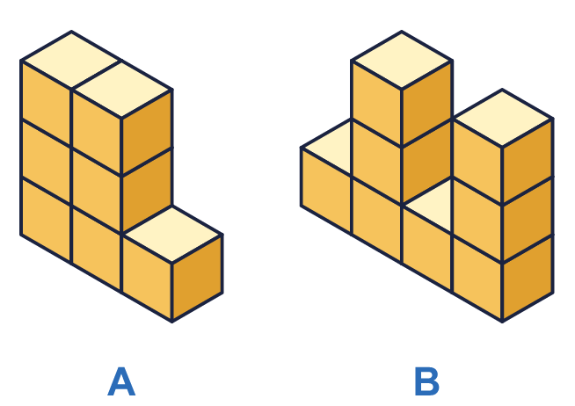  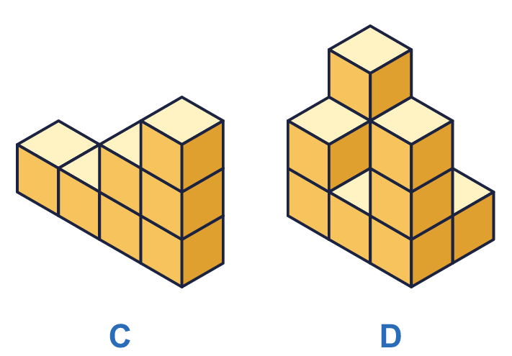
    Pair 1:
    Pair 2:
  2 | Write the letter of the shape with the greater volume in each pair. There are no hidden cubes.
    Pair 1:
    Pair 2:
  3 | Write <, > or = to compare the volumes of the two shapes. There are no hidden cubes.  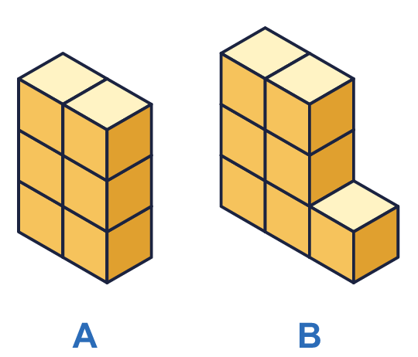  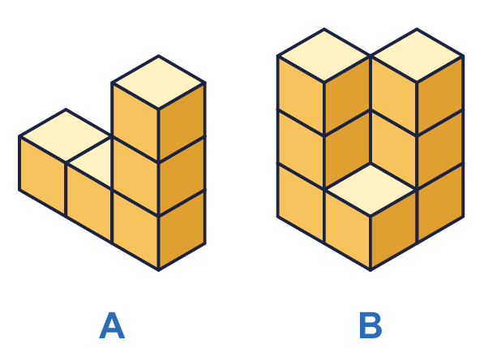  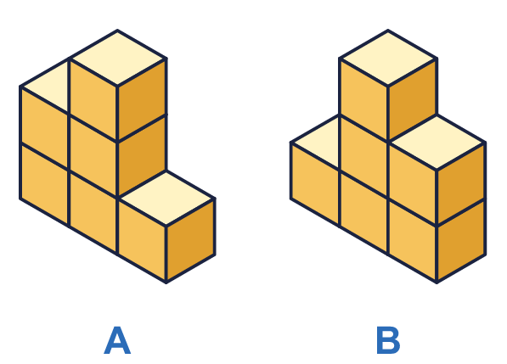
    a) Volume of A |  | volume of B
    b) Volume of A |  | volume of B
    c) Volume of A |  | volume of B
  3 | Write <, > or = to compare the volumes of the two shapes. There are no hidden cubes.
    a) Volume of A |  | volume of B
    b) Volume of A |  | volume of B
    c) Volume of A |  | volume of B
  4 | Here are five shapes made from cubes. Put the shapes in order of volume, starting with the smallest.  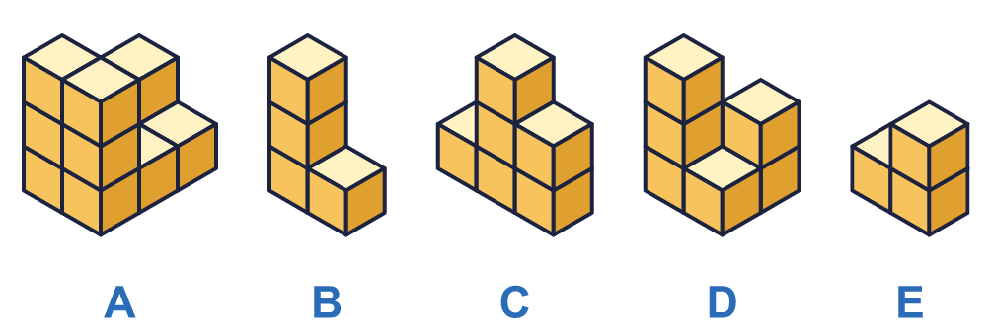
  4 | Here are five shapes made from cubes. Put the shapes in order of volume, starting with the smallest.
  5 | Tommy and Ron have each made a shape using cubes. Each cube has a volume of 1 cm³.  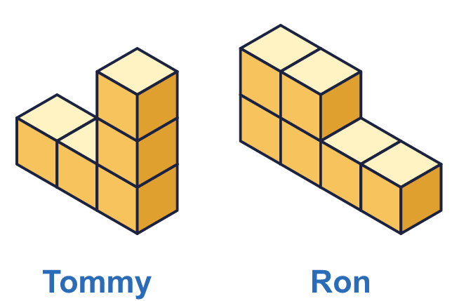  Is Boba correct? Circle yes or no.  Yes / No  Explain how you know.
     | 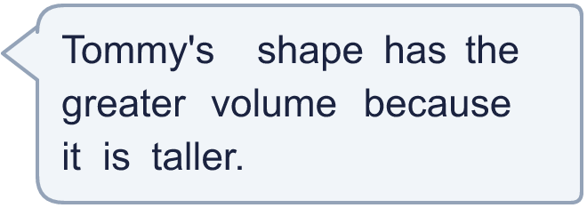
  5 | Tommy and Ron have each made a shape using cubes. Each cube has a volume of 1 cm³.  Is Boba correct? Circle yes or no.  Yes / No  Explain how you know.
  6 | Look at the two shapes. There are no hidden cubes.  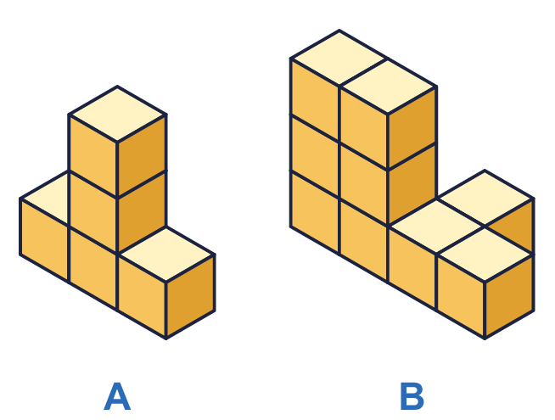
    Shape A: |  | cubes
    Shape B: |  | cubes
    The difference in volume is
    cm³
  6 | Look at the two shapes. There are no hidden cubes.
    Shape A: |  | cubes
    Shape B: |  | cubes
    The difference in volume is
    cm³
  7 | Amir and Eva have each made a shape out of centimetre cubes. Alex has made a shape with a volume that is greater than Amir's but less than Eva's. There are no hidden cubes.  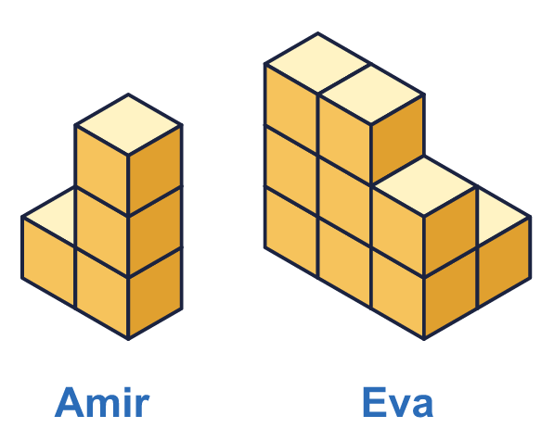
    What could the volume of Alex's shape be? Write all the possible whole numbers.
    cm³
  7 | Amir and Eva have each made a shape out of centimetre cubes. Alex has made a shape with a volume that is greater than Amir's but less than Eva's. There are no hidden cubes.
    What could the volume of Alex's shape be? Write all the possible whole numbers.
    cm³
  8 | Each cube has a volume of 1 cm³. Write <, > or = to compare the volumes of the cuboids.  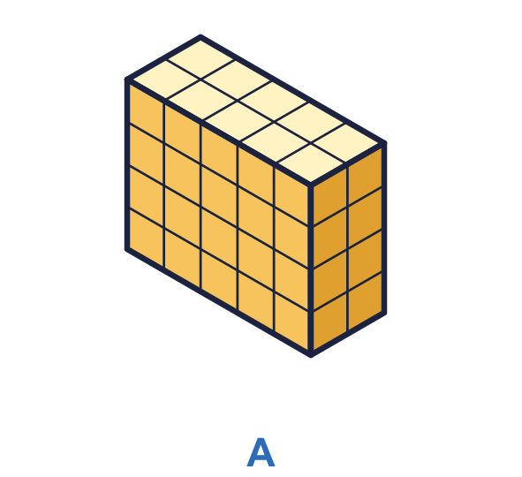  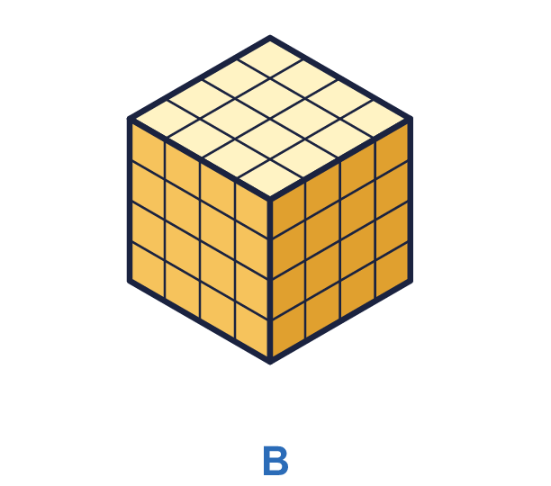
    Volume of A |  | volume of B
  8 | Each cube has a volume of 1 cm³. Write <, > or = to compare the volumes of the cuboids.
    Volume of A |  | volume of B

  9 | Dora and Ron have each made a shape using cubes.  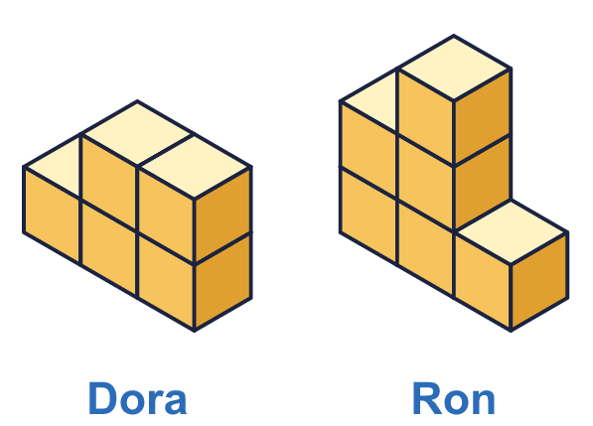  Is Boba correct? Circle yes or no.  Yes / No  Explain how you know.
     | 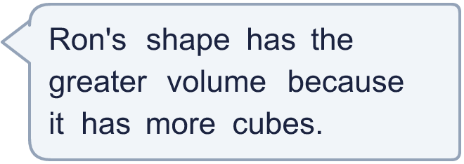
  9 | Dora and Ron have each made a shape using cubes.  Is Boba correct? Circle yes or no.  Yes / No  Explain how you know.
  10 | Rosie and Max have each made a shape using cubes.  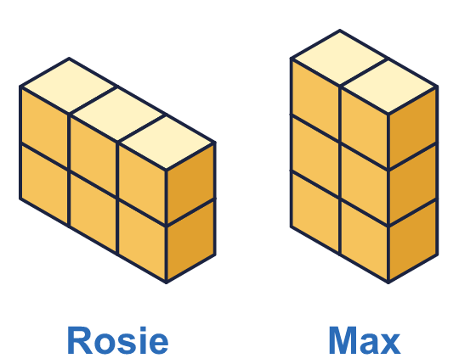  Is Boba correct? Circle yes or no.  Yes / No  Explain how you know.
    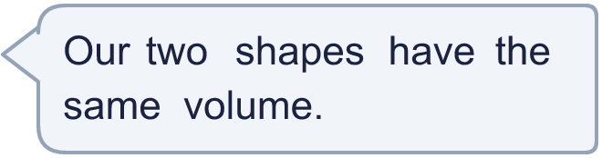
  10 | Rosie and Max have each made a shape using cubes.  Is Boba correct? Circle yes or no.  Yes / No  Explain how you know.
  11 | Here are four solids. Each cube has a volume of 1 cm³. Put the solids in order of volume, starting with the greatest.  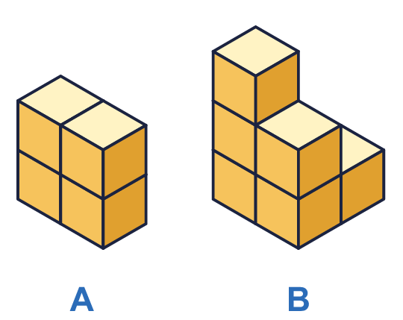  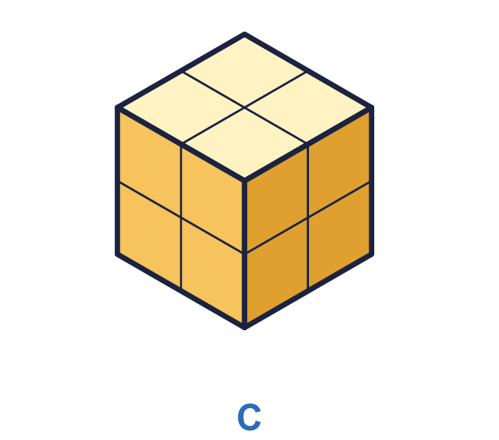  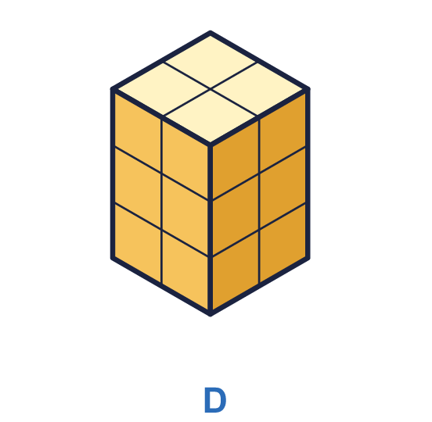
  11 | Here are four solids. Each cube has a volume of 1 cm³. Put the solids in order of volume, starting with the greatest.
  12 | Here are four shapes made from cubes. One of the shapes B, C and D has the same volume as shape A.  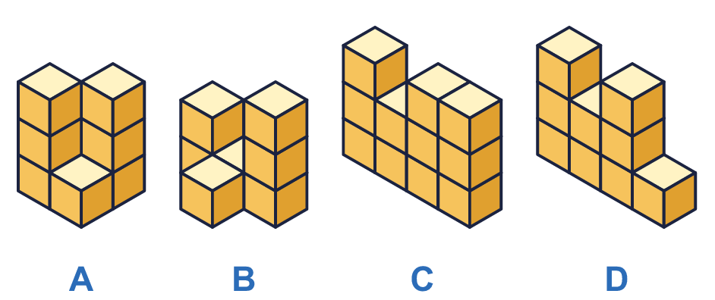
    Which shape has the same volume as shape A?
  12 | Here are four shapes made from cubes. One of the shapes B, C and D has the same volume as shape A.
    Which shape has the same volume as shape A?
  13 | Look at shapes A and B. There are no hidden cubes.  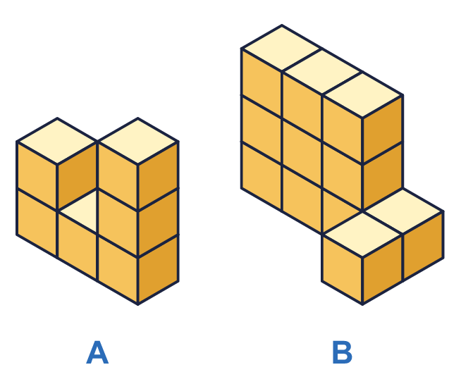
    How many cubes must be added to shape A to give it the same volume as the other shape?
  13 | Look at shapes A and B. There are no hidden cubes.
    How many cubes must be added to shape A to give it the same volume as the other shape?
  14 | Jack's shape has a volume that is greater than Amir's but less than Eva's. Each cube has a volume of 1 cm³. There are no hidden cubes.  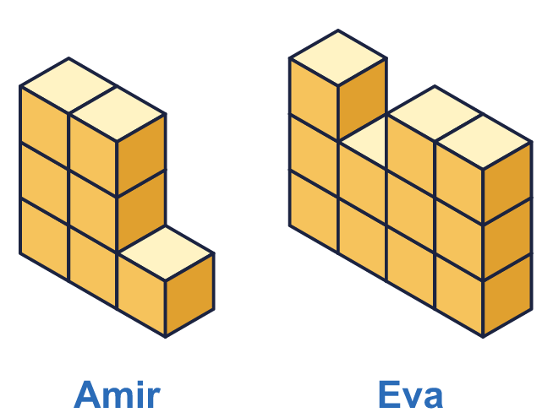  What could the volume of Jack's shape be? Write all the possible whole numbers.
    cm³
  14 | Jack's shape has a volume that is greater than Amir's but less than Eva's. Each cube has a volume of 1 cm³. There are no hidden cubes.  What could the volume of Jack's shape be? Write all the possible whole numbers.
    cm³

Year 5 · Volume · Step 2
Compare volume
Answers (teacher copy)

  1 | Whitney and Tommy have each made a shape using cubes. Each cube has a volume of 1 cm³. There are no hidden cubes.  What is the volume of Whitney's shape? 5 cm³  What is the volume of Tommy's shape? 6 cm³  Whose shape has the greater volume? Tommy
  2 | Write the letter of the shape with the greater volume in each pair. There are no hidden cubes.  Pair 1: B  Pair 2: D
  3 | Write <, > or = to compare the volumes of the two shapes. There are no hidden cubes.  a) Volume of A < volume of B  b) Volume of A < volume of B  c) Volume of A = volume of B
  4 | Here are five shapes made from cubes. Put the shapes in order of volume, starting with the smallest.  E, B, C, D, A
  5 | Tommy and Ron have each made a shape using cubes. Each cube has a volume of 1 cm³.  Is Boba correct? Circle yes or no.  Yes / No  Explain how you know.  No. Tommy's shape has 5 cubes and Ron's shape has 6 cubes. A shape that is taller does not always have more cubes.
  6 | Look at the two shapes. There are no hidden cubes.  Shape A: 5 cubes  Shape B: 9 cubes  The difference in volume is 4 cm³
  7 | Amir and Eva have each made a shape out of centimetre cubes. Alex has made a shape with a volume that is greater than Amir's but less than Eva's. There are no hidden cubes.  What could the volume of Alex's shape be? Write all the possible whole numbers. 5, 6, 7, 8 cm³
  8 | Each cube has a volume of 1 cm³. Write <, > or = to compare the volumes of the cuboids.  Volume of A < volume of B
  9 | Dora and Ron have each made a shape using cubes.  Is Boba correct? Circle yes or no.  Yes / No  Explain how you know.  Yes. Dora's shape has 5 cubes and Ron's shape has 6 cubes.
  10 | Rosie and Max have each made a shape using cubes.  Is Boba correct? Circle yes or no.  Yes / No  Explain how you know.  Yes. Each shape is made from 6 cubes, so each has a volume of 6 cm³.
  11 | Here are four solids. Each cube has a volume of 1 cm³. Put the solids in order of volume, starting with the greatest.  D, C, B, A
  12 | Here are four shapes made from cubes. One of the shapes B, C and D has the same volume as shape A.  Which shape has the same volume as shape A? B
  13 | Look at shapes A and B. There are no hidden cubes.  How many cubes must be added to shape A to give it the same volume as the other shape? 5
  14 | Jack's shape has a volume that is greater than Amir's but less than Eva's. Each cube has a volume of 1 cm³. There are no hidden cubes.  What could the volume of Jack's shape be? Write all the possible whole numbers.  8, 9, 10 cm³

