  Year 5 · Shape · Step 1  Understand and use degrees | 
  Year 5 · Shape · Step 1
  Understand and use degrees
  1 | Write the number of degrees in each turn.  a) A full turn  b) A half turn  c) A quarter turn
  1 | Write the number of degrees in each turn.  a) A full turn  b) A half turn  c) A quarter turn
  2 | Write the number of degrees in each turn.  a) How many degrees is three-quarters of a full turn?  b) How many degrees is an eighth of a full turn?
  2 | Write the number of degrees in each turn.  a) How many degrees is three-quarters of a full turn?  b) How many degrees is an eighth of a full turn?
  3 | Eva stands in the middle and is facing the bank. She makes a full turn.  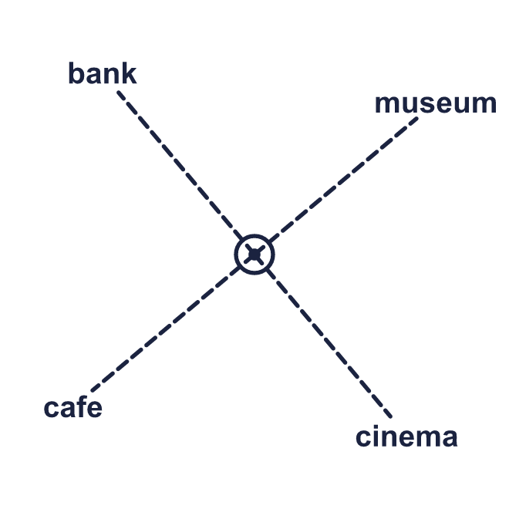  a) What is Eva facing now?  b) How many degrees has Eva turned through?
  3 | Eva stands in the middle and is facing the bank. She makes a full turn.  a) What is Eva facing now?  b) How many degrees has Eva turned through?
  4 | Mo is facing the school. He makes a half turn.  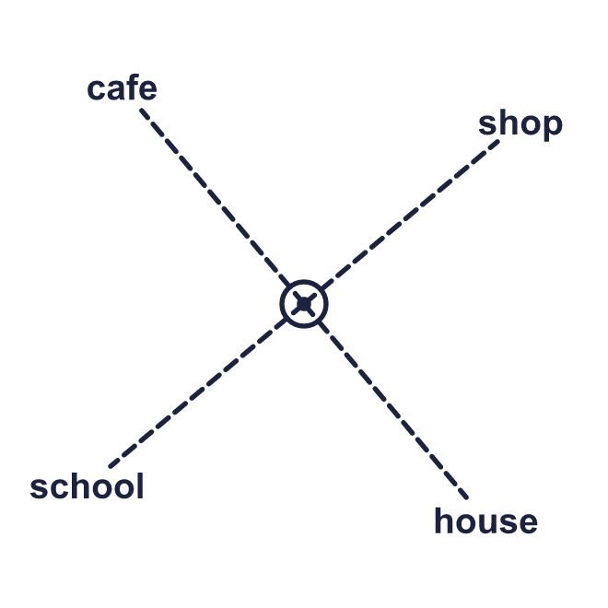  a) What is Mo facing now?  b) Does it matter which way he turns? Write yes or no.
  4 | Mo is facing the school. He makes a half turn.  a) What is Mo facing now?  b) Does it matter which way he turns? Write yes or no.
  5 | Amir is facing the bank. He turns 90° clockwise.  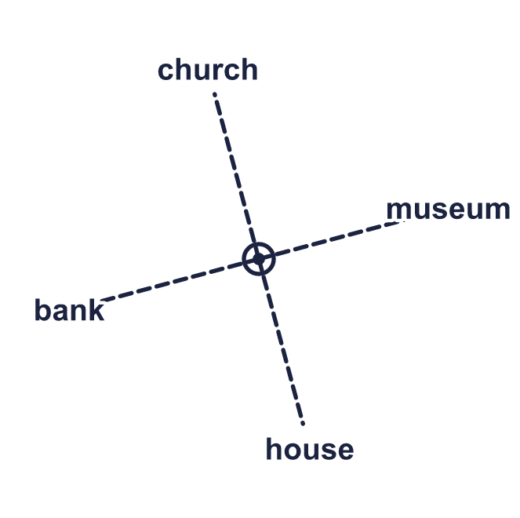  a) What is Amir facing now?
  5 | Amir is facing the bank. He turns 90° clockwise.  a) What is Amir facing now?
  6 | Amir is facing the cinema again. This time he turns 90° anticlockwise.  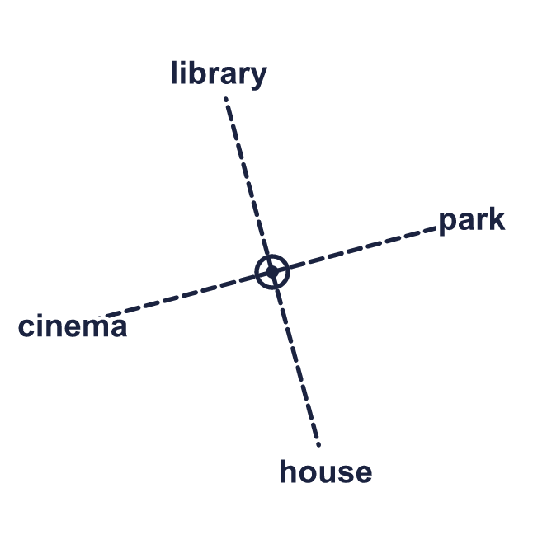  a) What is Amir facing now?
  6 | Amir is facing the cinema again. This time he turns 90° anticlockwise.  a) What is Amir facing now?
  7 | Filip is facing the park. He turns clockwise to face the library.  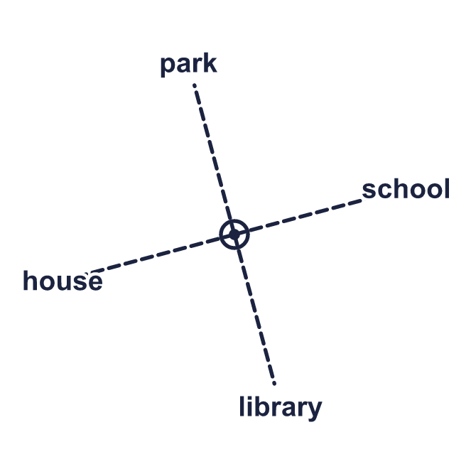
    How many degrees did he turn through?
    °
  7 | Filip is facing the park. He turns clockwise to face the library.
    How many degrees did he turn through?
    °
  8 | Jack is facing the house. The places are 45° apart.  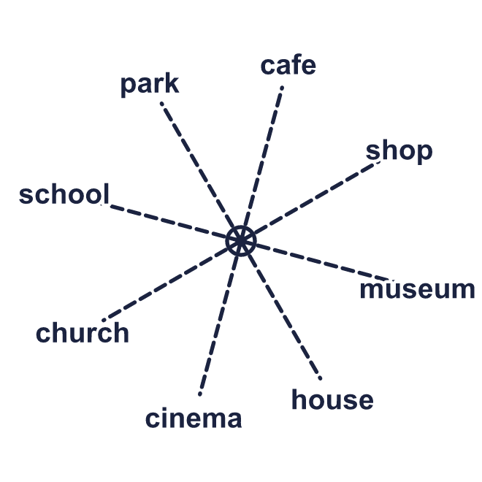  a) He turns 135° clockwise. What is he facing now?  b) He starts again and turns 135° anticlockwise. What is he facing now?
  8 | Jack is facing the house. The places are 45° apart.  a) He turns 135° clockwise. What is he facing now?  b) He starts again and turns 135° anticlockwise. What is he facing now?

  9 | Jack is facing the house. He makes a 90° turn. The direction of the turn is not stated.  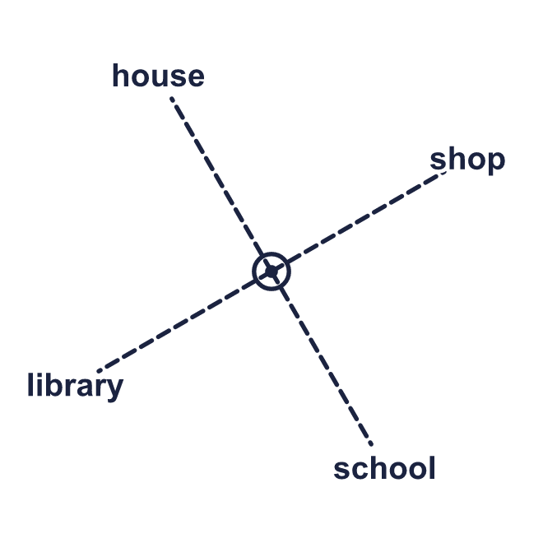  Which two places could he now be facing? Write both.
  9 | Jack is facing the house. He makes a 90° turn. The direction of the turn is not stated.  Which two places could he now be facing? Write both.
  10 | Dora is facing the cafe.  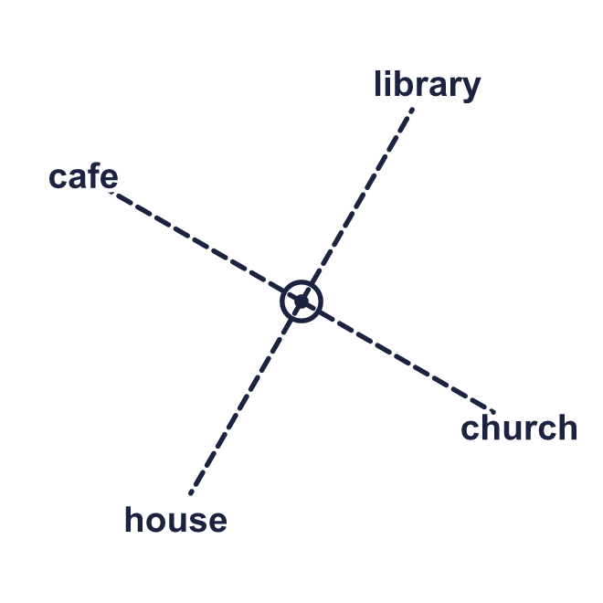  Is Dora correct? Circle yes or no.  Yes / No  Explain how you know.
     | 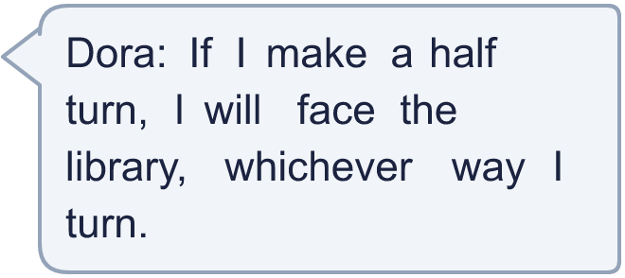
  10 | Dora is facing the cafe.  Is Dora correct? Circle yes or no.  Yes / No  Explain how you know.
  11 | Annie is facing the park. The places are 45° apart. She turns 270° clockwise.  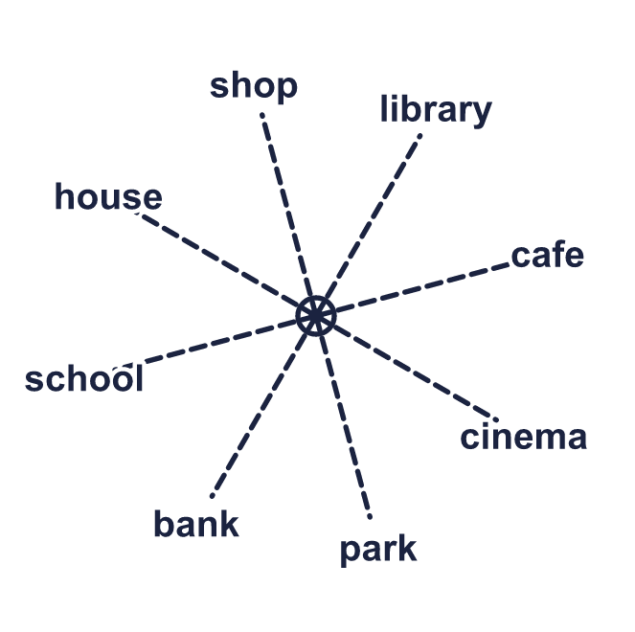  a) What is she facing now?  b) She could have turned the other way to face the same place. How many degrees would that turn be, anticlockwise?
  11 | Annie is facing the park. The places are 45° apart. She turns 270° clockwise.  a) What is she facing now?  b) She could have turned the other way to face the same place. How many degrees would that turn be, anticlockwise?
  12 | Annie is facing the shop. She turns to face the house. Describe two different turns she could have made.  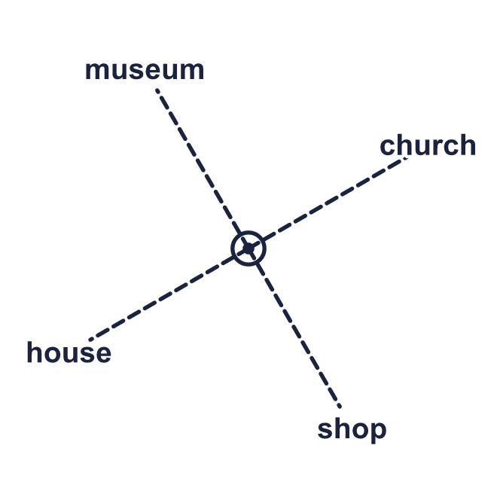
    Clockwise she turns |  | °
    Anticlockwise she turns |  | °
  12 | Annie is facing the shop. She turns to face the house. Describe two different turns she could have made.
    Clockwise she turns |  | °
    Anticlockwise she turns |  | °
  13 | Mo is facing the bank. The places are 45° apart. He turns 180° clockwise, then 90° anticlockwise, then 45° clockwise.  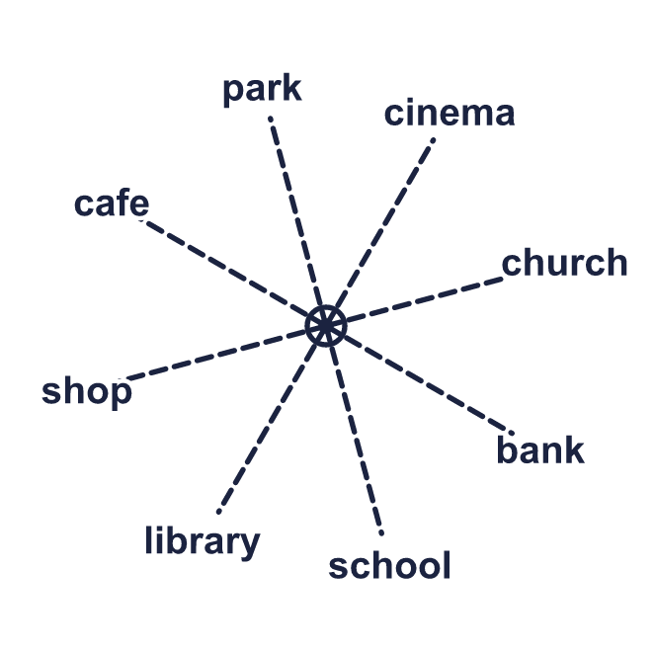  a) What is he facing now?
  13 | Mo is facing the bank. The places are 45° apart. He turns 180° clockwise, then 90° anticlockwise, then 45° clockwise.  a) What is he facing now?
  14 | Challenge  Ron turned 315° clockwise and is now facing the bank. The places are 45° apart.  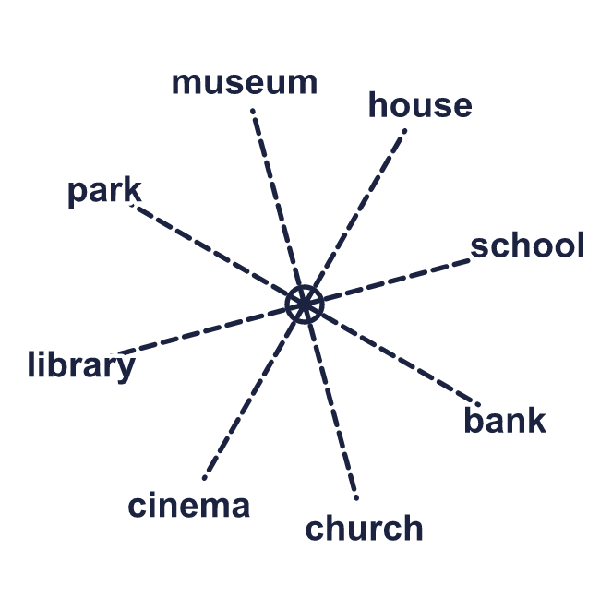  a) What was Ron facing before he turned?
  14 | Challenge  Ron turned 315° clockwise and is now facing the bank. The places are 45° apart.  a) What was Ron facing before he turned?

Year 5 · Shape · Step 1
Understand and use degrees
Answers (teacher copy)

  1 | Write the number of degrees in each turn.  a) A full turn 360  b) A half turn 180  c) A quarter turn 90
  2 | Write the number of degrees in each turn.  a) How many degrees is three-quarters of a full turn? 270  b) How many degrees is an eighth of a full turn? 45
  3 | Eva stands in the middle and is facing the bank. She makes a full turn.  a) What is Eva facing now? bank  b) How many degrees has Eva turned through? 360
  4 | Mo is facing the school. He makes a half turn.  a) What is Mo facing now? shop  b) Does it matter which way he turns? Write yes or no. No
  5 | Amir is facing the bank. He turns 90° clockwise.  a) What is Amir facing now? church
  6 | Amir is facing the cinema again. This time he turns 90° anticlockwise.  a) What is Amir facing now? house
  7 | Filip is facing the park. He turns clockwise to face the library.  How many degrees did he turn through? 180 °
  8 | Jack is facing the house. The places are 45° apart.  a) He turns 135° clockwise. What is he facing now? school  b) He starts again and turns 135° anticlockwise. What is he facing now? cafe
  9 | Jack is facing the house. He makes a 90° turn. The direction of the turn is not stated.  Which two places could he now be facing? Write both. library, shop
  10 | Dora is facing the cafe.  Is Dora correct? Circle yes or no.  Yes / No  Explain how you know.  No. A half turn is 180°. Turning either way, Dora ends up facing the church, not the library.
  11 | Annie is facing the park. The places are 45° apart. She turns 270° clockwise.  a) What is she facing now? cafe  b) She could have turned the other way to face the same place. How many degrees would that turn be, anticlockwise? 90
  12 | Annie is facing the shop. She turns to face the house. Describe two different turns she could have made.  Clockwise she turns 90 °  Anticlockwise she turns 270 °
  13 | Mo is facing the bank. The places are 45° apart. He turns 180° clockwise, then 90° anticlockwise, then 45° clockwise.  a) What is he facing now? shop
  14 | Challenge  Ron turned 315° clockwise and is now facing the bank. The places are 45° apart.  a) What was Ron facing before he turned? church

