  Year 5 · Shape · Step 9  Regular and irregular polygons | 
  Year 5 · Shape · Step 9
  Regular and irregular polygons
  1 | One of these quadrilaterals is regular. Which one? Write the letter.  Shape A    Shape B  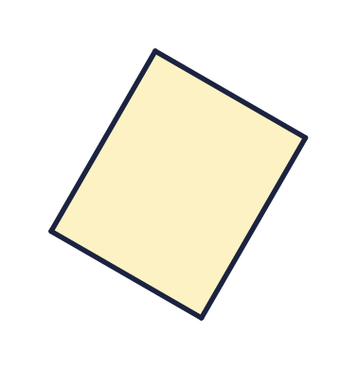  Shape C  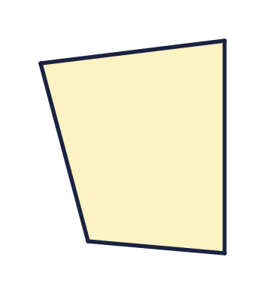  Shape D  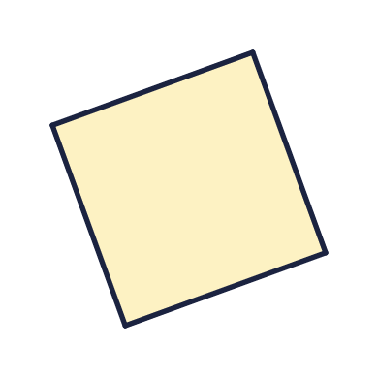
    The regular shape is shape
  1 | One of these quadrilaterals is regular. Which one? Write the letter.  Shape A  Shape B  Shape C  Shape D
    The regular shape is shape
  2 | One of these hexagons is regular. Which one? Write the letter.  Shape A  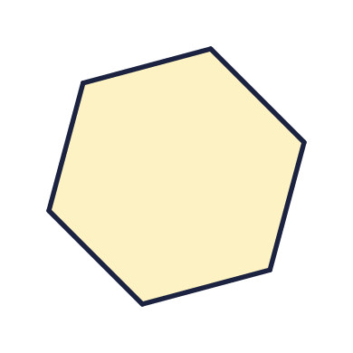  Shape B  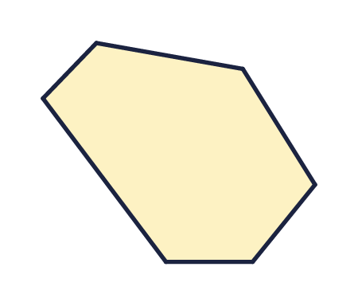  Shape C  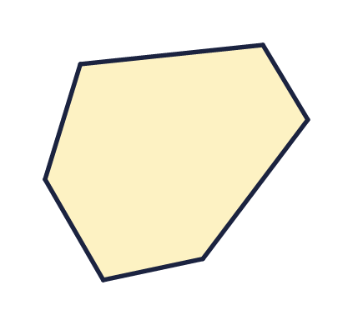  Shape D  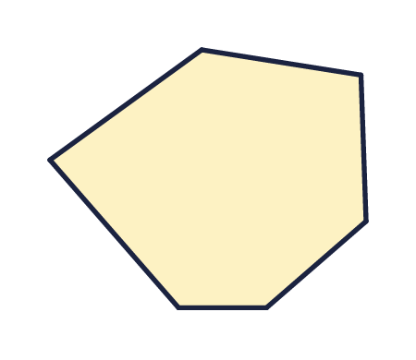
    The regular shape is shape
  2 | One of these hexagons is regular. Which one? Write the letter.  Shape A  Shape B  Shape C  Shape D
    The regular shape is shape
  3 | These are all regular polygons. Write the name of each polygon.  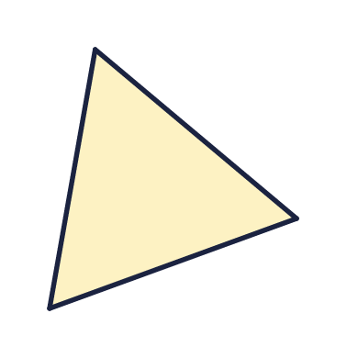  a) Name  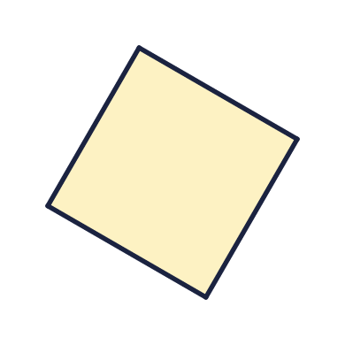  b) Name  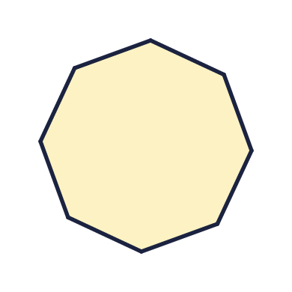  c) Name
  3 | These are all regular polygons. Write the name of each polygon.  a) Name  b) Name  c) Name
  4 | A polygon has 6 straight sides. What is it called?  a) It is a
  4 | A polygon has 6 straight sides. What is it called?  a) It is a
  5 | The marks on the sides show that all the sides are the same length. All the angles are the same size too.  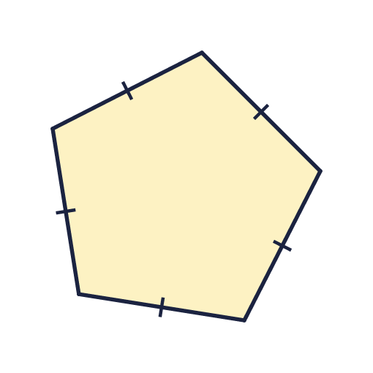  a) Is this polygon regular? Write yes or no.  b) How many sides does it have?
  5 | The marks on the sides show that all the sides are the same length. All the angles are the same size too.  a) Is this polygon regular? Write yes or no.  b) How many sides does it have?
  6 | All four angles of this rectangle are right angles. The sides are not all the same length.  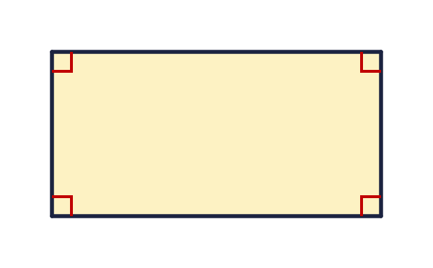  a) Is the rectangle a regular polygon? Write yes or no.
  6 | All four angles of this rectangle are right angles. The sides are not all the same length.  a) Is the rectangle a regular polygon? Write yes or no.
  7 | Look at the four shapes.  Shape A  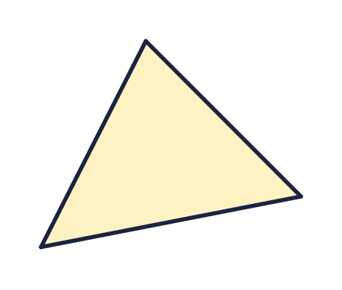  Shape B  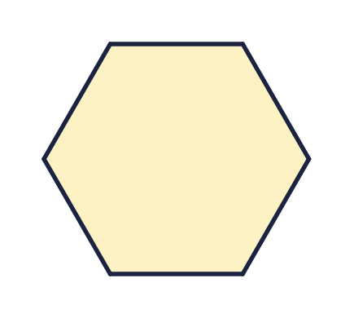  Shape C  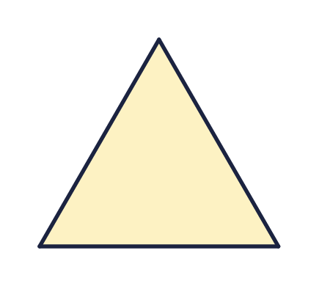  Shape D  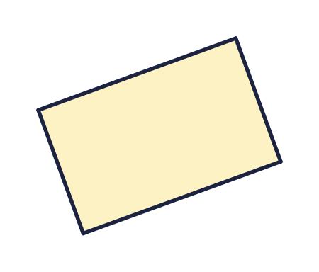  a) How many of the shapes are regular?
  7 | Look at the four shapes.  Shape A  Shape B  Shape C  Shape D  a) How many of the shapes are regular?
  8 | A regular octagon has sides of 7 cm.
    The perimeter is |  | cm
  8 | A regular octagon has sides of 7 cm.
    The perimeter is |  | cm

  9 | Here is a rhombus. The marks show that all four sides are the same length.  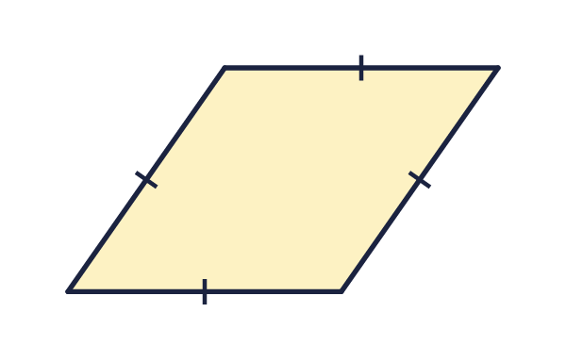  Is Sam correct? Circle yes or no.  Yes / No  Explain how you know.
     | 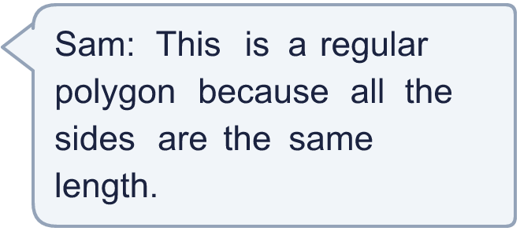
  9 | Here is a rhombus. The marks show that all four sides are the same length.  Is Sam correct? Circle yes or no.  Yes / No  Explain how you know.
  10 | Eva has drawn a square and a regular pentagon with sides of the same length. She has joined them to make a new shape with 7 sides. All the sides of the new shape are the same length.  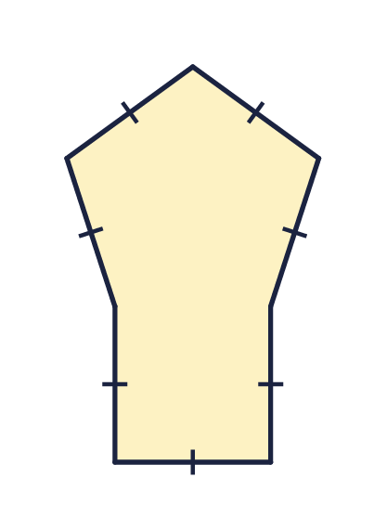  Is Eva correct? Circle yes or no.  Yes / No  Explain how you know.
     | 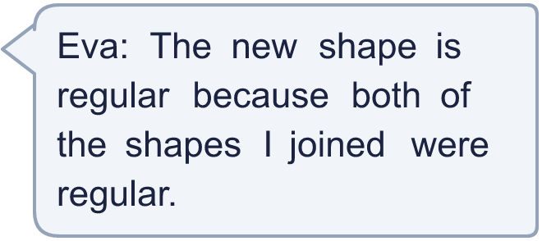
  10 | Eva has drawn a square and a regular pentagon with sides of the same length. She has joined them to make a new shape with 7 sides. All the sides of the new shape are the same length.  Is Eva correct? Circle yes or no.  Yes / No  Explain how you know.
  11 | Here is a rectangle. All its angles are right angles.  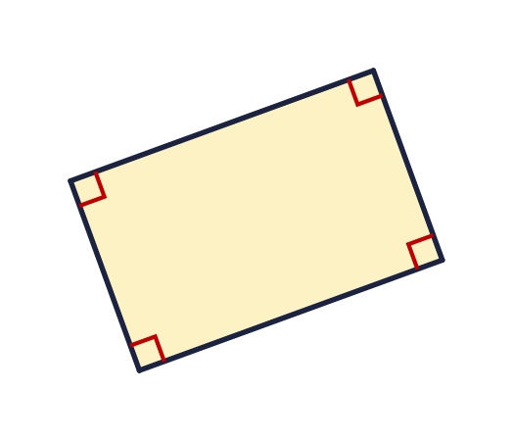  Is Dora correct? Circle yes or no.  Yes / No  Explain how you know.
    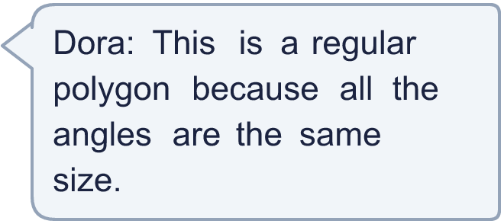
  11 | Here is a rectangle. All its angles are right angles.  Is Dora correct? Circle yes or no.  Yes / No  Explain how you know.
  12 | A shape has 9 sides of equal length and 9 equal angles.  a) Is it a regular or an irregular polygon?  b) What is the shape called?
  12 | A shape has 9 sides of equal length and 9 equal angles.  a) Is it a regular or an irregular polygon?  b) What is the shape called?
  13 | Look at the six shapes. Count how many are regular and how many are irregular.  Shape A  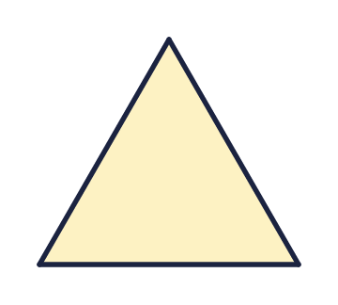  Shape B  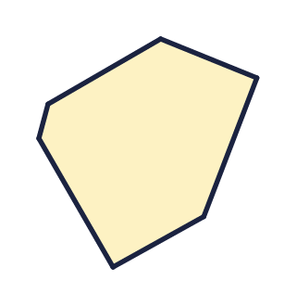  Shape C  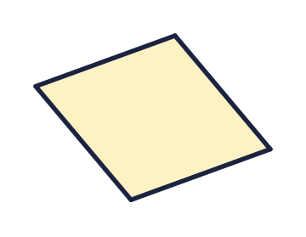  Shape D  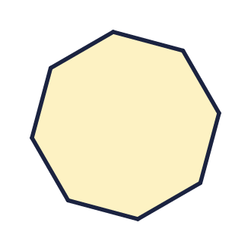  Shape E  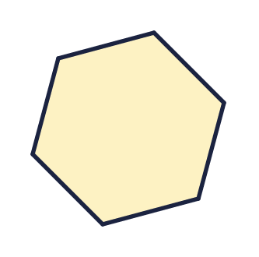  Shape F  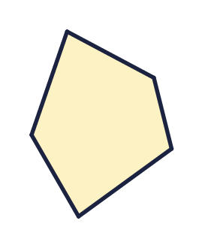  a) Regular shapes  b) Irregular shapes
  13 | Look at the six shapes. Count how many are regular and how many are irregular.  Shape A  Shape B  Shape C  Shape D  Shape E  Shape F  a) Regular shapes  b) Irregular shapes
  14 | Challenge  A regular polygon has a perimeter of 48 cm. Each side is 6 cm long.  a) How many sides does it have?  b) What is the polygon called?
  14 | Challenge  A regular polygon has a perimeter of 48 cm. Each side is 6 cm long.  a) How many sides does it have?  b) What is the polygon called?

Year 5 · Shape · Step 9
Regular and irregular polygons
Answers (teacher copy)

  1 | One of these quadrilaterals is regular. Which one? Write the letter.  Shape A  Shape B  Shape C  Shape D  The regular shape is shape D
  2 | One of these hexagons is regular. Which one? Write the letter.  Shape A  Shape B  Shape C  Shape D  The regular shape is shape A
  3 | These are all regular polygons. Write the name of each polygon.  a) Name triangle  b) Name quadrilateral  c) Name octagon
  4 | A polygon has 6 straight sides. What is it called?  a) It is a hexagon
  5 | The marks on the sides show that all the sides are the same length. All the angles are the same size too.  a) Is this polygon regular? Write yes or no. Yes  b) How many sides does it have? 5
  6 | All four angles of this rectangle are right angles. The sides are not all the same length.  a) Is the rectangle a regular polygon? Write yes or no. No
  7 | Look at the four shapes.  Shape A  Shape B  Shape C  Shape D  a) How many of the shapes are regular? 2
  8 | A regular octagon has sides of 7 cm.  The perimeter is 56 cm
  9 | Here is a rhombus. The marks show that all four sides are the same length.  Is Sam correct? Circle yes or no.  Yes / No  Explain how you know.  No. A regular polygon needs all its angles to be equal too. The angles of a rhombus are not all the same size, so it is not regular.
  10 | Eva has drawn a square and a regular pentagon with sides of the same length. She has joined them to make a new shape with 7 sides. All the sides of the new shape are the same length.  Is Eva correct? Circle yes or no.  Yes / No  Explain how you know.  No. The angles of the new shape are not all the same size, so it is not regular. A regular polygon needs equal sides and equal angles.
  11 | Here is a rectangle. All its angles are right angles.  Is Dora correct? Circle yes or no.  Yes / No  Explain how you know.  No. A regular polygon needs all its sides to be equal too. The sides of this rectangle are not all the same length, so it is not regular.
  12 | A shape has 9 sides of equal length and 9 equal angles.  a) Is it a regular or an irregular polygon? regular  b) What is the shape called? nonagon
  13 | Look at the six shapes. Count how many are regular and how many are irregular.  Shape A  Shape B  Shape C  Shape D  Shape E  Shape F  a) Regular shapes 3  b) Irregular shapes 3
  14 | Challenge  A regular polygon has a perimeter of 48 cm. Each side is 6 cm long.  a) How many sides does it have? 8  b) What is the polygon called? octagon

