  Year 5 · Shape · Step 4  Measure angles up to 180 degrees | 
  Year 5 · Shape · Step 4
  Measure angles up to 180 degrees
  1 | The corner of the angle is at the centre of the protractor and one arm is along the zero line. Read the size of the angle from the correct scale.  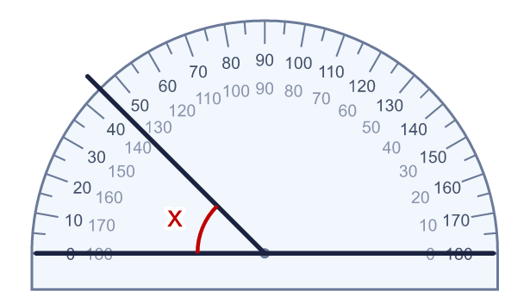
    x = |  | °
  1 | The corner of the angle is at the centre of the protractor and one arm is along the zero line. Read the size of the angle from the correct scale.
    x = |  | °
  2 | Read the size of the angle from the protractor. Start from the zero line.  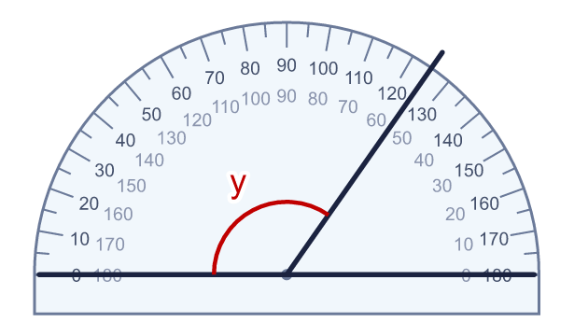
    y = |  | °
  2 | Read the size of the angle from the protractor. Start from the zero line.
    y = |  | °
  3 | Decide whether angle z is acute or obtuse. Then measure it.  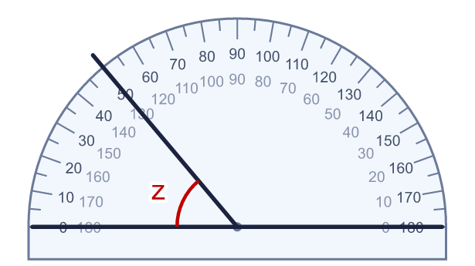  a) Acute or obtuse?
    z = |  | °
  3 | Decide whether angle z is acute or obtuse. Then measure it.  a) Acute or obtuse?
    z = |  | °
  4 | Two angles are marked from the zero line of the protractor. Read both of them.  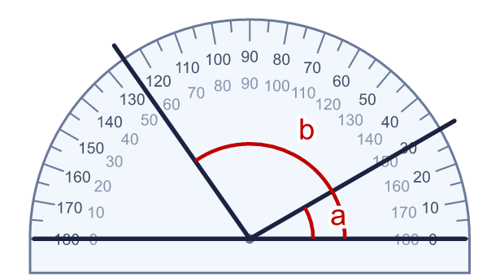
    a = |  | °
    b = |  | °
  4 | Two angles are marked from the zero line of the protractor. Read both of them.
    a = |  | °
    b = |  | °
  5 | Read the size of angle x from the protractor. What type of angle is it?  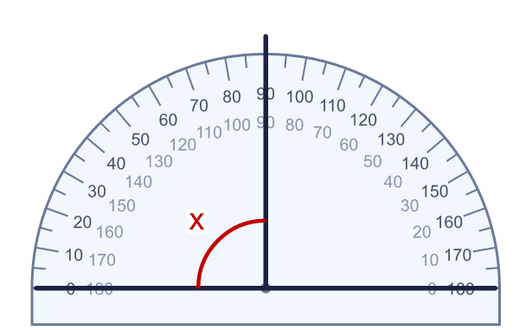  a) Type of angle
    x = |  | °
  5 | Read the size of angle x from the protractor. What type of angle is it?  a) Type of angle
    x = |  | °
  6 | Three angles are marked from the zero line. Read all three.  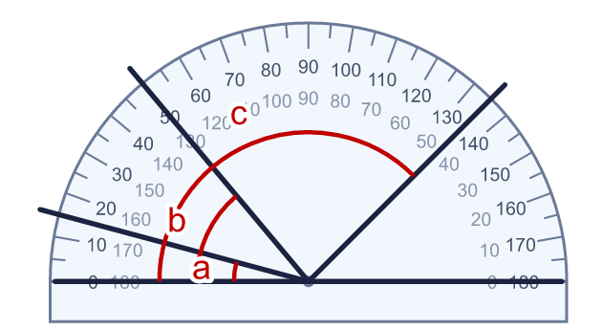
    a = |  | °
    b = |  | °
    c = |  | °
  6 | Three angles are marked from the zero line. Read all three.
    a = |  | °
    b = |  | °
    c = |  | °
  7 | Three angles are marked from the zero line. Which angle is the largest? What size is it?  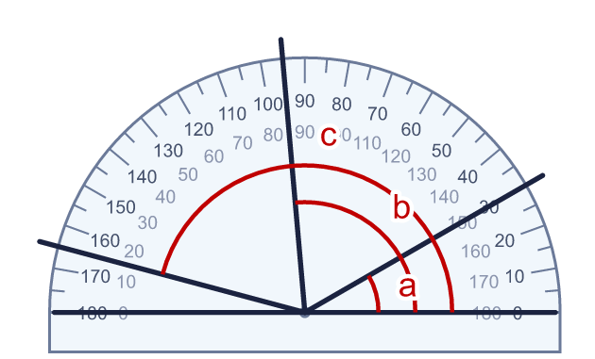  a) Largest angle (letter)
    Its size = |  | °
  7 | Three angles are marked from the zero line. Which angle is the largest? What size is it?  a) Largest angle (letter)
    Its size = |  | °
  8 | Read angles a and b from the protractor. Both are measured from the zero line.  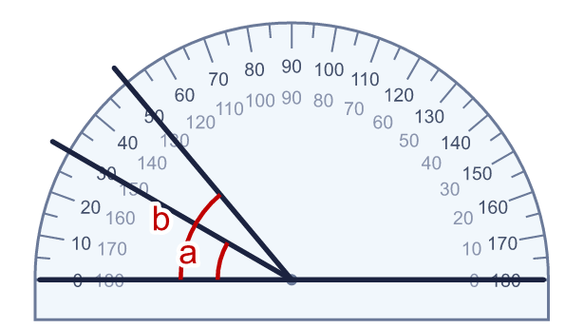
    a = |  | °
    b = |  | °
    How much bigger is angle b than angle a?
    °
  8 | Read angles a and b from the protractor. Both are measured from the zero line.
    a = |  | °
    b = |  | °
    How much bigger is angle b than angle a?
    °

  9 | Max is measuring angle x.  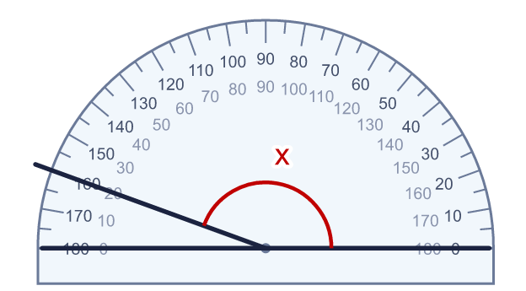  Is Max correct? Circle yes or no.  Yes / No  Explain how you know.
     | 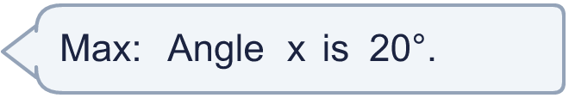
  9 | Max is measuring angle x.  Is Max correct? Circle yes or no.  Yes / No  Explain how you know.
  10 | The protractor measures angle a. The reflex angle y is on the other side of the same two arms. A full turn is 360°.  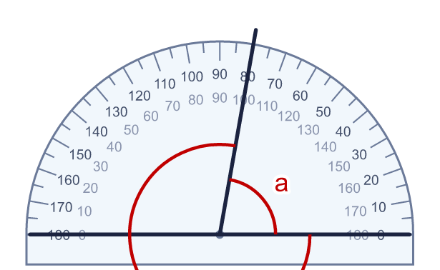
    a = |  | °
    y = |  | °
  10 | The protractor measures angle a. The reflex angle y is on the other side of the same two arms. A full turn is 360°.
    a = |  | °
    y = |  | °
  11 | Read the three angles a, b and c from the protractor.  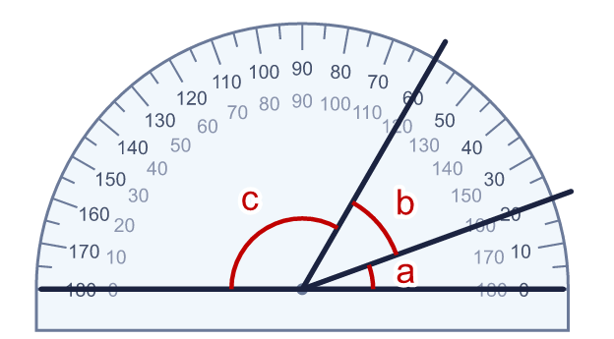
    a = |  | °
    b = |  | °
    c = |  | °
    What is a + b + c? |  | °
  11 | Read the three angles a, b and c from the protractor.
    a = |  | °
    b = |  | °
    c = |  | °
    What is a + b + c? |  | °
  12 | Four lines are drawn from the centre of the protractor. All the angles are measured from the zero line.  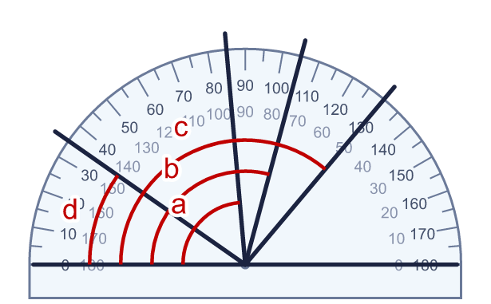
    Which angle is between 70° and 90°? Write the letter.
    Its size = |  | °
  12 | Four lines are drawn from the centre of the protractor. All the angles are measured from the zero line.
    Which angle is between 70° and 90°? Write the letter.
    Its size = |  | °
  13 | Two lines are drawn from the centre of the protractor. Angles a and b are both measured from the zero line. Work out the angle between the two lines.  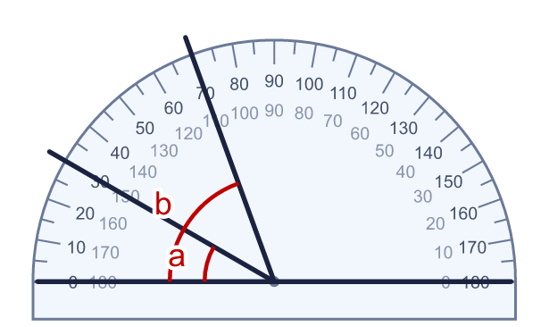
    a = |  | °
    b = |  | °
    The angle between the two lines is
    °
  13 | Two lines are drawn from the centre of the protractor. Angles a and b are both measured from the zero line. Work out the angle between the two lines.
    a = |  | °
    b = |  | °
    The angle between the two lines is
    °
  14 | Challenge  Angle b is double the size of angle a. Both are measured from the zero line.  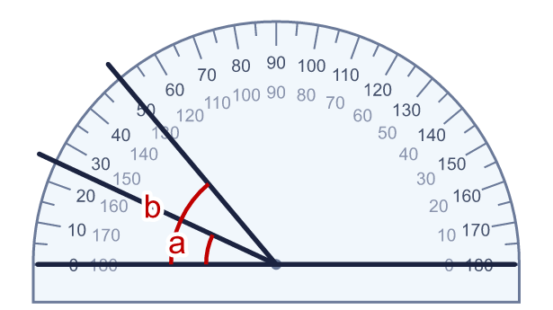
    a = |  | °
    b = |  | °
  14 | Challenge  Angle b is double the size of angle a. Both are measured from the zero line.
    a = |  | °
    b = |  | °

Year 5 · Shape · Step 4
Measure angles up to 180 degrees
Answers (teacher copy)

  1 | The corner of the angle is at the centre of the protractor and one arm is along the zero line. Read the size of the angle from the correct scale.  x = 45 °
  2 | Read the size of the angle from the protractor. Start from the zero line.  y = 125 °
  3 | Decide whether angle z is acute or obtuse. Then measure it.  a) Acute or obtuse? acute  z = 50 °
  4 | Two angles are marked from the zero line of the protractor. Read both of them.  a = 30 °  b = 125 °
  5 | Read the size of angle x from the protractor. What type of angle is it?  x = 90 °  a) Type of angle right
  6 | Three angles are marked from the zero line. Read all three.  a = 15 °  b = 50 °  c = 135 °
  7 | Three angles are marked from the zero line. Which angle is the largest? What size is it?  a) Largest angle (letter) c  Its size = 165 °
  8 | Read angles a and b from the protractor. Both are measured from the zero line.  a = 30 °  b = 50 °  How much bigger is angle b than angle a? 20 °
  9 | Max is measuring angle x.  Is Max correct? Circle yes or no.  Yes / No  Explain how you know.  No. The angle is greater than 90°, so it is obtuse, and 20° is less than 90°. Max read the wrong scale. Reading from the zero line gives 160°.
  10 | The protractor measures angle a. The reflex angle y is on the other side of the same two arms. A full turn is 360°.  a = 80 °  y = 280 °
  11 | Read the three angles a, b and c from the protractor.  a = 20 °  b = 40 °  c = 120 °  What is a + b + c? 180 °
  12 | Four lines are drawn from the centre of the protractor. All the angles are measured from the zero line.  Which angle is between 70° and 90°? Write the letter. a  Its size = 85 °
  13 | Two lines are drawn from the centre of the protractor. Angles a and b are both measured from the zero line. Work out the angle between the two lines.  a = 30 °  b = 70 °  The angle between the two lines is 40 °
  14 | Challenge  Angle b is double the size of angle a. Both are measured from the zero line.  a = 25 °  b = 50 °

