  Year 5 · Shape · Step 8  Lengths and angles in shapes | 
  Year 5 · Shape · Step 8
  Lengths and angles in shapes
  1 | This is a square. All its sides are the same length and every corner is a right angle.  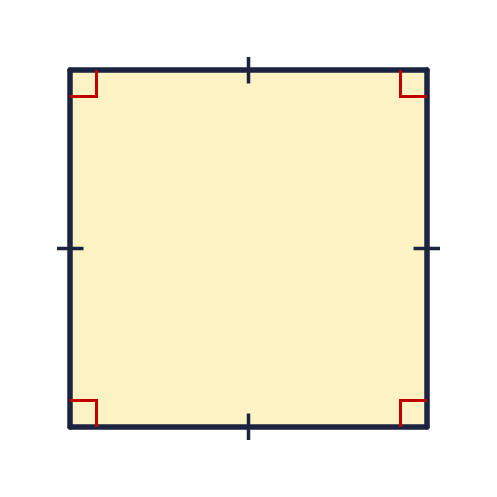  a) What size is each angle?  b) How many degrees do the four angles of a square add up to?
  1 | This is a square. All its sides are the same length and every corner is a right angle.  a) What size is each angle?  b) How many degrees do the four angles of a square add up to?
  2 | A diagonal is drawn across the square. It cuts the right angle at corner A into two equal angles. Work out the size of angle a.  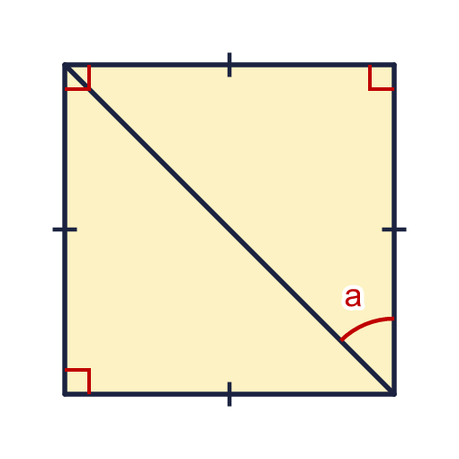
    a = |  | °
  2 | A diagonal is drawn across the square. It cuts the right angle at corner A into two equal angles. Work out the size of angle a.
    a = |  | °
  3 | A diagonal is drawn across a rectangle. One angle is 53°. Work out the size of angle p.  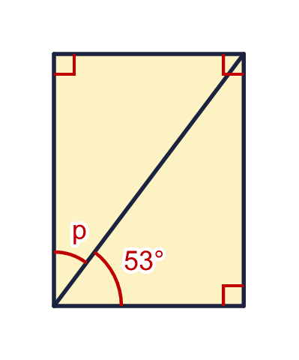
    p = |  | °
  3 | A diagonal is drawn across a rectangle. One angle is 53°. Work out the size of angle p.
    p = |  | °
  4 | This triangle is half of a square. It has a right angle and two sides of the same length. Work out the size of angle x.  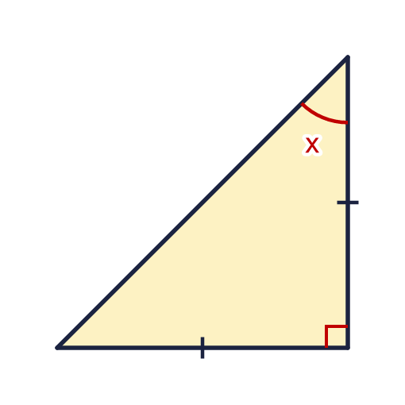
    x = |  | °
  4 | This triangle is half of a square. It has a right angle and two sides of the same length. Work out the size of angle x.
    x = |  | °
  5 | A diagonal is drawn across a rectangle. Angle q is 58°. Work out the size of angle r.  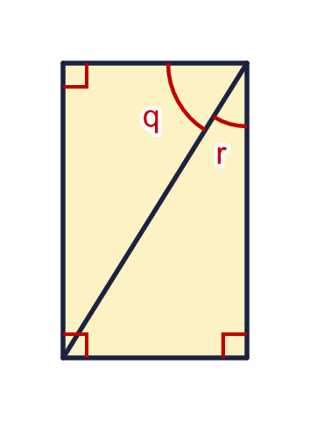
    r = |  | °
  5 | A diagonal is drawn across a rectangle. Angle q is 58°. Work out the size of angle r.
    r = |  | °
  6 | Tom has two identical paper rectangles. Each is 3 cm wide and 7 cm long. He joins them along their long sides to make one bigger rectangle.
    Length of the new rectangle =
    cm
    Width of the new rectangle =
    cm
    Perimeter of the new rectangle =
    cm
  6 | Tom has two identical paper rectangles. Each is 3 cm wide and 7 cm long. He joins them along their long sides to make one bigger rectangle.
    Length of the new rectangle =
    cm
    Width of the new rectangle =
    cm
    Perimeter of the new rectangle =
    cm
  7 | Mo joins three identical rectangles in a row, along their short sides. Each rectangle is 4 cm wide and 9 cm long.
    Length of the new rectangle =
    cm
    Width of the new rectangle =
    cm
    Perimeter of the new rectangle =
    cm
  7 | Mo joins three identical rectangles in a row, along their short sides. Each rectangle is 4 cm wide and 9 cm long.
    Length of the new rectangle =
    cm
    Width of the new rectangle =
    cm
    Perimeter of the new rectangle =
    cm
  8 | A square has sides of 8 cm. It is cut in half to make two identical rectangles.
    Length of each rectangle = |  | cm
    Width of each rectangle = |  | cm
    Perimeter of each rectangle =
    cm
  8 | A square has sides of 8 cm. It is cut in half to make two identical rectangles.
    Length of each rectangle = |  | cm
    Width of each rectangle = |  | cm
    Perimeter of each rectangle =
    cm

  9 | A square has a diagonal.  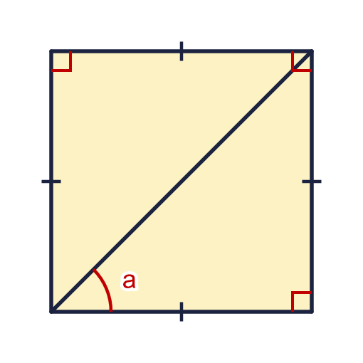  Is Eva correct? Circle yes or no.  Yes / No  Explain how you know.
     | 
  9 | A square has a diagonal.  Is Eva correct? Circle yes or no.  Yes / No  Explain how you know.
  10 | A diagonal is drawn across a rectangle. One angle is 52°.  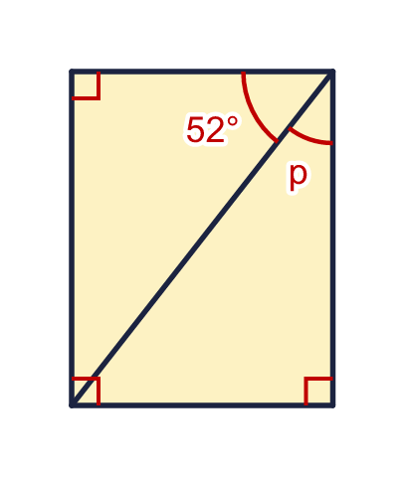  Is Dora correct? Circle yes or no.  Yes / No  Explain how you know.
    
  10 | A diagonal is drawn across a rectangle. One angle is 52°.  Is Dora correct? Circle yes or no.  Yes / No  Explain how you know.
  11 | A rectangle is 12 cm by 16 cm. A straight cut from one corner to the opposite corner (a diagonal) is 20 cm long. The rectangle is cut along the diagonal into two identical triangles.
    Perimeter of one triangle =
    cm
    Perimeter of the whole rectangle =
    cm
  11 | A rectangle is 12 cm by 16 cm. A straight cut from one corner to the opposite corner (a diagonal) is 20 cm long. The rectangle is cut along the diagonal into two identical triangles.
    Perimeter of one triangle =
    cm
    Perimeter of the whole rectangle =
    cm
  12 | A square and an equilateral triangle are joined to make this shape. All the sides are the same length. Angles in an equilateral triangle are 60°.  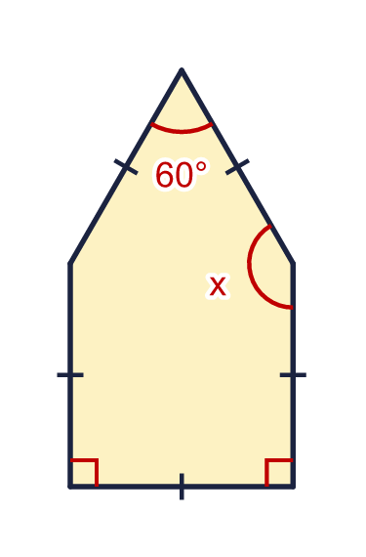  Angle x is made of a right angle and an angle of the triangle.
    x = |  | °
  12 | A square and an equilateral triangle are joined to make this shape. All the sides are the same length. Angles in an equilateral triangle are 60°.  Angle x is made of a right angle and an angle of the triangle.
    x = |  | °
  13 | The shape is made from a square and an equilateral triangle. Every side is 6 cm long. The side where the square and the triangle join is not part of the perimeter.  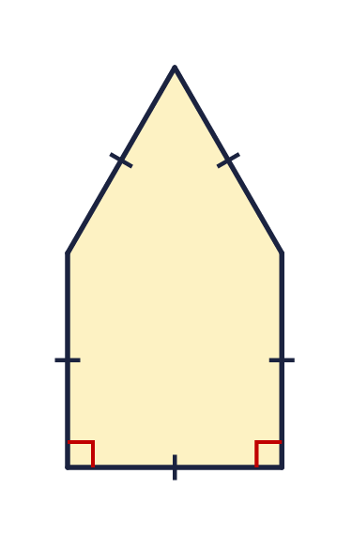
    Perimeter of the whole shape =
    cm
  13 | The shape is made from a square and an equilateral triangle. Every side is 6 cm long. The side where the square and the triangle join is not part of the perimeter.
    Perimeter of the whole shape =
    cm
  14 | Challenge  Two identical squares are joined side by side to make a rectangle. The perimeter of the rectangle is 24 cm.
    Side length of one square =
    cm
    Area of the rectangle = |  | cm²
  14 | Challenge  Two identical squares are joined side by side to make a rectangle. The perimeter of the rectangle is 24 cm.
    Side length of one square =
    cm
    Area of the rectangle = |  | cm²

Year 5 · Shape · Step 8
Lengths and angles in shapes
Answers (teacher copy)

  1 | This is a square. All its sides are the same length and every corner is a right angle.  a) What size is each angle? 90  b) How many degrees do the four angles of a square add up to? 360
  2 | A diagonal is drawn across the square. It cuts the right angle at corner A into two equal angles. Work out the size of angle a.  a = 45 °
  3 | A diagonal is drawn across a rectangle. One angle is 53°. Work out the size of angle p.  p = 37 °
  4 | This triangle is half of a square. It has a right angle and two sides of the same length. Work out the size of angle x.  x = 45 °
  5 | A diagonal is drawn across a rectangle. Angle q is 58°. Work out the size of angle r.  r = 32 °
  6 | Tom has two identical paper rectangles. Each is 3 cm wide and 7 cm long. He joins them along their long sides to make one bigger rectangle.  Length of the new rectangle = 7 cm  Width of the new rectangle = 6 cm  Perimeter of the new rectangle = 26 cm
  7 | Mo joins three identical rectangles in a row, along their short sides. Each rectangle is 4 cm wide and 9 cm long.  Length of the new rectangle = 12 cm  Width of the new rectangle = 9 cm  Perimeter of the new rectangle = 42 cm
  8 | A square has sides of 8 cm. It is cut in half to make two identical rectangles.  Length of each rectangle = 8 cm  Width of each rectangle = 4 cm  Perimeter of each rectangle = 24 cm
  9 | A square has a diagonal.  Is Eva correct? Circle yes or no.  Yes / No  Explain how you know.  No. The diagonal cuts the right angle of 90° in half. 90° ÷ 2 = 45°, so angle a is 45°, not 90°.
  10 | A diagonal is drawn across a rectangle. One angle is 52°.  Is Dora correct? Circle yes or no.  Yes / No  Explain how you know.  Yes. A rectangle has right angles, so 52° + p = 90° and p = 38°.
  11 | A rectangle is 12 cm by 16 cm. A straight cut from one corner to the opposite corner (a diagonal) is 20 cm long. The rectangle is cut along the diagonal into two identical triangles.  Perimeter of one triangle = 48 cm  Perimeter of the whole rectangle = 56 cm
  12 | A square and an equilateral triangle are joined to make this shape. All the sides are the same length. Angles in an equilateral triangle are 60°.  Angle x is made of a right angle and an angle of the triangle.  x = 150 °
  13 | The shape is made from a square and an equilateral triangle. Every side is 6 cm long. The side where the square and the triangle join is not part of the perimeter.  Perimeter of the whole shape = 30 cm
  14 | Challenge  Two identical squares are joined side by side to make a rectangle. The perimeter of the rectangle is 24 cm.  Side length of one square = 4 cm  Area of the rectangle = 32 cm²

