  Year 5 · Shape · Step 3  Estimate angles | 
  Year 5 · Shape · Step 3
  Estimate angles
  1 | Which is the most appropriate estimate for the size of the angle? Write the number of degrees.  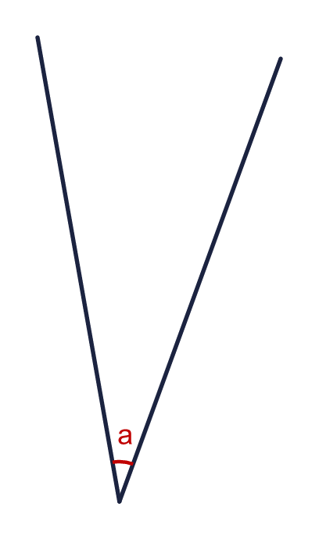  A: 90° B: 30°
    Best estimate = |  | °
  1 | Which is the most appropriate estimate for the size of the angle? Write the number of degrees.  A: 90° B: 30°
    Best estimate = |  | °
  2 | Which is the most appropriate estimate for the size of the angle? Write the number of degrees.  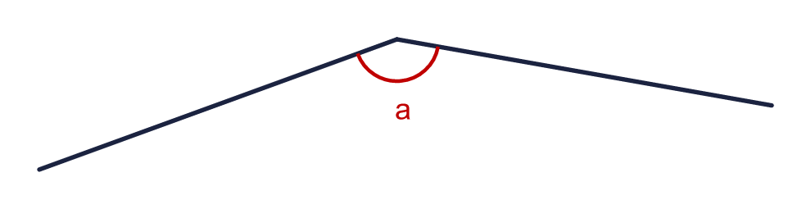  A: 105° B: 150°
    Best estimate = |  | °
  2 | Which is the most appropriate estimate for the size of the angle? Write the number of degrees.  A: 105° B: 150°
    Best estimate = |  | °
  3 | Which is the most appropriate estimate for the size of the angle? Write the number of degrees.  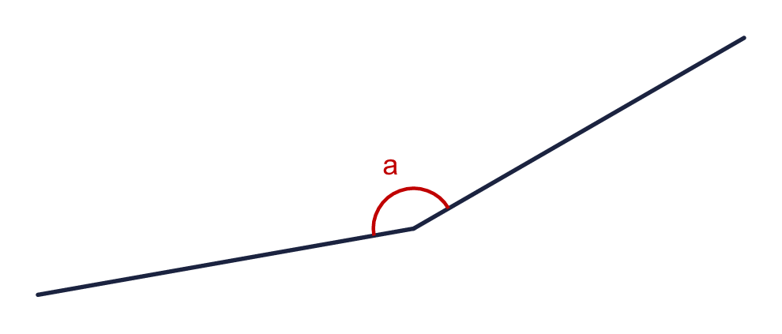  A: 70° B: 155°
    Best estimate = |  | °
  3 | Which is the most appropriate estimate for the size of the angle? Write the number of degrees.  A: 70° B: 155°
    Best estimate = |  | °
  4 | Which is the most appropriate estimate for the size of the angle? Write the number of degrees.  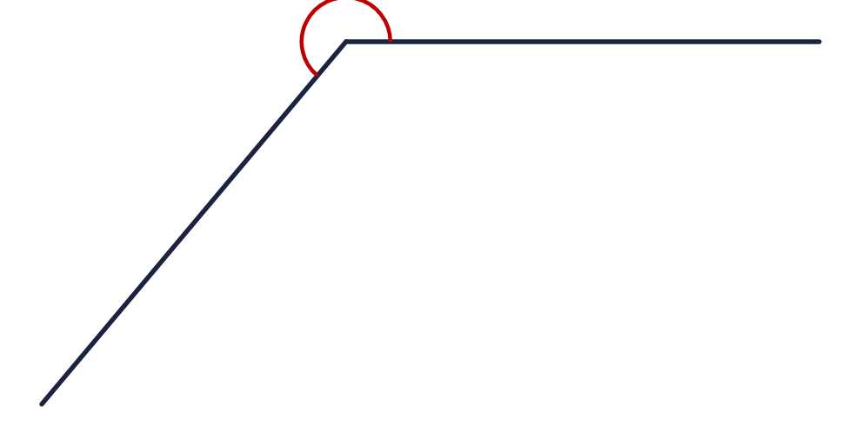  A: 140° B: 235°
    Best estimate = |  | °
  4 | Which is the most appropriate estimate for the size of the angle? Write the number of degrees.  A: 140° B: 235°
    Best estimate = |  | °
  5 | A line cuts the right angle into two angles, x and y. Which is the most appropriate estimate for angle x?  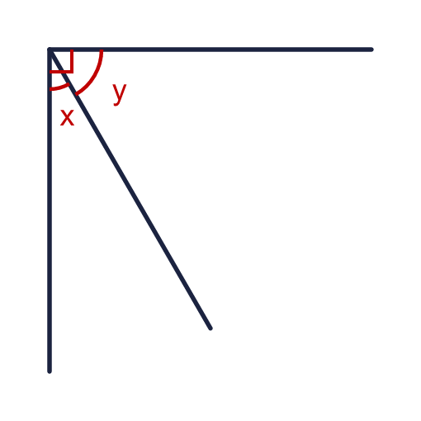  A: 100° B: 20°
    Best estimate for x = |  | °
  5 | A line cuts the right angle into two angles, x and y. Which is the most appropriate estimate for angle x?  A: 100° B: 20°
    Best estimate for x = |  | °
  6 | Which is the most appropriate estimate for the size of the angle?  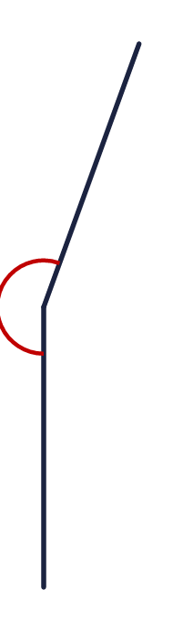  A: 130° B: 200° C: 245°
    Best estimate = |  | °
  6 | Which is the most appropriate estimate for the size of the angle?  A: 130° B: 200° C: 245°
    Best estimate = |  | °
  7 | Look at the angles a, b and c in the shape. Choose the most appropriate estimate for each.  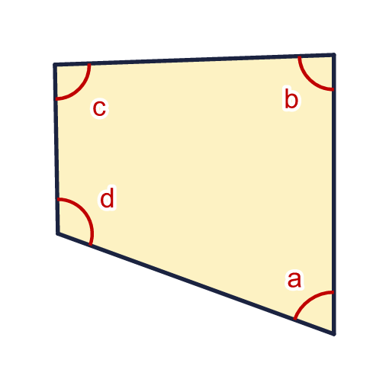  a: A 60° B 25°  b: A 35° B 80°  c: A 135° B 85°
    Best estimate for a = |  | °
    Best estimate for b = |  | °
    Best estimate for c = |  | °
  7 | Look at the angles a, b and c in the shape. Choose the most appropriate estimate for each.  a: A 60° B 25°  b: A 35° B 80°  c: A 135° B 85°
    Best estimate for a = |  | °
    Best estimate for b = |  | °
    Best estimate for c = |  | °
  8 | The clock shows 5 o'clock. Which is the most appropriate estimate for the angle x between the hands?  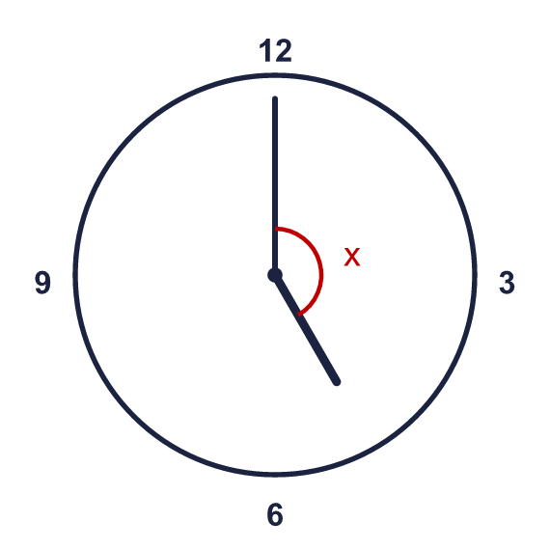  A: 155° B: 200°
    Best estimate = |  | °
  8 | The clock shows 5 o'clock. Which is the most appropriate estimate for the angle x between the hands?  A: 155° B: 200°
    Best estimate = |  | °

  9 | A good estimate is within 10° of the real size of the angle.  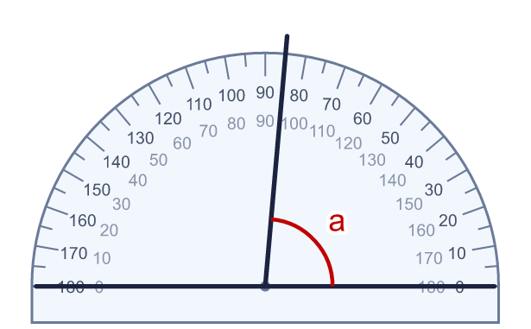  Is Sam's estimate a good one? Circle yes or no.  Yes / No  Explain how you know.
     | 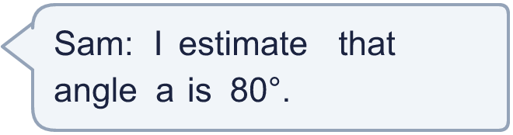
  9 | A good estimate is within 10° of the real size of the angle.  Is Sam's estimate a good one? Circle yes or no.  Yes / No  Explain how you know.
  10 | Estimate and then put the angles in order, starting with the smallest.  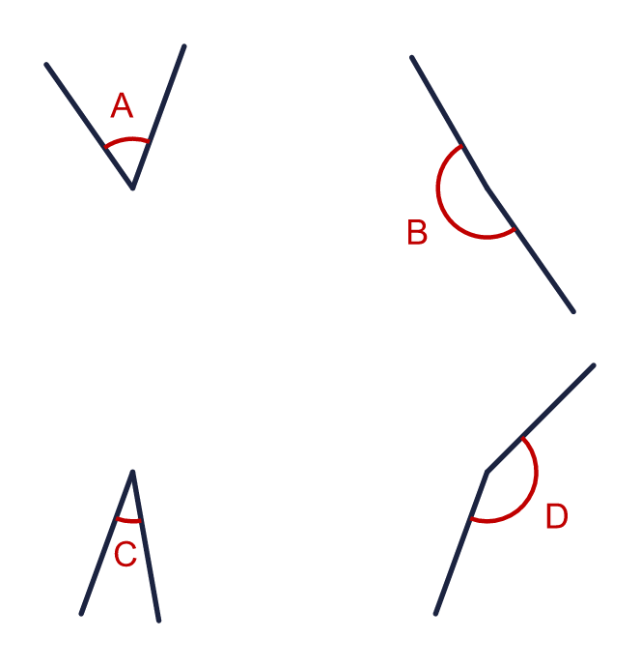
  10 | Estimate and then put the angles in order, starting with the smallest.
  11 | Estimate the size of angle x, then read its size from the protractor.  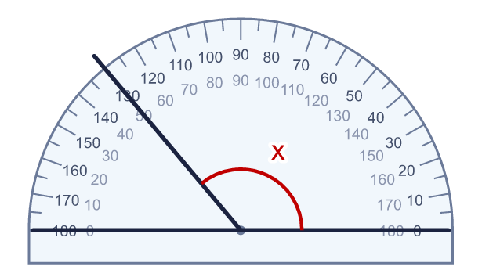  A: 210° B: 75° C: 120°
    Best estimate = |  | °
    Measured size = |  | °
  11 | Estimate the size of angle x, then read its size from the protractor.  A: 210° B: 75° C: 120°
    Best estimate = |  | °
    Measured size = |  | °
  12 | Eva says: "Angle b is about twice the size of angle a."  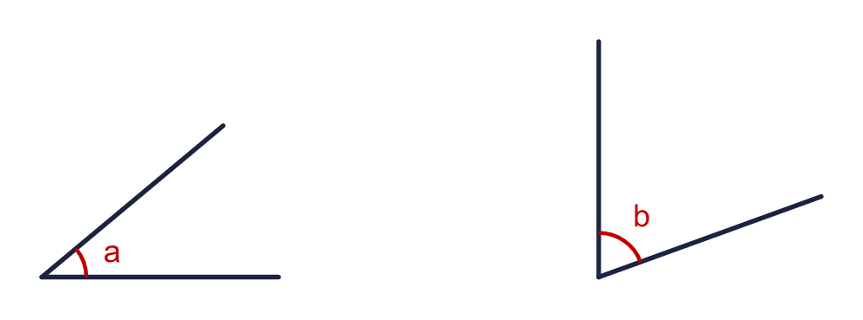  The sizes of the two angles are exact. Is the statement exactly correct? Circle yes or no.  Yes / No  Explain how you know.
  12 | Eva says: "Angle b is about twice the size of angle a."  The sizes of the two angles are exact. Is the statement exactly correct? Circle yes or no.  Yes / No  Explain how you know.
  13 | The right angle is cut by two lines into three angles x, y and z.  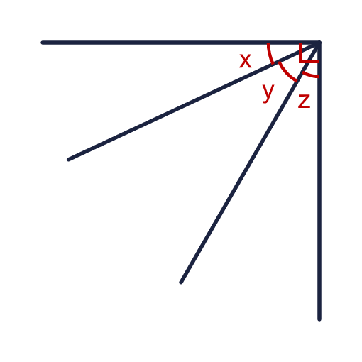  Which is the most appropriate estimate for angle y?  A: 115° B: 40°
    Best estimate for y = |  | °
    What is x + y + z? |  | °
  13 | The right angle is cut by two lines into three angles x, y and z.  Which is the most appropriate estimate for angle y?  A: 115° B: 40°
    Best estimate for y = |  | °
    What is x + y + z? |  | °
  14 | Challenge  At 4 o'clock the angle x between the hands is shown.  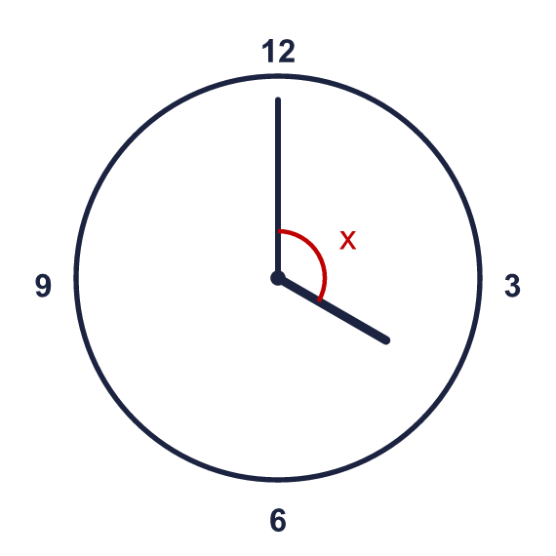  Which is the most appropriate estimate for angle x?  A: 115° B: 30° C: 60°
    Best estimate = |  | °
    The exact angle is |  | °
  14 | Challenge  At 4 o'clock the angle x between the hands is shown.  Which is the most appropriate estimate for angle x?  A: 115° B: 30° C: 60°
    Best estimate = |  | °
    The exact angle is |  | °

Year 5 · Shape · Step 3
Estimate angles
Answers (teacher copy)

  1 | Which is the most appropriate estimate for the size of the angle? Write the number of degrees.  A: 90° B: 30°  Best estimate = 30 °
  2 | Which is the most appropriate estimate for the size of the angle? Write the number of degrees.  A: 105° B: 150°  Best estimate = 150 °
  3 | Which is the most appropriate estimate for the size of the angle? Write the number of degrees.  A: 70° B: 155°  Best estimate = 155 °
  4 | Which is the most appropriate estimate for the size of the angle? Write the number of degrees.  A: 140° B: 235°  Best estimate = 235 °
  5 | A line cuts the right angle into two angles, x and y. Which is the most appropriate estimate for angle x?  A: 100° B: 20°  Best estimate for x = 20 °
  6 | Which is the most appropriate estimate for the size of the angle?  A: 130° B: 200° C: 245°  Best estimate = 200 °
  7 | Look at the angles a, b and c in the shape. Choose the most appropriate estimate for each.  a: A 60° B 25°  b: A 35° B 80°  c: A 135° B 85°  Best estimate for a = 60 °  Best estimate for b = 80 °  Best estimate for c = 85 °
  8 | The clock shows 5 o'clock. Which is the most appropriate estimate for the angle x between the hands?  A: 155° B: 200°  Best estimate = 155 °
  9 | A good estimate is within 10° of the real size of the angle.  Is Sam's estimate a good one? Circle yes or no.  Yes / No  Explain how you know.  Yes. Angle a is 85°. Sam's estimate of 80° is 5° too small, which is within 10°.
  10 | Estimate and then put the angles in order, starting with the smallest.  Order (smallest first): C, A, D, B
  11 | Estimate the size of angle x, then read its size from the protractor.  A: 210° B: 75° C: 120°  Best estimate = 120 °  Measured size = 130 °
  12 | Eva says: "Angle b is about twice the size of angle a."  The sizes of the two angles are exact. Is the statement exactly correct? Circle yes or no.  Yes / No  Explain how you know.  No. Angle a is 40° and angle b is 70°. 2 × 40 = 80°, but b is 70°.
  13 | The right angle is cut by two lines into three angles x, y and z.  Which is the most appropriate estimate for angle y?  A: 115° B: 40°  Best estimate for y = 40 °  What is x + y + z? 90 °
  14 | Challenge  At 4 o'clock the angle x between the hands is shown.  Which is the most appropriate estimate for angle x?  A: 115° B: 30° C: 60°  Best estimate = 115 °  The exact angle is 120 °

