  Year 5 · Shape · Step 5  Draw lines and angles accurately | 
  Year 5 · Shape · Step 5
  Draw lines and angles accurately
  1 | Draw an angle of 40°. Both arms are 6 cm long. Draw it accurately in your book. Use a ruler and a protractor.  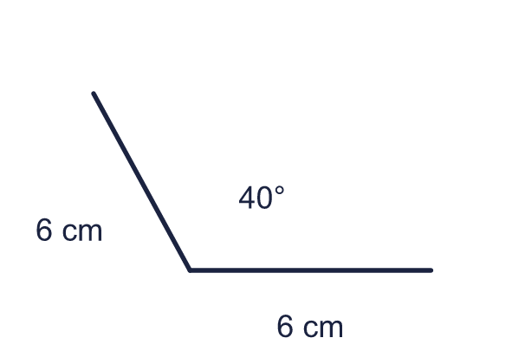  a) The reflex angle on the other side is (degrees)
  1 | Draw an angle of 40°. Both arms are 6 cm long. Draw it accurately in your book. Use a ruler and a protractor.  a) The reflex angle on the other side is (degrees)
  2 | Draw an angle of 125°. The arms are 40 mm and 48 mm long. Draw it accurately in your book. Use a ruler and a protractor.  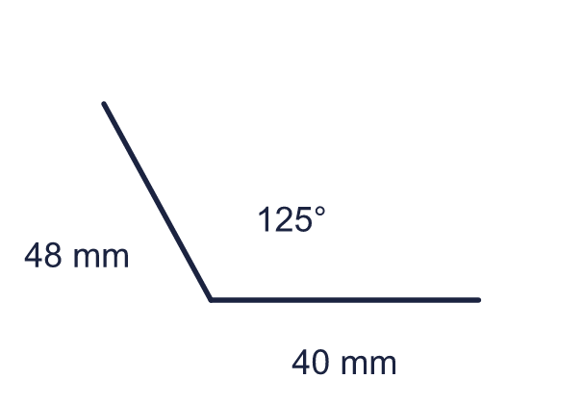  a) The reflex angle on the other side is (degrees)
  2 | Draw an angle of 125°. The arms are 40 mm and 48 mm long. Draw it accurately in your book. Use a ruler and a protractor.  a) The reflex angle on the other side is (degrees)
  3 | Draw a right angle. The arms are 3 cm and 4 cm long. Join the ends of the arms with a straight line. Draw it accurately in your book. Use a ruler and a protractor.  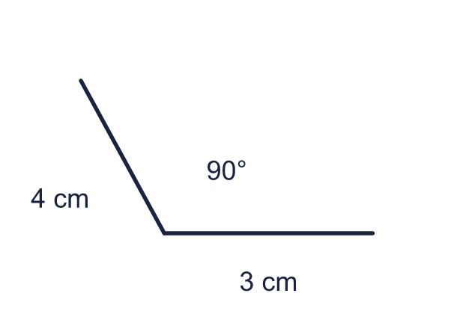  a) The length of the line you joined is (cm)
  3 | Draw a right angle. The arms are 3 cm and 4 cm long. Join the ends of the arms with a straight line. Draw it accurately in your book. Use a ruler and a protractor.  a) The length of the line you joined is (cm)
  4 | Draw an angle of 60°. Both arms are 7 cm long. Join the ends of the arms with a straight line. Draw it accurately in your book. Use a ruler and a protractor.  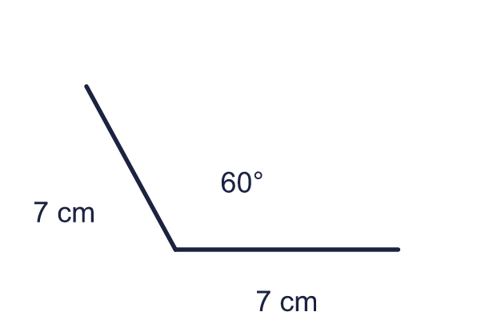  a) The length of the line you joined is (cm)
  4 | Draw an angle of 60°. Both arms are 7 cm long. Join the ends of the arms with a straight line. Draw it accurately in your book. Use a ruler and a protractor.  a) The length of the line you joined is (cm)
  5 | Draw a triangle. One side is 5 cm long. The angles at the two ends of this side are 65° and 70°. Draw it accurately in your book. Use a ruler and a protractor.  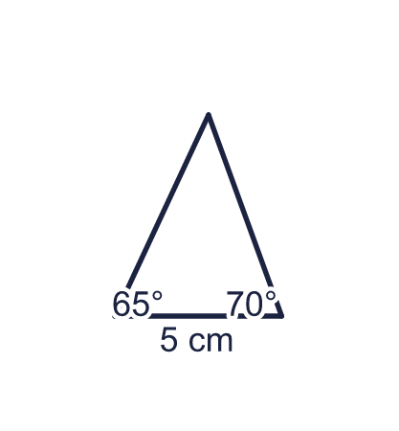  a) The third angle is (degrees)
  5 | Draw a triangle. One side is 5 cm long. The angles at the two ends of this side are 65° and 70°. Draw it accurately in your book. Use a ruler and a protractor.  a) The third angle is (degrees)
  6 | Draw a right-angled triangle. The two short sides are 6 cm and 8 cm. Draw it accurately in your book. Use a ruler and a protractor.  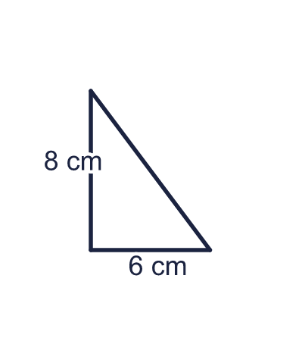  a) The length of the longest side is (cm)
  6 | Draw a right-angled triangle. The two short sides are 6 cm and 8 cm. Draw it accurately in your book. Use a ruler and a protractor.  a) The length of the longest side is (cm)
  7 | Draw a rectangle 8 cm long and 5 cm wide. Draw it accurately in your book. Use a ruler and a protractor.  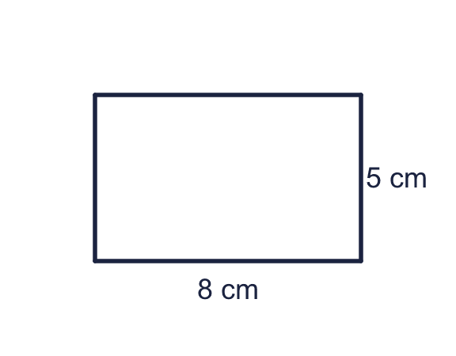  a) The perimeter of the rectangle is (cm)  b) The area of the rectangle is (cm²)
  7 | Draw a rectangle 8 cm long and 5 cm wide. Draw it accurately in your book. Use a ruler and a protractor.  a) The perimeter of the rectangle is (cm)  b) The area of the rectangle is (cm²)
  8 | Draw a triangle. The base is 6 cm long and both base angles are 65°. Draw it accurately in your book. Use a ruler and a protractor.  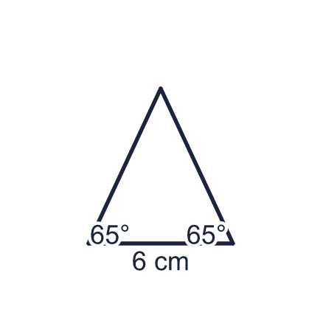  a) The angle at the top is (degrees)
  8 | Draw a triangle. The base is 6 cm long and both base angles are 65°. Draw it accurately in your book. Use a ruler and a protractor.  a) The angle at the top is (degrees)

  9 | Max wants to draw an angle of 15°. Max puts a mark on the protractor and draws the arm shown in the picture.  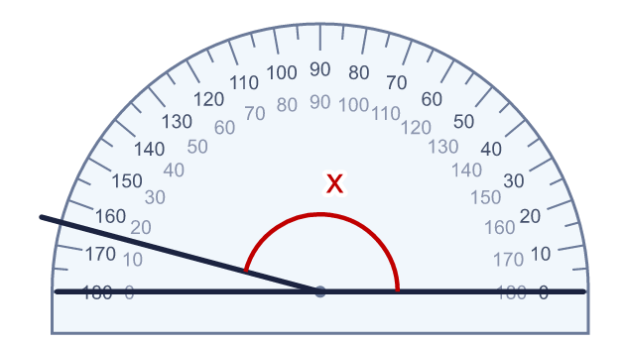  Is Max correct? Circle yes or no.  Yes / No  Explain how you know.
     | 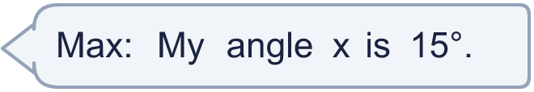
  9 | Max wants to draw an angle of 15°. Max puts a mark on the protractor and draws the arm shown in the picture.  Is Max correct? Circle yes or no.  Yes / No  Explain how you know.
  10 | Draw a triangle with a side of 7 cm. The angles at the ends of this side are 45° and 60°. Draw it accurately in your book. Use a ruler and a protractor.  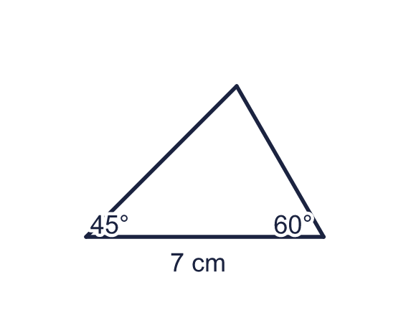  a) The third angle is (degrees)
  10 | Draw a triangle with a side of 7 cm. The angles at the ends of this side are 45° and 60°. Draw it accurately in your book. Use a ruler and a protractor.  a) The third angle is (degrees)
  11 | Draw a right-angled triangle. The two short sides are 6 cm and 8 cm. Draw it accurately in your book. Use a ruler and a protractor.  a) The perimeter of the triangle is (cm)  b) The area of the triangle is (cm²)
  11 | Draw a right-angled triangle. The two short sides are 6 cm and 8 cm. Draw it accurately in your book. Use a ruler and a protractor.  a) The perimeter of the triangle is (cm)  b) The area of the triangle is (cm²)
  12 | Draw a triangle with a right angle between sides of 60 mm and 80 mm. Draw it accurately in your book. Use a ruler and a protractor.  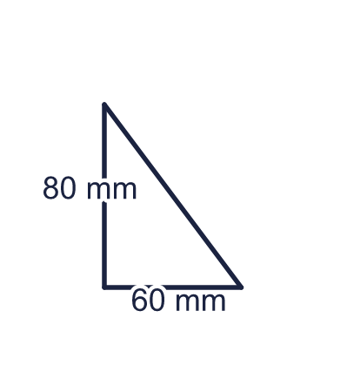  a) The length of the third side is (mm)  b) The perimeter of the triangle is (mm)
  12 | Draw a triangle with a right angle between sides of 60 mm and 80 mm. Draw it accurately in your book. Use a ruler and a protractor.  a) The length of the third side is (mm)  b) The perimeter of the triangle is (mm)
  13 | Draw a rectangle 6 cm long and 8 cm wide. Join two opposite corners with a straight line. Draw it accurately in your book. Use a ruler and a protractor.  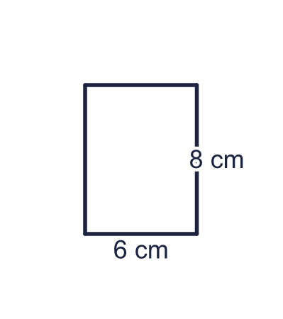  a) The length of the line you joined is (cm)
  13 | Draw a rectangle 6 cm long and 8 cm wide. Join two opposite corners with a straight line. Draw it accurately in your book. Use a ruler and a protractor.  a) The length of the line you joined is (cm)
  14 | Challenge  Draw an angle of 130° with both arms 5 cm long. Join the ends of the arms with a straight line to make a triangle. Draw it accurately in your book. Use a ruler and a protractor.  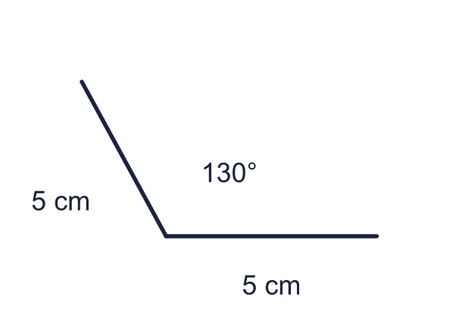  a) The other two angles of the triangle are each (degrees)
  14 | Challenge  Draw an angle of 130° with both arms 5 cm long. Join the ends of the arms with a straight line to make a triangle. Draw it accurately in your book. Use a ruler and a protractor.  a) The other two angles of the triangle are each (degrees)

Year 5 · Shape · Step 5
Draw lines and angles accurately
Answers (teacher copy)

  1 | Draw an angle of 40°. Both arms are 6 cm long. Draw it accurately in your book. Use a ruler and a protractor.  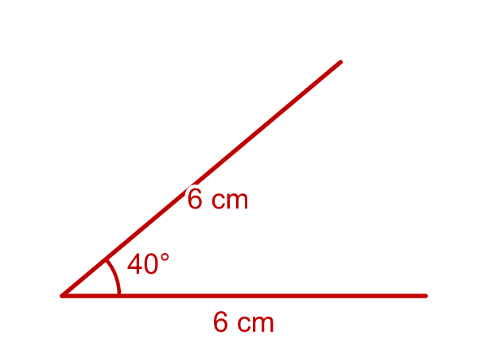  a) The reflex angle on the other side is (degrees) 320
  2 | Draw an angle of 125°. The arms are 40 mm and 48 mm long. Draw it accurately in your book. Use a ruler and a protractor.  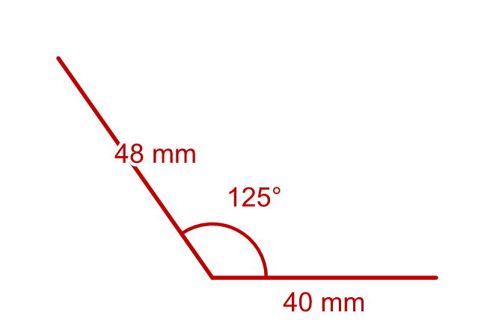  a) The reflex angle on the other side is (degrees) 235
  3 | Draw a right angle. The arms are 3 cm and 4 cm long. Join the ends of the arms with a straight line. Draw it accurately in your book. Use a ruler and a protractor.  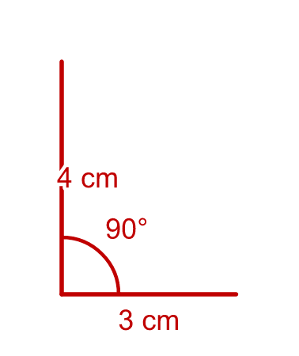  a) The length of the line you joined is (cm) 5
  4 | Draw an angle of 60°. Both arms are 7 cm long. Join the ends of the arms with a straight line. Draw it accurately in your book. Use a ruler and a protractor.  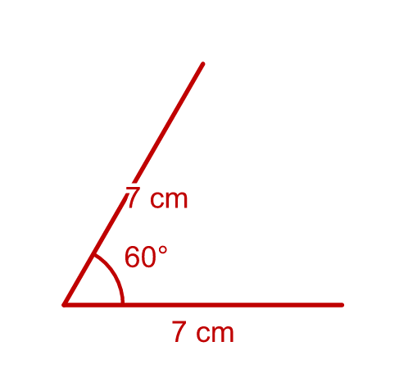  a) The length of the line you joined is (cm) 7
  5 | Draw a triangle. One side is 5 cm long. The angles at the two ends of this side are 65° and 70°. Draw it accurately in your book. Use a ruler and a protractor.  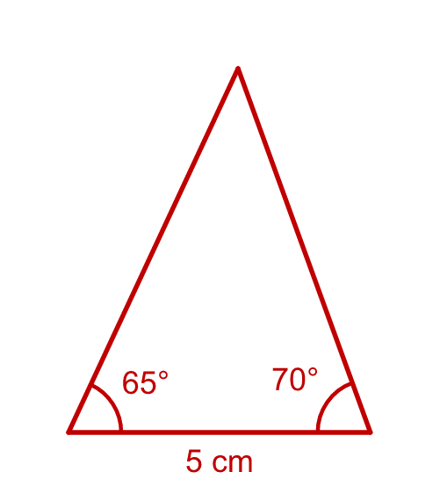  a) The third angle is (degrees) 45
  6 | Draw a right-angled triangle. The two short sides are 6 cm and 8 cm. Draw it accurately in your book. Use a ruler and a protractor.  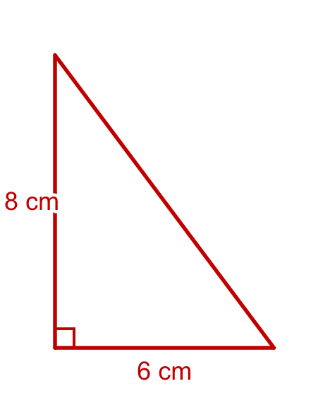  a) The length of the longest side is (cm) 10
  7 | Draw a rectangle 8 cm long and 5 cm wide. Draw it accurately in your book. Use a ruler and a protractor.  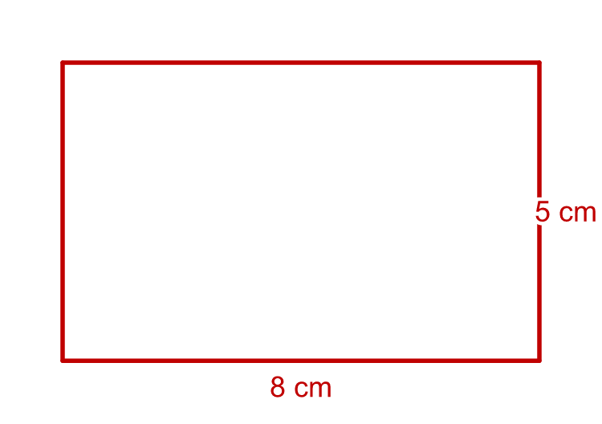  a) The perimeter of the rectangle is (cm) 26  b) The area of the rectangle is (cm²) 40
  8 | Draw a triangle. The base is 6 cm long and both base angles are 65°. Draw it accurately in your book. Use a ruler and a protractor.  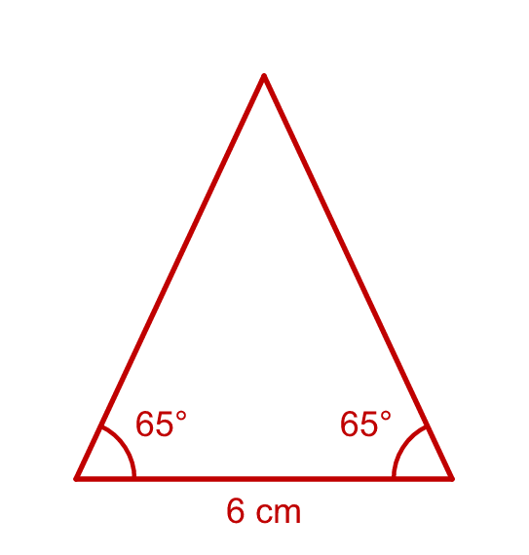  a) The angle at the top is (degrees) 50
  9 | Max wants to draw an angle of 15°. Max puts a mark on the protractor and draws the arm shown in the picture.  Is Max correct? Circle yes or no.  Yes / No  Explain how you know.  No. Angle x is 165°. Max read the wrong scale: 15° is on the inner scale but the arm starts from the zero line on the outer scale, so angle x is 165°.
  10 | Draw a triangle with a side of 7 cm. The angles at the ends of this side are 45° and 60°. Draw it accurately in your book. Use a ruler and a protractor.  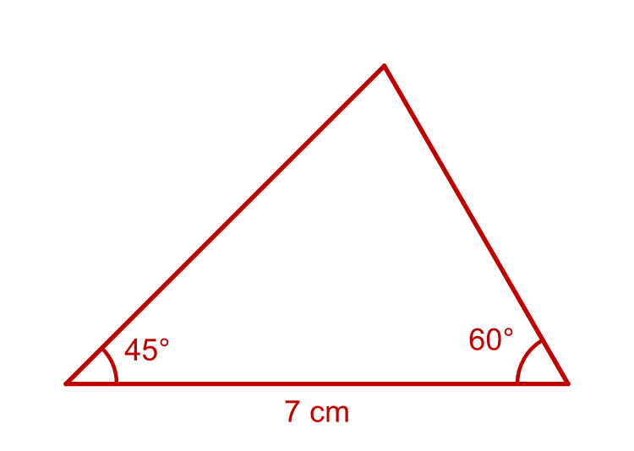  a) The third angle is (degrees) 75
  11 | Draw a right-angled triangle. The two short sides are 6 cm and 8 cm. Draw it accurately in your book. Use a ruler and a protractor.  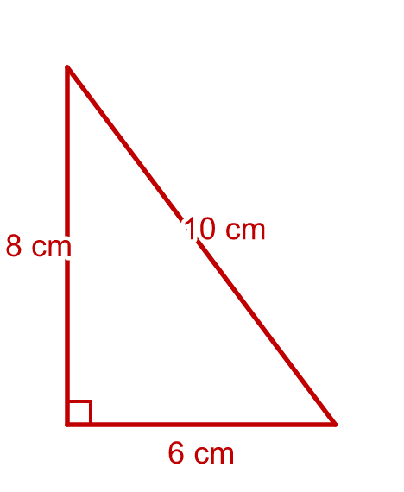  a) The perimeter of the triangle is (cm) 24  b) The area of the triangle is (cm²) 24
  12 | Draw a triangle with a right angle between sides of 60 mm and 80 mm. Draw it accurately in your book. Use a ruler and a protractor.  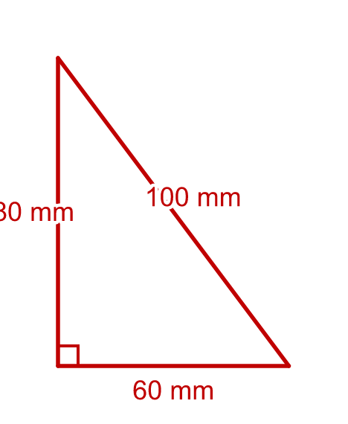  a) The length of the third side is (mm) 100  b) The perimeter of the triangle is (mm) 240
  13 | Draw a rectangle 6 cm long and 8 cm wide. Join two opposite corners with a straight line. Draw it accurately in your book. Use a ruler and a protractor.  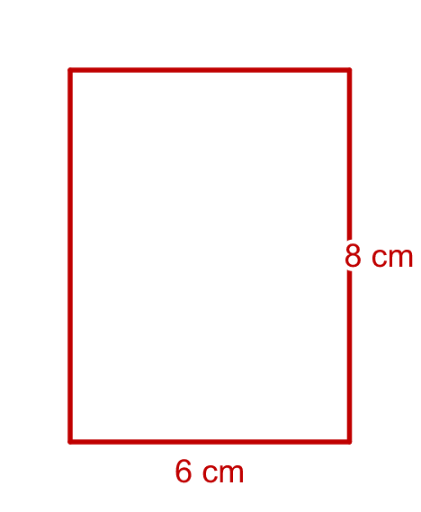  a) The length of the line you joined is (cm) 10
  14 | Challenge  Draw an angle of 130° with both arms 5 cm long. Join the ends of the arms with a straight line to make a triangle. Draw it accurately in your book. Use a ruler and a protractor.  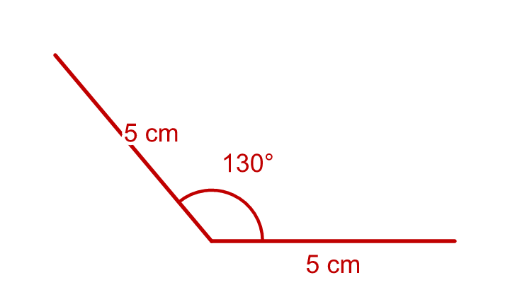  a) The other two angles of the triangle are each (degrees) 25

