  Year 5 · Shape · Step 2  Classify angles | 
  Year 5 · Shape · Step 2
  Classify angles
  1 | Look at the four angles. Write whether each angle is acute, obtuse, right or reflex.  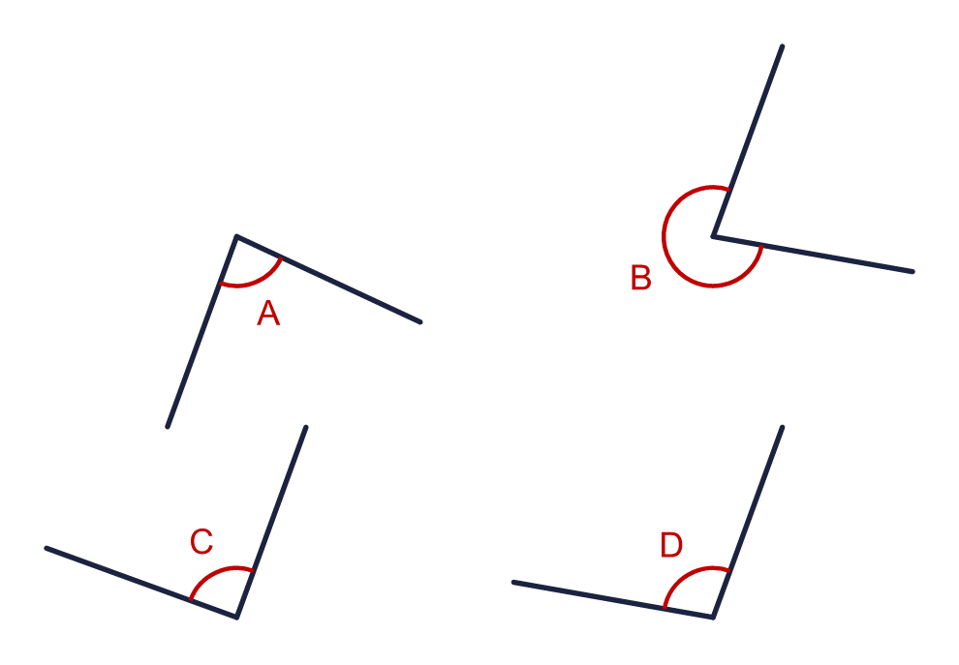  a) Angle A  b) Angle B  c) Angle C  d) Angle D
  1 | Look at the four angles. Write whether each angle is acute, obtuse, right or reflex.  a) Angle A  b) Angle B  c) Angle C  d) Angle D
  2 | Here are six angles. None of them is a right angle.  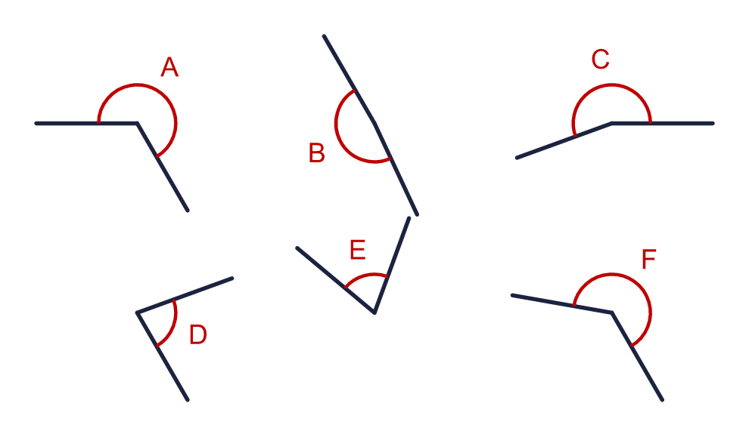  a) How many angles are less than a right angle?  b) How many angles are greater than a right angle?
  2 | Here are six angles. None of them is a right angle.  a) How many angles are less than a right angle?  b) How many angles are greater than a right angle?
  3 | Write whether each angle is acute, obtuse, right or reflex. If it is 180° write straight line.  a) An angle of 80°  b) An angle of 125°  c) An angle of 90°  d) An angle of 180°
  3 | Write whether each angle is acute, obtuse, right or reflex. If it is 180° write straight line.  a) An angle of 80°  b) An angle of 125°  c) An angle of 90°  d) An angle of 180°
  4 | Look at the six angles.  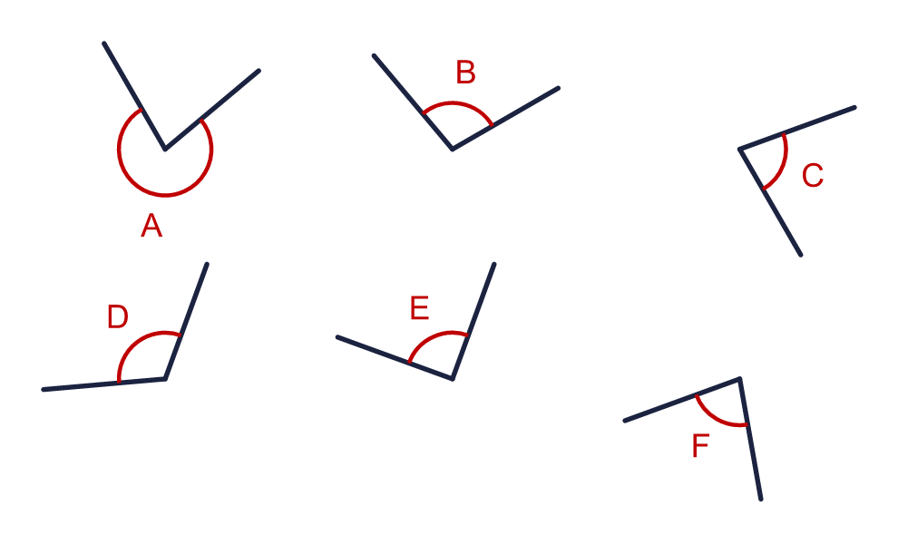  Which angles are acute? Write the letters.
  4 | Look at the six angles.  Which angles are acute? Write the letters.
  5 | Look at the six angles.  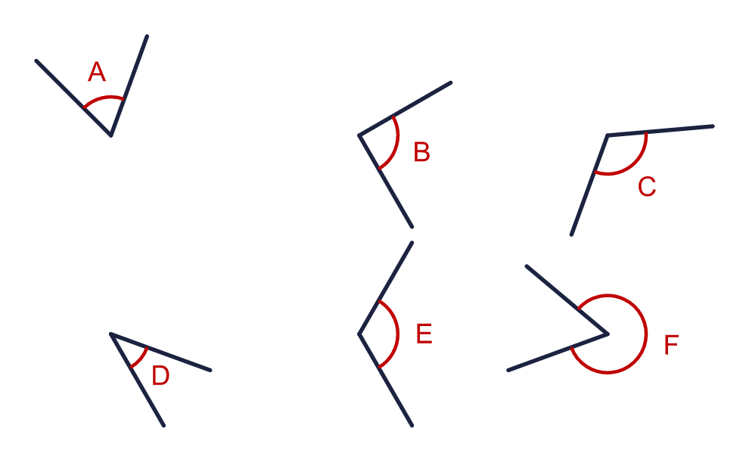  Which angles are obtuse? Write the letters.
  5 | Look at the six angles.  Which angles are obtuse? Write the letters.
  6 | Look at the four angles.  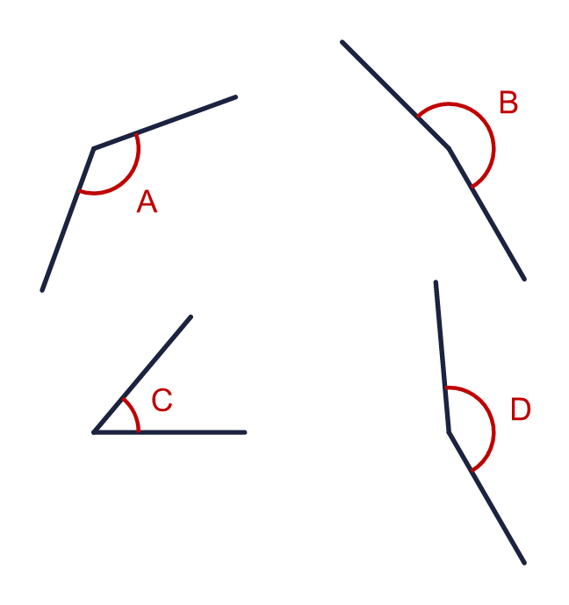  a) Which angle is the largest? Write the letter.  b) Which angle is the smallest? Write the letter.
  6 | Look at the four angles.  a) Which angle is the largest? Write the letter.  b) Which angle is the smallest? Write the letter.
  7 | Look at the four angles.  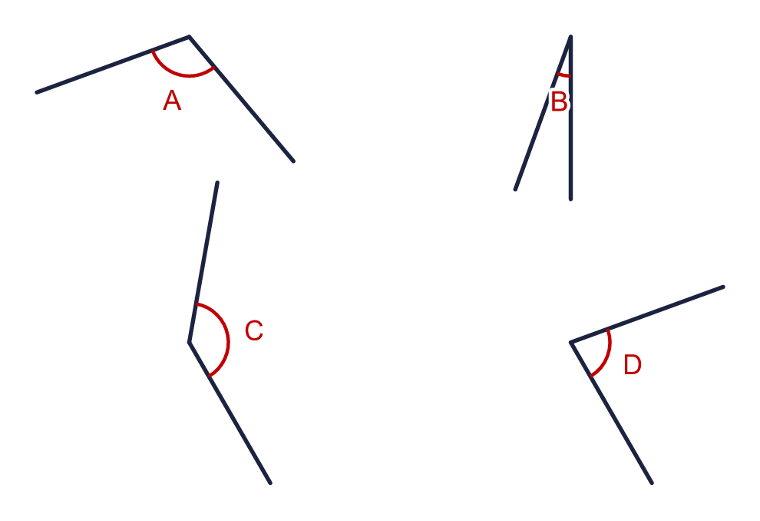  a) Which angle is closest to a right angle? Write the letter.
  7 | Look at the four angles.  a) Which angle is closest to a right angle? Write the letter.
  8 | Every angle in this shape is either a right angle or a reflex angle. The right angles are marked with squares.  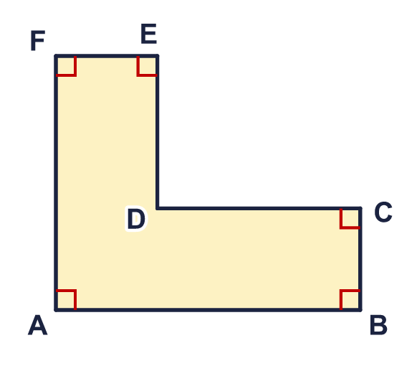  a) How many right angles are there?  b) How many reflex angles are there?
  8 | Every angle in this shape is either a right angle or a reflex angle. The right angles are marked with squares.  a) How many right angles are there?  b) How many reflex angles are there?

  9 | Rosie has drawn the angle a.  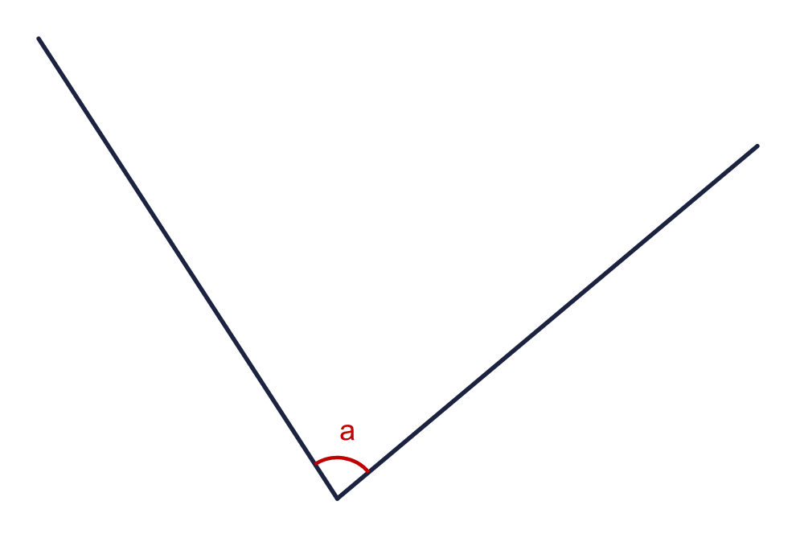  Is Rosie correct? Circle yes or no.  Yes / No  Explain how you know.
     | 
  9 | Rosie has drawn the angle a.  Is Rosie correct? Circle yes or no.  Yes / No  Explain how you know.
  10 | Dora says: "My angle is 5° more than a right angle."
    What type of angle is it? Write acute, obtuse, right or reflex.
    How many degrees is the angle?
    °
  10 | Dora says: "My angle is 5° more than a right angle."
    What type of angle is it? Write acute, obtuse, right or reflex.
    How many degrees is the angle?
    °
  11 | I am thinking of an obtuse angle. It is a multiple of 20. It is less than 111°.
    What size is my angle? |  | °
  11 | I am thinking of an obtuse angle. It is a multiple of 20. It is less than 111°.
    What size is my angle? |  | °
  12 | Tommy and Dora are describing the angle a.  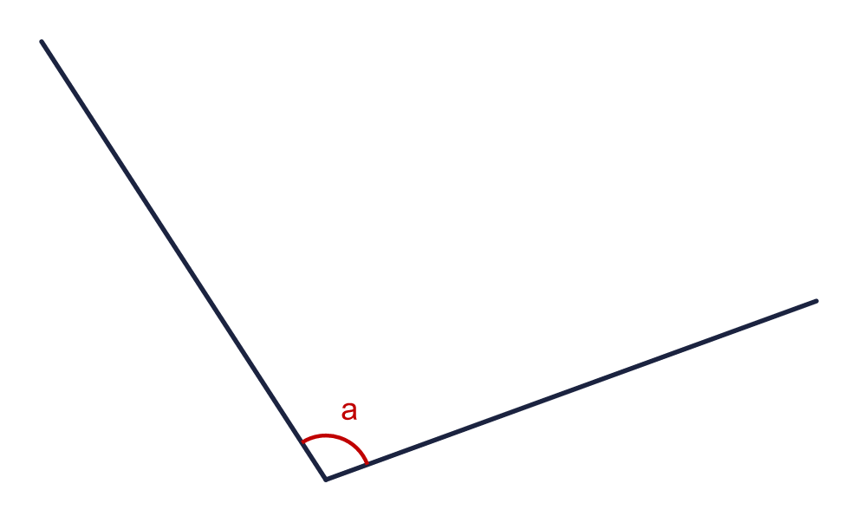
     | 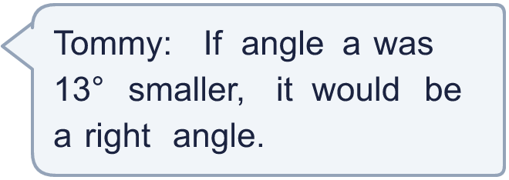
    
    Who is correct? Write Tommy or Dora.
  12 | Tommy and Dora are describing the angle a.
    Who is correct? Write Tommy or Dora.
  13 | Here are some angle sizes.  A: 125° B: 340° C: 180° D: 90° E: 105°  Which of them are obtuse angles? Write the letters.
  13 | Here are some angle sizes.  A: 125° B: 340° C: 180° D: 90° E: 105°  Which of them are obtuse angles? Write the letters.
  14 | Look at the shape. The right angles are marked with squares.  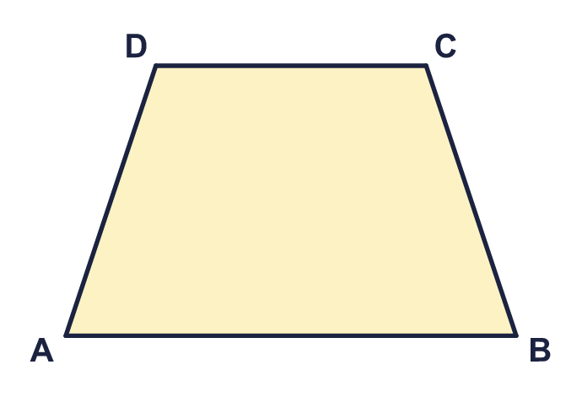  a) How many acute angles does it have?  b) How many obtuse angles does it have?  c) How many reflex angles does it have?
  14 | Look at the shape. The right angles are marked with squares.  a) How many acute angles does it have?  b) How many obtuse angles does it have?  c) How many reflex angles does it have?

Year 5 · Shape · Step 2
Classify angles
Answers (teacher copy)

  1 | Look at the four angles. Write whether each angle is acute, obtuse, right or reflex.  a) Angle A acute  b) Angle B reflex  c) Angle C right  d) Angle D obtuse
  2 | Here are six angles. None of them is a right angle.  a) How many angles are less than a right angle? 2  b) How many angles are greater than a right angle? 4
  3 | Write whether each angle is acute, obtuse, right or reflex. If it is 180° write straight line.  a) An angle of 80° acute  b) An angle of 125° obtuse  c) An angle of 90° right  d) An angle of 180° straight
  4 | Look at the six angles.  Which angles are acute? Write the letters. C, F
  5 | Look at the six angles.  Which angles are obtuse? Write the letters. C, E
  6 | Look at the four angles.  a) Which angle is the largest? Write the letter. B  b) Which angle is the smallest? Write the letter. C
  7 | Look at the four angles.  a) Which angle is closest to a right angle? Write the letter. D
  8 | Every angle in this shape is either a right angle or a reflex angle. The right angles are marked with squares.  a) How many right angles are there? 5  b) How many reflex angles are there? 1
  9 | Rosie has drawn the angle a.  Is Rosie correct? Circle yes or no.  Yes / No  Explain how you know.  No. Angle a is 83°. It is less than 90°, so it is acute.
  10 | Dora says: "My angle is 5° more than a right angle."  What type of angle is it? Write acute, obtuse, right or reflex. obtuse  How many degrees is the angle? 95 °
  11 | I am thinking of an obtuse angle. It is a multiple of 20. It is less than 111°.  What size is my angle? 100 °
  12 | Tommy and Dora are describing the angle a.  Who is correct? Write Tommy or Dora. Tommy
  13 | Here are some angle sizes.  A: 125° B: 340° C: 180° D: 90° E: 105°  Which of them are obtuse angles? Write the letters. A, E
  14 | Look at the shape. The right angles are marked with squares.  a) How many acute angles does it have? 2  b) How many obtuse angles does it have? 2  c) How many reflex angles does it have? 0

