  Year 5 · Shape · Step 7  Calculate angles on a straight line | 
  Year 5 · Shape · Step 7
  Calculate angles on a straight line
  1 | Work out the size of angle f.  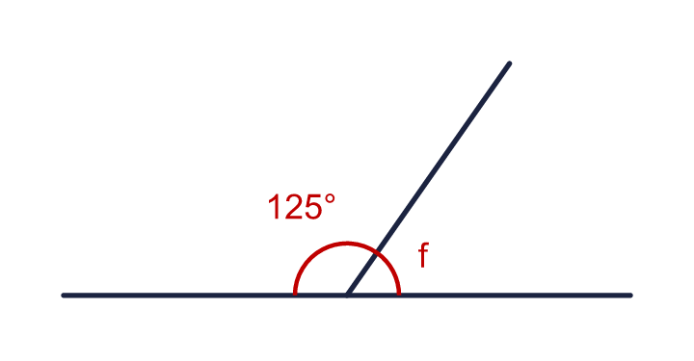
    f = |  | °
  1 | Work out the size of angle f.
    f = |  | °
  2 | Work out the size of angle q.  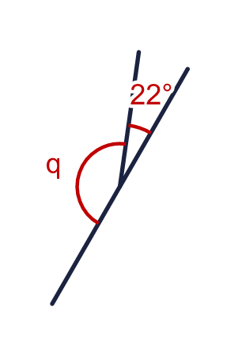
    q = |  | °
  2 | Work out the size of angle q.
    q = |  | °
  3 | Work out the size of angle r.  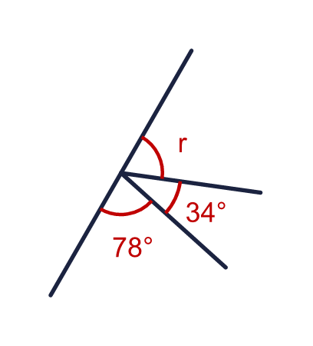
    r = |  | °
  3 | Work out the size of angle r.
    r = |  | °
  4 | Work out the size of angle w.  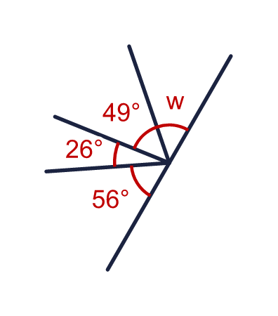
    w = |  | °
  4 | Work out the size of angle w.
    w = |  | °
  5 | Work out the size of angle k. One of the angles is 90°.  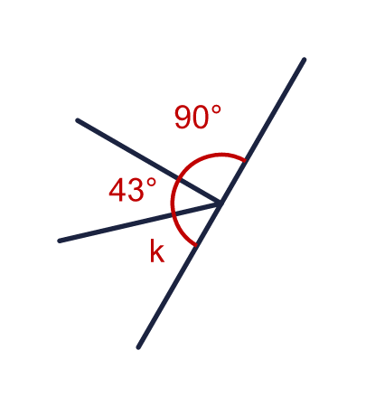
    k = |  | °
  5 | Work out the size of angle k. One of the angles is 90°.
    k = |  | °
  6 | 2 equal angles are on a straight line. Work out the size of angle k.  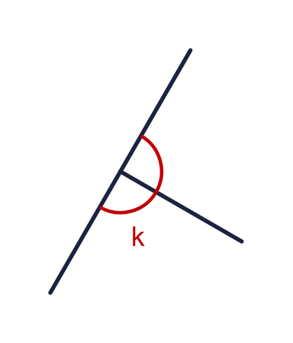
    k = |  | °
  6 | 2 equal angles are on a straight line. Work out the size of angle k.
    k = |  | °
  7 | Angles on a straight line add up to 180°. One of two angles on a line is 179°.  a) The other angle is  Three angles are on a straight line. Two of them are 41° and 53°.  b) The third angle is
  7 | Angles on a straight line add up to 180°. One of two angles on a line is 179°.  a) The other angle is  Three angles are on a straight line. Two of them are 41° and 53°.  b) The third angle is
  8 | Three straight lines cross at one point. Work out the size of angle m.  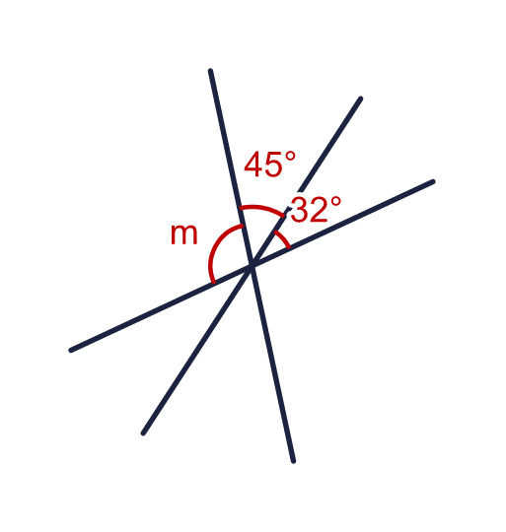
    m = |  | °
  8 | Three straight lines cross at one point. Work out the size of angle m.
    m = |  | °

  9 | Look at the angles on the straight line.  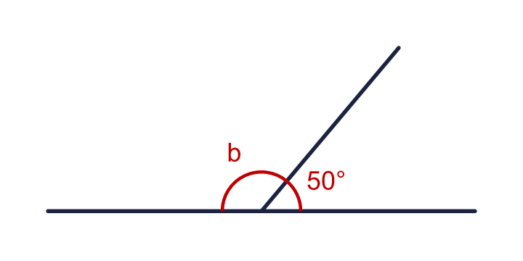  Is Boba correct? Circle yes or no.  Yes / No  Explain how you know.
     | 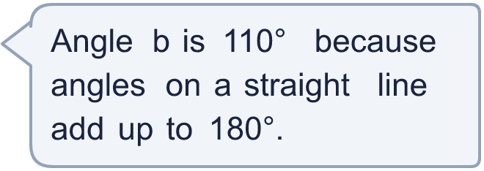
  9 | Look at the angles on the straight line.  Is Boba correct? Circle yes or no.  Yes / No  Explain how you know.
  10 | Angle b is three times the size of angle a.  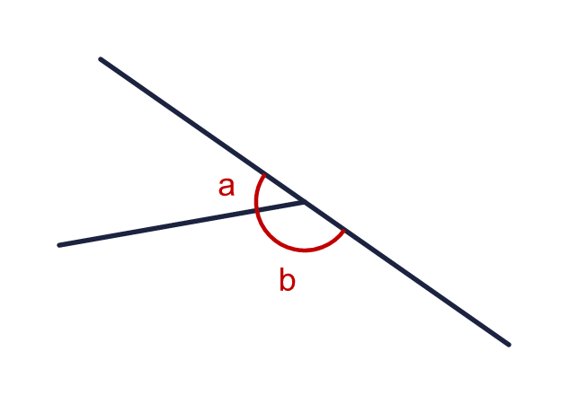
    a = |  | °
    b = |  | °
  10 | Angle b is three times the size of angle a.
    a = |  | °
    b = |  | °
  11 | Three angles on a straight line are x, 2x and 3x.  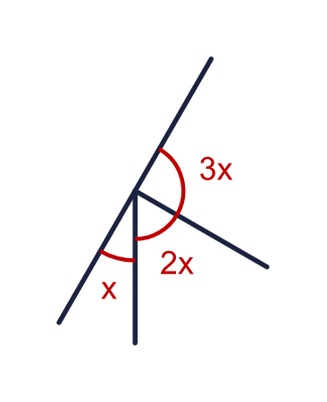
    x = |  | °
    3x = |  | °
  11 | Three angles on a straight line are x, 2x and 3x.
    x = |  | °
    3x = |  | °
  12 | Angle a is 50° more than angle b.  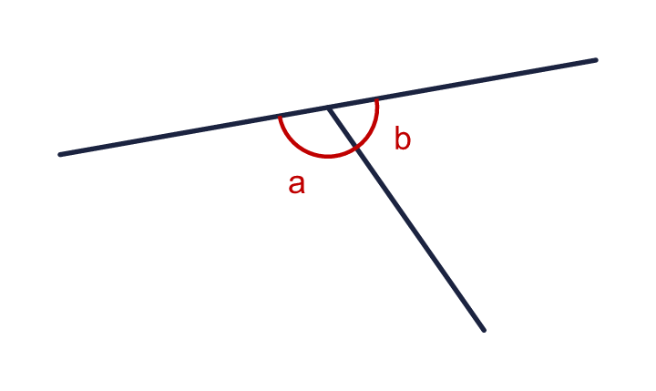
    a = |  | °
    b = |  | °
  12 | Angle a is 50° more than angle b.
    a = |  | °
    b = |  | °
  13 | This diagram is made from three straight lines. Work out the size of angle m. Show your working in the box.  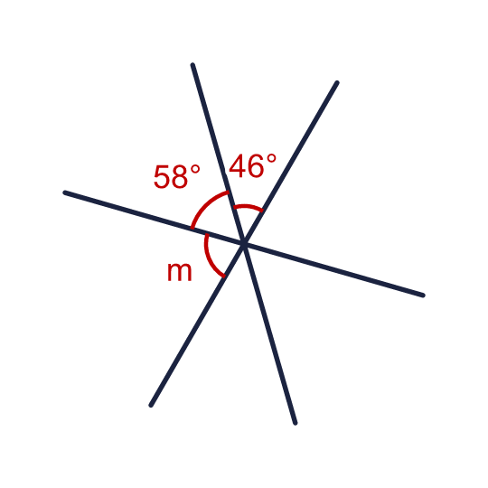
    m = |  | °
    Which number did you take away from 180? Write the sum of the two angles you know.
    °
  13 | This diagram is made from three straight lines. Work out the size of angle m. Show your working in the box.
    m = |  | °
    Which number did you take away from 180? Write the sum of the two angles you know.
    °
  14 | Challenge  Three angles a, b and c are on a straight line. Angle b is the same size as angle a and angle c is 4 times the size of angle a.  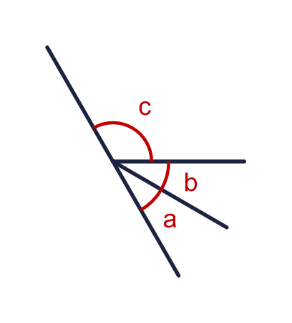
    a = |  | °
    b = |  | °
    c = |  | °
  14 | Challenge  Three angles a, b and c are on a straight line. Angle b is the same size as angle a and angle c is 4 times the size of angle a.
    a = |  | °
    b = |  | °
    c = |  | °

Year 5 · Shape · Step 7
Calculate angles on a straight line
Answers (teacher copy)

  1 | Work out the size of angle f.  f = 55 °
  2 | Work out the size of angle q.  q = 158 °
  3 | Work out the size of angle r.  r = 68 °
  4 | Work out the size of angle w.  w = 49 °
  5 | Work out the size of angle k. One of the angles is 90°.  k = 47 °
  6 | 2 equal angles are on a straight line. Work out the size of angle k.  k = 90 °
  7 | Angles on a straight line add up to 180°. One of two angles on a line is 179°.  a) The other angle is 1  Three angles are on a straight line. Two of them are 41° and 53°.  b) The third angle is 86
  8 | Three straight lines cross at one point. Work out the size of angle m.  m = 103 °
  9 | Look at the angles on the straight line.  Is Boba correct? Circle yes or no.  Yes / No  Explain how you know.  180 − 50 = 130, so b is 130°, not 110°.
  10 | Angle b is three times the size of angle a.  a = 45 °  b = 135 °
  11 | Three angles on a straight line are x, 2x and 3x.  x = 30 °  3x = 90 °
  12 | Angle a is 50° more than angle b.  a = 115 °  b = 65 °
  13 | This diagram is made from three straight lines. Work out the size of angle m. Show your working in the box.  m = 76 °  Which number did you take away from 180? Write the sum of the two angles you know. 104 °
  14 | Challenge  Three angles a, b and c are on a straight line. Angle b is the same size as angle a and angle c is 4 times the size of angle a.  a = 30 °  b = 30 °  c = 120 °

