  Year 5 · Shape · Step 6  Calculate angles around a point | 
  Year 5 · Shape · Step 6
  Calculate angles around a point
  1 | Work out the size of angle q.  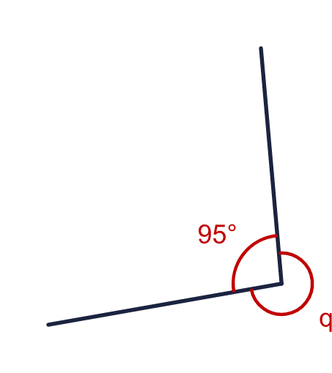
    q = |  | °
  1 | Work out the size of angle q.
    q = |  | °
  2 | Work out the size of angle p.  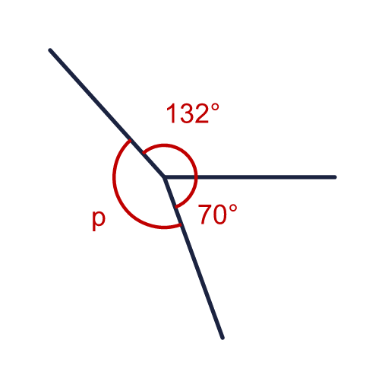
    p = |  | °
  2 | Work out the size of angle p.
    p = |  | °
  3 | Work out the size of angle h.  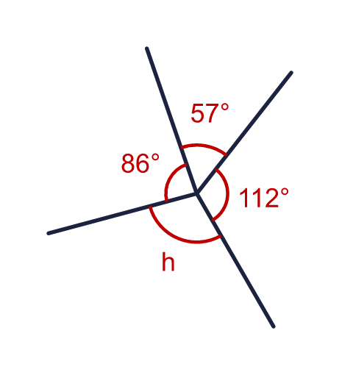
    h = |  | °
  3 | Work out the size of angle h.
    h = |  | °
  4 | Work out the size of angle p.  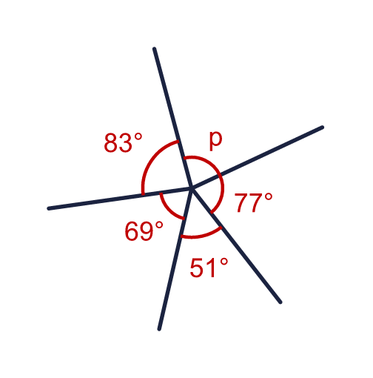
    p = |  | °
  4 | Work out the size of angle p.
    p = |  | °
  5 | A circle is divided into 6 equal sections. Work out the size of the angle g at the centre.  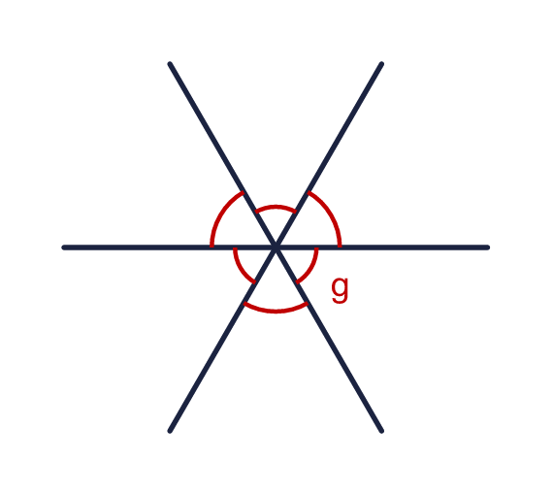
    g = |  | °
  5 | A circle is divided into 6 equal sections. Work out the size of the angle g at the centre.
    g = |  | °
  6 | Ron turns clockwise through 145°. He keeps turning the same way until he faces the way he started.
    How many more degrees does he need to turn?
    °
  6 | Ron turns clockwise through 145°. He keeps turning the same way until he faces the way he started.
    How many more degrees does he need to turn?
    °
  7 | The reflex angle y is 285°. Work out the size of the other angle b.  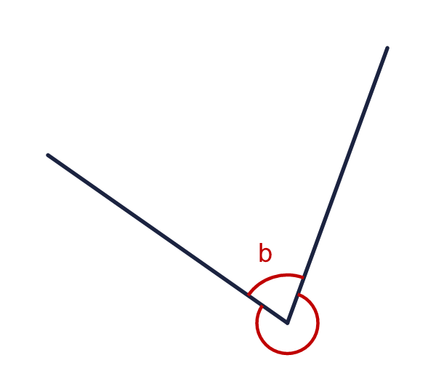
    b = |  | °
  7 | The reflex angle y is 285°. Work out the size of the other angle b.
    b = |  | °
  8 | Angles around a point add up to 360°. Three angles meet at a point. Two of them are 124° and 91°.  a) The third angle is  Four angles meet at a point. Three of them are 70°, 116° and 46°.  b) The fourth angle is
  8 | Angles around a point add up to 360°. Three angles meet at a point. Two of them are 124° and 91°.  a) The third angle is  Four angles meet at a point. Three of them are 70°, 116° and 46°.  b) The fourth angle is

  9 | Four angles meet at a point.  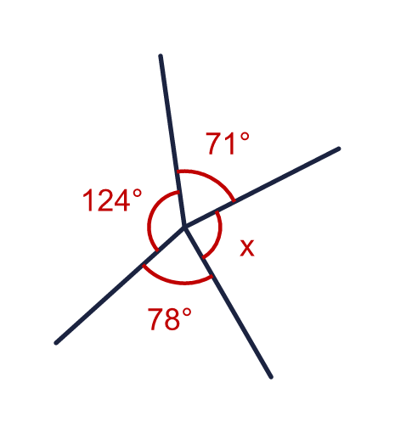  Is Boba correct? Circle yes or no.  Yes / No  Explain how you know.
     | 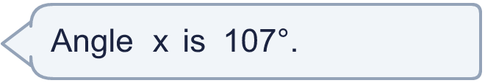
  9 | Four angles meet at a point.  Is Boba correct? Circle yes or no.  Yes / No  Explain how you know.
  10 | Four angles meet at a point. Their sizes are x, 2x, 2x and 5x.  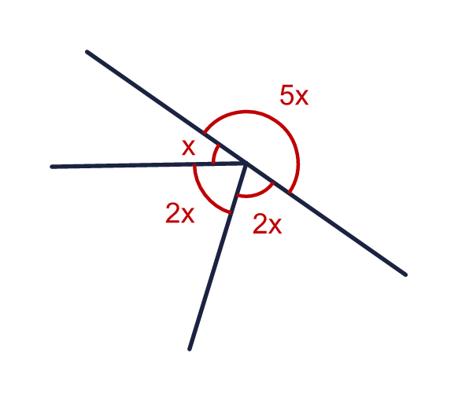
    x = |  | °
    5x = |  | °
  10 | Four angles meet at a point. Their sizes are x, 2x, 2x and 5x.
    x = |  | °
    5x = |  | °
  11 | The reflex angle is 250°. Work out the size of the obtuse or acute angle on the other side. Then draw the reflex angle of 250° accurately in your book, with arms of 4 cm. Use a ruler and a protractor.  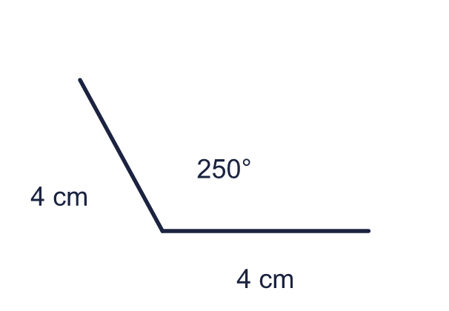  a) The angle on the other side is (degrees)
  11 | The reflex angle is 250°. Work out the size of the obtuse or acute angle on the other side. Then draw the reflex angle of 250° accurately in your book, with arms of 4 cm. Use a ruler and a protractor.  a) The angle on the other side is (degrees)
  12 | Three straight lines cross at one point. Five of the six angles are marked. Angles around a point add up to 360°.  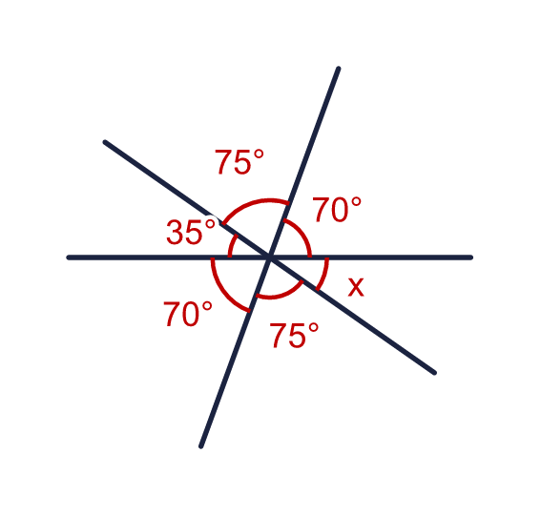
    x = |  | °
  12 | Three straight lines cross at one point. Five of the six angles are marked. Angles around a point add up to 360°.
    x = |  | °
  13 | The diagram shows the angles of a pie chart of favourite snacks. The angle for fruit (f) is 4 times the angle for sweets (s).  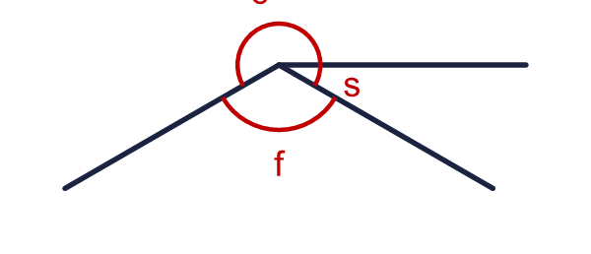  The three angles around the centre are c (chocolate), f (fruit) and s (sweets). Work out each angle.
    s = |  | °
    f = |  | °
    c = |  | °
  13 | The diagram shows the angles of a pie chart of favourite snacks. The angle for fruit (f) is 4 times the angle for sweets (s).  The three angles around the centre are c (chocolate), f (fruit) and s (sweets). Work out each angle.
    s = |  | °
    f = |  | °
    c = |  | °
  14 | The clock shows 4 o'clock. The angle x is marked between the hour hand and the minute hand.  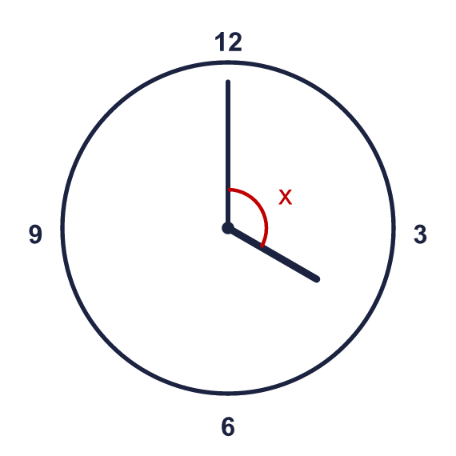
    x = |  | °
  14 | The clock shows 4 o'clock. The angle x is marked between the hour hand and the minute hand.
    x = |  | °

Year 5 · Shape · Step 6
Calculate angles around a point
Answers (teacher copy)

  1 | Work out the size of angle q.  q = 265 °
  2 | Work out the size of angle p.  p = 158 °
  3 | Work out the size of angle h.  h = 105 °
  4 | Work out the size of angle p.  p = 80 °
  5 | A circle is divided into 6 equal sections. Work out the size of the angle g at the centre.  g = 60 °
  6 | Ron turns clockwise through 145°. He keeps turning the same way until he faces the way he started.  How many more degrees does he need to turn? 215 °
  7 | The reflex angle y is 285°. Work out the size of the other angle b.  b = 75 °
  8 | Angles around a point add up to 360°. Three angles meet at a point. Two of them are 124° and 91°.  a) The third angle is 145  Four angles meet at a point. Three of them are 70°, 116° and 46°.  b) The fourth angle is 128
  9 | Four angles meet at a point.  Is Boba correct? Circle yes or no.  Yes / No  Explain how you know.  No. Angles around a point add up to 360°. The other three angles add up to 273°, so x = 87°, not 107°.
  10 | Four angles meet at a point. Their sizes are x, 2x, 2x and 5x.  x = 36 °  5x = 180 °
  11 | The reflex angle is 250°. Work out the size of the obtuse or acute angle on the other side. Then draw the reflex angle of 250° accurately in your book, with arms of 4 cm. Use a ruler and a protractor.  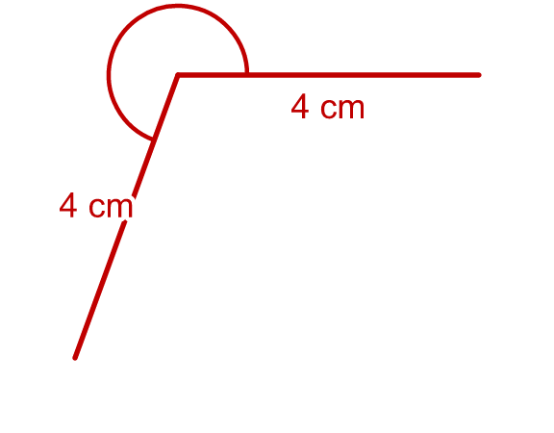  a) The angle on the other side is (degrees) 110
  12 | Three straight lines cross at one point. Five of the six angles are marked. Angles around a point add up to 360°.  x = 35 °
  13 | The diagram shows the angles of a pie chart of favourite snacks. The angle for fruit (f) is 4 times the angle for sweets (s).  The three angles around the centre are c (chocolate), f (fruit) and s (sweets). Work out each angle.  s = 30 °  f = 120 °  c = 210 °
  14 | The clock shows 4 o'clock. The angle x is marked between the hour hand and the minute hand.  x = 120 °

