  Year 5 · Shape · Step 10  3-D shapes | 
  Year 5 · Shape · Step 10
  3-D shapes
  1 | Write the mathematical name of each 3-D shape. The names are: cube, cuboid, square-based pyramid, triangular prism, cylinder, cone and sphere.  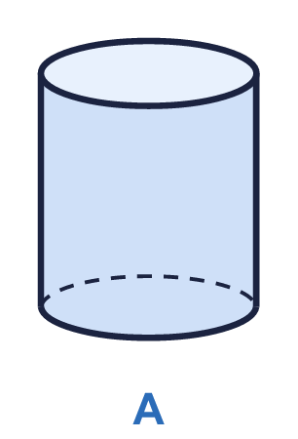  a) Shape A  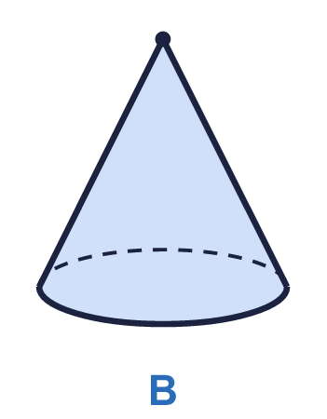  b) Shape B  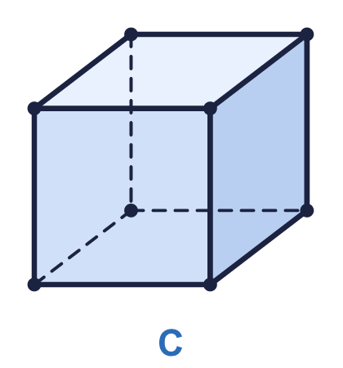  c) Shape C
  1 | Write the mathematical name of each 3-D shape. The names are: cube, cuboid, square-based pyramid, triangular prism, cylinder, cone and sphere.  a) Shape A  b) Shape B  c) Shape C
  2 | How many faces, edges and vertices does this shape have? Dashed lines are edges that you cannot see.  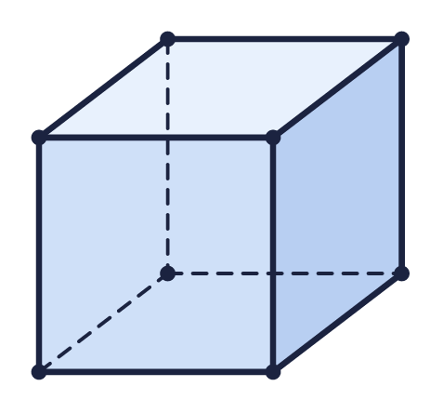  a) Faces  b) Edges  c) Vertices
  2 | How many faces, edges and vertices does this shape have? Dashed lines are edges that you cannot see.  a) Faces  b) Edges  c) Vertices
  3 | How many faces, edges and vertices does this shape have?  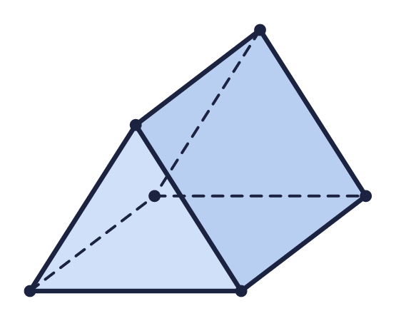  a) Faces  b) Edges  c) Vertices
  3 | How many faces, edges and vertices does this shape have?  a) Faces  b) Edges  c) Vertices
  4 | This shape has a curved surface. Count only the flat faces.  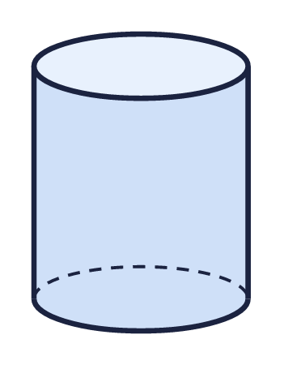  a) Flat faces  b) Edges  c) Vertices
  4 | This shape has a curved surface. Count only the flat faces.  a) Flat faces  b) Edges  c) Vertices
  5 | Look at the four shapes.  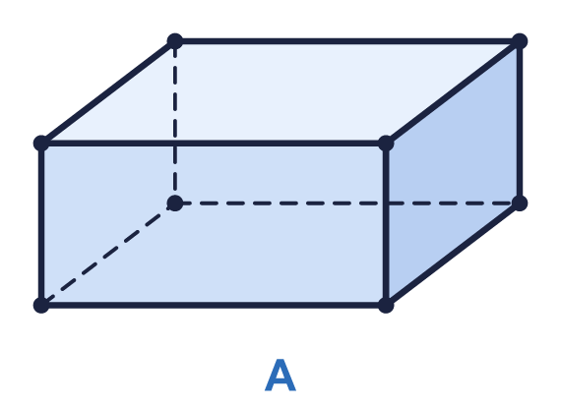  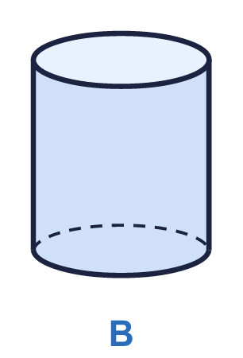  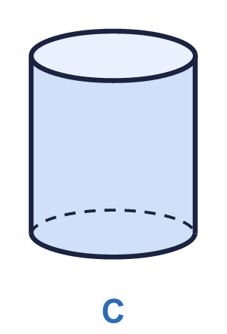  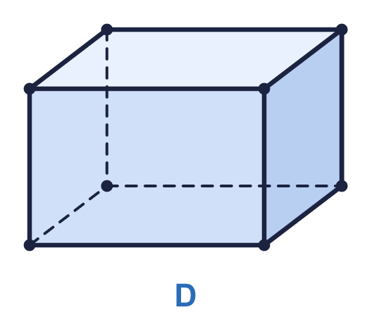  Which shapes have a curved surface? Write the letters.
  5 | Look at the four shapes.  Which shapes have a curved surface? Write the letters.
  6 | Which 3-D shape am I? Write the name.  1. I have 12 edges and every face is a square.  a) Shape 1  2. I have 5 faces and 5 vertices.  b) Shape 2
  6 | Which 3-D shape am I? Write the name.  1. I have 12 edges and every face is a square.  a) Shape 1  2. I have 5 faces and 5 vertices.  b) Shape 2
  7 | Complete the sentences about this square-based pyramid. It has one square face.  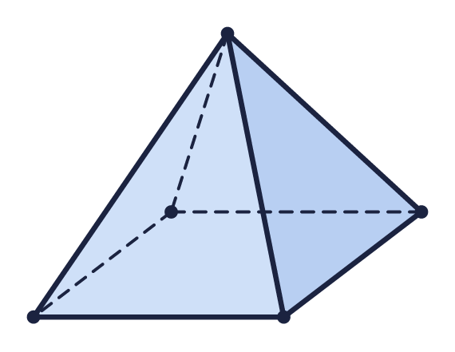  a) Number of triangular faces  b) Total number of faces
  7 | Complete the sentences about this square-based pyramid. It has one square face.  a) Number of triangular faces  b) Total number of faces
  8 | How many vertices does this cuboid have?  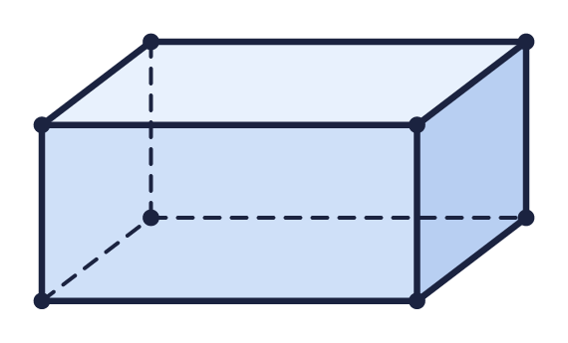  a) Vertices
  8 | How many vertices does this cuboid have?  a) Vertices

  9 | Ron has drawn a cuboid made of unit cubes on isometric paper.  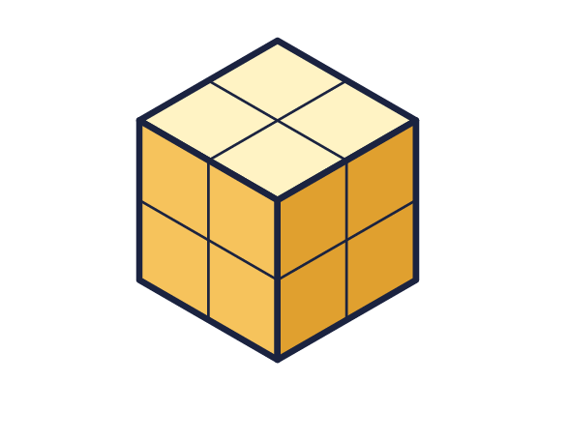  a) How many faces does the cuboid have?  b) How many edges does it have?  c) How many unit cubes make the cuboid?
  9 | Ron has drawn a cuboid made of unit cubes on isometric paper.  a) How many faces does the cuboid have?  b) How many edges does it have?  c) How many unit cubes make the cuboid?
  10 | Look at the square-based pyramid.  Is Jack correct? Circle yes or no.  Yes / No  Explain how you know.
     | 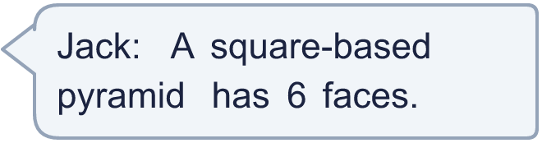
  10 | Look at the square-based pyramid.  Is Jack correct? Circle yes or no.  Yes / No  Explain how you know.
  11 | Which 3-D shape is each person thinking of?  a) Jack is thinking of a  b) Whitney is thinking of a
     | 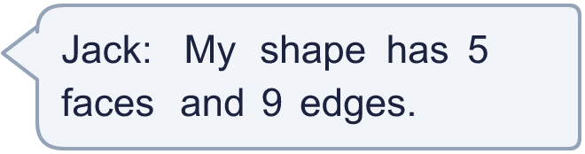
     | 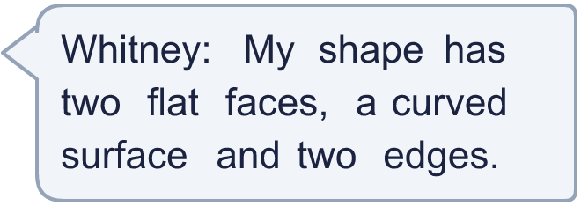
  11 | Which 3-D shape is each person thinking of?  a) Jack is thinking of a  b) Whitney is thinking of a
  12 | Challenge  Look at these shapes. For each one, add the number of faces and the number of vertices, then take away the number of edges.  Use the pattern. A shape has 10 vertices and 15 edges. How many faces does it have?
    Cube: 6 faces, 8 vertices, 12 edges.
    Triangular prism: 5 faces, 6 vertices, 9 edges.
    Number of faces =
  12 | Challenge  Look at these shapes. For each one, add the number of faces and the number of vertices, then take away the number of edges.  Use the pattern. A shape has 10 vertices and 15 edges. How many faces does it have?
    Cube: 6 faces, 8 vertices, 12 edges.
    Triangular prism: 5 faces, 6 vertices, 9 edges.
    Number of faces =
  13 | Look at the five shapes. A shape can roll if it has a curved surface.  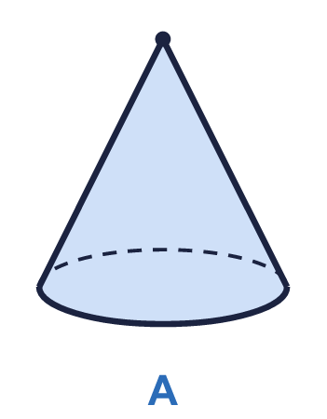  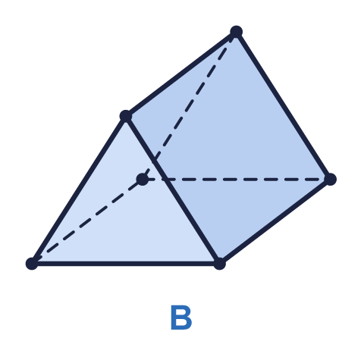  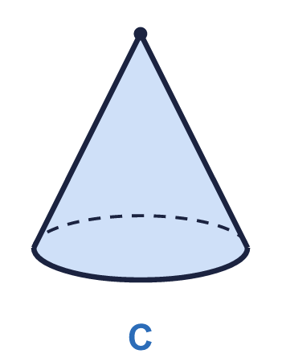  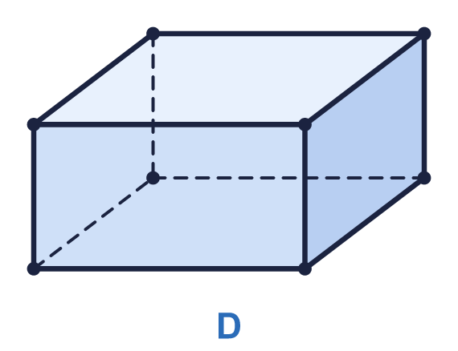  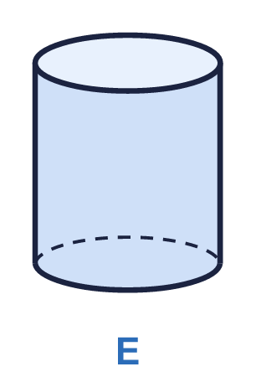  a) How many of the shapes can roll?
  13 | Look at the five shapes. A shape can roll if it has a curved surface.  a) How many of the shapes can roll?
  14 | Look at the four shapes.  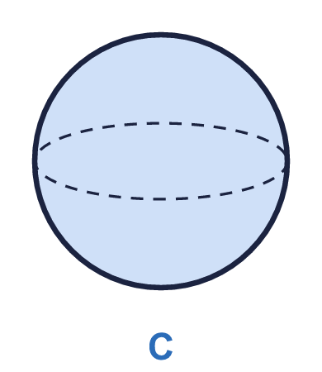  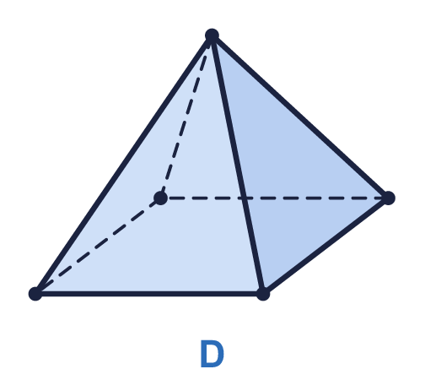  a) Which shape has the most edges? Write the letter.  b) How many edges does it have?
  14 | Look at the four shapes.  a) Which shape has the most edges? Write the letter.  b) How many edges does it have?

Year 5 · Shape · Step 10
3-D shapes
Answers (teacher copy)

  1 | Write the mathematical name of each 3-D shape. The names are: cube, cuboid, square-based pyramid, triangular prism, cylinder, cone and sphere.  a) Shape A cylinder  b) Shape B cone  c) Shape C cube
  2 | How many faces, edges and vertices does this shape have? Dashed lines are edges that you cannot see.  a) Faces 6  b) Edges 12  c) Vertices 8
  3 | How many faces, edges and vertices does this shape have?  a) Faces 5  b) Edges 9  c) Vertices 6
  4 | This shape has a curved surface. Count only the flat faces.  a) Flat faces 2  b) Edges 2  c) Vertices 0
  5 | Look at the four shapes.  Which shapes have a curved surface? Write the letters. B, C
  6 | Which 3-D shape am I? Write the name.  1. I have 12 edges and every face is a square.  a) Shape 1 cube  2. I have 5 faces and 5 vertices.  b) Shape 2 square-based pyramid
  7 | Complete the sentences about this square-based pyramid. It has one square face.  a) Number of triangular faces 4  b) Total number of faces 5
  8 | How many vertices does this cuboid have?  a) Vertices 8
  9 | Ron has drawn a cuboid made of unit cubes on isometric paper.  a) How many faces does the cuboid have? 6  b) How many edges does it have? 12  c) How many unit cubes make the cuboid? 8
  10 | Look at the square-based pyramid.  Is Jack correct? Circle yes or no.  Yes / No  Explain how you know.  No. It has 4 triangular faces and 1 square face, so it has 5 faces altogether, not 6.
  11 | Which 3-D shape is each person thinking of?  a) Jack is thinking of a triangular prism  b) Whitney is thinking of a cylinder
  12 | Challenge  Look at these shapes. For each one, add the number of faces and the number of vertices, then take away the number of edges.  Cube: 6 faces, 8 vertices, 12 edges. 2  Triangular prism: 5 faces, 6 vertices, 9 edges. 2  Use the pattern. A shape has 10 vertices and 15 edges. How many faces does it have?  Number of faces = 7
  13 | Look at the five shapes. A shape can roll if it has a curved surface.  a) How many of the shapes can roll? 3
  14 | Look at the four shapes.  a) Which shape has the most edges? Write the letter. B  b) How many edges does it have? 9

