  Year 5 · Position and direction · Step 3  Translation | 
  Year 5 · Position and direction · Step 3
  Translation
  1 | Translate triangle ABC 5 squares right. Draw the new triangle in your book. Then write the coordinates of the corners of the new triangle.  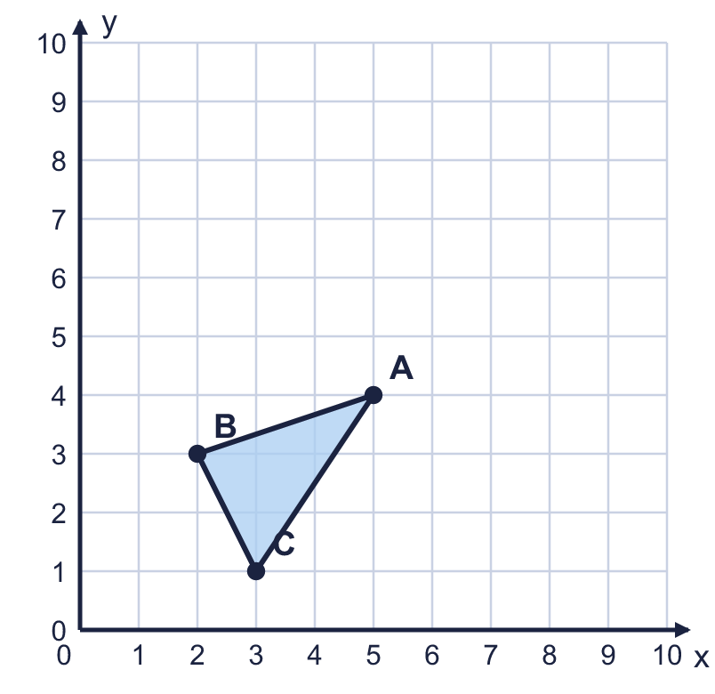  a) Corner A'  b) Corner B'  c) Corner C'
  1 | Translate triangle ABC 5 squares right. Draw the new triangle in your book. Then write the coordinates of the corners of the new triangle.  a) Corner A'  b) Corner B'  c) Corner C'
  2 | Translate triangle ABC 2 squares left and 3 squares down. Draw the new triangle in your book. Then write the coordinates of the corners of the new triangle.  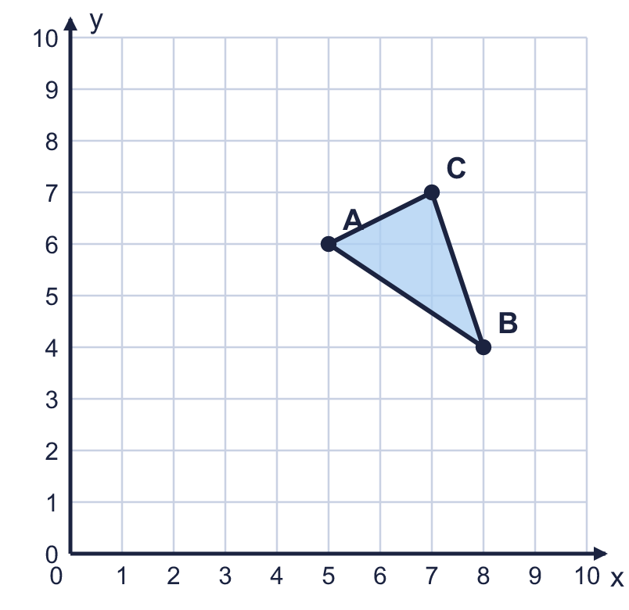  a) Corner A'  b) Corner B'  c) Corner C'
  2 | Translate triangle ABC 2 squares left and 3 squares down. Draw the new triangle in your book. Then write the coordinates of the corners of the new triangle.  a) Corner A'  b) Corner B'  c) Corner C'
  3 | Shape A has been translated to shape B. Describe the translation. Write it like this: 3 left and 4 up.  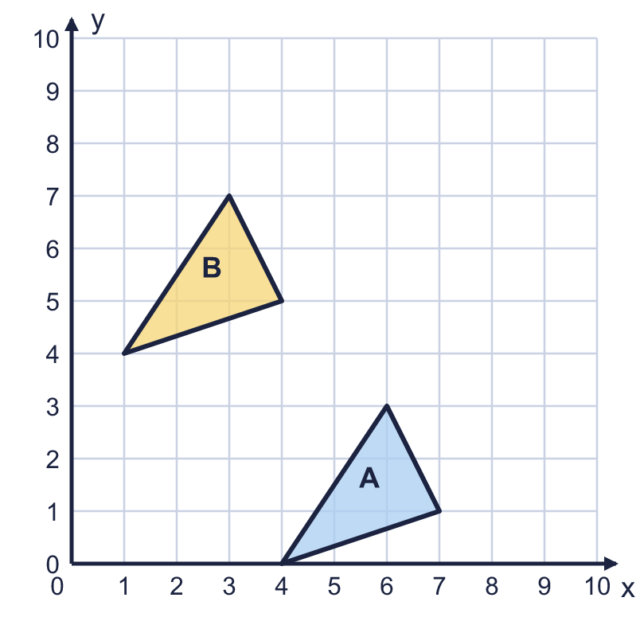  The translation from A to B is
  3 | Shape A has been translated to shape B. Describe the translation. Write it like this: 3 left and 4 up.  The translation from A to B is
  4 | Shape C has been translated to shape D. Describe the translation.  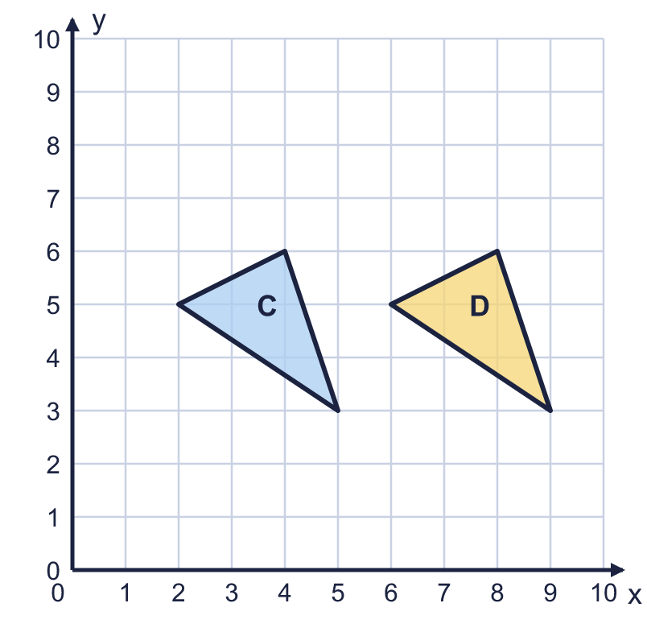  The translation from C to D is
  4 | Shape C has been translated to shape D. Describe the translation.  The translation from C to D is
  5 | The coordinate grid shows shape A and four other shapes. Some of the shapes are translations of shape A: they have been slid, but not turned or flipped.  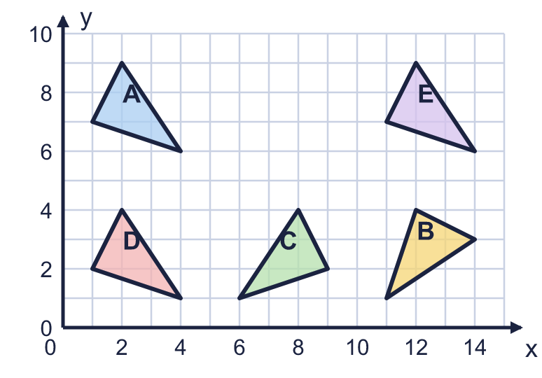  Which shapes are translations of A? Write the letters.
  5 | The coordinate grid shows shape A and four other shapes. Some of the shapes are translations of shape A: they have been slid, but not turned or flipped.  Which shapes are translations of A? Write the letters.
  6 | Rectangle ABCD is drawn on the coordinate grid. It is translated 6 squares right and 3 squares up.  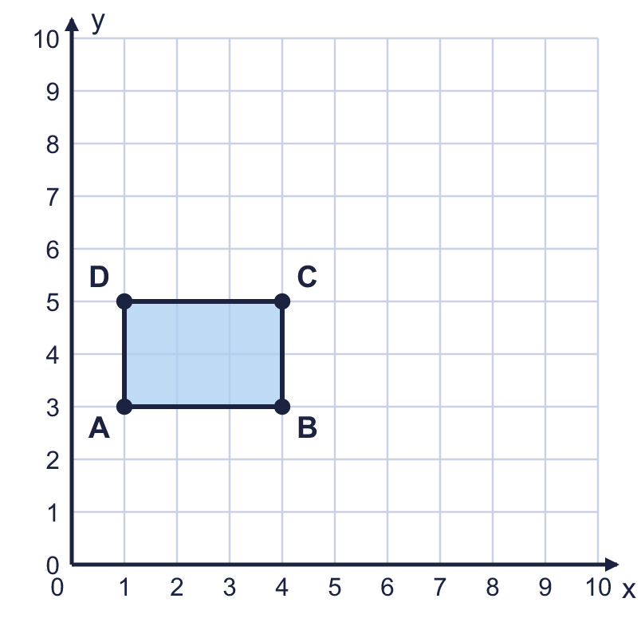  a) Where does A go? Write the coordinates of A'.  b) Where does C go? Write the coordinates of C'.
  6 | Rectangle ABCD is drawn on the coordinate grid. It is translated 6 squares right and 3 squares up.  a) Where does A go? Write the coordinates of A'.  b) Where does C go? Write the coordinates of C'.
  7 | Translate shape D 5 squares left and 2 squares up. Draw the new shape in your book and label it E. Then describe the translation from E back to D.  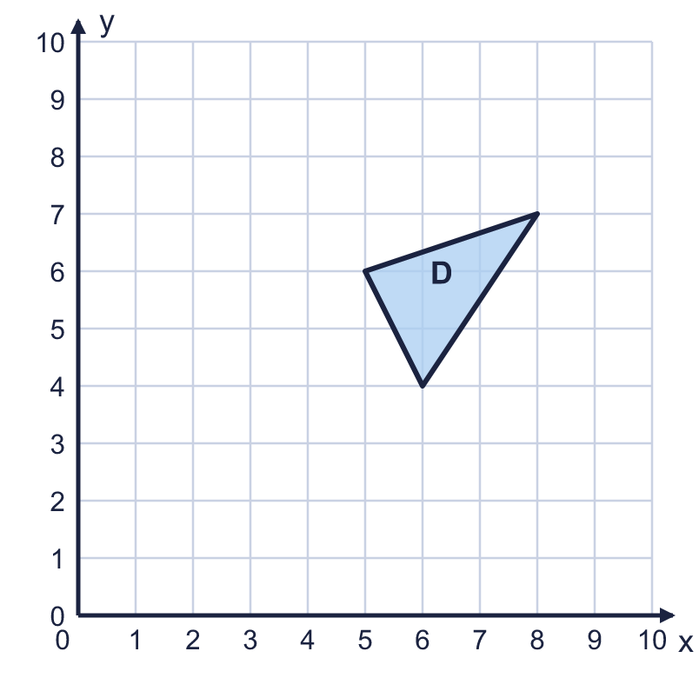  The translation from E to D is
  7 | Translate shape D 5 squares left and 2 squares up. Draw the new shape in your book and label it E. Then describe the translation from E back to D.  The translation from E to D is
  8 | Shape P has been translated to shape Q. Describe the translation. Write it like this: 3 left and 4 up.  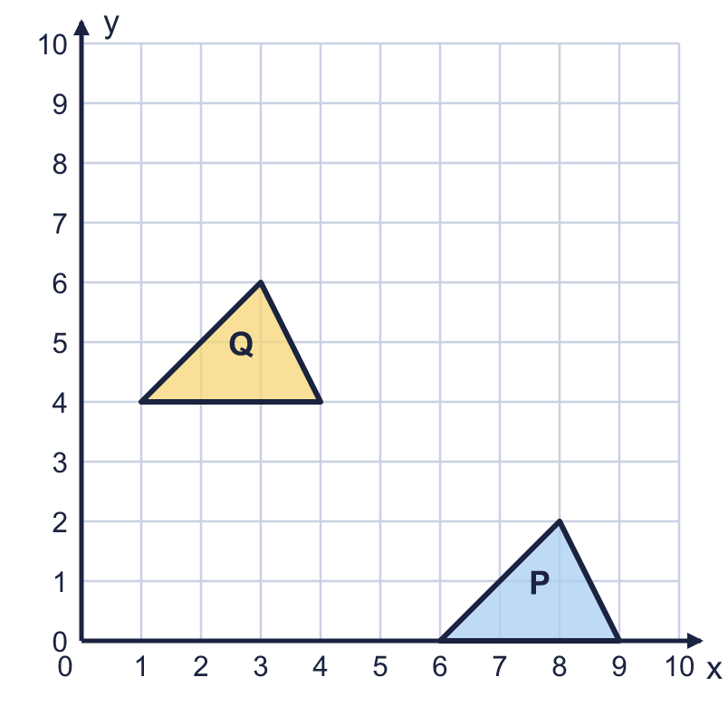  The translation from P to Q is
  8 | Shape P has been translated to shape Q. Describe the translation. Write it like this: 3 left and 4 up.  The translation from P to Q is

  9 | Square A is translated to square B.  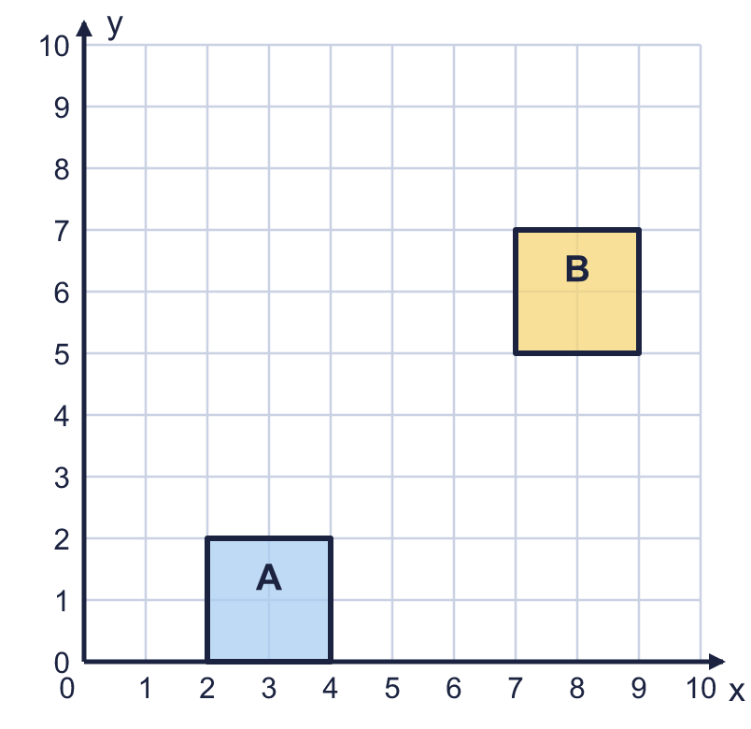  Is Boba correct? Circle yes or no.  Yes / No  Explain how you know.
     | 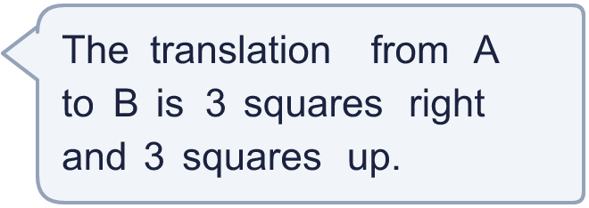
  9 | Square A is translated to square B.  Is Boba correct? Circle yes or no.  Yes / No  Explain how you know.
  10 | Triangle A is translated 3 squares right and 2 squares up. Tiny has drawn the new triangle B.  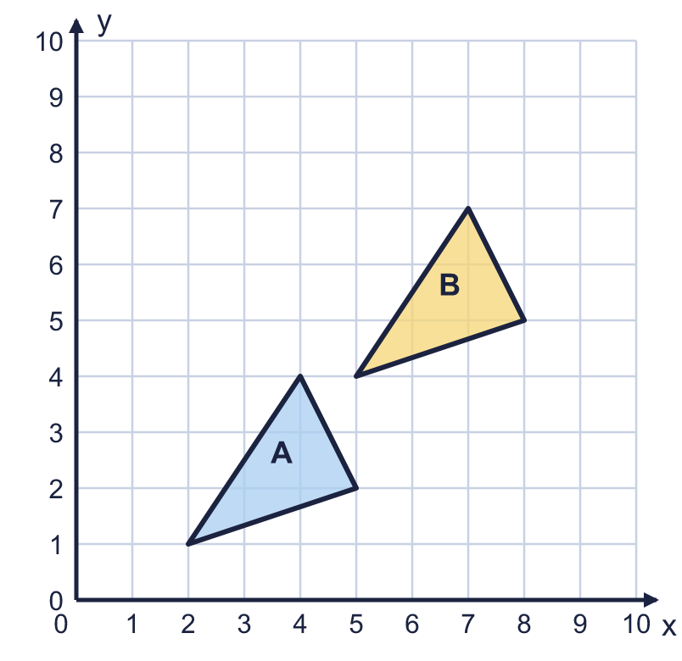  Is Tiny's drawing correct? Circle yes or no.  Yes / No  Explain how you know.
  10 | Triangle A is translated 3 squares right and 2 squares up. Tiny has drawn the new triangle B.  Is Tiny's drawing correct? Circle yes or no.  Yes / No  Explain how you know.
  11 | Triangle ABC is translated 1 square right and 2 squares up. Then it is translated 1 square right and 1 square down.  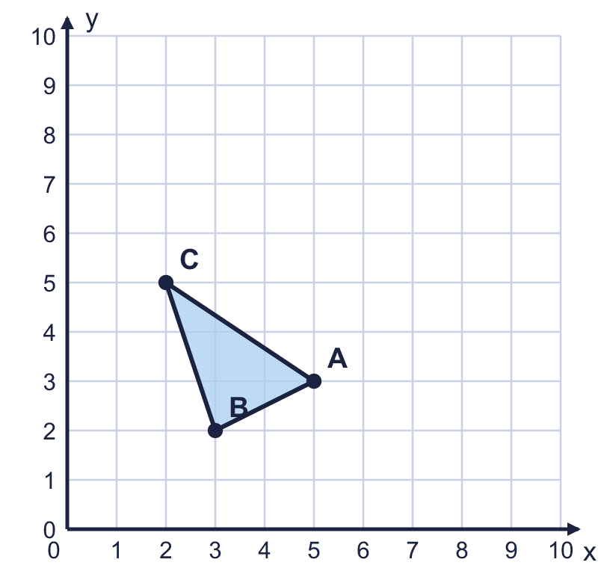  a) Where does A end up? Write the coordinates of A''.  b) What single translation takes ABC to its final position? Write it like this: 3 left and 4 up.
  11 | Triangle ABC is translated 1 square right and 2 squares up. Then it is translated 1 square right and 1 square down.  a) Where does A end up? Write the coordinates of A''.  b) What single translation takes ABC to its final position? Write it like this: 3 left and 4 up.
  12 | A triangle has corners at A (3, 6), B (5, 3), C (6, 6). It is translated so that A moves to (7, 7).  a) Where does B go? Write the coordinates of B'.  b) Where does C go? Write the coordinates of C'.
  12 | A triangle has corners at A (3, 6), B (5, 3), C (6, 6). It is translated so that A moves to (7, 7).  a) Where does B go? Write the coordinates of B'.  b) Where does C go? Write the coordinates of C'.
  13 | Triangle ABC is drawn on the coordinate grid.  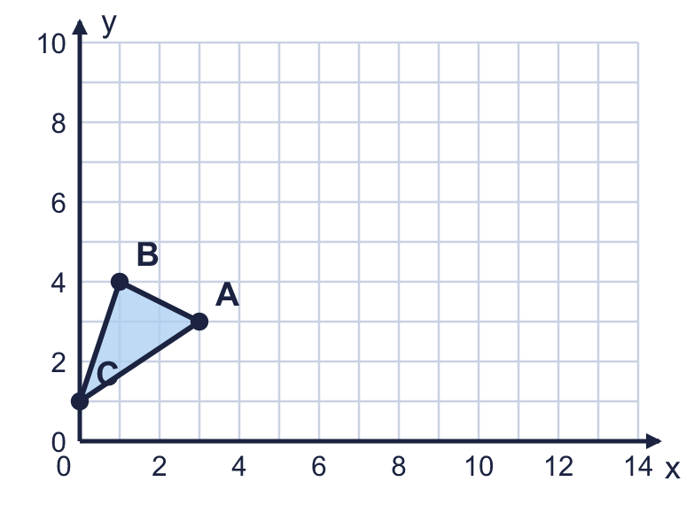  Write a translation that moves all of the triangle so that every corner is at least 7 across (every x-coordinate is 7 or more). Write it like this: 3 right and 4 up.
  13 | Triangle ABC is drawn on the coordinate grid.  Write a translation that moves all of the triangle so that every corner is at least 7 across (every x-coordinate is 7 or more). Write it like this: 3 right and 4 up.
  14 | Shape A has been translated to shape B. Then shape B is translated 2 squares left and 2 squares up to make shape C.  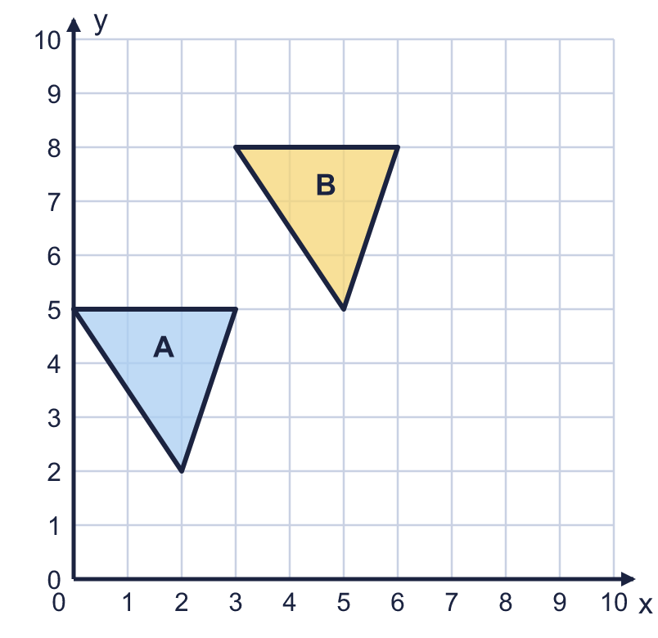  Describe the single translation from A to C. Write it like this: 3 left and 4 up.
  14 | Shape A has been translated to shape B. Then shape B is translated 2 squares left and 2 squares up to make shape C.  Describe the single translation from A to C. Write it like this: 3 left and 4 up.

Year 5 · Position and direction · Step 3
Translation
Answers (teacher copy)

  1 | Translate triangle ABC 5 squares right. Draw the new triangle in your book. Then write the coordinates of the corners of the new triangle.  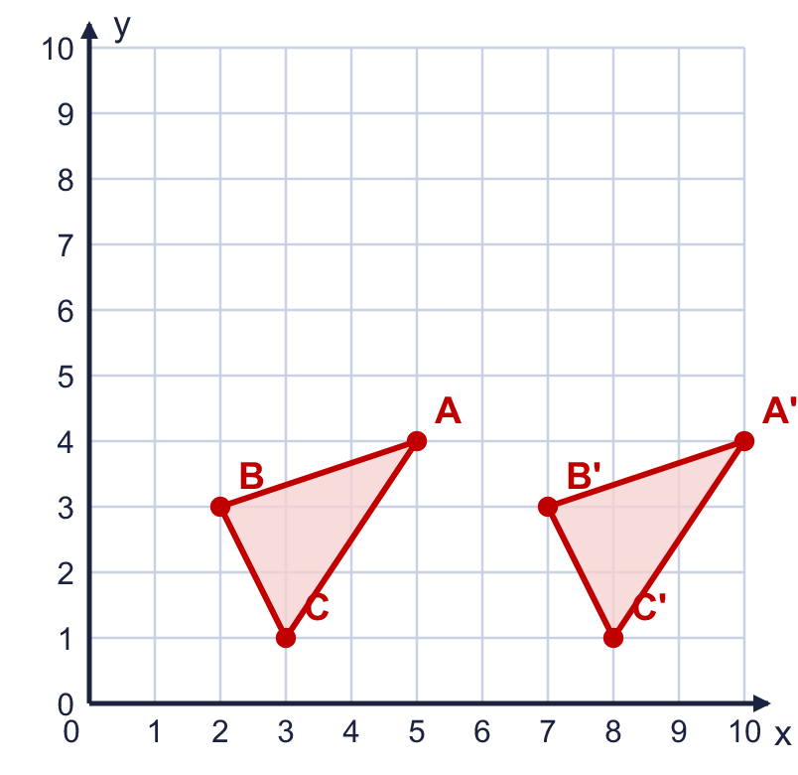  a) Corner A' (10, 4)  b) Corner B' (7, 3)  c) Corner C' (8, 1)
  2 | Translate triangle ABC 2 squares left and 3 squares down. Draw the new triangle in your book. Then write the coordinates of the corners of the new triangle.  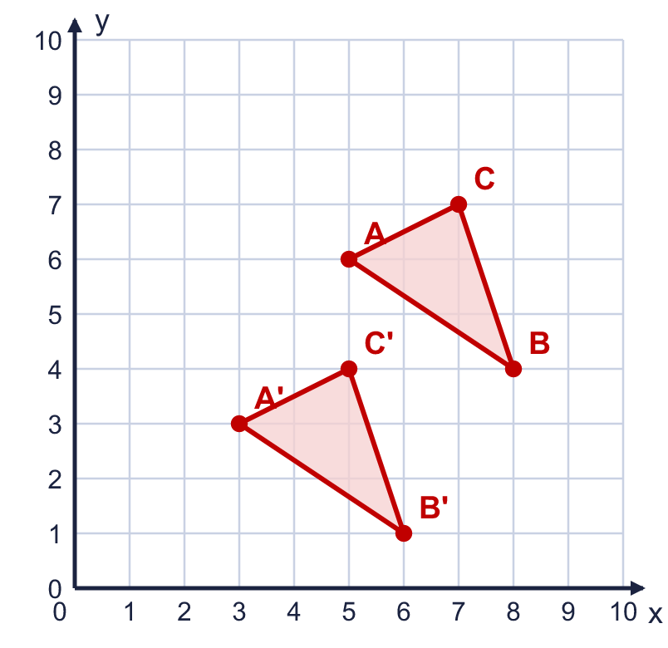  a) Corner A' (3, 3)  b) Corner B' (6, 1)  c) Corner C' (5, 4)
  3 | Shape A has been translated to shape B. Describe the translation. Write it like this: 3 left and 4 up.  The translation from A to B is 3 left and 4 up
  4 | Shape C has been translated to shape D. Describe the translation.  The translation from C to D is 4 right
  5 | The coordinate grid shows shape A and four other shapes. Some of the shapes are translations of shape A: they have been slid, but not turned or flipped.  Which shapes are translations of A? Write the letters. D, E
  6 | Rectangle ABCD is drawn on the coordinate grid. It is translated 6 squares right and 3 squares up.  a) Where does A go? Write the coordinates of A'. (7, 6)  b) Where does C go? Write the coordinates of C'. (10, 8)
  7 | Translate shape D 5 squares left and 2 squares up. Draw the new shape in your book and label it E. Then describe the translation from E back to D.  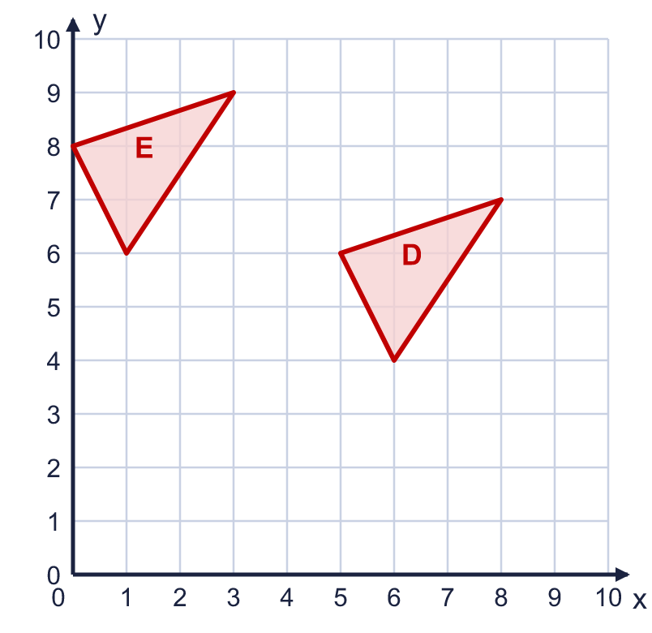  The translation from E to D is 5 right and 2 down
  8 | Shape P has been translated to shape Q. Describe the translation. Write it like this: 3 left and 4 up.  The translation from P to Q is 5 left and 4 up
  9 | Square A is translated to square B.  Is Boba correct? Circle yes or no.  Yes / No  Explain how you know.  Boba counted from the corner of A that is closest to B to the closest corner of B. You must count from a corner of A to the same corner of B. The bottom left corners are at (2, 0) and (7, 5), so the translation is 5 squares right and 5 squares up.
  10 | Triangle A is translated 3 squares right and 2 squares up. Tiny has drawn the new triangle B.  Is Tiny's drawing correct? Circle yes or no.  Yes / No  Explain how you know.  Tiny moved the triangle 3 squares right and 3 squares up, but the translation is 3 squares right and 2 squares up.
  11 | Triangle ABC is translated 1 square right and 2 squares up. Then it is translated 1 square right and 1 square down.  a) Where does A end up? Write the coordinates of A''. (7, 4)  b) What single translation takes ABC to its final position? Write it like this: 3 left and 4 up. 2 right and 1 up
  12 | A triangle has corners at A (3, 6), B (5, 3), C (6, 6). It is translated so that A moves to (7, 7).  a) Where does B go? Write the coordinates of B'. (9, 4)  b) Where does C go? Write the coordinates of C'. (10, 7)
  13 | Triangle ABC is drawn on the coordinate grid.  Write a translation that moves all of the triangle so that every corner is at least 7 across (every x-coordinate is 7 or more). Write it like this: 3 right and 4 up.  Any translation with at least 7 right, for example 7 right and 2 up or 8 right and 1 up
  14 | Shape A has been translated to shape B. Then shape B is translated 2 squares left and 2 squares up to make shape C.  Describe the single translation from A to C. Write it like this: 3 left and 4 up. 1 right and 5 up

