  Year 5 · Position and direction · Step 4  Translation with coordinates | 
  Year 5 · Position and direction · Step 4
  Translation with coordinates
  1 | Four points are plotted on the coordinate grid. Translate each point 4 squares right. Draw the new points in your book, then write their coordinates.  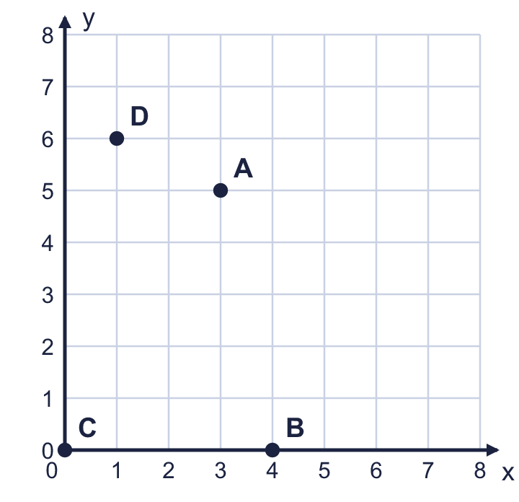  a) Point A'  b) Point B'  c) Point C'  d) Point D'
  1 | Four points are plotted on the coordinate grid. Translate each point 4 squares right. Draw the new points in your book, then write their coordinates.  a) Point A'  b) Point B'  c) Point C'  d) Point D'
  2 | Four points are plotted on the coordinate grid. Translate each point 3 squares up. Draw the new points in your book, then write their coordinates.  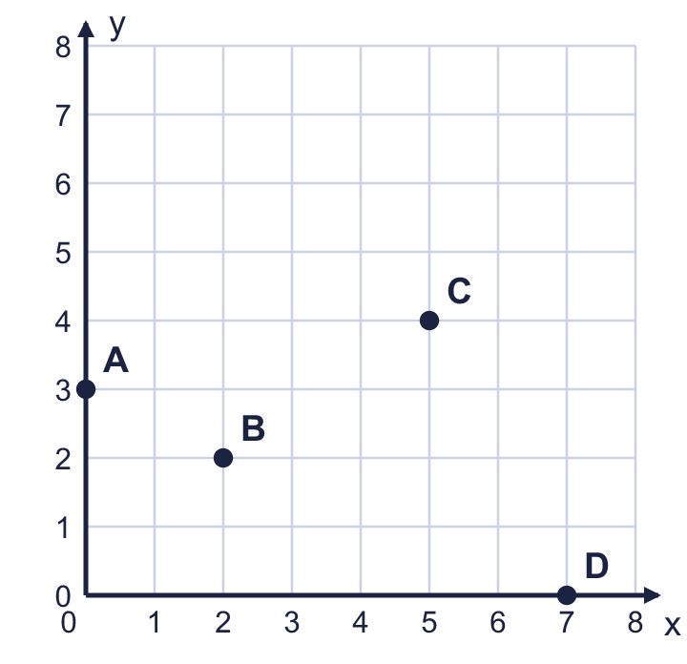  a) Point A'  b) Point B'  c) Point C'  d) Point D'
  2 | Four points are plotted on the coordinate grid. Translate each point 3 squares up. Draw the new points in your book, then write their coordinates.  a) Point A'  b) Point B'  c) Point C'  d) Point D'
  3 | The point (8, 6) is translated 2 squares up.  a) Which coordinate stays the same? Write x or y.  b) Write the coordinates of the new point.
  3 | The point (8, 6) is translated 2 squares up.  a) Which coordinate stays the same? Write x or y.  b) Write the coordinates of the new point.
  4 | The point (7, 6) is translated 5 squares left and 3 squares down.  Write the coordinates of the new point.
  4 | The point (7, 6) is translated 5 squares left and 3 squares down.  Write the coordinates of the new point.
  5 | The point (12, 9) is translated 1 square right and 5 squares down.  Write the coordinates of the new point.
  5 | The point (12, 9) is translated 1 square right and 5 squares down.  Write the coordinates of the new point.
  6 | The point (3, 9) is translated 9 squares down.  Write the coordinates of the new point.  Which axis is the new point on? Write the x-axis or the y-axis.
    The new point is on the
  6 | The point (3, 9) is translated 9 squares down.  Write the coordinates of the new point.  Which axis is the new point on? Write the x-axis or the y-axis.
    The new point is on the
  7 | The coordinates of the corners of a rectangle are (11, 3), (15, 3), (15, 7), (11, 7). The rectangle is translated 6 squares left and 1 square down. Write the coordinates of the corners now.
  7 | The coordinates of the corners of a rectangle are (11, 3), (15, 3), (15, 7), (11, 7). The rectangle is translated 6 squares left and 1 square down. Write the coordinates of the corners now.
  8 | A point moves from (12, 2) to (7, 1). Describe the translation. Write it like this: 3 left and 4 up.
  8 | A point moves from (12, 2) to (7, 1). Describe the translation. Write it like this: 3 left and 4 up.

  9 | Point M is at (12, 20). It is translated 23 squares right and 6 squares down.  Is Boba correct? Circle yes or no.  Yes / No  Explain how you know.
     | 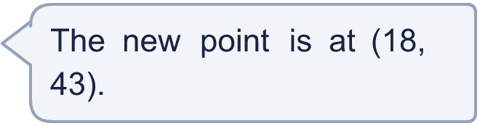
  9 | Point M is at (12, 20). It is translated 23 squares right and 6 squares down.  Is Boba correct? Circle yes or no.  Yes / No  Explain how you know.
  10 | Point X is at (13, 19). After a translation it is at (30, 21).  Describe the translation. Write it like this: 3 left and 4 up.  Is there more than one translation that takes X to this point? Explain.
  10 | Point X is at (13, 19). After a translation it is at (30, 21).  Describe the translation. Write it like this: 3 left and 4 up.  Is there more than one translation that takes X to this point? Explain.
  11 | A pentagon is translated. The table shows the coordinates of each corner before and after the translation. Some numbers are missing. The first row is complete.  Corner 1: Before (11, 17) After (10, 19)  Describe the translation. Write it like this: 3 left and 4 up.
    Corner 2: | Before (
    , 7) After (5, 9)
    Corner 3: | Before (
    , 13) After (11, 15)
    Corner 4:
    Before (20, 12) After (
    , 14)
    Corner 5: | Before (13,
    ) After (12, 8)
  11 | A pentagon is translated. The table shows the coordinates of each corner before and after the translation. Some numbers are missing. The first row is complete.  Corner 1: Before (11, 17) After (10, 19)  Describe the translation. Write it like this: 3 left and 4 up.
    Corner 2: | Before (
    , 7) After (5, 9)
    Corner 3: | Before (
    , 13) After (11, 15)
    Corner 4:
    Before (20, 12) After (
    , 14)
    Corner 5: | Before (13,
    ) After (12, 8)
  12 | The point (12, 11) is translated 3 squares right and 4 squares up. Then it is translated 4 squares right and 4 squares up.  a) Where does the point end up? Write the coordinates.  b) What single translation takes the point from the start to the end? Write it like this: 3 left and 4 up.
  12 | The point (12, 11) is translated 3 squares right and 4 squares up. Then it is translated 4 squares right and 4 squares up.  a) Where does the point end up? Write the coordinates.  b) What single translation takes the point from the start to the end? Write it like this: 3 left and 4 up.
  13 | A point is translated 3 squares right and 3 squares down. It ends at (20, 18).  Where did the point start? Write the coordinates.
  13 | A point is translated 3 squares right and 3 squares down. It ends at (20, 18).  Where did the point start? Write the coordinates.
  14 | Rectangle ABCD has corners at A (3, 3), B (7, 3), C (7, 6), D (3, 6). It is translated so that A moves to (24, 16).  a) Where does B go? Write the coordinates of B'.  b) Where does C go? Write the coordinates of C'.  c) Where does D go? Write the coordinates of D'.
  14 | Rectangle ABCD has corners at A (3, 3), B (7, 3), C (7, 6), D (3, 6). It is translated so that A moves to (24, 16).  a) Where does B go? Write the coordinates of B'.  b) Where does C go? Write the coordinates of C'.  c) Where does D go? Write the coordinates of D'.

Year 5 · Position and direction · Step 4
Translation with coordinates
Answers (teacher copy)

  1 | Four points are plotted on the coordinate grid. Translate each point 4 squares right. Draw the new points in your book, then write their coordinates.  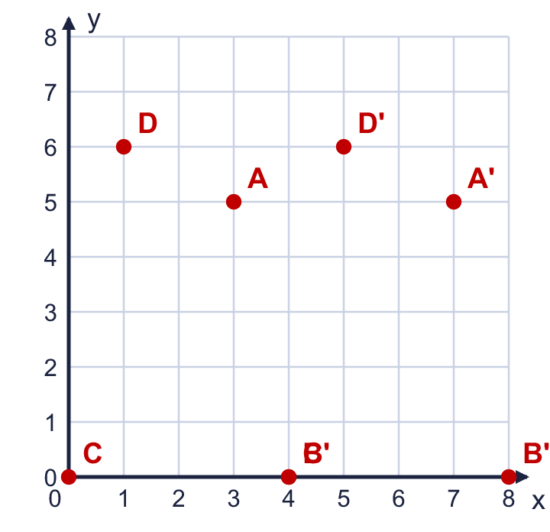  a) Point A' (7, 5)  b) Point B' (8, 0)  c) Point C' (4, 0)  d) Point D' (5, 6)
  2 | Four points are plotted on the coordinate grid. Translate each point 3 squares up. Draw the new points in your book, then write their coordinates.  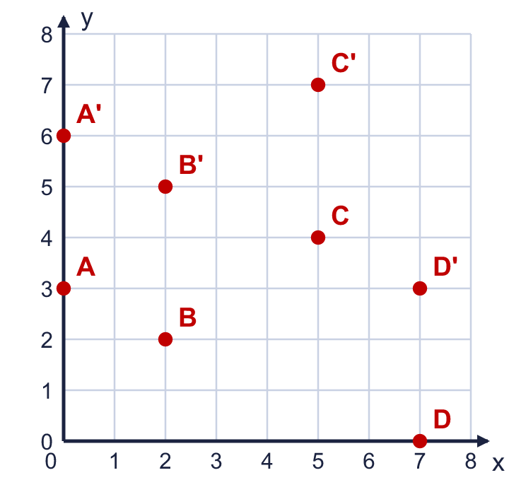  a) Point A' (0, 6)  b) Point B' (2, 5)  c) Point C' (5, 7)  d) Point D' (7, 3)
  3 | The point (8, 6) is translated 2 squares up.  a) Which coordinate stays the same? Write x or y. x  b) Write the coordinates of the new point. (8, 8)
  4 | The point (7, 6) is translated 5 squares left and 3 squares down.  Write the coordinates of the new point. (2, 3)
  5 | The point (12, 9) is translated 1 square right and 5 squares down.  Write the coordinates of the new point. (13, 4)
  6 | The point (3, 9) is translated 9 squares down.  Write the coordinates of the new point. (3, 0)  Which axis is the new point on? Write the x-axis or the y-axis.  The new point is on the x-axis
  7 | The coordinates of the corners of a rectangle are (11, 3), (15, 3), (15, 7), (11, 7). The rectangle is translated 6 squares left and 1 square down. Write the coordinates of the corners now.  The new corners are (5, 2), (9, 2), (9, 6), (5, 6)
  8 | A point moves from (12, 2) to (7, 1). Describe the translation. Write it like this: 3 left and 4 up.  The translation is 5 left and 1 down
  9 | Point M is at (12, 20). It is translated 23 squares right and 6 squares down.  Is Boba correct? Circle yes or no.  Yes / No  Explain how you know.  Moving 23 squares right adds 23 to the x-coordinate. Moving 6 squares down takes 6 off the y-coordinate. The new point is (35, 14), not (18, 43).
  10 | Point X is at (13, 19). After a translation it is at (30, 21).  Describe the translation. Write it like this: 3 left and 4 up. 17 right and 2 up  Is there more than one translation that takes X to this point? Explain.  No. The change in the x-coordinate and the change in the y-coordinate are fixed, so only one translation works.
  11 | A pentagon is translated. The table shows the coordinates of each corner before and after the translation. Some numbers are missing. The first row is complete.  Corner 1: Before (11, 17) After (10, 19)  Corner 2: Before ( 6 , 7) After (5, 9)  Corner 3: Before ( 12 , 13) After (11, 15)  Corner 4: Before (20, 12) After ( 19 , 14)  Corner 5: Before (13, 6 ) After (12, 8)  Describe the translation. Write it like this: 3 left and 4 up. 1 left and 2 up
  12 | The point (12, 11) is translated 3 squares right and 4 squares up. Then it is translated 4 squares right and 4 squares up.  a) Where does the point end up? Write the coordinates. (19, 19)  b) What single translation takes the point from the start to the end? Write it like this: 3 left and 4 up. 7 right and 8 up
  13 | A point is translated 3 squares right and 3 squares down. It ends at (20, 18).  Where did the point start? Write the coordinates. (17, 21)
  14 | Rectangle ABCD has corners at A (3, 3), B (7, 3), C (7, 6), D (3, 6). It is translated so that A moves to (24, 16).  a) Where does B go? Write the coordinates of B'. (28, 16)  b) Where does C go? Write the coordinates of C'. (28, 19)  c) Where does D go? Write the coordinates of D'. (24, 19)

