  Year 5 · Position and direction · Step 6  Reflection in horizontal and vertical lines | 
  Year 5 · Position and direction · Step 6
  Reflection in horizontal and vertical lines
  1 | Shape B should be the reflection of shape A in the dashed mirror line. Is each reflection correct?  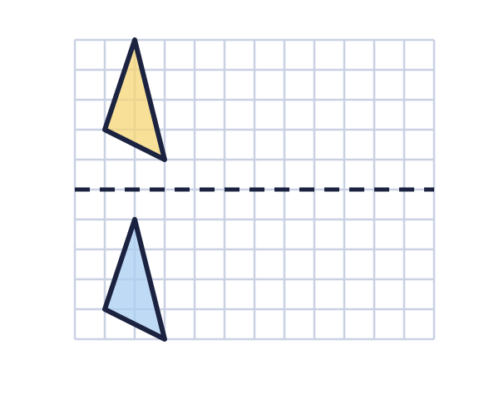  a) Is shape B a correct reflection of A? Write yes or no.  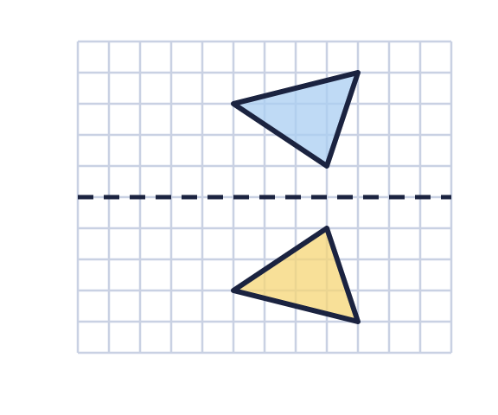  b) Is shape B a correct reflection of A? Write yes or no.
  1 | Shape B should be the reflection of shape A in the dashed mirror line. Is each reflection correct?  a) Is shape B a correct reflection of A? Write yes or no.  b) Is shape B a correct reflection of A? Write yes or no.
  2 | Reflect triangle ABC in the dashed mirror line. Draw the reflection in your book. Then write the coordinates of the corners A' and C' of the new triangle.  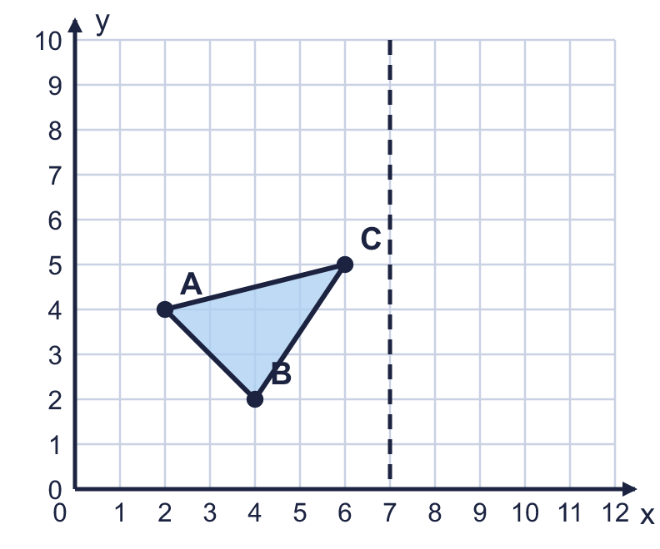  a) Write the coordinates of A'.  b) Write the coordinates of C'.
  2 | Reflect triangle ABC in the dashed mirror line. Draw the reflection in your book. Then write the coordinates of the corners A' and C' of the new triangle.  a) Write the coordinates of A'.  b) Write the coordinates of C'.
  3 | Reflect triangle ABC in the dashed mirror line. Draw the reflection in your book. Then write the coordinates of the corners A' and C' of the new triangle.  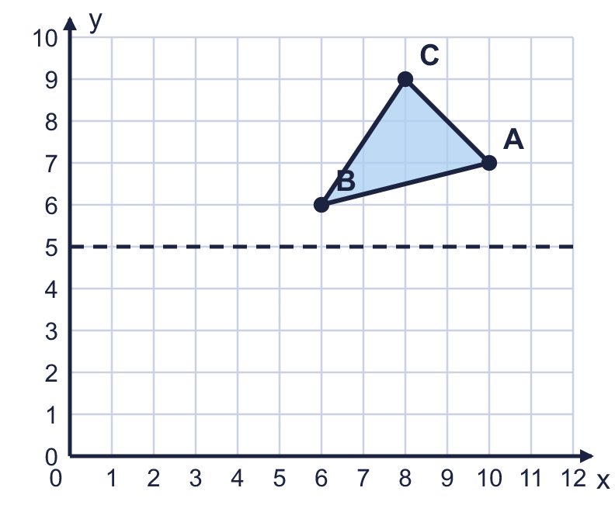  a) Write the coordinates of A'.  b) Write the coordinates of C'.
  3 | Reflect triangle ABC in the dashed mirror line. Draw the reflection in your book. Then write the coordinates of the corners A' and C' of the new triangle.  a) Write the coordinates of A'.  b) Write the coordinates of C'.
  4 | One corner of triangle ABC is on the mirror line. Reflect the triangle in the mirror line. Draw the reflection in your book. Then write the coordinates of A' and C'.  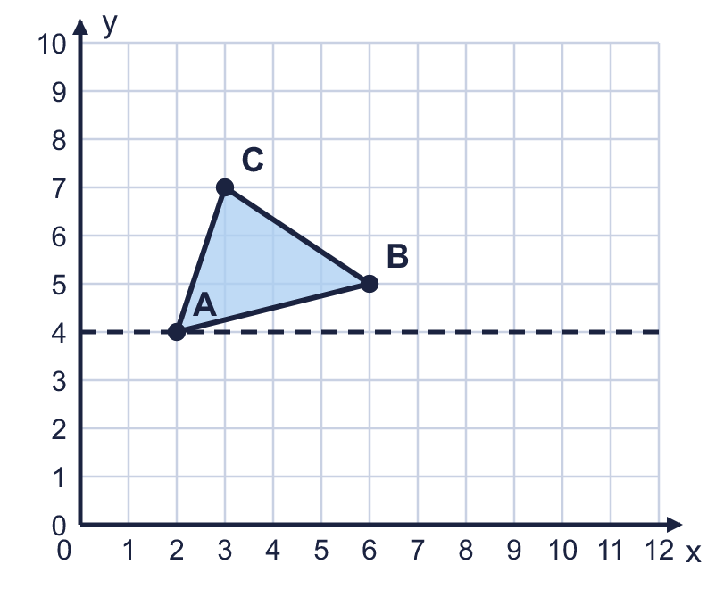  a) Write the coordinates of A'.  b) Write the coordinates of C'.
  4 | One corner of triangle ABC is on the mirror line. Reflect the triangle in the mirror line. Draw the reflection in your book. Then write the coordinates of A' and C'.  a) Write the coordinates of A'.  b) Write the coordinates of C'.
  5 | Reflect the shaded squares in the mirror line. Shade the squares of the reflection.  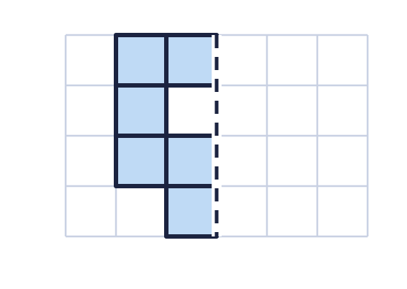  a) How many squares are shaded altogether when you have finished?
  5 | Reflect the shaded squares in the mirror line. Shade the squares of the reflection.  a) How many squares are shaded altogether when you have finished?
  6 | Write the coordinates of each point after it is reflected in the mirror line.  a) The point (1, 9) is reflected in the horizontal mirror line y = 5.  b) The point (2, 5) is reflected in the vertical mirror line x = 8.
  6 | Write the coordinates of each point after it is reflected in the mirror line.  a) The point (1, 9) is reflected in the horizontal mirror line y = 5.  b) The point (2, 5) is reflected in the vertical mirror line x = 8.
  7 | Triangle ABC is reflected in the dashed mirror line. Look at corner A.  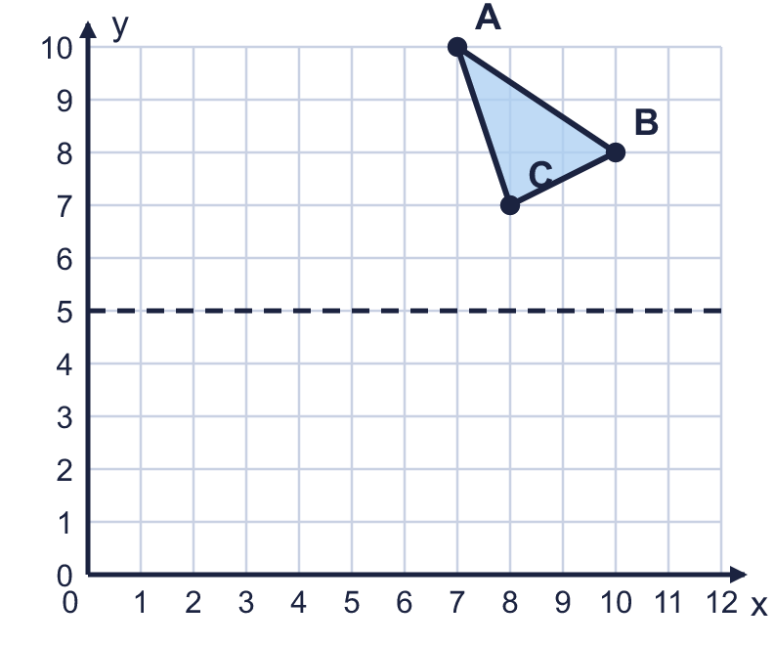  a) How many squares is A from the mirror line?  b) How many squares is A' (the reflection of A) from the mirror line?  c) Write the coordinates of A'.
  7 | Triangle ABC is reflected in the dashed mirror line. Look at corner A.  a) How many squares is A from the mirror line?  b) How many squares is A' (the reflection of A) from the mirror line?  c) Write the coordinates of A'.
  8 | The corners of a rectangle are at (2, 1), (6, 1), (6, 4), (2, 4). It is reflected in the vertical mirror line x = 8.  Write the coordinates of the corners of the reflection.
  8 | The corners of a rectangle are at (2, 1), (6, 1), (6, 4), (2, 4). It is reflected in the vertical mirror line x = 8.  Write the coordinates of the corners of the reflection.

  9 | Is Boba correct? Circle yes or no.  Yes / No  Explain how you know.
     | 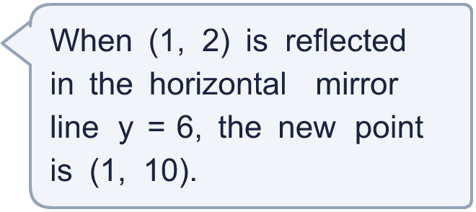
  9 | Is Boba correct? Circle yes or no.  Yes / No  Explain how you know.
  10 | The point (3, 4) is reflected in a horizontal mirror line. Its reflection is at (3, 6).  What is the equation of the mirror line? Write it like this: y = 3.
  10 | The point (3, 4) is reflected in a horizontal mirror line. Its reflection is at (3, 6).  What is the equation of the mirror line? Write it like this: y = 3.
  11 | The point (5, 2) is reflected in the vertical mirror line x = 6. The new point is then reflected in the horizontal mirror line y = 6.  Write the coordinates of the point at the end.
  11 | The point (5, 2) is reflected in the vertical mirror line x = 6. The new point is then reflected in the horizontal mirror line y = 6.  Write the coordinates of the point at the end.
  12 | The point (1, 7) is reflected in the vertical mirror line x = 6. Then it is translated 1 square left and 3 squares down.  Write the coordinates of the point at the end.
  12 | The point (1, 7) is reflected in the vertical mirror line x = 6. Then it is translated 1 square left and 3 squares down.  Write the coordinates of the point at the end.
  13 | A point is reflected in the vertical mirror line x = 4. After the reflection it is at (10, 7).  Where was the point before it was reflected? Write the coordinates.
  13 | A point is reflected in the vertical mirror line x = 4. After the reflection it is at (10, 7).  Where was the point before it was reflected? Write the coordinates.
  14 | Write three different points that stay in the same place when they are reflected in the horizontal mirror line y = 7.
  14 | Write three different points that stay in the same place when they are reflected in the horizontal mirror line y = 7.

Year 5 · Position and direction · Step 6
Reflection in horizontal and vertical lines
Answers (teacher copy)

  1 | Shape B should be the reflection of shape A in the dashed mirror line. Is each reflection correct?  a) Is shape B a correct reflection of A? Write yes or no. No  b) Is shape B a correct reflection of A? Write yes or no. Yes
  2 | Reflect triangle ABC in the dashed mirror line. Draw the reflection in your book. Then write the coordinates of the corners A' and C' of the new triangle.  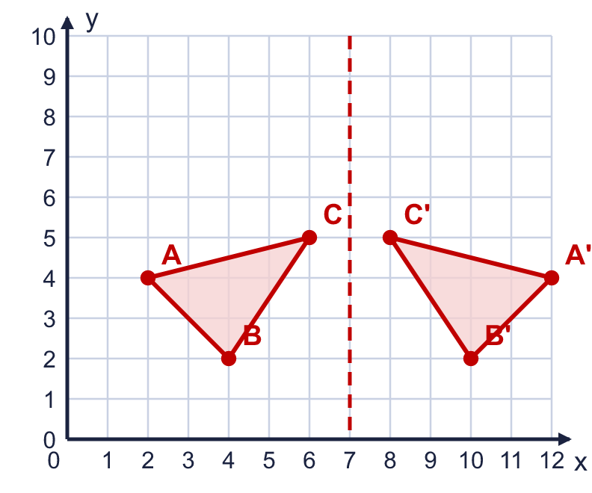  a) Write the coordinates of A'. (12, 4)  b) Write the coordinates of C'. (8, 5)
  3 | Reflect triangle ABC in the dashed mirror line. Draw the reflection in your book. Then write the coordinates of the corners A' and C' of the new triangle.  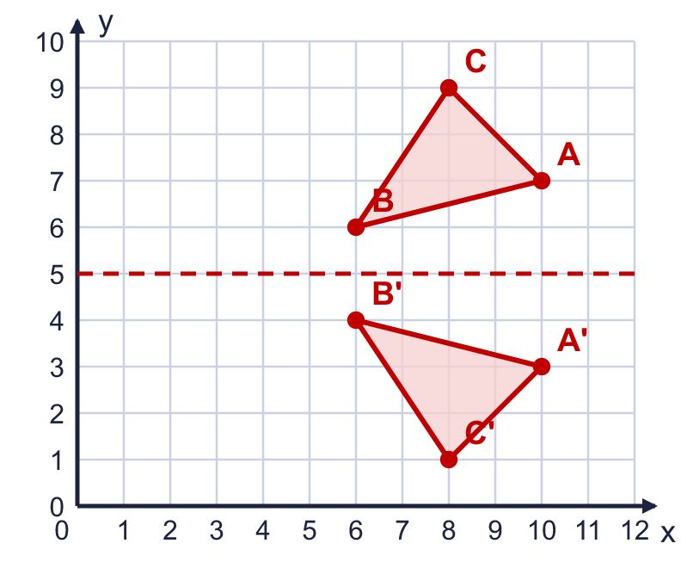  a) Write the coordinates of A'. (10, 3)  b) Write the coordinates of C'. (8, 1)
  4 | One corner of triangle ABC is on the mirror line. Reflect the triangle in the mirror line. Draw the reflection in your book. Then write the coordinates of A' and C'.  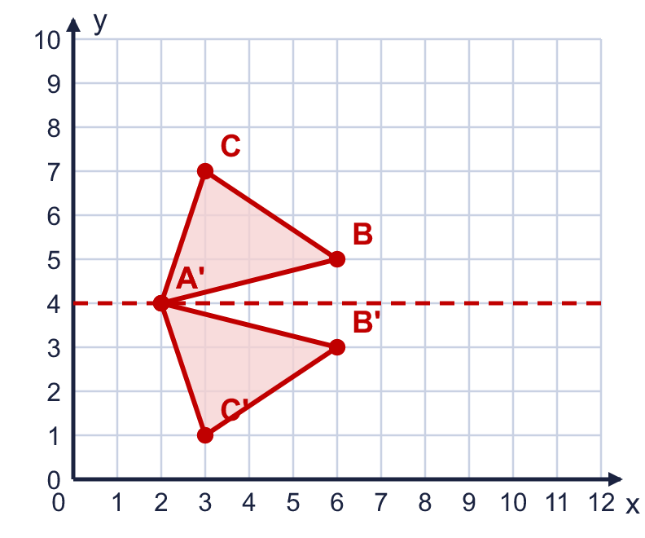  a) Write the coordinates of A'. (2, 4)  b) Write the coordinates of C'. (3, 1)
  5 | Reflect the shaded squares in the mirror line. Shade the squares of the reflection.  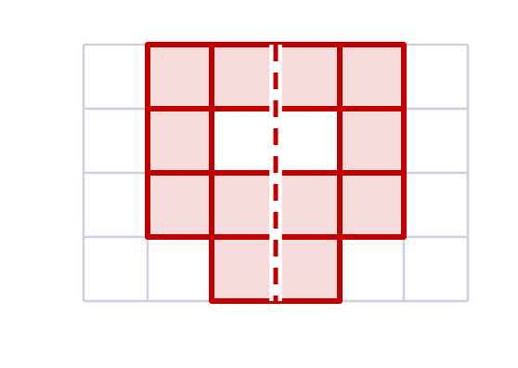  a) How many squares are shaded altogether when you have finished? 12
  6 | Write the coordinates of each point after it is reflected in the mirror line.  a) The point (1, 9) is reflected in the horizontal mirror line y = 5. (1, 1)  b) The point (2, 5) is reflected in the vertical mirror line x = 8. (14, 5)
  7 | Triangle ABC is reflected in the dashed mirror line. Look at corner A.  a) How many squares is A from the mirror line? 5  b) How many squares is A' (the reflection of A) from the mirror line? 5  c) Write the coordinates of A'. (7, 0)
  8 | The corners of a rectangle are at (2, 1), (6, 1), (6, 4), (2, 4). It is reflected in the vertical mirror line x = 8.  Write the coordinates of the corners of the reflection. (14, 1), (10, 1), (10, 4), (14, 4)
  9 | Is Boba correct? Circle yes or no.  Yes / No  Explain how you know.  (1, 2) is 4 squares from the mirror line, so its reflection is 4 squares on the other side of the line. The new point is (1, 10).
  10 | The point (3, 4) is reflected in a horizontal mirror line. Its reflection is at (3, 6).  What is the equation of the mirror line? Write it like this: y = 3. y = 5
  11 | The point (5, 2) is reflected in the vertical mirror line x = 6. The new point is then reflected in the horizontal mirror line y = 6.  Write the coordinates of the point at the end. (7, 10)
  12 | The point (1, 7) is reflected in the vertical mirror line x = 6. Then it is translated 1 square left and 3 squares down.  Write the coordinates of the point at the end. (10, 4)
  13 | A point is reflected in the vertical mirror line x = 4. After the reflection it is at (10, 7).  Where was the point before it was reflected? Write the coordinates. (−2, 7)
  14 | Write three different points that stay in the same place when they are reflected in the horizontal mirror line y = 7.  Any three different points on the mirror line, for example (2, 7), (6, 7), (10, 7)

