  Year 5 · Position and direction · Step 5  Lines of symmetry | 
  Year 5 · Position and direction · Step 5
  Lines of symmetry
  1 | A line of symmetry cuts a shape into two halves that are mirror images. Look at each shape and its dashed line.  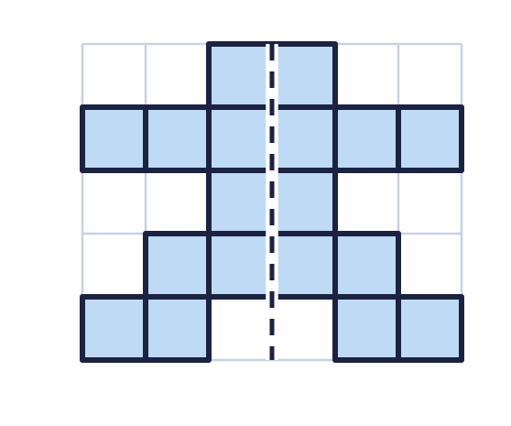  a) Is the dashed line a line of symmetry? Write yes or no.  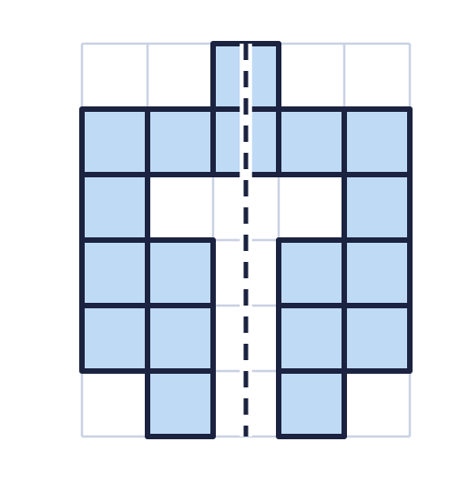  b) Is the dashed line a line of symmetry? Write yes or no.
  1 | A line of symmetry cuts a shape into two halves that are mirror images. Look at each shape and its dashed line.  a) Is the dashed line a line of symmetry? Write yes or no.  b) Is the dashed line a line of symmetry? Write yes or no.
  2 | The shape has a horizontal line of symmetry. A horizontal line goes across the page from left to right. Draw the line of symmetry on the shape.  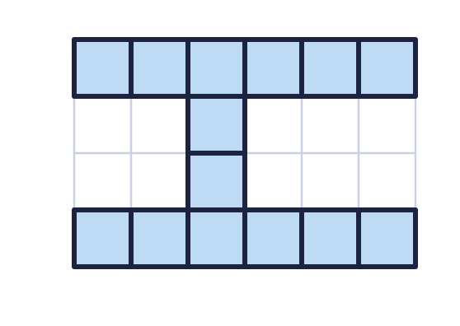  a) How many lines of symmetry does the shape have?
  2 | The shape has a horizontal line of symmetry. A horizontal line goes across the page from left to right. Draw the line of symmetry on the shape.  a) How many lines of symmetry does the shape have?
  3 | The shape has a vertical line of symmetry. A vertical line goes up and down the page. Draw the line of symmetry on the shape.  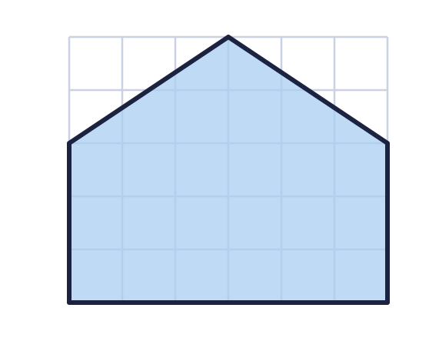  a) How many lines of symmetry does the shape have?
  3 | The shape has a vertical line of symmetry. A vertical line goes up and down the page. Draw the line of symmetry on the shape.  a) How many lines of symmetry does the shape have?
  4 | The shape has a horizontal line of symmetry and a vertical line of symmetry. Draw both lines on the shape.  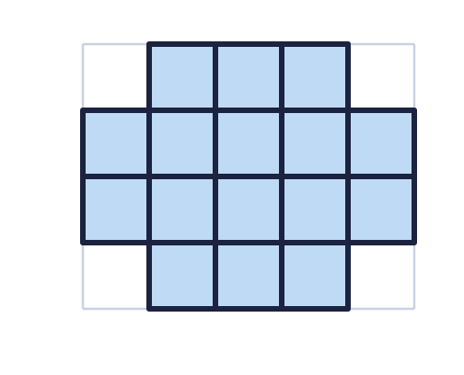  a) How many lines of symmetry does the shape have?
  4 | The shape has a horizontal line of symmetry and a vertical line of symmetry. Draw both lines on the shape.  a) How many lines of symmetry does the shape have?
  5 | Count the lines of symmetry of each shape. They are horizontal or vertical.  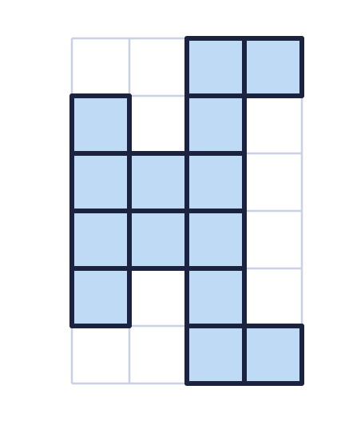  a) Shape A  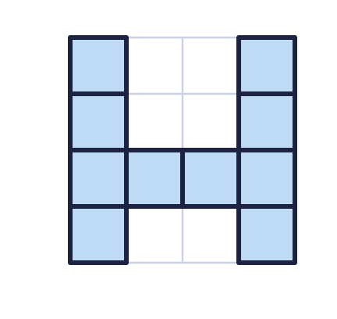  b) Shape B  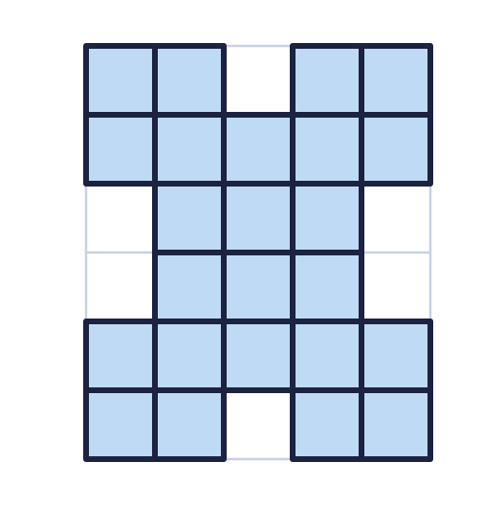  c) Shape C
  5 | Count the lines of symmetry of each shape. They are horizontal or vertical.  a) Shape A  b) Shape B  c) Shape C
  6 | The shape has a diagonal line of symmetry. A diagonal line goes from corner to corner of the square grid. Draw the line of symmetry on the shape.  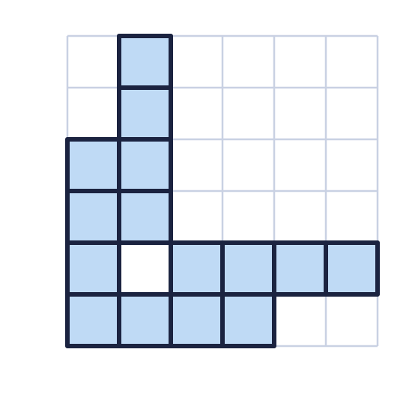  a) How many lines of symmetry does the shape have?
  6 | The shape has a diagonal line of symmetry. A diagonal line goes from corner to corner of the square grid. Draw the line of symmetry on the shape.  a) How many lines of symmetry does the shape have?
  7 | Count the lines of symmetry of each shape.  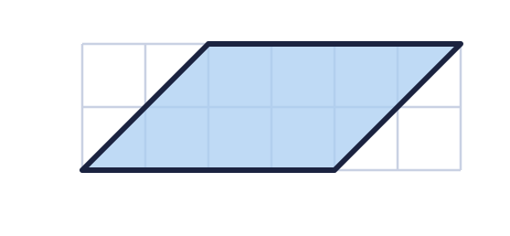  a) Shape A  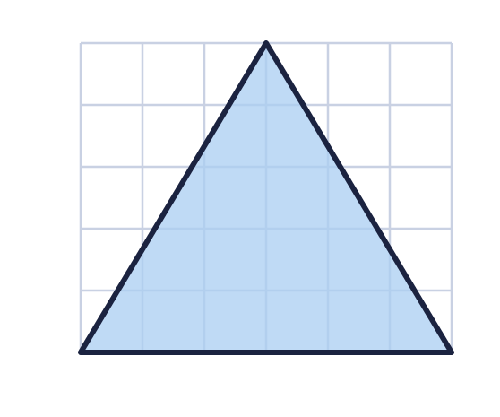  b) Shape B  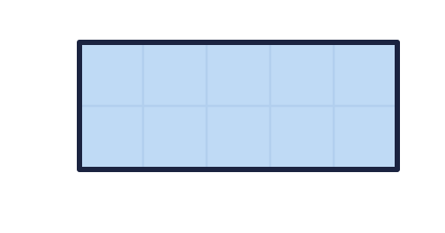  c) Shape C
  7 | Count the lines of symmetry of each shape.  a) Shape A  b) Shape B  c) Shape C
  8 | Two of these shapes have at least one line of symmetry. Which shape has no line of symmetry?  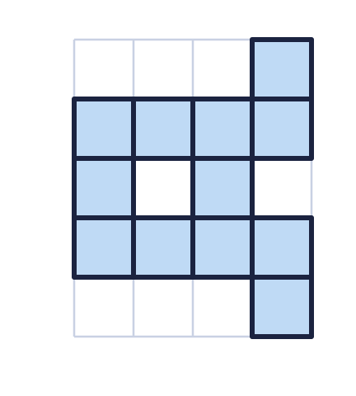  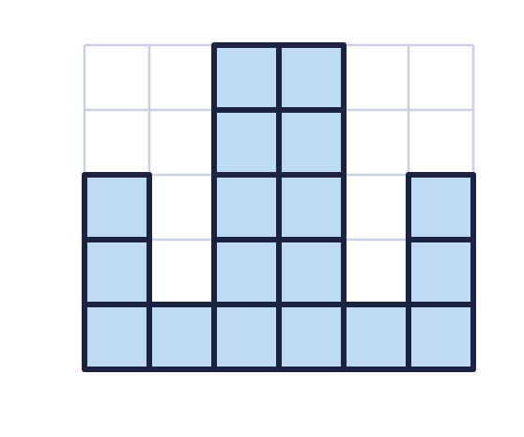  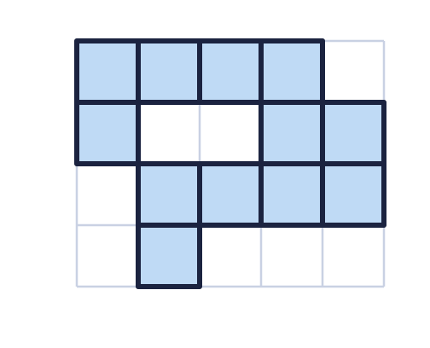
    The shape with no line of symmetry is shape
  8 | Two of these shapes have at least one line of symmetry. Which shape has no line of symmetry?
    The shape with no line of symmetry is shape

  9 | Look at the shape.  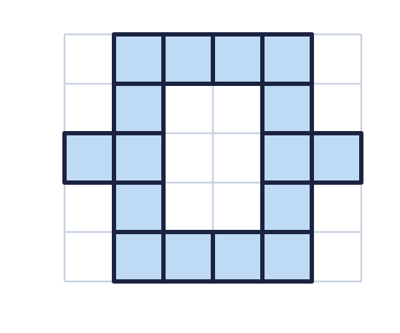  Is Boba correct? Circle yes or no.  Yes / No  Explain how you know.
     | 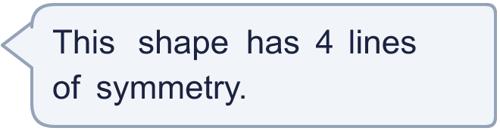
  9 | Look at the shape.  Is Boba correct? Circle yes or no.  Yes / No  Explain how you know.
  10 | Draw a shape on the grid that has a horizontal line of symmetry and a vertical line of symmetry. Shade whole squares. Compare with a partner.  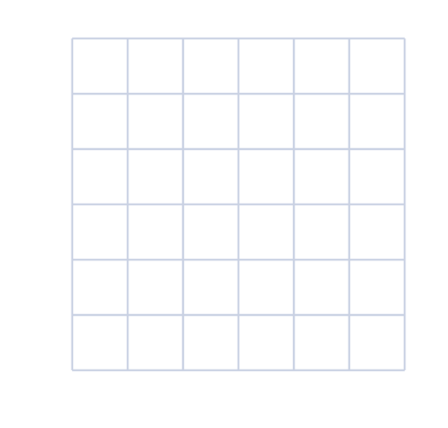
  10 | Draw a shape on the grid that has a horizontal line of symmetry and a vertical line of symmetry. Shade whole squares. Compare with a partner.
  11 | Shade one more square so that the shape has exactly one line of symmetry.  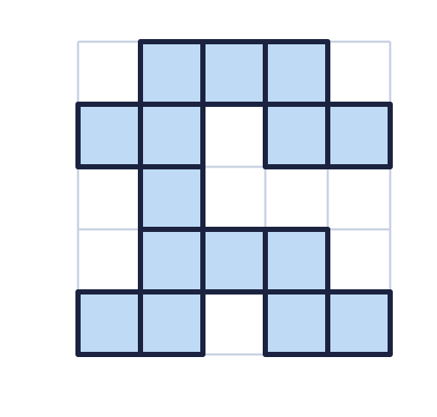  a) How many different squares could you shade to do this?
  11 | Shade one more square so that the shape has exactly one line of symmetry.  a) How many different squares could you shade to do this?
  12 | Draw a shape with five sides and exactly one line of symmetry. Use the grid. Compare with a partner.
  12 | Draw a shape with five sides and exactly one line of symmetry. Use the grid. Compare with a partner.
  13 | Draw a shape with six sides and a diagonal line of symmetry. Use the grid. Compare with a partner.
  13 | Draw a shape with six sides and a diagonal line of symmetry. Use the grid. Compare with a partner.
  14 | The dashed line is a line of symmetry. Complete the shape by shading the squares on the other side of the line.  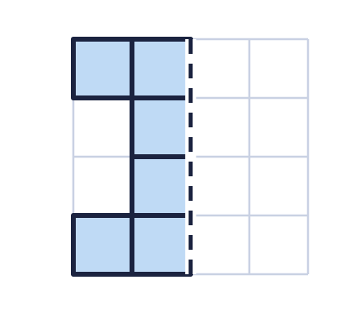  a) How many squares are shaded in the finished shape?
  14 | The dashed line is a line of symmetry. Complete the shape by shading the squares on the other side of the line.  a) How many squares are shaded in the finished shape?

Year 5 · Position and direction · Step 5
Lines of symmetry
Answers (teacher copy)

  1 | A line of symmetry cuts a shape into two halves that are mirror images. Look at each shape and its dashed line.  a) Is the dashed line a line of symmetry? Write yes or no. Yes  b) Is the dashed line a line of symmetry? Write yes or no. Yes
  2 | The shape has a horizontal line of symmetry. A horizontal line goes across the page from left to right. Draw the line of symmetry on the shape.  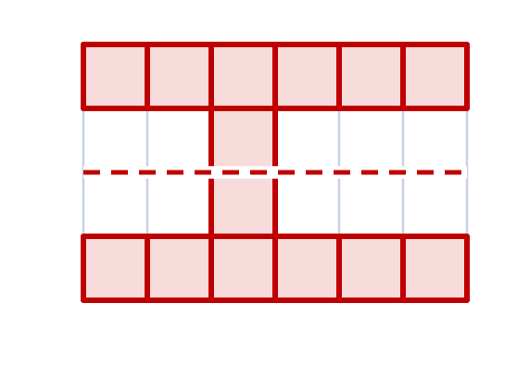  a) How many lines of symmetry does the shape have? 1
  3 | The shape has a vertical line of symmetry. A vertical line goes up and down the page. Draw the line of symmetry on the shape.  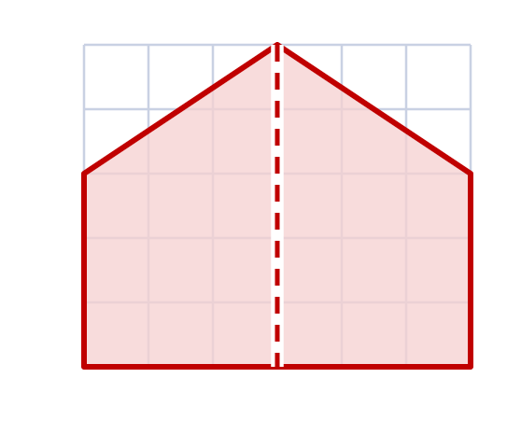  a) How many lines of symmetry does the shape have? 1
  4 | The shape has a horizontal line of symmetry and a vertical line of symmetry. Draw both lines on the shape.  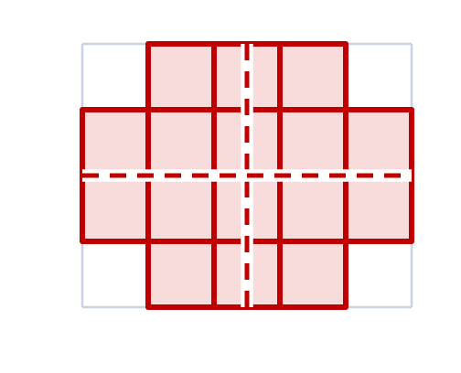  a) How many lines of symmetry does the shape have? 2
  5 | Count the lines of symmetry of each shape. They are horizontal or vertical.  a) Shape A 1  b) Shape B 1  c) Shape C 2
  6 | The shape has a diagonal line of symmetry. A diagonal line goes from corner to corner of the square grid. Draw the line of symmetry on the shape.  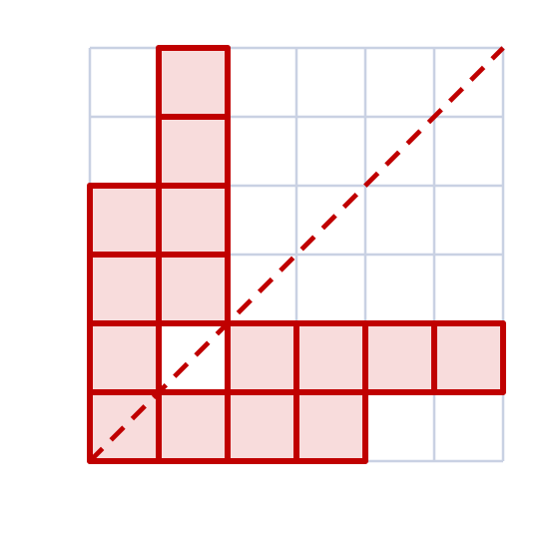  a) How many lines of symmetry does the shape have? 1
  7 | Count the lines of symmetry of each shape.  a) Shape A 0  b) Shape B 1  c) Shape C 2
  8 | Two of these shapes have at least one line of symmetry. Which shape has no line of symmetry?  The shape with no line of symmetry is shape C
  9 | Look at the shape.  Is Boba correct? Circle yes or no.  Yes / No  Explain how you know.  The shape has a horizontal line of symmetry and a vertical line of symmetry. It has 2 lines of symmetry. A diagonal line is not a line of symmetry because the two halves do not match.
  10 | Draw a shape on the grid that has a horizontal line of symmetry and a vertical line of symmetry. Shade whole squares. Compare with a partner.  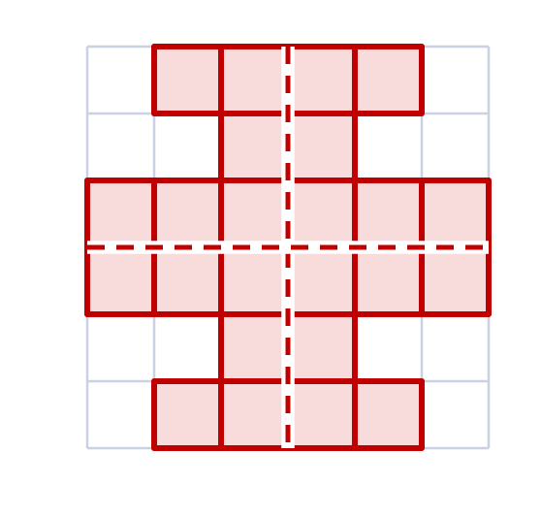  Any shape of shaded squares with a horizontal and a vertical line of symmetry, for example the one in the picture
  11 | Shade one more square so that the shape has exactly one line of symmetry.  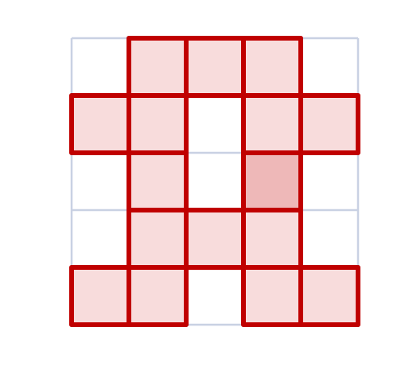  a) How many different squares could you shade to do this? 1
  12 | Draw a shape with five sides and exactly one line of symmetry. Use the grid. Compare with a partner.  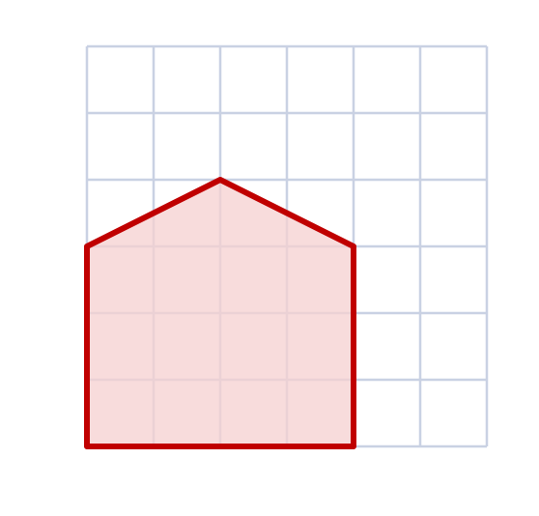  Any shape with five sides and exactly one line of symmetry, for example the one in the picture
  13 | Draw a shape with six sides and a diagonal line of symmetry. Use the grid. Compare with a partner.  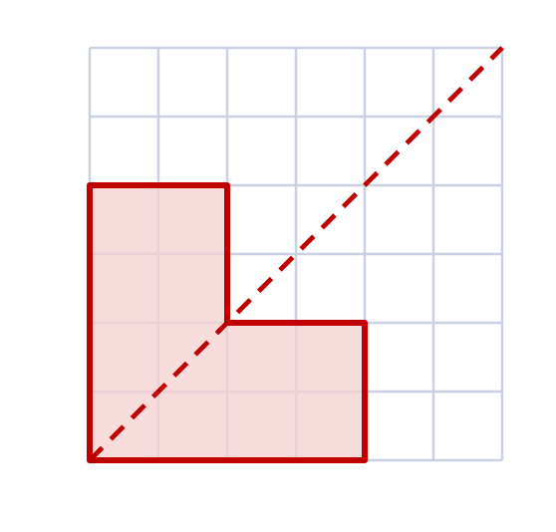  Any shape with six sides and a diagonal line of symmetry, for example the one in the picture
  14 | The dashed line is a line of symmetry. Complete the shape by shading the squares on the other side of the line.  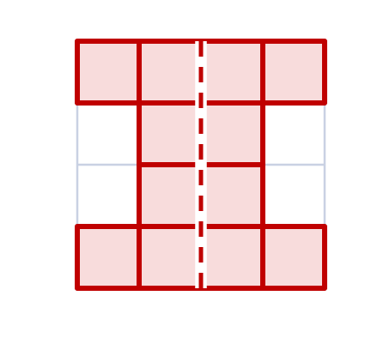  a) How many squares are shaded in the finished shape? 12

