  Year 5 · Negative numbers · Step 1  Understand negative numbers | 
  Year 5 · Negative numbers · Step 1
  Understand negative numbers
  1 | The buttons in a lift show the floors −3, −2, −1, 0, 1, 2, 3, 4 and 5. Floor 0 is the ground floor. Work out which floor each person is on now.  a) Amir is on floor 1 and goes down 5 floors. Which floor is Amir on now?  b) Tommy is on floor −1 and goes up 4 floors. Which floor is Tommy on now?  c) Ella is on floor 0 and goes down 3 floors. Which floor is Ella on now?
  1 | The buttons in a lift show the floors −3, −2, −1, 0, 1, 2, 3, 4 and 5. Floor 0 is the ground floor. Work out which floor each person is on now.  a) Amir is on floor 1 and goes down 5 floors. Which floor is Amir on now?  b) Tommy is on floor −1 and goes up 4 floors. Which floor is Tommy on now?  c) Ella is on floor 0 and goes down 3 floors. Which floor is Ella on now?
  2 | The number line is a thermometer. Write the temperature that each arrow points to.  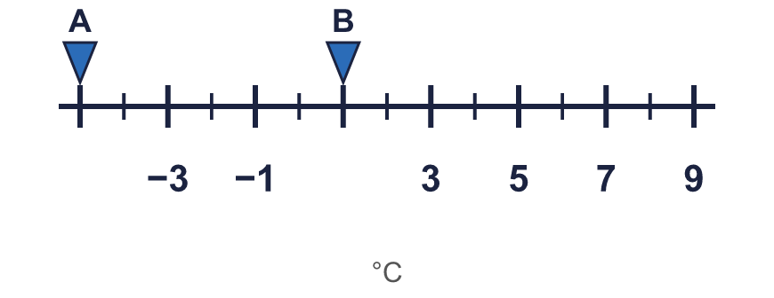
    A = |  | °C B = |  | °C
  2 | The number line is a thermometer. Write the temperature that each arrow points to.
    A = |  | °C B = |  | °C
  3 | Here are the temperatures in five cities: 2 °C, −4 °C, 10 °C, −1 °C, −9 °C.
    What is the warmest temperature?
    °C
    What is the coldest temperature?
    °C
  3 | Here are the temperatures in five cities: 2 °C, −4 °C, 10 °C, −1 °C, −9 °C.
    What is the warmest temperature?
    °C
    What is the coldest temperature?
    °C
  4 | Write the missing numbers in the boxes on the number line.  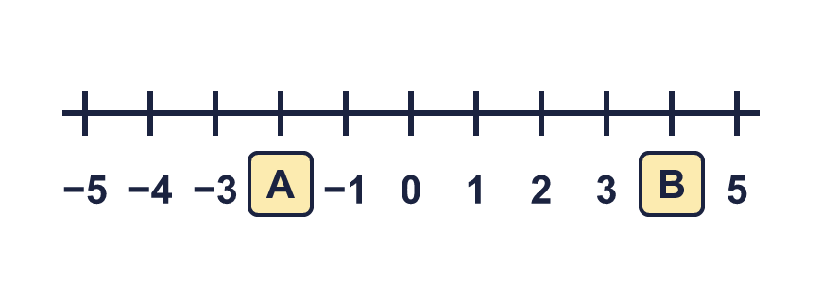
    A = |  | B =
  4 | Write the missing numbers in the boxes on the number line.
    A = |  | B =
  5 | Write each of these as a number. Use a minus sign when it is below zero.
    a) 5 °C below zero =
    b) 8 m above sea level =
    c) 2 floors below the ground floor =
  5 | Write each of these as a number. Use a minus sign when it is below zero.
    a) 5 °C below zero =
    b) 8 m above sea level =
    c) 2 floors below the ground floor =
  6 | The temperature in Oslo is −7 °C. The temperature in Lima is −4 °C.
    What is the lower (colder) temperature?
    °C
    What is the higher (warmer) temperature?
    °C
  6 | The temperature in Oslo is −7 °C. The temperature in Lima is −4 °C.
    What is the lower (colder) temperature?
    °C
    What is the higher (warmer) temperature?
    °C
  7 | Work out the new temperatures.  a) At 6 am the temperature was −3 °C. By noon it had risen by 9 degrees. What was the temperature at noon? °C  b) At noon the temperature was 4 °C. By midnight it had fallen by 8 degrees. What was the temperature at midnight? °C
  7 | Work out the new temperatures.  a) At 6 am the temperature was −3 °C. By noon it had risen by 9 degrees. What was the temperature at noon? °C  b) At noon the temperature was 4 °C. By midnight it had fallen by 8 degrees. What was the temperature at midnight? °C
  8 | A lift goes from floor −3 to floor 3.
    How many floors does the lift go up?
    floors
  8 | A lift goes from floor −3 to floor 3.
    How many floors does the lift go up?
    floors

  9 | −3 and −7 are temperatures in °C.  Is Boba correct? Circle yes or no.  Yes / No  Explain how you know.
     | 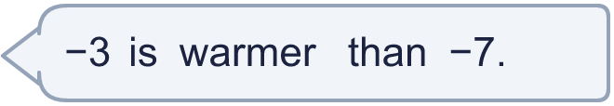
  9 | −3 and −7 are temperatures in °C.  Is Boba correct? Circle yes or no.  Yes / No  Explain how you know.
  10 | Mo is on floor −3. Alex is on floor 3. Sam is on a floor between Mo and Alex.  Write all the floors that Sam could be on.
  10 | Mo is on floor −3. Alex is on floor 3. Sam is on a floor between Mo and Alex.  Write all the floors that Sam could be on.
  11 | The temperature in Halifax is −5 °C. The temperature in London is warmer than in Halifax, but colder than freezing point (0 °C).  Write all the whole-number temperatures that London could be.
  11 | The temperature in Halifax is −5 °C. The temperature in London is warmer than in Halifax, but colder than freezing point (0 °C).  Write all the whole-number temperatures that London could be.
  12 | A bird flies 5 m above sea level. A diver is 4 m below sea level. An octopus is 7 m below sea level.
    How many metres is the diver below the bird?
    m
    How many metres is the octopus below the diver?
    m
  12 | A bird flies 5 m above sea level. A diver is 4 m below sea level. An octopus is 7 m below sea level.
    How many metres is the diver below the bird?
    m
    How many metres is the octopus below the diver?
    m
  13 | A fish is swimming at −3 m. It swims down another 4 m.  Is Boba correct? Circle yes or no.  Yes / No  Explain the mistake. Then write the correct answer.
    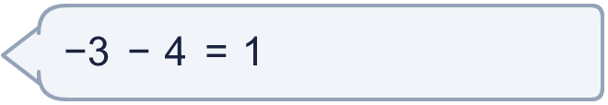
  13 | A fish is swimming at −3 m. It swims down another 4 m.  Is Boba correct? Circle yes or no.  Yes / No  Explain the mistake. Then write the correct answer.
  14 | I am thinking of a number. It is greater than −6 and less than 0. It is a multiple of 2.  Write all the numbers I could be thinking of.
  14 | I am thinking of a number. It is greater than −6 and less than 0. It is a multiple of 2.  Write all the numbers I could be thinking of.

Year 5 · Negative numbers · Step 1
Understand negative numbers
Answers (teacher copy)

  1 | The buttons in a lift show the floors −3, −2, −1, 0, 1, 2, 3, 4 and 5. Floor 0 is the ground floor. Work out which floor each person is on now.  a) Amir is on floor 1 and goes down 5 floors. Which floor is Amir on now? −4  b) Tommy is on floor −1 and goes up 4 floors. Which floor is Tommy on now? 3  c) Ella is on floor 0 and goes down 3 floors. Which floor is Ella on now? −3
  2 | The number line is a thermometer. Write the temperature that each arrow points to.  A = −5 °C B = 1 °C
  3 | Here are the temperatures in five cities: 2 °C, −4 °C, 10 °C, −1 °C, −9 °C.  What is the warmest temperature? 10 °C  What is the coldest temperature? −9 °C
  4 | Write the missing numbers in the boxes on the number line.  A = −2 B = 4
  5 | Write each of these as a number. Use a minus sign when it is below zero.  a) 5 °C below zero = −5  b) 8 m above sea level = 8  c) 2 floors below the ground floor = −2
  6 | The temperature in Oslo is −7 °C. The temperature in Lima is −4 °C.  What is the lower (colder) temperature? −7 °C  What is the higher (warmer) temperature? −4 °C
  7 | Work out the new temperatures.  a) At 6 am the temperature was −3 °C. By noon it had risen by 9 degrees. What was the temperature at noon? 6 °C  b) At noon the temperature was 4 °C. By midnight it had fallen by 8 degrees. What was the temperature at midnight? −4 °C
  8 | A lift goes from floor −3 to floor 3.  How many floors does the lift go up? 6 floors
  9 | −3 and −7 are temperatures in °C.  Is Boba correct? Circle yes or no.  Yes / No  Explain how you know.  Yes. −3 is to the right of −7 on a number line, so −3 is greater (warmer) than −7.
  10 | Mo is on floor −3. Alex is on floor 3. Sam is on a floor between Mo and Alex.  Write all the floors that Sam could be on.  −2, −1, 0, 1, 2
  11 | The temperature in Halifax is −5 °C. The temperature in London is warmer than in Halifax, but colder than freezing point (0 °C).  Write all the whole-number temperatures that London could be.  −4, −3, −2, −1
  12 | A bird flies 5 m above sea level. A diver is 4 m below sea level. An octopus is 7 m below sea level.  How many metres is the diver below the bird? 9 m  How many metres is the octopus below the diver? 3 m
  13 | A fish is swimming at −3 m. It swims down another 4 m.  Is Boba correct? Circle yes or no.  Yes / No  Explain the mistake. Then write the correct answer.  No. Down means a smaller number, so you move to the left on the number line, not to the right. The correct answer is −7.  −7
  14 | I am thinking of a number. It is greater than −6 and less than 0. It is a multiple of 2.  Write all the numbers I could be thinking of.  −4, −2

