  Year 5 · Negative numbers · Step 5  Find the difference | 
  Year 5 · Negative numbers · Step 5
  Find the difference
  1 | Use the number line to find each difference. Count the jumps.  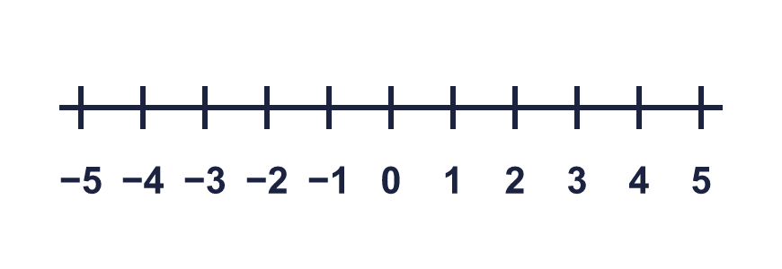
    a) The difference between 5 and −4 is
    b) The difference between −5 and 1 is
    c) The difference between 3 and −1 is
  1 | Use the number line to find each difference. Count the jumps.
    a) The difference between 5 and −4 is
    b) The difference between −5 and 1 is
    c) The difference between 3 and −1 is
  2 | How many jumps are there from each number to 0 on a number line?
    a) from −8 to 0: |  | jumps
    b) from 1 to 0: |  | jumps
    c) from 8 to 0: |  | jumps
    d) from −1 to 0: |  | jumps
  2 | How many jumps are there from each number to 0 on a number line?
    a) from −8 to 0: |  | jumps
    b) from 1 to 0: |  | jumps
    c) from 8 to 0: |  | jumps
    d) from −1 to 0: |  | jumps
  3 | Tiny finds the difference between 6 and −5 by jumping to zero.
    How many jumps from 6 to 0?
    jumps
    How many jumps from 0 to −5?
    jumps
    What is the difference between 6 and −5?
  3 | Tiny finds the difference between 6 and −5 by jumping to zero.
    How many jumps from 6 to 0?
    jumps
    How many jumps from 0 to −5?
    jumps
    What is the difference between 6 and −5?
  4 | Use the number line to find each difference. Jump to zero and then on.  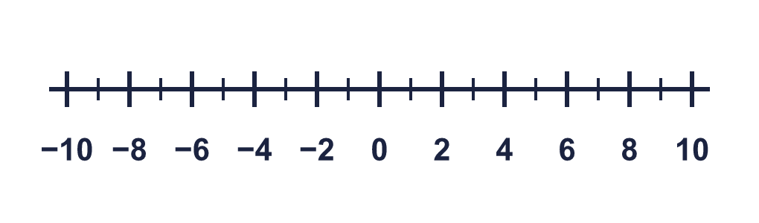
    a) The difference between −4 and 9 is
    b) The difference between −2 and 1 is
    c) The difference between 8 and −6 is
    d) The difference between −6 and 7 is
  4 | Use the number line to find each difference. Jump to zero and then on.
    a) The difference between −4 and 9 is
    b) The difference between −2 and 1 is
    c) The difference between 8 and −6 is
    d) The difference between −6 and 7 is
  5 | Find the difference between each pair of numbers.
    a) The difference between 89 and −11 is
    b) The difference between 26 and −33 is
    c) The difference between 105 and −13 is
    d) The difference between 65 and −74 is
  5 | Find the difference between each pair of numbers.
    a) The difference between 89 and −11 is
    b) The difference between 26 and −33 is
    c) The difference between 105 and −13 is
    d) The difference between 65 and −74 is
  6 | The average temperature in July is 27 °C. The average temperature in January is −6 °C.
    What is the difference between the average temperatures?
    °C
  6 | The average temperature in July is 27 °C. The average temperature in January is −6 °C.
    What is the difference between the average temperatures?
    °C
  7 | Mr Rose parks his car on floor −2 of a building. He goes up 8 floors in a lift to his office. He then goes down 2 floors for a meeting.
    How many floors does Mr Rose need to go down to get back to his car?
    floors
  7 | Mr Rose parks his car on floor −2 of a building. He goes up 8 floors in a lift to his office. He then goes down 2 floors for a meeting.
    How many floors does Mr Rose need to go down to get back to his car?
    floors
  8 | A bird is flying 9 m above sea level. A fish is swimming 8 m below sea level.
    How many metres is the bird above the fish?
    m
  8 | A bird is flying 9 m above sea level. A fish is swimming 8 m below sea level.
    How many metres is the bird above the fish?
    m

  9 | Ron and Annie are comparing the differences between two pairs of numbers.  Pair A: −9 and −7 Pair B: 4 and −8
    Which pair has the greater difference? Write A or B.
  9 | Ron and Annie are comparing the differences between two pairs of numbers.  Pair A: −9 and −7 Pair B: 4 and −8
    Which pair has the greater difference? Write A or B.
  10 | Ron is finding the difference between 6 and −5.  Is Boba correct? Circle yes or no.  Yes / No  Explain the mistake. Then write the correct difference.
    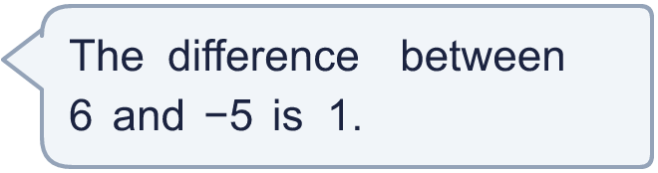
  10 | Ron is finding the difference between 6 and −5.  Is Boba correct? Circle yes or no.  Yes / No  Explain the mistake. Then write the correct difference.
  11 | A lift starts on floor −3. It goes up 10 floors and then down 4 floors.
    How many floors is the lift from where it started?
    floors
  11 | A lift starts on floor −3. It goes up 10 floors and then down 4 floors.
    How many floors is the lift from where it started?
    floors
  12 | The highest temperature in a week was 17 °C. The lowest temperature was −5 °C.
    What is the difference between the highest and lowest temperatures?
    °C
  12 | The highest temperature in a week was 17 °C. The lowest temperature was −5 °C.
    What is the difference between the highest and lowest temperatures?
    °C
  13 | A helicopter is flying 109 m above sea level. A submarine is 67 m below sea level.
    How far apart are the helicopter and the submarine?
    m
  13 | A helicopter is flying 109 m above sea level. A submarine is 67 m below sea level.
    How far apart are the helicopter and the submarine?
    m
  14 | Two numbers have a difference of 7. One of the numbers is −4.  What could the other number be? Write both possible answers.
  14 | Two numbers have a difference of 7. One of the numbers is −4.  What could the other number be? Write both possible answers.

Year 5 · Negative numbers · Step 5
Find the difference
Answers (teacher copy)

  1 | Use the number line to find each difference. Count the jumps.  a) The difference between 5 and −4 is 9  b) The difference between −5 and 1 is 6  c) The difference between 3 and −1 is 4
  2 | How many jumps are there from each number to 0 on a number line?  a) from −8 to 0: 8 jumps  b) from 1 to 0: 1 jumps  c) from 8 to 0: 8 jumps  d) from −1 to 0: 1 jumps
  3 | Tiny finds the difference between 6 and −5 by jumping to zero.  How many jumps from 6 to 0? 6 jumps  How many jumps from 0 to −5? 5 jumps  What is the difference between 6 and −5? 11
  4 | Use the number line to find each difference. Jump to zero and then on.  a) The difference between −4 and 9 is 13  b) The difference between −2 and 1 is 3  c) The difference between 8 and −6 is 14  d) The difference between −6 and 7 is 13
  5 | Find the difference between each pair of numbers.  a) The difference between 89 and −11 is 100  b) The difference between 26 and −33 is 59  c) The difference between 105 and −13 is 118  d) The difference between 65 and −74 is 139
  6 | The average temperature in July is 27 °C. The average temperature in January is −6 °C.  What is the difference between the average temperatures? 33 °C
  7 | Mr Rose parks his car on floor −2 of a building. He goes up 8 floors in a lift to his office. He then goes down 2 floors for a meeting.  How many floors does Mr Rose need to go down to get back to his car? 6 floors
  8 | A bird is flying 9 m above sea level. A fish is swimming 8 m below sea level.  How many metres is the bird above the fish? 17 m
  9 | Ron and Annie are comparing the differences between two pairs of numbers.  Pair A: −9 and −7 Pair B: 4 and −8  Which pair has the greater difference? Write A or B. B
  10 | Ron is finding the difference between 6 and −5.  Is Boba correct? Circle yes or no.  Yes / No  Explain the mistake. Then write the correct difference.  No. Ron took 5 away from 6. The numbers are on opposite sides of zero, so you add the jumps: 6 + 5 = 11.  11
  11 | A lift starts on floor −3. It goes up 10 floors and then down 4 floors.  How many floors is the lift from where it started? 6 floors
  12 | The highest temperature in a week was 17 °C. The lowest temperature was −5 °C.  What is the difference between the highest and lowest temperatures? 22 °C
  13 | A helicopter is flying 109 m above sea level. A submarine is 67 m below sea level.  How far apart are the helicopter and the submarine? 176 m
  14 | Two numbers have a difference of 7. One of the numbers is −4.  What could the other number be? Write both possible answers.  −11, 3

