  Year 5 · Negative numbers · Step 3  Count through zero in multiples | 
  Year 5 · Negative numbers · Step 3
  Count through zero in multiples
  1 | The numbers go up or down in equal steps. Work out the missing numbers.  −50, −40, ?, −20, ?, ?, 10
    The missing numbers are
  1 | The numbers go up or down in equal steps. Work out the missing numbers.  −50, −40, ?, −20, ?, ?, 10
    The missing numbers are
  2 | Write the missing numbers in the boxes on the number line.  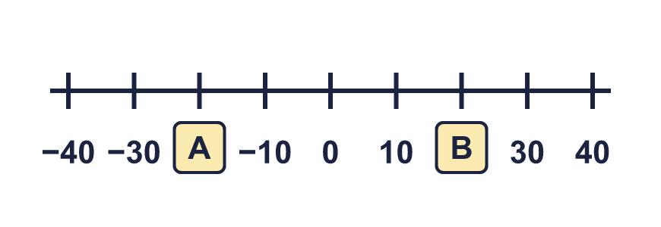
    A = |  | B =
  2 | Write the missing numbers in the boxes on the number line.
    A = |  | B =
  3 | Write the next three numbers in each sequence.
    a) −2, 0, 2, 4, 6,
    b) 2, 0, −2, −4, −6,
    c) −8, −4, 0, 4, 8,
    d) 10, 5, 0, −5, −10,
  3 | Write the next three numbers in each sequence.
    a) −2, 0, 2, 4, 6,
    b) 2, 0, −2, −4, −6,
    c) −8, −4, 0, 4, 8,
    d) 10, 5, 0, −5, −10,
  4 | A diver is swimming at −6 m. The surface of the water is 0 m. The diver goes up 2 m every minute.
    How many minutes does the diver take to reach the surface?
    minutes
  4 | A diver is swimming at −6 m. The surface of the water is 0 m. The diver goes up 2 m every minute.
    How many minutes does the diver take to reach the surface?
    minutes
  5 | Write the rule for each sequence. Write it like this: add 2 or subtract 2.
    a) −3, 0, 3, 6, …
    b) 4, 2, 0, −2, …
    c) −8, −4, 0, 4, …
    d) 4, 0, −4, −8, …
  5 | Write the rule for each sequence. Write it like this: add 2 or subtract 2.
    a) −3, 0, 3, 6, …
    b) 4, 2, 0, −2, …
    c) −8, −4, 0, 4, …
    d) 4, 0, −4, −8, …
  6 | Write the next three numbers in the sequence.  18, 12, 6, 0, −6,
    The next three numbers are
  6 | Write the next three numbers in the sequence.  18, 12, 6, 0, −6,
    The next three numbers are
  7 | The first number in the sequence is missing. Write it in.  ?, −6, −4, −2, 0, 2, …
    The first number is
  7 | The first number in the sequence is missing. Write it in.  ?, −6, −4, −2, 0, 2, …
    The first number is
  8 | At 6 pm the temperature is 8 °C. It falls by 3 degrees every hour.  What is the temperature after 3 hours? °C
  8 | At 6 pm the temperature is 8 °C. It falls by 3 degrees every hour.  What is the temperature after 3 hours? °C

  9 | Eva is counting back in 4s from 11.  Is Boba correct? Circle yes or no.  Yes / No  Explain the mistake. Then write the correct numbers from the mistake onwards.
     | 
    The correct numbers are
  9 | Eva is counting back in 4s from 11.  Is Boba correct? Circle yes or no.  Yes / No  Explain the mistake. Then write the correct numbers from the mistake onwards.
    The correct numbers are
  10 | Write the next three numbers in each sequence.
    a) 11, 7, 3,
    b) −11, −7, −3,
    c) 9, 5, 1,
    d) −5, −3, −1,
  10 | Write the next three numbers in each sequence.
    a) 11, 7, 3,
    b) −11, −7, −3,
    c) 9, 5, 1,
    d) −5, −3, −1,
  11 | Teddy counts forwards in 4s from −13. Dora counts backwards in 3s from 5. They stop when they reach each other's starting number.  Which numbers will they both say?
  11 | Teddy counts forwards in 4s from −13. Dora counts backwards in 3s from 5. They stop when they reach each other's starting number.  Which numbers will they both say?
  12 | Jack is counting back in 5s. He says:  16, 11, 6, …
    What is the first negative number that Jack will say?
  12 | Jack is counting back in 5s. He says:  16, 11, 6, …
    What is the first negative number that Jack will say?
  13 | The temperature is −20 °C at 6 am. It rises by 4 degrees every hour.
    How many hours until the temperature is 8 °C?
    hours
  13 | The temperature is −20 °C at 6 am. It rises by 4 degrees every hour.
    How many hours until the temperature is 8 °C?
    hours
  14 | Count forwards in 4s.  −12, −8, −4, 0,
    Write the next five numbers.
  14 | Count forwards in 4s.  −12, −8, −4, 0,
    Write the next five numbers.

Year 5 · Negative numbers · Step 3
Count through zero in multiples
Answers (teacher copy)

  1 | The numbers go up or down in equal steps. Work out the missing numbers.  −50, −40, ?, −20, ?, ?, 10  The missing numbers are −30, −10, 0
  2 | Write the missing numbers in the boxes on the number line.  A = −20 B = 20
  3 | Write the next three numbers in each sequence.  a) −2, 0, 2, 4, 6, 8, 10, 12  b) 2, 0, −2, −4, −6, −8, −10, −12  c) −8, −4, 0, 4, 8, 12, 16, 20  d) 10, 5, 0, −5, −10, −15, −20, −25
  4 | A diver is swimming at −6 m. The surface of the water is 0 m. The diver goes up 2 m every minute.  How many minutes does the diver take to reach the surface? 3 minutes
  5 | Write the rule for each sequence. Write it like this: add 2 or subtract 2.  a) −3, 0, 3, 6, … add 3  b) 4, 2, 0, −2, … subtract 2  c) −8, −4, 0, 4, … add 4  d) 4, 0, −4, −8, … subtract 4
  6 | Write the next three numbers in the sequence.  18, 12, 6, 0, −6,  The next three numbers are −12, −18, −24
  7 | The first number in the sequence is missing. Write it in.  ?, −6, −4, −2, 0, 2, …  The first number is −8
  8 | At 6 pm the temperature is 8 °C. It falls by 3 degrees every hour.  What is the temperature after 3 hours? −1 °C
  9 | Eva is counting back in 4s from 11.  Is Boba correct? Circle yes or no.  Yes / No  Explain the mistake. Then write the correct numbers from the mistake onwards.  No. 3 − 4 = −1, not 0. Eva counted 0 as one of the 4 steps. Count back the whole 4 from 3.  The correct numbers are −1, −5
  10 | Write the next three numbers in each sequence.  a) 11, 7, 3, −1, −5, −9  b) −11, −7, −3, 1, 5, 9  c) 9, 5, 1, −3, −7, −11  d) −5, −3, −1, 1, 3, 5
  11 | Teddy counts forwards in 4s from −13. Dora counts backwards in 3s from 5. They stop when they reach each other's starting number.  Which numbers will they both say?  −13, −1
  12 | Jack is counting back in 5s. He says:  16, 11, 6, …  What is the first negative number that Jack will say? −4
  13 | The temperature is −20 °C at 6 am. It rises by 4 degrees every hour.  How many hours until the temperature is 8 °C? 7 hours
  14 | Count forwards in 4s.  −12, −8, −4, 0,  Write the next five numbers. 4, 8, 12, 16, 20

