  Year 5 · Negative numbers · Step 2  Count through zero in 1s | 
  Year 5 · Negative numbers · Step 2
  Count through zero in 1s
  1 | The numbers go up or down in 1s. Work out the missing numbers.  6, ?, 4, ?, 2, 1, ?, −1, −2
    The missing numbers are
  1 | The numbers go up or down in 1s. Work out the missing numbers.  6, ?, 4, ?, 2, 1, ?, −1, −2
    The missing numbers are
  2 | Write the missing numbers in the boxes on the number line.  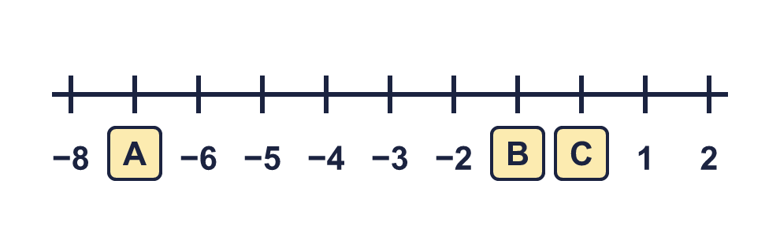
    A = |  | B = |  | C =
  2 | Write the missing numbers in the boxes on the number line.
    A = |  | B = |  | C =
  3 | What numbers are the arrows pointing to?  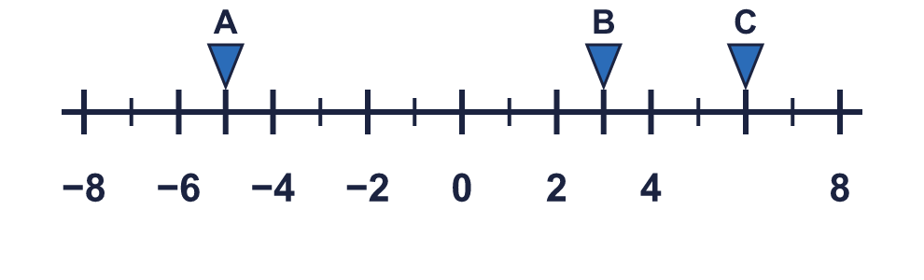
    A = |  | B = |  | C =
  3 | What numbers are the arrows pointing to?
    A = |  | B = |  | C =
  4 | Write the next four numbers in each sequence.
    a) 8, 7, 6, 5,
    b) −6, −5, −4, −3,
    c) −3, −4, −5, −6,
    d) −28, −27, −26, −25,
  4 | Write the next four numbers in each sequence.
    a) 8, 7, 6, 5,
    b) −6, −5, −4, −3,
    c) −3, −4, −5, −6,
    d) −28, −27, −26, −25,
  5 | Work out the temperatures.  a) On Thursday it is 3 °C in Moscow. On Saturday it is 7 degrees colder. What is the temperature on Saturday? °C  b) On Thursday it is −2 °C in Stockholm. On Saturday it is 4 degrees warmer. What is the temperature on Saturday? °C
  5 | Work out the temperatures.  a) On Thursday it is 3 °C in Moscow. On Saturday it is 7 degrees colder. What is the temperature on Saturday? °C  b) On Thursday it is −2 °C in Stockholm. On Saturday it is 4 degrees warmer. What is the temperature on Saturday? °C
  6 | A diver is swimming at −8 m. The surface of the water is 0 m. The diver swims up 1 m every second.
    How many seconds does it take to reach the surface?
    seconds
  6 | A diver is swimming at −8 m. The surface of the water is 0 m. The diver swims up 1 m every second.
    How many seconds does it take to reach the surface?
    seconds
  7 | The temperature in Paris is 7 °C. The temperature in Glasgow is −1 °C. The temperature in London is halfway between them.
    What is the temperature in London?
    °C
  7 | The temperature in Paris is 7 °C. The temperature in Glasgow is −1 °C. The temperature in London is halfway between them.
    What is the temperature in London?
    °C
  8 | Write the rule for the sequence. Write it like this: add 2 or subtract 2.  4, 3, 2, 1, …
    The rule is
  8 | Write the rule for the sequence. Write it like this: add 2 or subtract 2.  4, 3, 2, 1, …
    The rule is

  9 | Whitney is counting on from −2.  Is Boba correct? Circle yes or no.  Yes / No  Explain the mistake. Then write the number that was missed.
     | 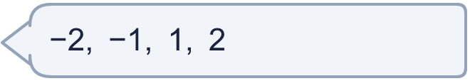
    The number that was missed is
  9 | Whitney is counting on from −2.  Is Boba correct? Circle yes or no.  Yes / No  Explain the mistake. Then write the number that was missed.
    The number that was missed is
  10 | Whitney is counting back in 1s. These are the numbers she says:  2, 1, 0, −2, −1  She has put some numbers in the wrong order. Write the numbers in the correct order, counting back.
  10 | Whitney is counting back in 1s. These are the numbers she says:  2, 1, 0, −2, −1  She has put some numbers in the wrong order. Write the numbers in the correct order, counting back.
  11 | A fish is swimming at −2 m. It swims down another 2 m. Tiny says that it is now at 0 m.  Is Boba correct? Circle yes or no.  Yes / No  Explain the mistake. Then write the correct answer.
    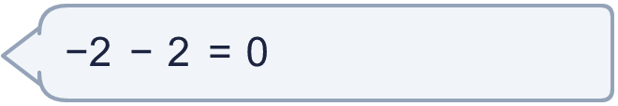
  11 | A fish is swimming at −2 m. It swims down another 2 m. Tiny says that it is now at 0 m.  Is Boba correct? Circle yes or no.  Yes / No  Explain the mistake. Then write the correct answer.
  12 | Write the next four numbers in each sequence.
    a) −9, −10, −11, −12,
    b) 8, 7, 6, 5,
  12 | Write the next four numbers in each sequence.
    a) −9, −10, −11, −12,
    b) 8, 7, 6, 5,
  13 | The temperature is −9 °C at 6 am. It rises by 3 degrees every hour.
    How many hours until the temperature is 0 °C?
    hours
    How many hours until the temperature is 6 °C?
    hours
  13 | The temperature is −9 °C at 6 am. It rises by 3 degrees every hour.
    How many hours until the temperature is 0 °C?
    hours
    How many hours until the temperature is 6 °C?
    hours
  14 | A lift is on floor −2. It goes up 1 floor at a time until it reaches floor 3.
    How many floors does the lift stop at after floor −2?
    floors
  14 | A lift is on floor −2. It goes up 1 floor at a time until it reaches floor 3.
    How many floors does the lift stop at after floor −2?
    floors

Year 5 · Negative numbers · Step 2
Count through zero in 1s
Answers (teacher copy)

  1 | The numbers go up or down in 1s. Work out the missing numbers.  6, ?, 4, ?, 2, 1, ?, −1, −2  The missing numbers are 5, 3, 0
  2 | Write the missing numbers in the boxes on the number line.  A = −7 B = −1 C = 0
  3 | What numbers are the arrows pointing to?  A = −5 B = 3 C = 6
  4 | Write the next four numbers in each sequence.  a) 8, 7, 6, 5, 4, 3, 2, 1  b) −6, −5, −4, −3, −2, −1, 0, 1  c) −3, −4, −5, −6, −7, −8, −9, −10  d) −28, −27, −26, −25, −24, −23, −22, −21
  5 | Work out the temperatures.  a) On Thursday it is 3 °C in Moscow. On Saturday it is 7 degrees colder. What is the temperature on Saturday? −4 °C  b) On Thursday it is −2 °C in Stockholm. On Saturday it is 4 degrees warmer. What is the temperature on Saturday? 2 °C
  6 | A diver is swimming at −8 m. The surface of the water is 0 m. The diver swims up 1 m every second.  How many seconds does it take to reach the surface? 8 seconds
  7 | The temperature in Paris is 7 °C. The temperature in Glasgow is −1 °C. The temperature in London is halfway between them.  What is the temperature in London? 3 °C
  8 | Write the rule for the sequence. Write it like this: add 2 or subtract 2.  4, 3, 2, 1, …  The rule is subtract 1
  9 | Whitney is counting on from −2.  Is Boba correct? Circle yes or no.  Yes / No  Explain the mistake. Then write the number that was missed.  No. The count missed out 0. 0 comes between 1 and −1.  The number that was missed is 0
  10 | Whitney is counting back in 1s. These are the numbers she says:  2, 1, 0, −2, −1  She has put some numbers in the wrong order. Write the numbers in the correct order, counting back.  2, 1, 0, −1, −2
  11 | A fish is swimming at −2 m. It swims down another 2 m. Tiny says that it is now at 0 m.  Is Boba correct? Circle yes or no.  Yes / No  Explain the mistake. Then write the correct answer.  No. Swimming down means the number gets smaller, so the fish is further below zero. How do you know Tiny must be wrong? 0 is higher than −2. The correct answer is −4.  −4
  12 | Write the next four numbers in each sequence.  a) −9, −10, −11, −12, −13, −14, −15, −16  b) 8, 7, 6, 5, 4, 3, 2, 1
  13 | The temperature is −9 °C at 6 am. It rises by 3 degrees every hour.  How many hours until the temperature is 0 °C? 3 hours  How many hours until the temperature is 6 °C? 5 hours
  14 | A lift is on floor −2. It goes up 1 floor at a time until it reaches floor 3.  How many floors does the lift stop at after floor −2? 5 floors

