  Year 5 · Negative numbers · Step 4  Compare and order negative numbers | 
  Year 5 · Negative numbers · Step 4
  Compare and order negative numbers
  1 | Write < or > in each box. Numbers to the right on a number line are greater.
    a) 8 |  | 2
    b) 4 |  | 2
    c) 7 |  | 3
  1 | Write < or > in each box. Numbers to the right on a number line are greater.
    a) 8 |  | 2
    b) 4 |  | 2
    c) 7 |  | 3
  2 | Write < or > to compare the temperatures.
    a) 2 °C |  | 4 °C
    b) 3 °C |  | 4 °C
    c) −3 °C |  | −5 °C
  2 | Write < or > to compare the temperatures.
    a) 2 °C |  | 4 °C
    b) 3 °C |  | 4 °C
    c) −3 °C |  | −5 °C
  3 | Write < or > in each box. Use the number line to help you.  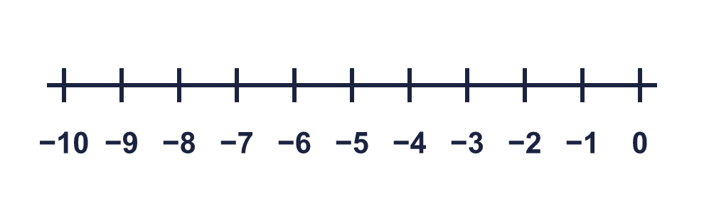
    a) −2 |  | −6
    b) −3 |  | −1
    c) −1 |  | −9
  3 | Write < or > in each box. Use the number line to help you.
    a) −2 |  | −6
    b) −3 |  | −1
    c) −1 |  | −9
  4 | Write < or > in each box.
    a) 2 |  | 1
    b) −2 |  | 9
    c) −7 |  | 2
  4 | Write < or > in each box.
    a) 2 |  | 1
    b) −2 |  | 9
    c) −7 |  | 2
  5 | Use the number line to write the numbers in order, starting with the smallest.  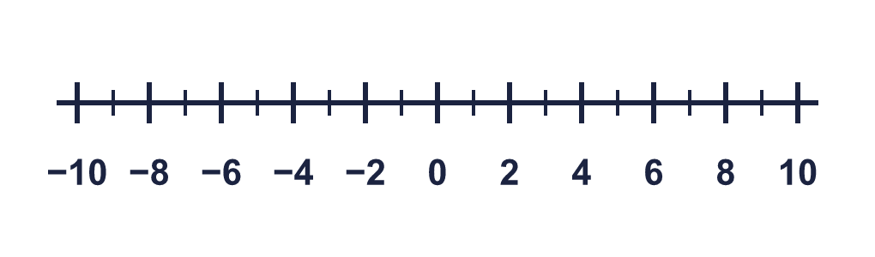  −9, 5, 0, −5, 8
  5 | Use the number line to write the numbers in order, starting with the smallest.  −9, 5, 0, −5, 8
  6 | Order the temperatures, starting with the warmest.  12 °C, 0 °C, −15 °C, −5 °C, 7 °C
  6 | Order the temperatures, starting with the warmest.  12 °C, 0 °C, −15 °C, −5 °C, 7 °C
  7 | Look at the numbers −7 and −6.
    Which number is greater?
    Which number is less?
  7 | Look at the numbers −7 and −6.
    Which number is greater?
    Which number is less?
  8 | Write all the whole numbers that are greater than −4 and less than 4.
  8 | Write all the whole numbers that are greater than −4 and less than 4.

  9 | Tiny is ordering these numbers, starting with the greatest: −3, −9, −8, 2, −7, −6.  Is Boba correct? Circle yes or no.  Yes / No  Explain the mistake. Then write the numbers in the correct order.
    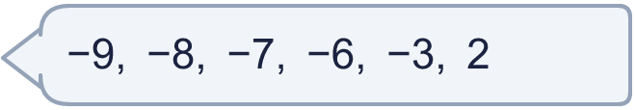
  9 | Tiny is ordering these numbers, starting with the greatest: −3, −9, −8, 2, −7, −6.  Is Boba correct? Circle yes or no.  Yes / No  Explain the mistake. Then write the numbers in the correct order.
  10 | Dora, Amir and Jo are each thinking of a number. Dora says: "My number is the second multiple of 3." Amir says: "My number is negative 2." Jo says: "My number is less than Dora's, but greater than Amir's."  What numbers could Jo be thinking of? Find all the possible answers.
  10 | Dora, Amir and Jo are each thinking of a number. Dora says: "My number is the second multiple of 3." Amir says: "My number is negative 2." Jo says: "My number is less than Dora's, but greater than Amir's."  What numbers could Jo be thinking of? Find all the possible answers.
  11 | On Monday the temperature in London was 0 °C and in Rome it was −3 °C. On Tuesday London is 5 degrees colder than on Monday and Rome is 5 degrees warmer than on Monday. On Tuesday the temperature in Paris is warmer than London, but colder than Rome.  What whole-number temperatures could Paris be? Find all the possible answers.
  11 | On Monday the temperature in London was 0 °C and in Rome it was −3 °C. On Tuesday London is 5 degrees colder than on Monday and Rome is 5 degrees warmer than on Monday. On Tuesday the temperature in Paris is warmer than London, but colder than Rome.  What whole-number temperatures could Paris be? Find all the possible answers.
  12 | Write all the even whole numbers that are greater than −9 and less than −1.
  12 | Write all the even whole numbers that are greater than −9 and less than −1.
  13 | Order the temperatures, starting with the coldest.  −5 °C, 25 °C, −25 °C, 0 °C, 10 °C
  13 | Order the temperatures, starting with the coldest.  −5 °C, 25 °C, −25 °C, 0 °C, 10 °C
  14 | Look at −6 and −2.  Is Boba correct? Circle yes or no.  Yes / No  Explain how you know.
     | 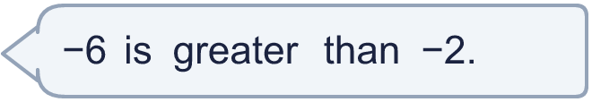
  14 | Look at −6 and −2.  Is Boba correct? Circle yes or no.  Yes / No  Explain how you know.

Year 5 · Negative numbers · Step 4
Compare and order negative numbers
Answers (teacher copy)

  1 | Write < or > in each box. Numbers to the right on a number line are greater.  a) 8 > 2  b) 4 > 2  c) 7 > 3
  2 | Write < or > to compare the temperatures.  a) 2 °C < 4 °C  b) 3 °C < 4 °C  c) −3 °C > −5 °C
  3 | Write < or > in each box. Use the number line to help you.  a) −2 > −6  b) −3 < −1  c) −1 > −9
  4 | Write < or > in each box.  a) 2 > 1  b) −2 < 9  c) −7 < 2
  5 | Use the number line to write the numbers in order, starting with the smallest.  −9, 5, 0, −5, 8  −9, −5, 0, 5, 8
  6 | Order the temperatures, starting with the warmest.  12 °C, 0 °C, −15 °C, −5 °C, 7 °C  12 °C, 7 °C, 0 °C, −5 °C, −15 °C
  7 | Look at the numbers −7 and −6.  Which number is greater? −6  Which number is less? −7
  8 | Write all the whole numbers that are greater than −4 and less than 4.  −3, −2, −1, 0, 1, 2, 3
  9 | Tiny is ordering these numbers, starting with the greatest: −3, −9, −8, 2, −7, −6.  Is Boba correct? Circle yes or no.  Yes / No  Explain the mistake. Then write the numbers in the correct order.  No. The numbers were put in order of the size of their digits and the minus signs were ignored. A negative number is less than 0, so −7 is less than −2.  2, −3, −6, −7, −8, −9
  10 | Dora, Amir and Jo are each thinking of a number. Dora says: "My number is the second multiple of 3." Amir says: "My number is negative 2." Jo says: "My number is less than Dora's, but greater than Amir's."  What numbers could Jo be thinking of? Find all the possible answers.  −1, 0, 1, 2, 3, 4, 5
  11 | On Monday the temperature in London was 0 °C and in Rome it was −3 °C. On Tuesday London is 5 degrees colder than on Monday and Rome is 5 degrees warmer than on Monday. On Tuesday the temperature in Paris is warmer than London, but colder than Rome.  What whole-number temperatures could Paris be? Find all the possible answers.  −4, −3, −2, −1, 0, 1
  12 | Write all the even whole numbers that are greater than −9 and less than −1.  −8, −6, −4, −2
  13 | Order the temperatures, starting with the coldest.  −5 °C, 25 °C, −25 °C, 0 °C, 10 °C  −25 °C, −5 °C, 0 °C, 10 °C, 25 °C
  14 | Look at −6 and −2.  Is Boba correct? Circle yes or no.  Yes / No  Explain how you know.  No. On a number line −6 is to the left of −2, so −6 is less than −2.

