  Year 5 · Decimals · Step 1  Use known facts to add and subtract decimals within 1 | 
  Year 5 · Decimals · Step 1
  Use known facts to add and subtract decimals within 1
  1 | Each hundred square is worth 1. The pink squares show one number and the yellow squares show another. Write the addition that the hundred square shows.  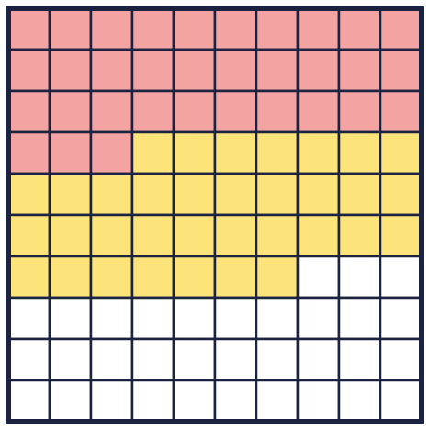
    pink + yellow = |  | + |  | =
  1 | Each hundred square is worth 1. The pink squares show one number and the yellow squares show another. Write the addition that the hundred square shows.
    pink + yellow = |  | + |  | =
  2 | The hundred square shows 0.81. The yellow squares are taken away.  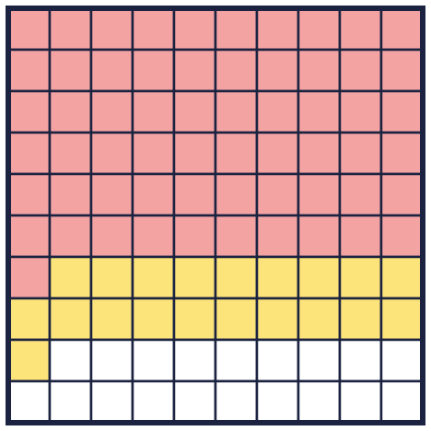
    0.81 − 0.2 =
  2 | The hundred square shows 0.81. The yellow squares are taken away.
    0.81 − 0.2 =
  3 | Use what you know about whole numbers to work out each calculation. 38 + 21 = 59, so 38 hundredths + 21 hundredths = 59 hundredths.
    a) 0.36 + 0.55 =
    b) 0.58 + 0.16 =
    c) 0.59 − 0.25 =
    d) 0.53 − 0.37 =
  3 | Use what you know about whole numbers to work out each calculation. 38 + 21 = 59, so 38 hundredths + 21 hundredths = 59 hundredths.
    a) 0.36 + 0.55 =
    b) 0.58 + 0.16 =
    c) 0.59 − 0.25 =
    d) 0.53 − 0.37 =
  4 | Work out each calculation. Take care to line up the tenths and the hundredths.
    a) 0.17 + 0.4 =
    b) 0.73 − 0.5 =
    c) 0.4 + 0.39 =
  4 | Work out each calculation. Take care to line up the tenths and the hundredths.
    a) 0.17 + 0.4 =
    b) 0.73 − 0.5 =
    c) 0.4 + 0.39 =
  5 | Ron has made a number on a place value chart.  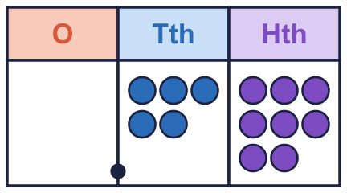
    a) What number has Ron made?
    b) What is 2 tenths more than Ron's number?
    c) What is 4 tenths less than Ron's number?
  5 | Ron has made a number on a place value chart.
    a) What number has Ron made?
    b) What is 2 tenths more than Ron's number?
    c) What is 4 tenths less than Ron's number?
  6 | Complete the calculations.
    a) 0.17 m + 0.45 m = |  | m
    b) 0.93 km − 0.48 km = |  | km
    c) 0.29 kg + 0.3 kg = |  | kg
  6 | Complete the calculations.
    a) 0.17 m + 0.45 m = |  | m
    b) 0.93 km − 0.48 km = |  | km
    c) 0.29 kg + 0.3 kg = |  | kg
  7 | Work out the amounts of money.
    a) £0.48 + £0.39 =
    b) £0.94 − £0.74 =
  7 | Work out the amounts of money.
    a) £0.48 + £0.39 =
    b) £0.94 − £0.74 =
  8 | Complete the calculations. What do you notice?
    a) 90 − 32 =
    b) 0.9 − 0.32 =
    c) 9 − 0.32 =
  8 | Complete the calculations. What do you notice?
    a) 90 − 32 =
    b) 0.9 − 0.32 =
    c) 9 − 0.32 =

  9 | Ron works out 0.5 + 0.22.  Is Boba correct? Circle yes or no.  Yes / No  Explain the mistake. Then write the correct answer.
    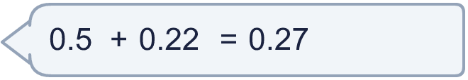
  9 | Ron works out 0.5 + 0.22.  Is Boba correct? Circle yes or no.  Yes / No  Explain the mistake. Then write the correct answer.
  10 | The mass of a box is 0.3 kg. The mass of a basket is 0.13 kg.  What is the total mass of the box and the basket? kg  How much heavier is the box than the basket? kg
  10 | The mass of a box is 0.3 kg. The mass of a basket is 0.13 kg.  What is the total mass of the box and the basket? kg  How much heavier is the box than the basket? kg
  11 | Write the missing number.
    a) 0.3 + |  | = 0.63
    b) |  | − 0.3 = 0.33
    c) 0.63 − |  | = 0.3
  11 | Write the missing number.
    a) 0.3 + |  | = 0.63
    b) |  | − 0.3 = 0.33
    c) 0.63 − |  | = 0.3
  12 | Which calculations give 0.71? Write the letters.  A: 0.91 − 0.2  B: 0.39 + 0.32  C: 0.18 + 0.63  D: 0.61 + 0.1
  12 | Which calculations give 0.71? Write the letters.  A: 0.91 − 0.2  B: 0.39 + 0.32  C: 0.18 + 0.63  D: 0.61 + 0.1
  13 | Write <, > or = in the box.
    0.59 + 0.25 |  | 0.9 − 0.2
  13 | Write <, > or = in the box.
    0.59 + 0.25 |  | 0.9 − 0.2
  14 | Challenge  Two decimals add up to 0.96. The difference between them is 0.2.
    The numbers are |  | and
  14 | Challenge  Two decimals add up to 0.96. The difference between them is 0.2.
    The numbers are |  | and

Year 5 · Decimals · Step 1
Use known facts to add and subtract decimals within 1
Answers (teacher copy)

  1 | Each hundred square is worth 1. The pink squares show one number and the yellow squares show another. Write the addition that the hundred square shows.  pink + yellow = 0.33 + 0.34 = 0.67
  2 | The hundred square shows 0.81. The yellow squares are taken away.  0.81 − 0.2 = 0.61
  3 | Use what you know about whole numbers to work out each calculation. 38 + 21 = 59, so 38 hundredths + 21 hundredths = 59 hundredths.  a) 0.36 + 0.55 = 0.91  b) 0.58 + 0.16 = 0.74  c) 0.59 − 0.25 = 0.34  d) 0.53 − 0.37 = 0.16
  4 | Work out each calculation. Take care to line up the tenths and the hundredths.  a) 0.17 + 0.4 = 0.57  b) 0.73 − 0.5 = 0.23  c) 0.4 + 0.39 = 0.79
  5 | Ron has made a number on a place value chart.  a) What number has Ron made? 0.58  b) What is 2 tenths more than Ron's number? 0.78  c) What is 4 tenths less than Ron's number? 0.18
  6 | Complete the calculations.  a) 0.17 m + 0.45 m = 0.62 m  b) 0.93 km − 0.48 km = 0.45 km  c) 0.29 kg + 0.3 kg = 0.59 kg
  7 | Work out the amounts of money.  a) £0.48 + £0.39 = £0.87  b) £0.94 − £0.74 = £0.20
  8 | Complete the calculations. What do you notice?  a) 90 − 32 = 58  b) 0.9 − 0.32 = 0.58  c) 9 − 0.32 = 8.68
  9 | Ron works out 0.5 + 0.22.  Is Boba correct? Circle yes or no.  Yes / No  Explain the mistake. Then write the correct answer.  No. 5 tenths is not 5 hundredths. Line up the tenths with the tenths: 0.50 + 0.22 = 0.72. The correct answer is 0.72.  0.72
  10 | The mass of a box is 0.3 kg. The mass of a basket is 0.13 kg.  What is the total mass of the box and the basket? 0.43 kg  How much heavier is the box than the basket? 0.17 kg
  11 | Write the missing number.  a) 0.3 + 0.33 = 0.63  b) 0.63 − 0.3 = 0.33  c) 0.63 − 0.33 = 0.3
  12 | Which calculations give 0.71? Write the letters.  A: 0.91 − 0.2  B: 0.39 + 0.32  C: 0.18 + 0.63  D: 0.61 + 0.1  A, B, D
  13 | Write <, > or = in the box.  0.59 + 0.25 > 0.9 − 0.2
  14 | Challenge  Two decimals add up to 0.96. The difference between them is 0.2.  The numbers are 0.58 and 0.38

