  Year 5 · Decimals · Step 10  Multiply by 10, 100 and 1,000 | 
  Year 5 · Decimals · Step 10
  Multiply by 10, 100 and 1,000
  1 | Each place value chart shows a number. Multiply the number by 10. Write the answer.  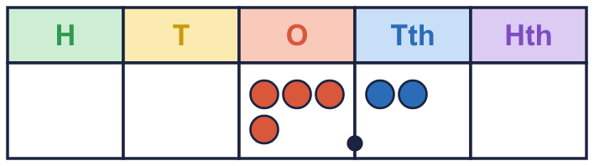  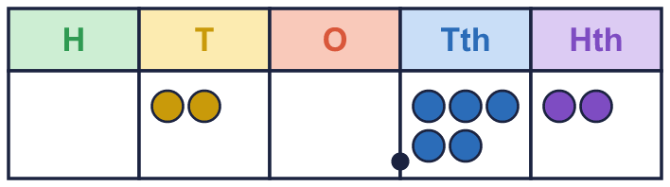
    a) the number × 10 =
    b) the number × 10 =
  1 | Each place value chart shows a number. Multiply the number by 10. Write the answer.
    a) the number × 10 =
    b) the number × 10 =
  2 | Work out each multiplication. Every digit moves 1 place to the left.
    a) 44.59 × 10 =
    b) 75.7 × 10 =
    c) 87.2 × 10 =
    d) 83.7 × 10 =
  2 | Work out each multiplication. Every digit moves 1 place to the left.
    a) 44.59 × 10 =
    b) 75.7 × 10 =
    c) 87.2 × 10 =
    d) 83.7 × 10 =
  3 | Each place value chart shows a number. Multiply the number by 100. Write the answer.  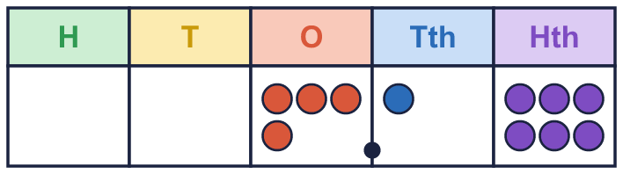  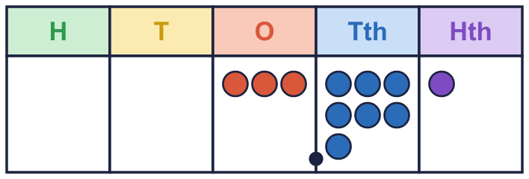
    a) the number × 100 =
    b) the number × 100 =
  3 | Each place value chart shows a number. Multiply the number by 100. Write the answer.
    a) the number × 100 =
    b) the number × 100 =
  4 | Work out each multiplication. Every digit moves 2 places to the left.
    a) 61.384 × 100 =
    b) 81.157 × 100 =
    c) 84.07 × 100 =
    d) 55.5 × 100 =
  4 | Work out each multiplication. Every digit moves 2 places to the left.
    a) 61.384 × 100 =
    b) 81.157 × 100 =
    c) 84.07 × 100 =
    d) 55.5 × 100 =
  5 | Work out each multiplication. Every digit moves 3 places to the left. You may need to write zeros.
    a) 2.5 × 1,000 =
    b) 2.24 × 1,000 =
    c) 8.9 × 1,000 =
  5 | Work out each multiplication. Every digit moves 3 places to the left. You may need to write zeros.
    a) 2.5 × 1,000 =
    b) 2.24 × 1,000 =
    c) 8.9 × 1,000 =
  6 | Complete the multiplications. What do you notice?
    a) 6.1 × 10 =
    b) 6.1 × 100 =
    c) 6.1 × 1,000 =
  6 | Complete the multiplications. What do you notice?
    a) 6.1 × 10 =
    b) 6.1 × 100 =
    c) 6.1 × 1,000 =
  7 | Complete the conversions. There are 100 cm in 1 m, 100 p in £1, 1,000 g in 1 kg and 1,000 ml in 1 l.
    a) 7.75 m = |  | cm
    b) £38.92 = |  | p
    c) 0.899 kg = |  | g
    d) 3.523 l = |  | ml
  7 | Complete the conversions. There are 100 cm in 1 m, 100 p in £1, 1,000 g in 1 kg and 1,000 ml in 1 l.
    a) 7.75 m = |  | cm
    b) £38.92 = |  | p
    c) 0.899 kg = |  | g
    d) 3.523 l = |  | ml
  8 | Write the missing number.
    a) 46.96 × |  | = 4,696
    b) 31.8 × |  | = 318
    c) 11.2 × |  | = 112
  8 | Write the missing number.
    a) 46.96 × |  | = 4,696
    b) 31.8 × |  | = 318
    c) 11.2 × |  | = 112

  9 | Tiny works out 1.6 × 1,000.  Is Boba correct? Circle yes or no.  Yes / No  Explain the mistake. Then write the correct answer.
    
  9 | Tiny works out 1.6 × 1,000.  Is Boba correct? Circle yes or no.  Yes / No  Explain the mistake. Then write the correct answer.
  10 | Tommy is 1.4 m tall. A tree is 10 times as tall as Tommy. A building is 100 times as tall as Tommy.  How much taller is the building than the tree? m
  10 | Tommy is 1.4 m tall. A tree is 10 times as tall as Tommy. A building is 100 times as tall as Tommy.  How much taller is the building than the tree? m
  11 | Which of these are equal to 290? Write the letters.  A: 29 × 10  B: 0.29 × 1,000  C: 2.9 × 100  D: 29 × 100
  11 | Which of these are equal to 290? Write the letters.  A: 29 × 10  B: 0.29 × 1,000  C: 2.9 × 100  D: 29 × 100
  12 | Write <, > or = in each box.
    a) 7.5 × 10 × 10 |  | 7.5 × 1,000
    b) 7.5 × 10 × 100 |  | 7.5 × 100
    c) 7.5 × 10 × 10 × 10
    7.5 × 1,000
  12 | Write <, > or = in each box.
    a) 7.5 × 10 × 10 |  | 7.5 × 1,000
    b) 7.5 × 10 × 100 |  | 7.5 × 100
    c) 7.5 × 10 × 10 × 10
    7.5 × 1,000
  13 | Write the missing number.
    a) |  | × 1,000 = 61,820
    b) 61.82 × |  | = 61,820
  13 | Write the missing number.
    a) |  | × 1,000 = 61,820
    b) 61.82 × |  | = 61,820
  14 | One sheet of paper is 0.34 mm thick. A pile has 100 sheets.  There are 10 mm in 1 cm. How thick is the pile in centimetres? cm
  14 | One sheet of paper is 0.34 mm thick. A pile has 100 sheets.  There are 10 mm in 1 cm. How thick is the pile in centimetres? cm

Year 5 · Decimals · Step 10
Multiply by 10, 100 and 1,000
Answers (teacher copy)

  1 | Each place value chart shows a number. Multiply the number by 10. Write the answer.  a) the number × 10 = 42  b) the number × 10 = 205.2
  2 | Work out each multiplication. Every digit moves 1 place to the left.  a) 44.59 × 10 = 445.9  b) 75.7 × 10 = 757  c) 87.2 × 10 = 872  d) 83.7 × 10 = 837
  3 | Each place value chart shows a number. Multiply the number by 100. Write the answer.  a) the number × 100 = 416  b) the number × 100 = 371
  4 | Work out each multiplication. Every digit moves 2 places to the left.  a) 61.384 × 100 = 6,138.4  b) 81.157 × 100 = 8,115.7  c) 84.07 × 100 = 8,407  d) 55.5 × 100 = 5,550
  5 | Work out each multiplication. Every digit moves 3 places to the left. You may need to write zeros.  a) 2.5 × 1,000 = 2,500  b) 2.24 × 1,000 = 2,240  c) 8.9 × 1,000 = 8,900
  6 | Complete the multiplications. What do you notice?  a) 6.1 × 10 = 61  b) 6.1 × 100 = 610  c) 6.1 × 1,000 = 6,100
  7 | Complete the conversions. There are 100 cm in 1 m, 100 p in £1, 1,000 g in 1 kg and 1,000 ml in 1 l.  a) 7.75 m = 775 cm  b) £38.92 = 3,892 p  c) 0.899 kg = 899 g  d) 3.523 l = 3,523 ml
  8 | Write the missing number.  a) 46.96 × 100 = 4,696  b) 31.8 × 10 = 318  c) 11.2 × 10 = 112
  9 | Tiny works out 1.6 × 1,000.  Is Boba correct? Circle yes or no.  Yes / No  Explain the mistake. Then write the correct answer.  No. Tiny just added zeros after the decimal. The digits move 3 places to the left, so the answer is a whole number: 1,600. The correct answer is 1,600.  1,600
  10 | Tommy is 1.4 m tall. A tree is 10 times as tall as Tommy. A building is 100 times as tall as Tommy.  How tall is the tree? 14 m  How much taller is the building than the tree? 126 m
  11 | Which of these are equal to 290? Write the letters.  A: 29 × 10  B: 0.29 × 1,000  C: 2.9 × 100  D: 29 × 100  A, B, C
  12 | Write <, > or = in each box.  a) 7.5 × 10 × 10 < 7.5 × 1,000  b) 7.5 × 10 × 100 > 7.5 × 100  c) 7.5 × 10 × 10 × 10 = 7.5 × 1,000
  13 | Write the missing number.  a) 61.82 × 1,000 = 61,820  b) 61.82 × 1,000 = 61,820
  14 | One sheet of paper is 0.34 mm thick. A pile has 100 sheets.  How thick is the pile? 34 mm  There are 10 mm in 1 cm. How thick is the pile in centimetres? 3.4 cm

