  Year 5 · Decimals · Step 12  Multiply and divide decimals - missing values | 
  Year 5 · Decimals · Step 12
  Multiply and divide decimals - missing values
  1 | The first place value chart shows a number. The second chart shows the number after it was multiplied or divided. Complete the sentences. Write left or right, and multiplied or divided.  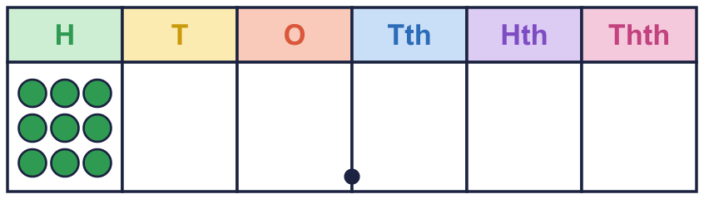  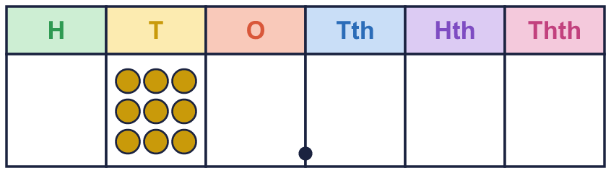
    a) The counters have moved
    place(s).
    They have moved to the |  | .
    The number has been |  | .
    It has been multiplied or divided by
    .
  1 | The first place value chart shows a number. The second chart shows the number after it was multiplied or divided. Complete the sentences. Write left or right, and multiplied or divided.
    a) The counters have moved
    place(s).
    They have moved to the |  | .
    The number has been |  | .
    It has been multiplied or divided by
    .
  2 | Complete the sentences for each pair of place value charts. Write left or right, and multiplied or divided.  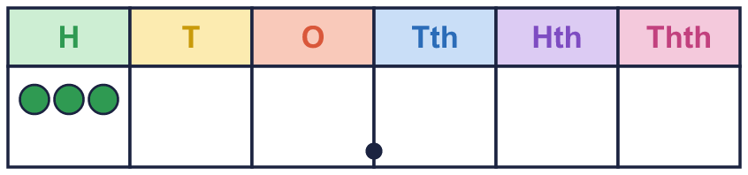  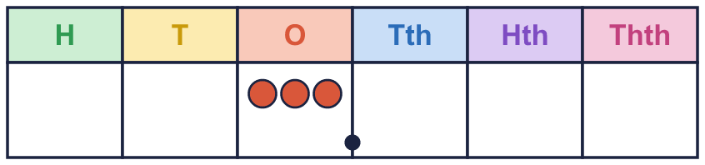  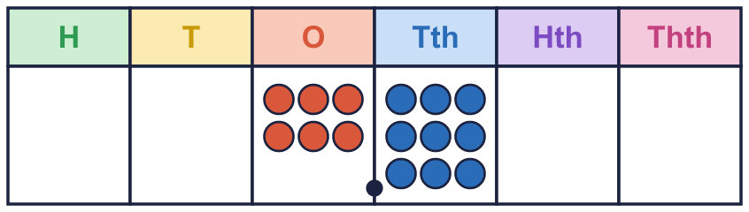  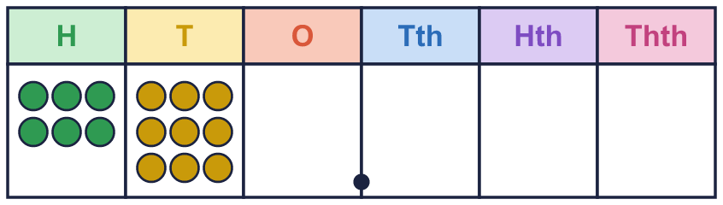
    a) The counters have moved
    place(s).
    They have moved to the |  | .
    The number has been |  | .
    It has been multiplied or divided by
    .
    b) The counters have moved
    place(s).
    They have moved to the |  | .
    The number has been |  | .
    It has been multiplied or divided by
    .
  2 | Complete the sentences for each pair of place value charts. Write left or right, and multiplied or divided.
    a) The counters have moved
    place(s).
    They have moved to the |  | .
    The number has been |  | .
    It has been multiplied or divided by
    .
    b) The counters have moved
    place(s).
    They have moved to the |  | .
    The number has been |  | .
    It has been multiplied or divided by
    .
  3 | Rosie thinks of a number. She divides it by 100. She ends with the number shown on the place value chart.  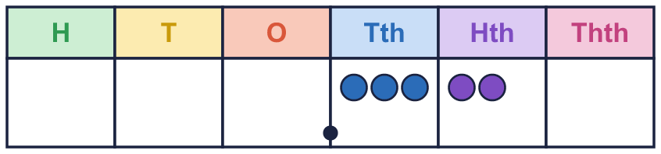
    What number did Rosie start with?
  3 | Rosie thinks of a number. She divides it by 100. She ends with the number shown on the place value chart.
    What number did Rosie start with?
  4 | Amir thinks of a number. He multiplies it by 1,000. He ends with the number shown on the place value chart.  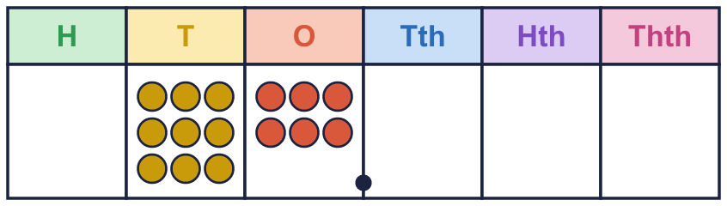
    What number did Amir start with?
  4 | Amir thinks of a number. He multiplies it by 1,000. He ends with the number shown on the place value chart.
    What number did Amir start with?
  5 | Write the missing number.
    a) 8.7 × |  | = 8,700
    b) |  | × 1,000 = 9,800
    c) |  | × 100 = 2,024
    d) |  | × 16.81 = 1,681
  5 | Write the missing number.
    a) 8.7 × |  | = 8,700
    b) |  | × 1,000 = 9,800
    c) |  | × 100 = 2,024
    d) |  | × 16.81 = 1,681
  6 | Write the missing number. Is it 10, 100 or 1,000?
    a) 185 ÷ |  | = 18.5
    b) 744 ÷ |  | = 0.744
    c) 169 ÷ |  | = 0.169
    d) 53 ÷ |  | = 5.3
  6 | Write the missing number. Is it 10, 100 or 1,000?
    a) 185 ÷ |  | = 18.5
    b) 744 ÷ |  | = 0.744
    c) 169 ÷ |  | = 0.169
    d) 53 ÷ |  | = 5.3
  7 | Write the missing number.
    a) |  | × 100 = 1,340
    b) |  | × 100 = 3,980
    c) |  | ÷ 100 = 0.813
    d) |  | ÷ 100 = 0.293
  7 | Write the missing number.
    a) |  | × 100 = 1,340
    b) |  | × 100 = 3,980
    c) |  | ÷ 100 = 0.813
    d) |  | ÷ 100 = 0.293
  8 | Work out each answer.
    a) 5.1 × 10 ÷ 100 =
    b) 5.1 ÷ 10 × 100 =
  8 | Work out each answer.
    a) 5.1 × 10 ÷ 100 =
    b) 5.1 ÷ 10 × 100 =

  9 | Is Boba correct? Circle yes or no.  Yes / No  Explain how you know.
     | 
  9 | Is Boba correct? Circle yes or no.  Yes / No  Explain how you know.
  10 | Write the missing number.
    a) |  | × 100 ÷ 100 = 88
  10 | Write the missing number.
    a) |  | × 100 ÷ 100 = 88
  11 | Write the missing number. Think about how many places the digits move.
    a) 9.7 ÷ |  | = 0.097
    b) 2.3 ÷ |  | = 0.023
  11 | Write the missing number. Think about how many places the digits move.
    a) 9.7 ÷ |  | = 0.097
    b) 2.3 ÷ |  | = 0.023
  12 | Work out the number each machine started with.
    a) |  | × 10 ÷ 100 = 5.1
    b) |  | ÷ 1,000 ÷ 10 = 0.0084
    c) |  | ÷ 100 ÷ 10 = 0.095
  12 | Work out the number each machine started with.
    a) |  | × 10 ÷ 100 = 5.1
    b) |  | ÷ 1,000 ÷ 10 = 0.0084
    c) |  | ÷ 100 ÷ 10 = 0.095
  13 | Tommy multiplies 3.6 by 100. Then he divides his answer by 1,000.
    What is his number after he multiplies by 100?
    What is his number at the end?
  13 | Tommy multiplies 3.6 by 100. Then he divides his answer by 1,000.
    What is his number after he multiplies by 100?
    What is his number at the end?
  14 | Challenge  Dev thinks of a number. He multiplies it, then divides it by 10.
    a) |  | × 100 ÷ 10 = 17
  14 | Challenge  Dev thinks of a number. He multiplies it, then divides it by 10.
    a) |  | × 100 ÷ 10 = 17

Year 5 · Decimals · Step 12
Multiply and divide decimals - missing values
Answers (teacher copy)

  1 | The first place value chart shows a number. The second chart shows the number after it was multiplied or divided. Complete the sentences. Write left or right, and multiplied or divided.  a) The counters have moved 1 place(s).  They have moved to the right .  The number has been divided .  It has been multiplied or divided by 10 .
  2 | Complete the sentences for each pair of place value charts. Write left or right, and multiplied or divided.  a) The counters have moved 2 place(s).  They have moved to the right .  The number has been divided .  It has been multiplied or divided by 100 .  b) The counters have moved 2 place(s).  They have moved to the left .  The number has been multiplied .  It has been multiplied or divided by 100 .
  3 | Rosie thinks of a number. She divides it by 100. She ends with the number shown on the place value chart.  What number did Rosie start with? 32
  4 | Amir thinks of a number. He multiplies it by 1,000. He ends with the number shown on the place value chart.  What number did Amir start with? 0.096
  5 | Write the missing number.  a) 8.7 × 1,000 = 8,700  b) 9.8 × 1,000 = 9,800  c) 20.24 × 100 = 2,024  d) 100 × 16.81 = 1,681
  6 | Write the missing number. Is it 10, 100 or 1,000?  a) 185 ÷ 10 = 18.5  b) 744 ÷ 1,000 = 0.744  c) 169 ÷ 1,000 = 0.169  d) 53 ÷ 10 = 5.3
  7 | Write the missing number.  a) 13.4 × 100 = 1,340  b) 39.8 × 100 = 3,980  c) 81.3 ÷ 100 = 0.813  d) 29.3 ÷ 100 = 0.293
  8 | Work out each answer.  a) 5.1 × 10 ÷ 100 = 0.51  b) 5.1 ÷ 10 × 100 = 51
  9 | Is Boba correct? Circle yes or no.  Yes / No  Explain how you know.  No. 4.2 × 100 = 420 and 42 = 42, so they are not equal.
  10 | Write the missing number.  a) 88 × 100 ÷ 100 = 88
  11 | Write the missing number. Think about how many places the digits move.  a) 9.7 ÷ 100 = 0.097  b) 2.3 ÷ 100 = 0.023
  12 | Work out the number each machine started with.  a) 51 × 10 ÷ 100 = 5.1  b) 84 ÷ 1,000 ÷ 10 = 0.0084  c) 95 ÷ 100 ÷ 10 = 0.095
  13 | Tommy multiplies 3.6 by 100. Then he divides his answer by 1,000.  What is his number after he multiplies by 100? 360  What is his number at the end? 0.36
  14 | Challenge  Dev thinks of a number. He multiplies it, then divides it by 10.  a) 1.7 × 100 ÷ 10 = 17

