  Year 5 · Decimals · Step 11  Divide by 10, 100 and 1,000 | 
  Year 5 · Decimals · Step 11
  Divide by 10, 100 and 1,000
  1 | Each place value chart shows a number. Divide the number by 10. Write the answer.  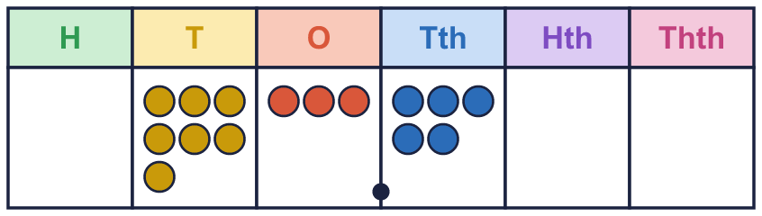  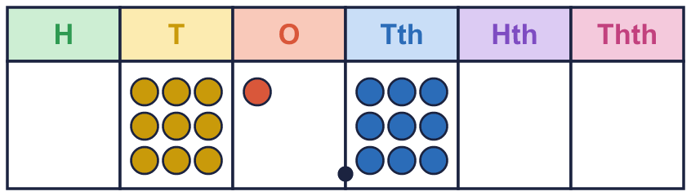
    a) the number ÷ 10 =
    b) the number ÷ 10 =
  1 | Each place value chart shows a number. Divide the number by 10. Write the answer.
    a) the number ÷ 10 =
    b) the number ÷ 10 =
  2 | Work out each division. Every digit moves 1 place to the right.
    a) 8 ÷ 10 =
    b) 5.4 ÷ 10 =
    c) 2.59 ÷ 10 =
    d) 46 ÷ 10 =
  2 | Work out each division. Every digit moves 1 place to the right.
    a) 8 ÷ 10 =
    b) 5.4 ÷ 10 =
    c) 2.59 ÷ 10 =
    d) 46 ÷ 10 =
  3 | Each place value chart shows a number. Divide the number by 100. Write the answer.  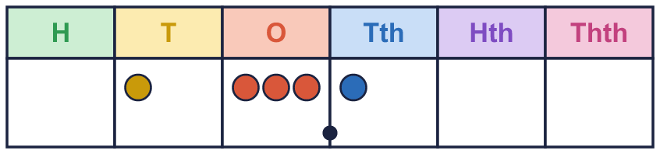  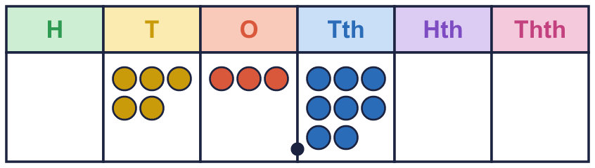
    a) the number ÷ 100 =
    b) the number ÷ 100 =
  3 | Each place value chart shows a number. Divide the number by 100. Write the answer.
    a) the number ÷ 100 =
    b) the number ÷ 100 =
  4 | Work out each division. Every digit moves 2 places to the right.
    a) 5 ÷ 100 =
    b) 6.2 ÷ 100 =
    c) 859 ÷ 100 =
    d) 24.18 ÷ 100 =
  4 | Work out each division. Every digit moves 2 places to the right.
    a) 5 ÷ 100 =
    b) 6.2 ÷ 100 =
    c) 859 ÷ 100 =
    d) 24.18 ÷ 100 =
  5 | Each place value chart shows a number. Divide the number by 1,000. Write the answer.  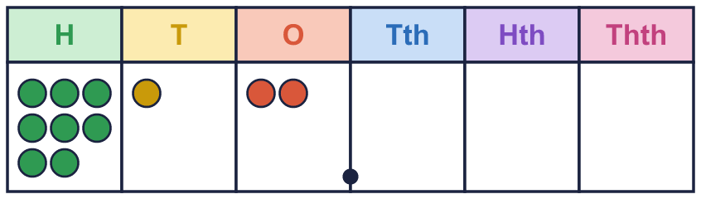
    a) the number ÷ 1,000 =
  5 | Each place value chart shows a number. Divide the number by 1,000. Write the answer.
    a) the number ÷ 1,000 =
  6 | Complete the divisions. What do you notice?
    a) 787 ÷ 10 =
    b) 787 ÷ 100 =
    c) 787 ÷ 1,000 =
  6 | Complete the divisions. What do you notice?
    a) 787 ÷ 10 =
    b) 787 ÷ 100 =
    c) 787 ÷ 1,000 =
  7 | Complete the conversions. There are 1,000 g in 1 kg, 100 cm in 1 m, 1,000 ml in 1 l and 1,000 m in 1 km.
    a) 8,450 g = |  | kg
    b) 219 cm = |  | m
    c) 897 ml = |  | l
    d) 8,700 m = |  | km
  7 | Complete the conversions. There are 1,000 g in 1 kg, 100 cm in 1 m, 1,000 ml in 1 l and 1,000 m in 1 km.
    a) 8,450 g = |  | kg
    b) 219 cm = |  | m
    c) 897 ml = |  | l
    d) 8,700 m = |  | km
  8 | Write the missing number. Think: what must you multiply by to get back to the first number?
    a) 0.961 × |  | = 961
    b) 0.72 × |  | = 72
    c) 92.7 × |  | = 927
  8 | Write the missing number. Think: what must you multiply by to get back to the first number?
    a) 0.961 × |  | = 961
    b) 0.72 × |  | = 72
    c) 92.7 × |  | = 927

  9 | Tiny works out 7.2 ÷ 100.  Is Boba correct? Circle yes or no.  Yes / No  Explain the mistake. Then write the correct answer.
    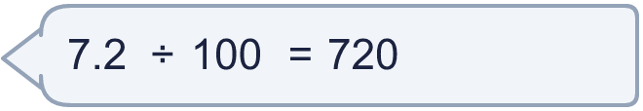
  9 | Tiny works out 7.2 ÷ 100.  Is Boba correct? Circle yes or no.  Yes / No  Explain the mistake. Then write the correct answer.
  10 | Write <, > or = in each box.
    a) 368 ÷ 10 ÷ 10 |  | 368 ÷ 100
    b) 368 ÷ 10 ÷ 100 |  | 368 ÷ 100
    c) 368 ÷ 100 ÷ 10 |  | 368 ÷ 1,000
  10 | Write <, > or = in each box.
    a) 368 ÷ 10 ÷ 10 |  | 368 ÷ 100
    b) 368 ÷ 10 ÷ 100 |  | 368 ÷ 100
    c) 368 ÷ 100 ÷ 10 |  | 368 ÷ 1,000
  11 | Which of these are equal to 4.14? Write the letters.  A: 414 ÷ 1,000  B: 41.4 ÷ 10  C: 414 ÷ 100  D: 4,140 ÷ 1,000
  11 | Which of these are equal to 4.14? Write the letters.  A: 414 ÷ 1,000  B: 41.4 ÷ 10  C: 414 ÷ 100  D: 4,140 ÷ 1,000
  12 | Write the missing number.
    a) |  | ÷ 100 ÷ 10 = 0.202
  12 | Write the missing number.
    a) |  | ÷ 100 ÷ 10 = 0.202
  13 | Write the missing number.
    a) |  | ÷ 10 = 0.72
    b) 0.085 × |  | = 85
    c) |  | ÷ 100 = 15.1
  13 | Write the missing number.
    a) |  | ÷ 10 = 0.72
    b) 0.085 × |  | = 85
    c) |  | ÷ 100 = 15.1
  14 | A sunflower is 695 cm tall. A jug holds 412 ml of juice. There are 100 cm in 1 m and 1,000 ml in 1 l.  How tall is the sunflower in metres? m  How much juice is in the jug in litres? l
  14 | A sunflower is 695 cm tall. A jug holds 412 ml of juice. There are 100 cm in 1 m and 1,000 ml in 1 l.  How tall is the sunflower in metres? m  How much juice is in the jug in litres? l

Year 5 · Decimals · Step 11
Divide by 10, 100 and 1,000
Answers (teacher copy)

  1 | Each place value chart shows a number. Divide the number by 10. Write the answer.  a) the number ÷ 10 = 7.35  b) the number ÷ 10 = 9.19
  2 | Work out each division. Every digit moves 1 place to the right.  a) 8 ÷ 10 = 0.8  b) 5.4 ÷ 10 = 0.54  c) 2.59 ÷ 10 = 0.259  d) 46 ÷ 10 = 4.6
  3 | Each place value chart shows a number. Divide the number by 100. Write the answer.  a) the number ÷ 100 = 0.131  b) the number ÷ 100 = 0.538
  4 | Work out each division. Every digit moves 2 places to the right.  a) 5 ÷ 100 = 0.05  b) 6.2 ÷ 100 = 0.062  c) 859 ÷ 100 = 8.59  d) 24.18 ÷ 100 = 0.2418
  5 | Each place value chart shows a number. Divide the number by 1,000. Write the answer.  a) the number ÷ 1,000 = 0.812
  6 | Complete the divisions. What do you notice?  a) 787 ÷ 10 = 78.7  b) 787 ÷ 100 = 7.87  c) 787 ÷ 1,000 = 0.787
  7 | Complete the conversions. There are 1,000 g in 1 kg, 100 cm in 1 m, 1,000 ml in 1 l and 1,000 m in 1 km.  a) 8,450 g = 8.45 kg  b) 219 cm = 2.19 m  c) 897 ml = 0.897 l  d) 8,700 m = 8.7 km
  8 | Write the missing number. Think: what must you multiply by to get back to the first number?  a) 0.961 × 1,000 = 961  b) 0.72 × 100 = 72  c) 92.7 × 10 = 927
  9 | Tiny works out 7.2 ÷ 100.  Is Boba correct? Circle yes or no.  Yes / No  Explain the mistake. Then write the correct answer.  No. Dividing makes the number smaller. Tiny moved the digits the wrong way. The digits move 2 places to the right: 7.2 ÷ 100 = 0.072. The correct answer is 0.072.  0.072
  10 | Write <, > or = in each box.  a) 368 ÷ 10 ÷ 10 = 368 ÷ 100  b) 368 ÷ 10 ÷ 100 < 368 ÷ 100  c) 368 ÷ 100 ÷ 10 = 368 ÷ 1,000
  11 | Which of these are equal to 4.14? Write the letters.  A: 414 ÷ 1,000  B: 41.4 ÷ 10  C: 414 ÷ 100  D: 4,140 ÷ 1,000  B, C, D
  12 | Write the missing number.  a) 202 ÷ 100 ÷ 10 = 0.202
  13 | Write the missing number.  a) 7.2 ÷ 10 = 0.72  b) 0.085 × 1,000 = 85  c) 1,510 ÷ 100 = 15.1
  14 | A sunflower is 695 cm tall. A jug holds 412 ml of juice. There are 100 cm in 1 m and 1,000 ml in 1 l.  How tall is the sunflower in metres? 6.95 m  How much juice is in the jug in litres? 0.412 l

