  Year 5 · Decimals · Step 2  Complements to 1 | 
  Year 5 · Decimals · Step 2
  Complements to 1
  1 | The hundred square is worth 1 whole. The pink squares show a number. How much more makes 1?  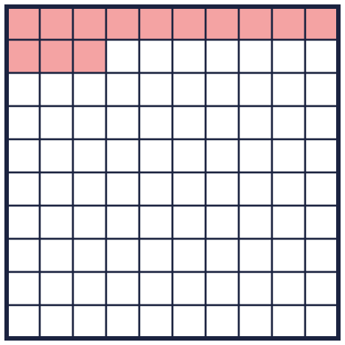
    0.13 + |  | = 1
  1 | The hundred square is worth 1 whole. The pink squares show a number. How much more makes 1?
    0.13 + |  | = 1
  2 | Write the missing number.
    a) 0.9 + |  | = 1
    b) |  | + 0.24 = 1
    c) 1 = 0.5 +
  2 | Write the missing number.
    a) 0.9 + |  | = 1
    b) |  | + 0.24 = 1
    c) 1 = 0.5 +
  3 | Use what you know about whole numbers to help you. 23 + 77 = 100, so 23 hundredths + 77 hundredths = 100 hundredths = 1.
    a) 21 + |  | = 100
    b) 0.21 + |  | = 1
    c) 678 + |  | = 1,000
    d) 0.678 + |  | = 1
  3 | Use what you know about whole numbers to help you. 23 + 77 = 100, so 23 hundredths + 77 hundredths = 100 hundredths = 1.
    a) 21 + |  | = 100
    b) 0.21 + |  | = 1
    c) 678 + |  | = 1,000
    d) 0.678 + |  | = 1
  4 | Work out each subtraction. The answer is the number that makes 1 with the number you take away.
    a) 1 − 0.1 =
    b) 1 − 0.29 =
    c) 1 − 0.02 =
  4 | Work out each subtraction. The answer is the number that makes 1 with the number you take away.
    a) 1 − 0.1 =
    b) 1 − 0.29 =
    c) 1 − 0.02 =
  5 | A piece of ribbon is 1 m long. It is cut into four smaller pieces. Piece A is 0.3 m long. Piece B is 0.04 m long. Piece C is 0.007 m long.
  5 | A piece of ribbon is 1 m long. It is cut into four smaller pieces. Piece A is 0.3 m long. Piece B is 0.04 m long. Piece C is 0.007 m long.
  6 | Write the missing number.
    a) |  | + 0.525 = 1
    b) 1 = 0.61 +
    c) 0.167 + |  | = 1
  6 | Write the missing number.
    a) |  | + 0.525 = 1
    b) 1 = 0.61 +
    c) 0.167 + |  | = 1
  7 | Sam has £0.67. How much more money does Sam need to have £1?
    Sam needs another
  7 | Sam has £0.67. How much more money does Sam need to have £1?
    Sam needs another
  8 | A jug holds 1 litre. 0.12 litre of orange juice and 0.25 litre of apple juice are poured in.  How much more juice fills the jug? litre
  8 | A jug holds 1 litre. 0.12 litre of orange juice and 0.25 litre of apple juice are poured in.  How much more juice fills the jug? litre

  9 | Eva works out 1 − 0.73.  Is Boba correct? Circle yes or no.  Yes / No  Explain the mistake. Then write the correct answer.
    
  9 | Eva works out 1 − 0.73.  Is Boba correct? Circle yes or no.  Yes / No  Explain the mistake. Then write the correct answer.
  10 | Is Boba correct? Circle yes or no.  Yes / No  Explain how you know.
     | 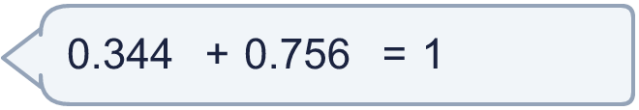
  10 | Is Boba correct? Circle yes or no.  Yes / No  Explain how you know.
  11 | Which of these additions make 1? Write the letters.  A: 0.863 + 0.037  B: 0.863 + 0.137  C: 0.563 + 0.437  D: 0.516 + 0.494
  11 | Which of these additions make 1? Write the letters.  A: 0.863 + 0.037  B: 0.863 + 0.137  C: 0.563 + 0.437  D: 0.516 + 0.494
  12 | Write the missing number.
    a) 0.06 + 0.2 + |  | = 1
    b) 0.03 + 0.016 + |  | = 1
  12 | Write the missing number.
    a) 0.06 + 0.2 + |  | = 1
    b) 0.03 + 0.016 + |  | = 1
  13 | A bottle holds 1 litre. 0.2 litre is poured into a jug and then 0.16 litre is poured into a bowl.  How much is left in the bottle? litre  How much has been poured out in total? litre
  13 | A bottle holds 1 litre. 0.2 litre is poured into a jug and then 0.16 litre is poured into a bowl.  How much is left in the bottle? litre  How much has been poured out in total? litre
  14 | Challenge  Two decimals add up to 1. The bigger decimal is 0.25 more than the smaller one.
    The numbers are |  | and
  14 | Challenge  Two decimals add up to 1. The bigger decimal is 0.25 more than the smaller one.
    The numbers are |  | and

Year 5 · Decimals · Step 2
Complements to 1
Answers (teacher copy)

  1 | The hundred square is worth 1 whole. The pink squares show a number. How much more makes 1?  0.13 + 0.87 = 1
  2 | Write the missing number.  a) 0.9 + 0.1 = 1  b) 0.76 + 0.24 = 1  c) 1 = 0.5 + 0.5
  3 | Use what you know about whole numbers to help you. 23 + 77 = 100, so 23 hundredths + 77 hundredths = 100 hundredths = 1.  a) 21 + 79 = 100  b) 0.21 + 0.79 = 1  c) 678 + 322 = 1,000  d) 0.678 + 0.322 = 1
  4 | Work out each subtraction. The answer is the number that makes 1 with the number you take away.  a) 1 − 0.1 = 0.9  b) 1 − 0.29 = 0.71  c) 1 − 0.02 = 0.98
  5 | A piece of ribbon is 1 m long. It is cut into four smaller pieces. Piece A is 0.3 m long. Piece B is 0.04 m long. Piece C is 0.007 m long.  How long is piece D? 0.653 m
  6 | Write the missing number.  a) 0.475 + 0.525 = 1  b) 1 = 0.61 + 0.39  c) 0.167 + 0.833 = 1
  7 | Sam has £0.67. How much more money does Sam need to have £1?  Sam needs another £0.33
  8 | A jug holds 1 litre. 0.12 litre of orange juice and 0.25 litre of apple juice are poured in.  How much more juice fills the jug? 0.63 litre
  9 | Eva works out 1 − 0.73.  Is Boba correct? Circle yes or no.  Yes / No  Explain the mistake. Then write the correct answer.  No. Tiny made both digits add to 10. Only the last digit makes 10. The tenths digit must make 9: 0.73 + 0.27 = 1. The correct answer is 0.27.  0.27
  10 | Is Boba correct? Circle yes or no.  Yes / No  Explain how you know.  No. 0.344 + 0.756 = 1.1 and 1 = 1, so they are not equal.
  11 | Which of these additions make 1? Write the letters.  A: 0.863 + 0.037  B: 0.863 + 0.137  C: 0.563 + 0.437  D: 0.516 + 0.494  B, C
  12 | Write the missing number.  a) 0.06 + 0.2 + 0.74 = 1  b) 0.03 + 0.016 + 0.954 = 1
  13 | A bottle holds 1 litre. 0.2 litre is poured into a jug and then 0.16 litre is poured into a bowl.  How much is left in the bottle? 0.64 litre  How much has been poured out in total? 0.36 litre
  14 | Challenge  Two decimals add up to 1. The bigger decimal is 0.25 more than the smaller one.  The numbers are 0.625 and 0.375

