  Year 5 · Converting units · Step 2  Millimetres and millilitres | 
  Year 5 · Converting units · Step 2
  Millimetres and millilitres
  1 | The bar model shows that 1 m = 1,000 mm. Use it to work out how many mm are in 5 m.  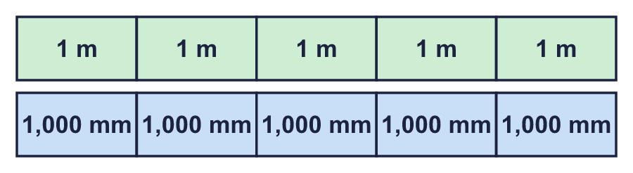  a) 5 m = mm
  1 | The bar model shows that 1 m = 1,000 mm. Use it to work out how many mm are in 5 m.  a) 5 m = mm
  2 | Complete the conversions. Multiply by 1,000.  a) 20 m = mm  b) 28 litres = ml  c) 55 m = mm  d) 87 litres = ml
  2 | Complete the conversions. Multiply by 1,000.  a) 20 m = mm  b) 28 litres = ml  c) 55 m = mm  d) 87 litres = ml
  3 | Complete the conversions. Divide by 1,000.  a) 47,000 mm = m  b) 68,000 ml = litres  c) 91,000 mm = m  d) 85,000 ml = litres
  3 | Complete the conversions. Divide by 1,000.  a) 47,000 mm = m  b) 68,000 ml = litres  c) 91,000 mm = m  d) 85,000 ml = litres
  4 | Complete the conversions. Take care with the decimal point.  a) 3.6 m = mm  b) 19.6 litres = ml  c) 0.12 m = mm  d) 0.34 litres = ml
  4 | Complete the conversions. Take care with the decimal point.  a) 3.6 m = mm  b) 19.6 litres = ml  c) 0.12 m = mm  d) 0.34 litres = ml
  5 | Complete the conversions. The answers are decimals.  a) 34,967 ml = litres  b) 63,087 ml = litres  c) 76,017 mm = m  d) 58,691 mm = m
  5 | Complete the conversions. The answers are decimals.  a) 34,967 ml = litres  b) 63,087 ml = litres  c) 76,017 mm = m  d) 58,691 mm = m
  6 | Complete the conversions.  a) 7 litres = ml  b) 7.75 litres = ml  c) 0.75 litres = ml
  6 | Complete the conversions.  a) 7 litres = ml  b) 7.75 litres = ml  c) 0.75 litres = ml
  7 | Write <, > or = in each box.  a) 4,500 ml 4.7 litres  b) 6,600 mm 7.1 m  c) 8,400 ml 8.3 litres  d) 2,700 ml 2.7 litres
  7 | Write <, > or = in each box.  a) 4,500 ml 4.7 litres  b) 6,600 mm 7.1 m  c) 8,400 ml 8.3 litres  d) 2,700 ml 2.7 litres
  8 | A piece of string is 2.02 m long. Pieces that are 30 mm long are cut from it.  How many whole pieces can be cut?  How many millimetres are left over? mm
  8 | A piece of string is 2.02 m long. Pieces that are 30 mm long are cut from it.  How many whole pieces can be cut?  How many millimetres are left over? mm

  9 | Is Boba correct? Circle yes or no.  Yes / No  Explain. If not, write the correct answer.
     | 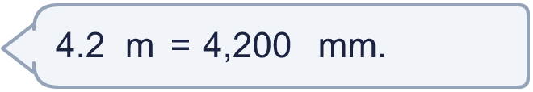
  9 | Is Boba correct? Circle yes or no.  Yes / No  Explain. If not, write the correct answer.
  10 | Tom pours 4 litres of orange juice into glasses. Each glass holds 250 ml.  How many glasses can he fill?
  10 | Tom pours 4 litres of orange juice into glasses. Each glass holds 250 ml.  How many glasses can he fill?
  11 | Tom buys a bottle of juice that holds 4 litres and 3 cartons that hold 250 ml each.  How much juice has he bought in total? Give your answer in litres. litres
  11 | Tom buys a bottle of juice that holds 4 litres and 3 cartons that hold 250 ml each.  How much juice has he bought in total? Give your answer in litres. litres
  12 | A ribbon is 3.76 m long. Pieces that are 60 mm long are cut from it.  How many whole pieces can be cut?  How many millimetres are left over? mm
  12 | A ribbon is 3.76 m long. Pieces that are 60 mm long are cut from it.  How many whole pieces can be cut?  How many millimetres are left over? mm
  13 | Here are five capacities.  A: 1.76 litres  B: 18.31 litres  C: 28,910 ml  D: 11,360 ml  E: 15,750 ml  Write the letters in order, from the smallest to the largest.
  13 | Here are five capacities.  A: 1.76 litres  B: 18.31 litres  C: 28,910 ml  D: 11,360 ml  E: 15,750 ml  Write the letters in order, from the smallest to the largest.
  14 | A plank is 0.9 m long. A carpenter cuts off 300 mm.  How long is the plank now? Give your answer in millimetres. mm
  14 | A plank is 0.9 m long. A carpenter cuts off 300 mm.  How long is the plank now? Give your answer in millimetres. mm

Year 5 · Converting units · Step 2
Millimetres and millilitres
Answers (teacher copy)

  1 | The bar model shows that 1 m = 1,000 mm. Use it to work out how many mm are in 5 m.  a) 5 m = 5,000 mm
  2 | Complete the conversions. Multiply by 1,000.  a) 20 m = 20,000 mm  b) 28 litres = 28,000 ml  c) 55 m = 55,000 mm  d) 87 litres = 87,000 ml
  3 | Complete the conversions. Divide by 1,000.  a) 47,000 mm = 47 m  b) 68,000 ml = 68 litres  c) 91,000 mm = 91 m  d) 85,000 ml = 85 litres
  4 | Complete the conversions. Take care with the decimal point.  a) 3.6 m = 3,600 mm  b) 19.6 litres = 19,600 ml  c) 0.12 m = 120 mm  d) 0.34 litres = 340 ml
  5 | Complete the conversions. The answers are decimals.  a) 34,967 ml = 34.967 litres  b) 63,087 ml = 63.087 litres  c) 76,017 mm = 76.017 m  d) 58,691 mm = 58.691 m
  6 | Complete the conversions.  a) 7 litres = 7,000 ml  b) 7.75 litres = 7,750 ml  c) 0.75 litres = 750 ml
  7 | Write <, > or = in each box.  a) 4,500 ml < 4.7 litres  b) 6,600 mm < 7.1 m  c) 8,400 ml > 8.3 litres  d) 2,700 ml = 2.7 litres
  8 | A piece of string is 2.02 m long. Pieces that are 30 mm long are cut from it.  How many whole pieces can be cut? 67  How many millimetres are left over? 10 mm
  9 | Is Boba correct? Circle yes or no.  Yes / No  Explain. If not, write the correct answer.  Yes. 4.2 m = 4,200 mm.
  10 | Tom pours 4 litres of orange juice into glasses. Each glass holds 250 ml.  How many glasses can he fill? 16
  11 | Tom buys a bottle of juice that holds 4 litres and 3 cartons that hold 250 ml each.  How much juice has he bought in total? Give your answer in litres. 4.75 litres
  12 | A ribbon is 3.76 m long. Pieces that are 60 mm long are cut from it.  How many whole pieces can be cut? 62  How many millimetres are left over? 40 mm
  13 | Here are five capacities.  A: 1.76 litres  B: 18.31 litres  C: 28,910 ml  D: 11,360 ml  E: 15,750 ml  Write the letters in order, from the smallest to the largest.  A, D, E, B, C
  14 | A plank is 0.9 m long. A carpenter cuts off 300 mm.  How long is the plank now? Give your answer in millimetres. 600 mm

