  Year 5 · Converting units · Step 3  Convert units of length | 
  Year 5 · Converting units · Step 3
  Convert units of length
  1 | How long is the strip? Write the length in millimetres and in centimetres.  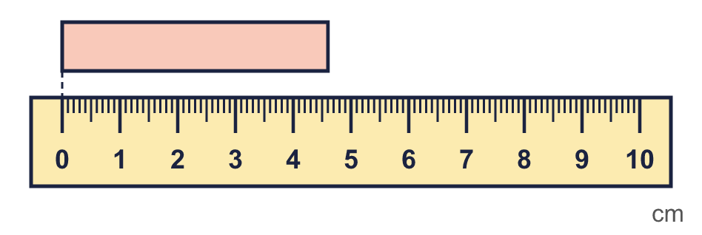
  1 | How long is the strip? Write the length in millimetres and in centimetres.
  2 | Dexter says: if I know how many millimetres are in 1 cm, and how many centimetres are in 1 m, I can work out how many millimetres are in 1 m. Complete the conversions.  a) 1 cm = mm  b) 1 m = cm  c) 1 m = mm
  2 | Dexter says: if I know how many millimetres are in 1 cm, and how many centimetres are in 1 m, I can work out how many millimetres are in 1 m. Complete the conversions.  a) 1 cm = mm  b) 1 m = cm  c) 1 m = mm
  3 | Complete the conversions.  a) 11 cm = mm  b) 23 m = cm  c) 300 mm = cm  d) 4,800 cm = m
  3 | Complete the conversions.  a) 11 cm = mm  b) 23 m = cm  c) 300 mm = cm  d) 4,800 cm = m
  4 | Complete the conversions. Take care with the decimal point.  a) 3.05 m = cm  b) 1.55 m = mm  c) 28.9 m = cm  d) 23.2 cm = mm
  4 | Complete the conversions. Take care with the decimal point.  a) 3.05 m = cm  b) 1.55 m = mm  c) 28.9 m = cm  d) 23.2 cm = mm
  5 | Complete the conversions. The answers are decimals.  a) 48,074 cm = m  b) 45,467 mm = cm  c) 12,073 mm = m  d) 16,307 mm = m
  5 | Complete the conversions. The answers are decimals.  a) 48,074 cm = m  b) 45,467 mm = cm  c) 12,073 mm = m  d) 16,307 mm = m
  6 | Write <, > or = in each box.  a) 0.69 m 670 mm  b) 0.31 m 31 cm  c) 0.83 m 103 cm  d) 14 cm 0.13 m
  6 | Write <, > or = in each box.  a) 0.69 m 670 mm  b) 0.31 m 31 cm  c) 0.83 m 103 cm  d) 14 cm 0.13 m
  7 | The depth of a plank is 16 mm. 20 of the planks are stacked on top of each other.  What is the depth of the stack? Give your answer in centimetres. cm
  7 | The depth of a plank is 16 mm. 20 of the planks are stacked on top of each other.  What is the depth of the stack? Give your answer in centimetres. cm
  8 | Max is 146 cm tall. Annie is 0.15 m shorter than Max.  How tall is Annie? Give your answer in metres. m
  8 | Max is 146 cm tall. Annie is 0.15 m shorter than Max.  How tall is Annie? Give your answer in metres. m

  9 | Is Boba correct? Circle yes or no.  Yes / No  Explain. If not, write the correct answer.
     | 
  9 | Is Boba correct? Circle yes or no.  Yes / No  Explain. If not, write the correct answer.
  10 | The thickness of a 10p coin is 2 mm. Tommy stacks £4 worth of 10p coins on top of each other.  How tall is the stack? Give your answer in centimetres. cm
  10 | The thickness of a 10p coin is 2 mm. Tommy stacks £4 worth of 10p coins on top of each other.  How tall is the stack? Give your answer in centimetres. cm
  11 | The table shows the heights of four sunflowers.  A: 83 cm  B: 0.9 m  C: 84.6 cm  D: 890 mm  Write the letters in order, starting with the shortest sunflower.
  11 | The table shows the heights of four sunflowers.  A: 83 cm  B: 0.9 m  C: 84.6 cm  D: 890 mm  Write the letters in order, starting with the shortest sunflower.
  12 | Rosie measures the length of the playground as 843 cm. Mo measures it in metres.
  12 | Rosie measures the length of the playground as 843 cm. Mo measures it in metres.
  13 | Amir measures the width of a paper clip as 2.7 cm. Eva measures it in millimetres.
  13 | Amir measures the width of a paper clip as 2.7 cm. Eva measures it in millimetres.
  14 | Challenge  A fence has 5 panels. Each panel is 0.6 m long. There is also a gap of 30 cm.  What is the total length of the fence and the gap in centimetres? cm
  14 | Challenge  A fence has 5 panels. Each panel is 0.6 m long. There is also a gap of 30 cm.  What is the total length of the fence and the gap in centimetres? cm

Year 5 · Converting units · Step 3
Convert units of length
Answers (teacher copy)

  1 | How long is the strip? Write the length in millimetres and in centimetres.  In mm: 46 mm  In cm: 4.6 cm
  2 | Dexter says: if I know how many millimetres are in 1 cm, and how many centimetres are in 1 m, I can work out how many millimetres are in 1 m. Complete the conversions.  a) 1 cm = 10 mm  b) 1 m = 100 cm  c) 1 m = 1,000 mm
  3 | Complete the conversions.  a) 11 cm = 110 mm  b) 23 m = 2,300 cm  c) 300 mm = 30 cm  d) 4,800 cm = 48 m
  4 | Complete the conversions. Take care with the decimal point.  a) 3.05 m = 305 cm  b) 1.55 m = 1,550 mm  c) 28.9 m = 2,890 cm  d) 23.2 cm = 232 mm
  5 | Complete the conversions. The answers are decimals.  a) 48,074 cm = 480.74 m  b) 45,467 mm = 4,546.7 cm  c) 12,073 mm = 12.073 m  d) 16,307 mm = 16.307 m
  6 | Write <, > or = in each box.  a) 0.69 m > 670 mm  b) 0.31 m = 31 cm  c) 0.83 m < 103 cm  d) 14 cm > 0.13 m
  7 | The depth of a plank is 16 mm. 20 of the planks are stacked on top of each other.  What is the depth of the stack? Give your answer in centimetres. 32 cm
  8 | Max is 146 cm tall. Annie is 0.15 m shorter than Max.  How tall is Annie? Give your answer in metres. 1.31 m
  9 | Is Boba correct? Circle yes or no.  Yes / No  Explain. If not, write the correct answer.  No. 0.37 m = 37 cm.
  10 | The thickness of a 10p coin is 2 mm. Tommy stacks £4 worth of 10p coins on top of each other.  How tall is the stack? Give your answer in centimetres. 8 cm
  11 | The table shows the heights of four sunflowers.  A: 83 cm  B: 0.9 m  C: 84.6 cm  D: 890 mm  Write the letters in order, starting with the shortest sunflower.  A, C, D, B
  12 | Rosie measures the length of the playground as 843 cm. Mo measures it in metres.  What answer will Mo get? 8.43 m
  13 | Amir measures the width of a paper clip as 2.7 cm. Eva measures it in millimetres.  What answer will Eva get? 27 mm
  14 | Challenge  A fence has 5 panels. Each panel is 0.6 m long. There is also a gap of 30 cm.  What is the total length of the fence and the gap in centimetres? 330 cm

