  Year 5 · Converting units · Step 6  Calculate with timetables | 
  Year 5 · Converting units · Step 6
  Calculate with timetables
  1 | Here is a bus timetable.  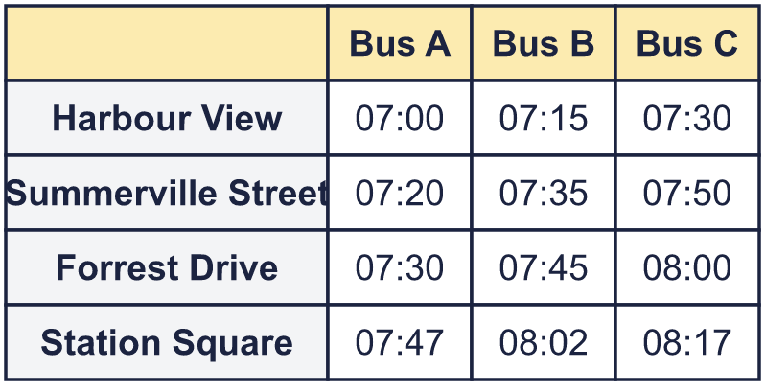
    a) What time does Bus A arrive at Harbour View?
    b) What time does Bus B arrive at Forrest Drive?
    c) What time does Bus C arrive at Summerville Street?
  1 | Here is a bus timetable.
    a) What time does Bus A arrive at Harbour View?
    b) What time does Bus B arrive at Forrest Drive?
    c) What time does Bus C arrive at Summerville Street?
  2 | Each bus takes the same amount of time to get from Station Square to Green Park Road. One time is missing from the timetable.  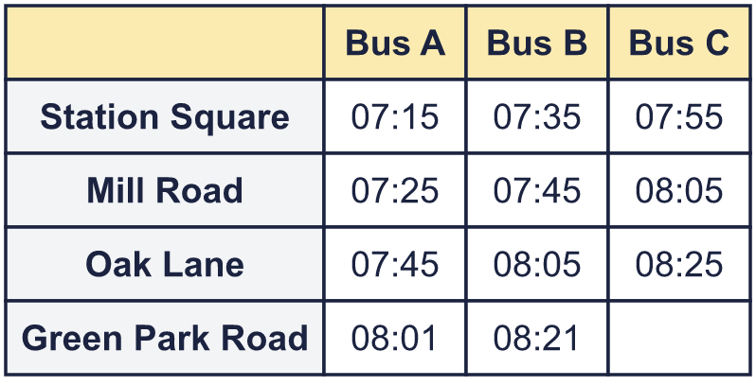
    What time does Bus C arrive at Green Park Road?
  2 | Each bus takes the same amount of time to get from Station Square to Green Park Road. One time is missing from the timetable.
    What time does Bus C arrive at Green Park Road?
  3 | Here is a bus timetable.  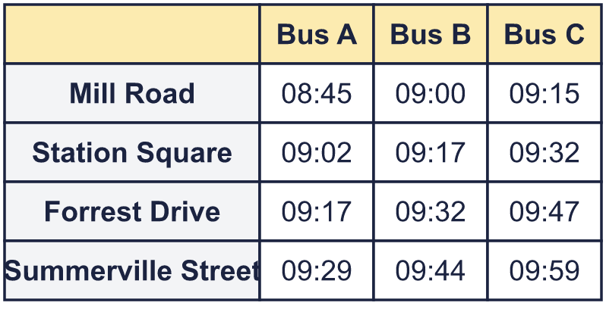
    How many minutes does Bus A take to get from Mill Road to Summerville Street?
    minutes
  3 | Here is a bus timetable.
    How many minutes does Bus A take to get from Mill Road to Summerville Street?
    minutes
  4 | Here is a bus timetable.  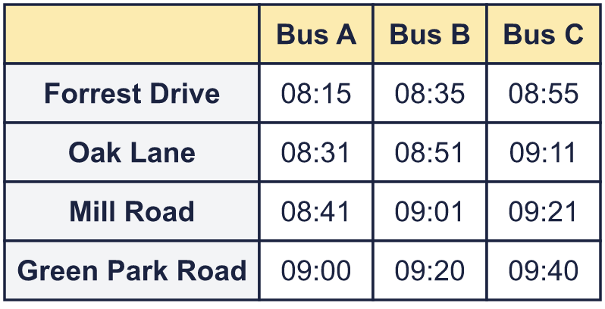  Eva needs to be at Green Park Road by 09:40.
    Which bus does she need to catch from Forrest Drive? Write the bus.
  4 | Here is a bus timetable.  Eva needs to be at Green Park Road by 09:40.
    Which bus does she need to catch from Forrest Drive? Write the bus.
  5 | Here is an extract from a TV guide. Each programme starts when the one before it ends.  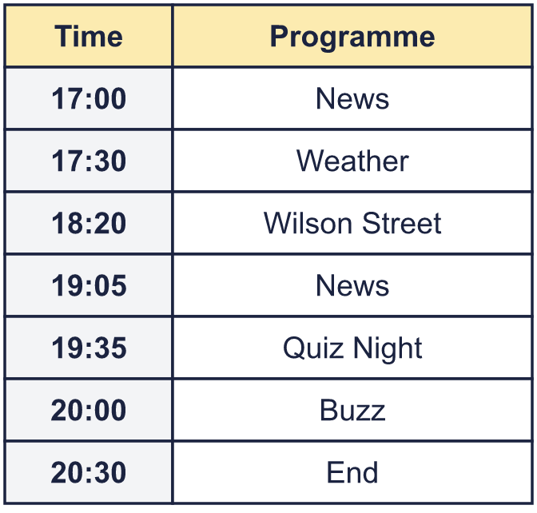
    At what times is the News on?
    How long is Weather on for?
    minutes
  5 | Here is an extract from a TV guide. Each programme starts when the one before it ends.
    At what times is the News on?
    How long is Weather on for?
    minutes
  6 | Here is an extract from a TV guide.  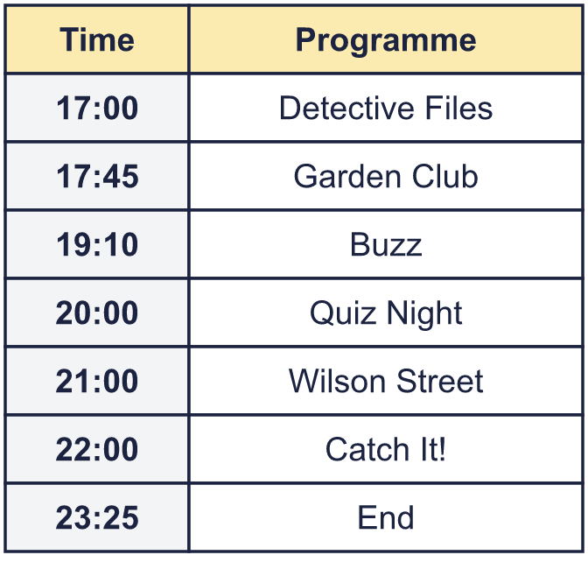  Is Boba correct? Circle yes or no.  Yes / No  Explain how you know.
     | 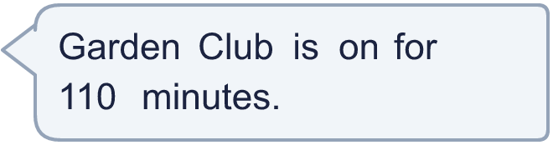
  6 | Here is an extract from a TV guide.  Is Boba correct? Circle yes or no.  Yes / No  Explain how you know.
  7 | Here is part of a train timetable. A dash (–) means the train does not stop.  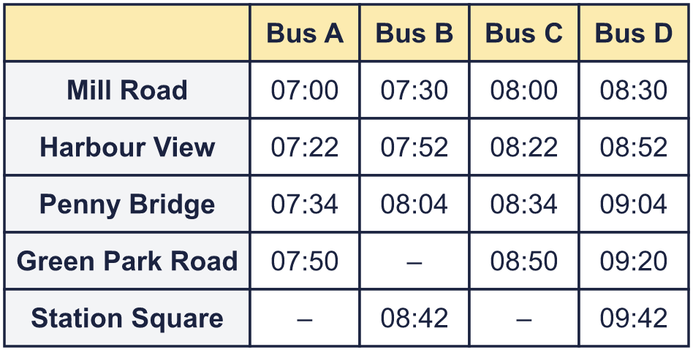
    How many of the trains stop at every station from Mill Road to Station Square?
  7 | Here is part of a train timetable. A dash (–) means the train does not stop.
    How many of the trains stop at every station from Mill Road to Station Square?
  8 | Here is part of a train timetable.  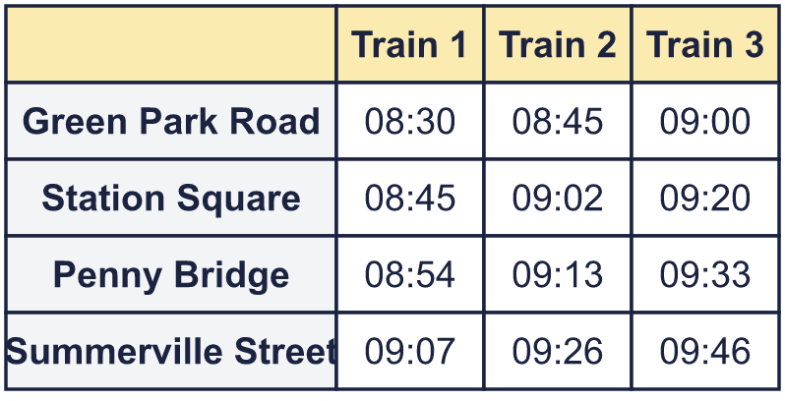
    Which train takes the least time to get from Green Park Road to Summerville Street?
  8 | Here is part of a train timetable.
    Which train takes the least time to get from Green Park Road to Summerville Street?

  9 | Here is part of a train timetable.  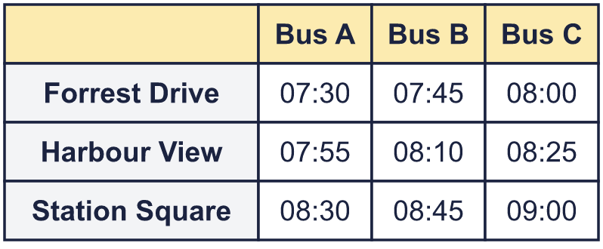
    How many minutes does Bus C take to get from Forrest Drive to Station Square?
    minutes
  9 | Here is part of a train timetable.
    How many minutes does Bus C take to get from Forrest Drive to Station Square?
    minutes
  10 | Here is an extract from a TV guide. Each programme starts when the one before it ends.  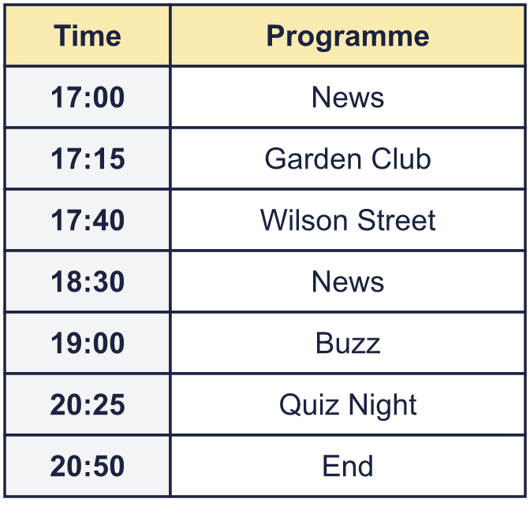
    How long is the News on for in total?
    minutes
  10 | Here is an extract from a TV guide. Each programme starts when the one before it ends.
    How long is the News on for in total?
    minutes
  11 | Every bus takes the same time between two stops. One time is missing from the timetable.  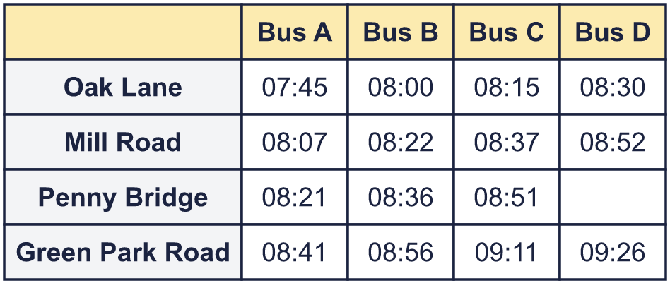
    What time does Bus D arrive at Penny Bridge?
  11 | Every bus takes the same time between two stops. One time is missing from the timetable.
    What time does Bus D arrive at Penny Bridge?
  12 | Here is a bus timetable.  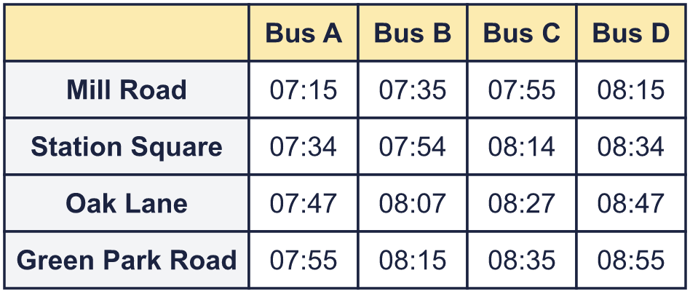  Max wants to arrive at Green Park Road by 08:57. He wants to leave Mill Road as late as he can.
    Which bus should he catch?
  12 | Here is a bus timetable.  Max wants to arrive at Green Park Road by 08:57. He wants to leave Mill Road as late as he can.
    Which bus should he catch?
  13 | School starts at 09:20 and finishes at 15:20. The lunch break is from 12:00 to 13:00.
    How many minutes are there in the school day?
    minutes
    How many seconds is the lunch break?
    seconds
  13 | School starts at 09:20 and finishes at 15:20. The lunch break is from 12:00 to 13:00.
    How many minutes are there in the school day?
    minutes
    How many seconds is the lunch break?
    seconds
  14 | Here is part of a train timetable. A dash (–) means the train does not stop.  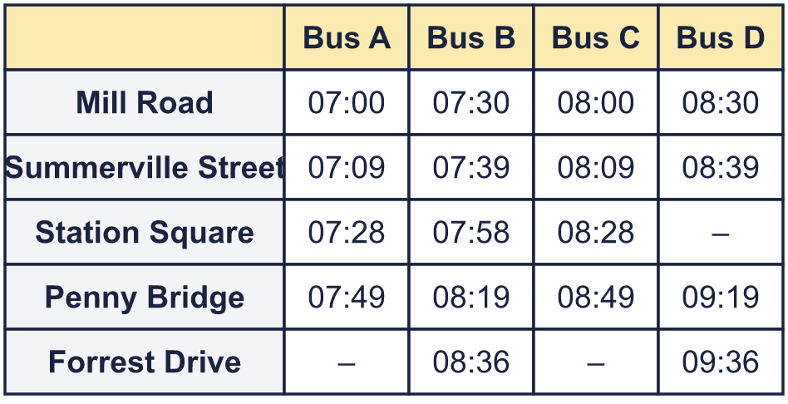
    How many of the trains stop at every station from Mill Road to Penny Bridge?
    How many minutes does Bus A take to get from Mill Road to Penny Bridge?
    minutes
  14 | Here is part of a train timetable. A dash (–) means the train does not stop.
    How many of the trains stop at every station from Mill Road to Penny Bridge?
    How many minutes does Bus A take to get from Mill Road to Penny Bridge?
    minutes

Year 5 · Converting units · Step 6
Calculate with timetables
Answers (teacher copy)

  1 | Here is a bus timetable.  a) What time does Bus A arrive at Harbour View? 07:00  b) What time does Bus B arrive at Forrest Drive? 07:45  c) What time does Bus C arrive at Summerville Street? 07:50
  2 | Each bus takes the same amount of time to get from Station Square to Green Park Road. One time is missing from the timetable.  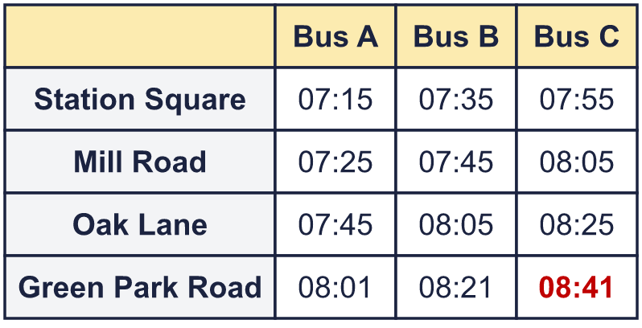  What time does Bus C arrive at Green Park Road? 08:41
  3 | Here is a bus timetable.  How many minutes does Bus A take to get from Mill Road to Summerville Street? 44 minutes
  4 | Here is a bus timetable.  Eva needs to be at Green Park Road by 09:40.  Which bus does she need to catch from Forrest Drive? Write the bus. Bus C
  5 | Here is an extract from a TV guide. Each programme starts when the one before it ends.  At what times is the News on? 17:00 and 19:05  How long is Weather on for? 50 minutes
  6 | Here is an extract from a TV guide.  Is Boba correct? Circle yes or no.  Yes / No  Explain how you know.  No. Garden Club starts at 17:45 and ends at 19:10, so it is on for 85 minutes.
  7 | Here is part of a train timetable. A dash (–) means the train does not stop.  How many of the trains stop at every station from Mill Road to Station Square? 1
  8 | Here is part of a train timetable.  Which train takes the least time to get from Green Park Road to Summerville Street? Train 1
  9 | Here is part of a train timetable.  How many minutes does Bus C take to get from Forrest Drive to Station Square? 60 minutes
  10 | Here is an extract from a TV guide. Each programme starts when the one before it ends.  How long is the News on for in total? 45 minutes
  11 | Every bus takes the same time between two stops. One time is missing from the timetable.  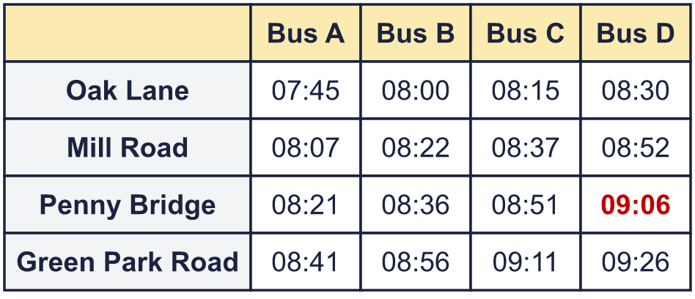  What time does Bus D arrive at Penny Bridge? 09:06
  12 | Here is a bus timetable.  Max wants to arrive at Green Park Road by 08:57. He wants to leave Mill Road as late as he can.  Which bus should he catch? Bus D
  13 | School starts at 09:20 and finishes at 15:20. The lunch break is from 12:00 to 13:00.  How many minutes are there in the school day? 360 minutes  How many seconds is the lunch break? 3,600 seconds
  14 | Here is part of a train timetable. A dash (–) means the train does not stop.  How many of the trains stop at every station from Mill Road to Penny Bridge? 3  How many minutes does Bus A take to get from Mill Road to Penny Bridge? 49 minutes

