  Year 5 · Statistics · Step 3  Read and interpret tables | 
  Year 5 · Statistics · Step 3
  Read and interpret tables
  1 | The table shows the masses of five dogs, to the nearest kilogram.  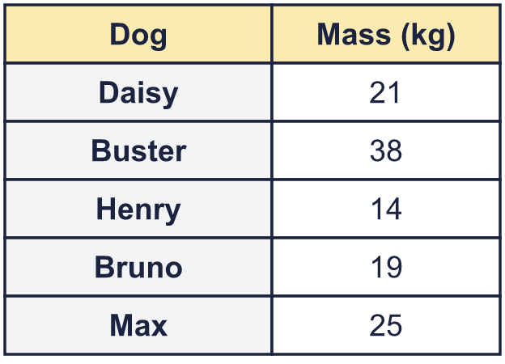
    What is the total mass of Buster and Max?
    kg
    Which dog is the heaviest?
  1 | The table shows the masses of five dogs, to the nearest kilogram.
    What is the total mass of Buster and Max?
    kg
    Which dog is the heaviest?
  2 | The table shows the average summer temperature in six cities.  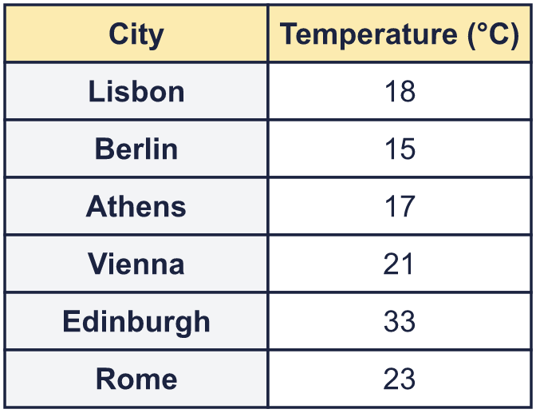
    What is the average summer temperature in Berlin?
    °C
    Which city is the warmest?
  2 | The table shows the average summer temperature in six cities.
    What is the average summer temperature in Berlin?
    °C
    Which city is the warmest?
  3 | The table shows the average summer temperature in six cities.  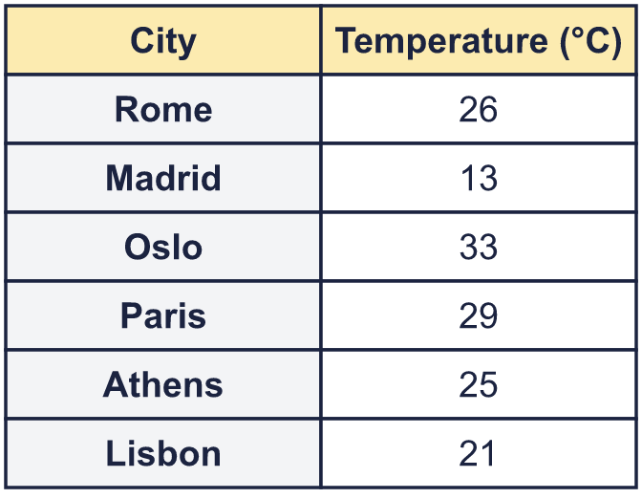
    What is the difference in temperature between Paris and Athens?
    °C
    Which city is the coolest?
  3 | The table shows the average summer temperature in six cities.
    What is the difference in temperature between Paris and Athens?
    °C
    Which city is the coolest?
  4 | Daisy is 8 kg heavier than Buster. Work out Daisy's mass and write it in the table.  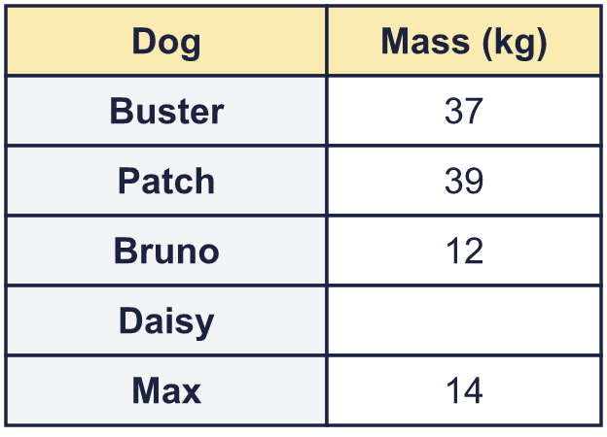
    Daisy's mass = |  | kg
  4 | Daisy is 8 kg heavier than Buster. Work out Daisy's mass and write it in the table.
    Daisy's mass = |  | kg
  5 | The table shows the number of children in each year group of a school. There are 180 children altogether. Work out the missing number and write it in the table.  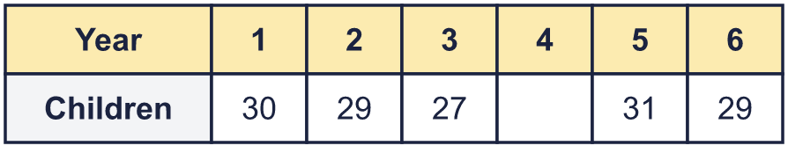
    Children in Year 4 =
  5 | The table shows the number of children in each year group of a school. There are 180 children altogether. Work out the missing number and write it in the table.
    Children in Year 4 =
  6 | The tables show how the children in Year 4 and Year 5 travel to school.  Year 4  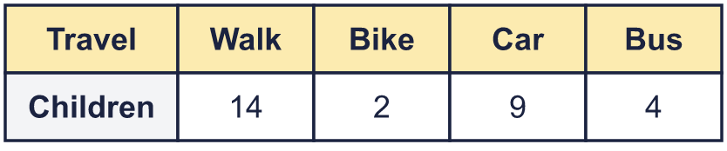  Year 5  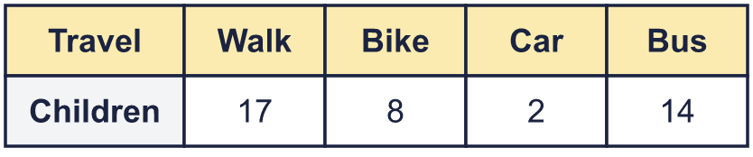
    Most common way to travel in Year 4:
    How many more children go by car in Year 4 than in Year 5?
  6 | The tables show how the children in Year 4 and Year 5 travel to school.  Year 4  Year 5
    Most common way to travel in Year 4:
    How many more children go by car in Year 4 than in Year 5?
  7 | Each child in two classes chose one club. The tables show how many children chose each club.  Class 5A  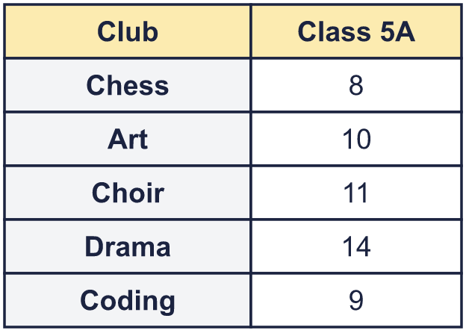  Class 5B  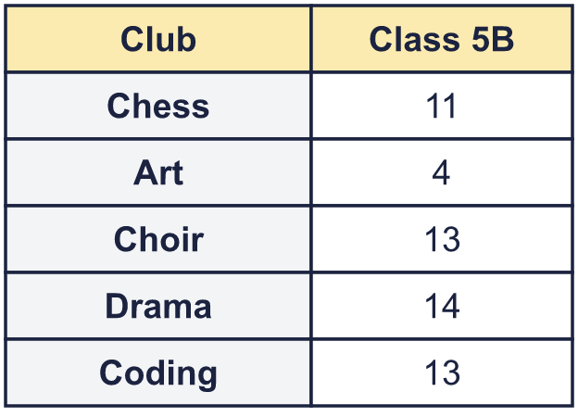
    Which class has more children?
    How many more children are there?
  7 | Each child in two classes chose one club. The tables show how many children chose each club.  Class 5A  Class 5B
    Which class has more children?
    How many more children are there?
  8 | The table shows the heights of five pupils.  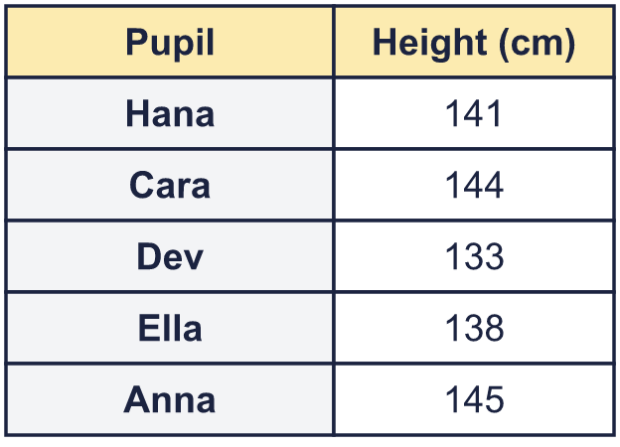  Write the names in order, starting with the shortest.
  8 | The table shows the heights of five pupils.  Write the names in order, starting with the shortest.

  9 | The table shows the number of ice cream cones a shop sold last week.  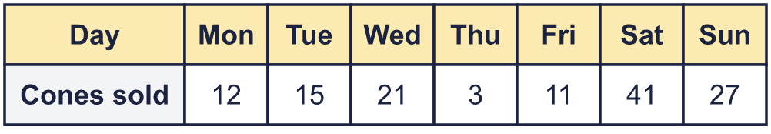  Is Dora correct? Circle yes or no.  Yes / No  Explain how you know.
     | 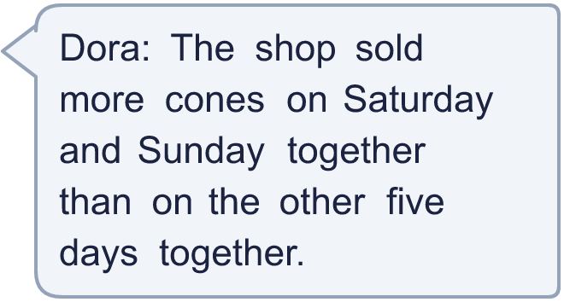
  9 | The table shows the number of ice cream cones a shop sold last week.  Is Dora correct? Circle yes or no.  Yes / No  Explain how you know.
  10 | The table shows the average summer temperature in six cities.  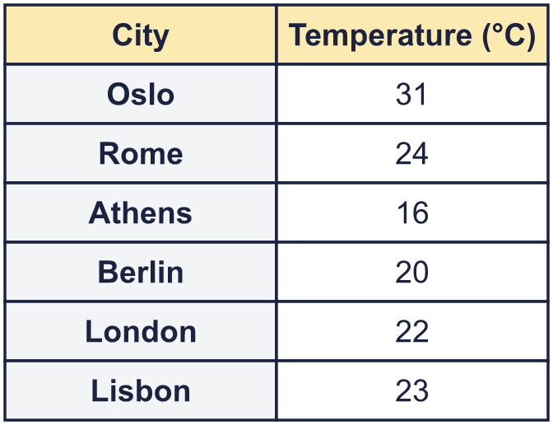  How many pairs of cities have average temperatures that differ by exactly 2 °C? Count each pair once.
    Number of pairs =
  10 | The table shows the average summer temperature in six cities.  How many pairs of cities have average temperatures that differ by exactly 2 °C? Count each pair once.
    Number of pairs =
  11 | The table shows the average summer temperature in four cities. The average in Edinburgh is warmer than in London but colder than in Berlin. The temperature in Edinburgh is a whole number of degrees.  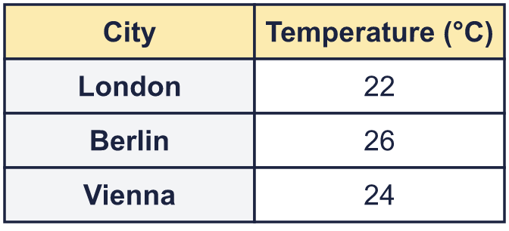  Write every temperature Edinburgh could have.
  11 | The table shows the average summer temperature in four cities. The average in Edinburgh is warmer than in London but colder than in Berlin. The temperature in Edinburgh is a whole number of degrees.  Write every temperature Edinburgh could have.
  12 | Class 5B did a survey about the pets that the children have at home. A child can have more than one pet, or none.  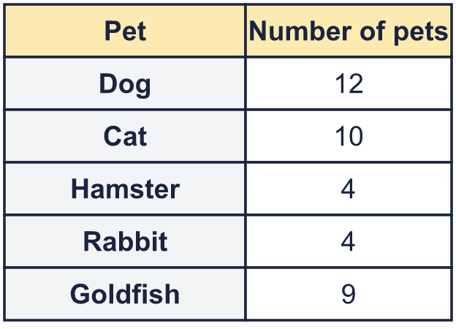  Is Sam correct? Circle yes or no.  Yes / No  Explain how you know.
    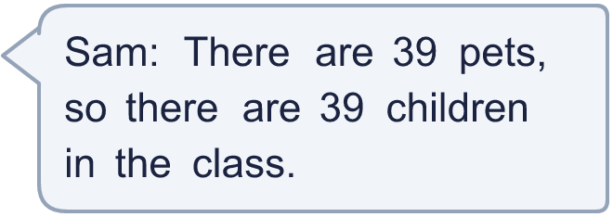
  12 | Class 5B did a survey about the pets that the children have at home. A child can have more than one pet, or none.  Is Sam correct? Circle yes or no.  Yes / No  Explain how you know.
  13 | The table shows the votes in a class poll of favourite colours. There were 40 votes in all. Red got 2 times as many votes as blue.  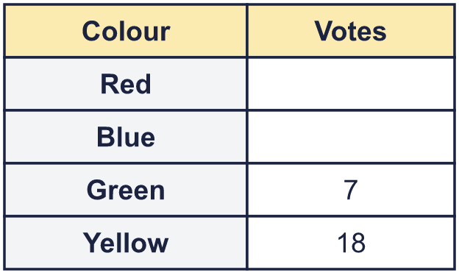
    Votes for red =
    Votes for blue =
  13 | The table shows the votes in a class poll of favourite colours. There were 40 votes in all. Red got 2 times as many votes as blue.
    Votes for red =
    Votes for blue =
  14 | The table shows the masses of five dogs. Henry's mass is not shown. Henry is heavier than Buster but lighter than Max.  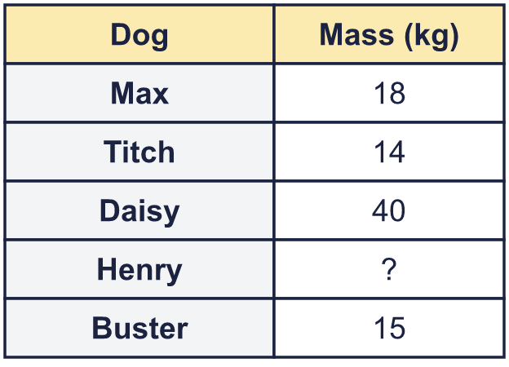  Write the names in order, starting with the lightest dog.
  14 | The table shows the masses of five dogs. Henry's mass is not shown. Henry is heavier than Buster but lighter than Max.  Write the names in order, starting with the lightest dog.

Year 5 · Statistics · Step 3
Read and interpret tables
Answers (teacher copy)

  1 | The table shows the masses of five dogs, to the nearest kilogram.  What is the total mass of Buster and Max? 63 kg  Which dog is the heaviest? Buster
  2 | The table shows the average summer temperature in six cities.  What is the average summer temperature in Berlin? 15 °C  Which city is the warmest? Edinburgh
  3 | The table shows the average summer temperature in six cities.  What is the difference in temperature between Paris and Athens? 4 °C  Which city is the coolest? Madrid
  4 | Daisy is 8 kg heavier than Buster. Work out Daisy's mass and write it in the table.  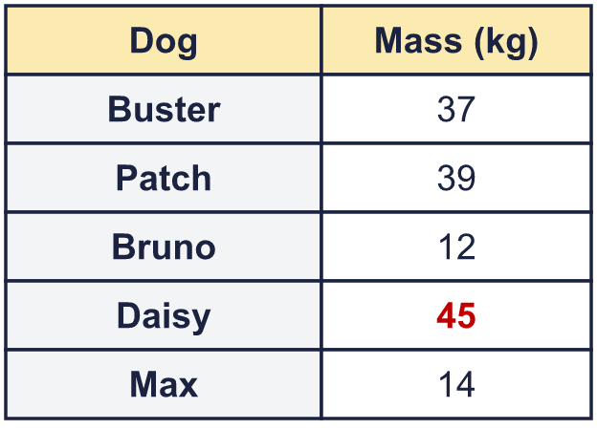  Daisy's mass = 45 kg
  5 | The table shows the number of children in each year group of a school. There are 180 children altogether. Work out the missing number and write it in the table.  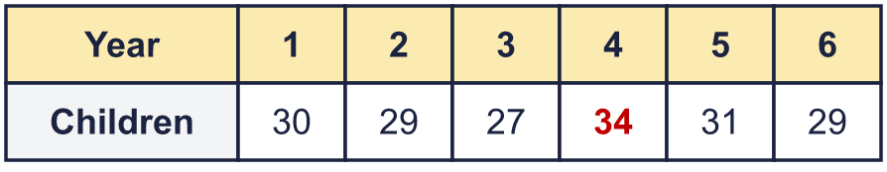  Children in Year 4 = 34
  6 | The tables show how the children in Year 4 and Year 5 travel to school.  Year 4  Year 5  Most common way to travel in Year 4: Walk  How many more children go by car in Year 4 than in Year 5? 7
  7 | Each child in two classes chose one club. The tables show how many children chose each club.  Class 5A  Class 5B  Which class has more children? Class 5B  How many more children are there? 3
  8 | The table shows the heights of five pupils.  Write the names in order, starting with the shortest. Dev, Ella, Hana, Cara, Anna
  9 | The table shows the number of ice cream cones a shop sold last week.  Is Dora correct? Circle yes or no.  Yes / No  Explain how you know.  Yes. Saturday and Sunday: 41 + 27 = 68. The other five days: 12 + 15 + 21 + 3 + 11 = 62. 68 is more than 62.
  10 | The table shows the average summer temperature in six cities.  How many pairs of cities have average temperatures that differ by exactly 2 °C? Count each pair once.  Number of pairs = 2
  11 | The table shows the average summer temperature in four cities. The average in Edinburgh is warmer than in London but colder than in Berlin. The temperature in Edinburgh is a whole number of degrees.  Write every temperature Edinburgh could have. 23, 24, 25
  12 | Class 5B did a survey about the pets that the children have at home. A child can have more than one pet, or none.  Is Sam correct? Circle yes or no.  Yes / No  Explain how you know.  No. We know the total number of pets is 39, but a child can have more than one pet, or no pet, so we cannot tell how many children there are.
  13 | The table shows the votes in a class poll of favourite colours. There were 40 votes in all. Red got 2 times as many votes as blue.  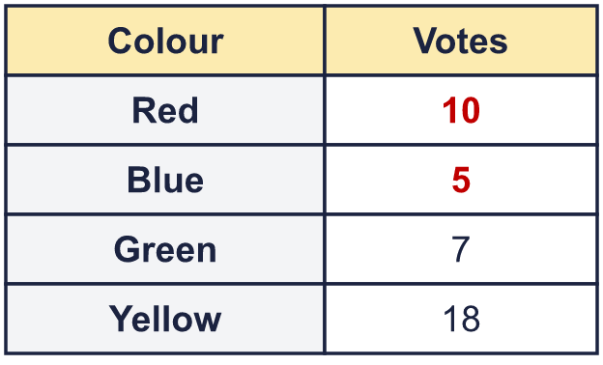  Votes for red = 10  Votes for blue = 5
  14 | The table shows the masses of five dogs. Henry's mass is not shown. Henry is heavier than Buster but lighter than Max.  Write the names in order, starting with the lightest dog. Titch, Buster, Henry, Max, Daisy

