  Year 5 · Statistics · Step 1  Draw line graphs | 
  Year 5 · Statistics · Step 1
  Draw line graphs
  1 | The table shows the mass of a calf at the end of each week. Draw a line graph of the data in your book. Put the weeks along the bottom and the mass up the side.  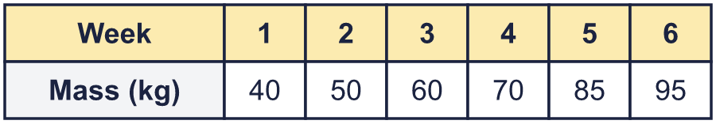
    Use your graph. What was the mass at the end of week 5?
    kg
    By how many kg did the mass go up between week 2 and week 6?
    kg
  1 | The table shows the mass of a calf at the end of each week. Draw a line graph of the data in your book. Put the weeks along the bottom and the mass up the side.
    Use your graph. What was the mass at the end of week 5?
    kg
    By how many kg did the mass go up between week 2 and week 6?
    kg
  2 | The table shows the height of a child at different ages. Draw a line graph of the data in your book.  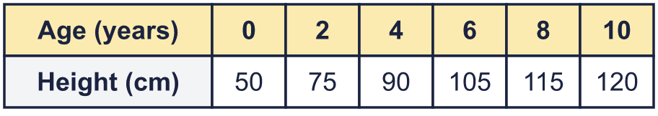
    By how many cm did the child grow between age 2 and age 6?
    cm
    At which age did the child's height first reach more than 100 cm? The age was
    years.
  2 | The table shows the height of a child at different ages. Draw a line graph of the data in your book.
    By how many cm did the child grow between age 2 and age 6?
    cm
    At which age did the child's height first reach more than 100 cm? The age was
    years.
  3 | The graph shows the height of a sunflower at the start of each week.  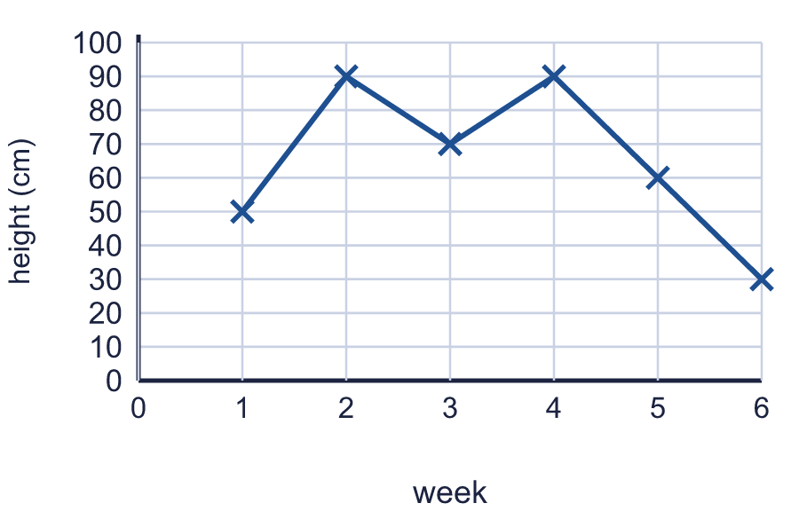
    What was the height at the start of week 2?
    cm
    What was the height at the start of week 6?
    cm
  3 | The graph shows the height of a sunflower at the start of each week.
    What was the height at the start of week 2?
    cm
    What was the height at the start of week 6?
    cm
  4 | The table shows the rainfall on five days. Which graph shows the data correctly? Write the letter.  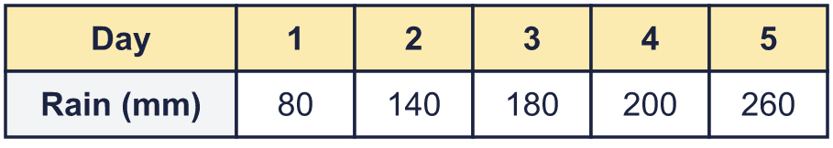  Graph A  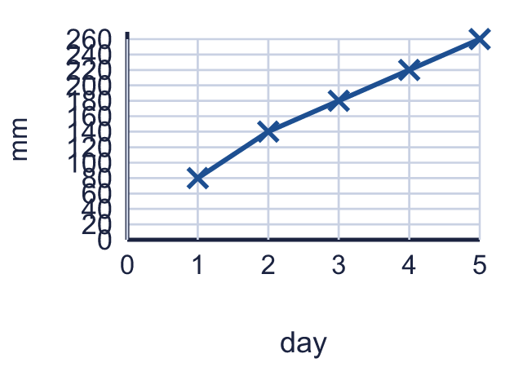  Graph B  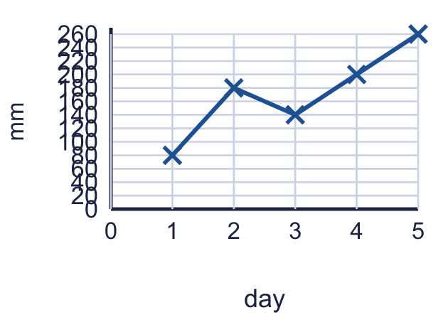  Graph C  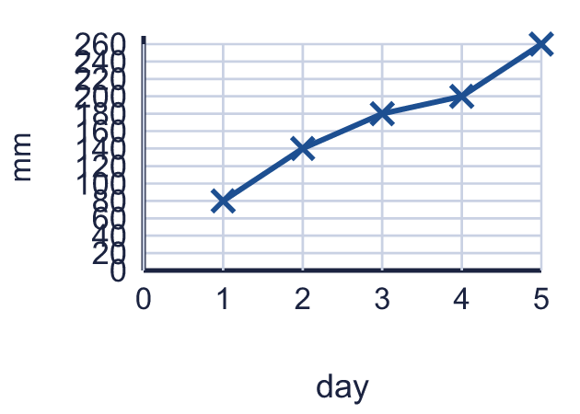
    Correct graph:
  4 | The table shows the rainfall on five days. Which graph shows the data correctly? Write the letter.  Graph A  Graph B  Graph C
    Correct graph:
  5 | The greatest value in a table is 167. You draw the vertical axis starting at 0 and going up in 20s.
    What is the smallest number the axis must reach?
    How many gridlines are there above 0?
  5 | The greatest value in a table is 167. You draw the vertical axis starting at 0 and going up in 20s.
    What is the smallest number the axis must reach?
    How many gridlines are there above 0?
  6 | The table shows that 5 miles is the same distance as 8 km. The points make a straight line, so the same pattern carries on.  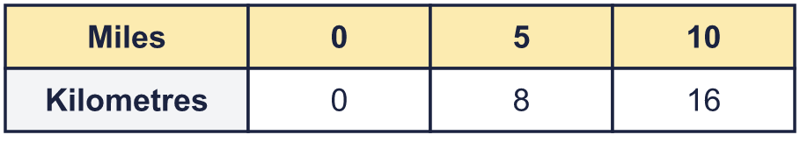
    How many km is 15 miles? |  | km
    How many km is 25 miles? |  | km
  6 | The table shows that 5 miles is the same distance as 8 km. The points make a straight line, so the same pattern carries on.
    How many km is 15 miles? |  | km
    How many km is 25 miles? |  | km
  7 | The table shows the hour of sunrise and sunset on the first day of each month. Draw one line graph with two lines in your book. Use a different line for sunrise and sunset.  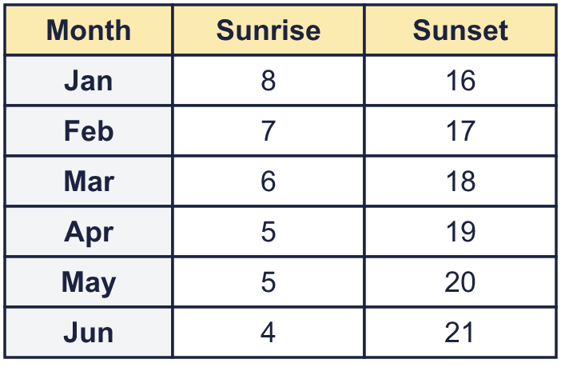
    In which month does the sun set latest? Write the month.
    How many hours of daylight are there on 1 June? Sunset minus sunrise =
    hours
  7 | The table shows the hour of sunrise and sunset on the first day of each month. Draw one line graph with two lines in your book. Use a different line for sunrise and sunset.
    In which month does the sun set latest? Write the month.
    How many hours of daylight are there on 1 June? Sunset minus sunrise =
    hours
  8 | The table shows miles and the same distances in kilometres. Plot the points on a graph in your book and join them with a ruler.  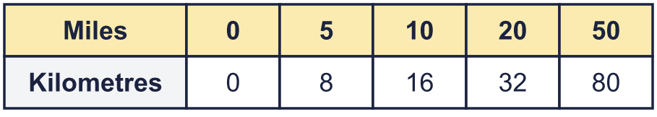
    Use your graph. About how many km is 25 miles?
    km
    About how many miles is 64 km?
    miles
  8 | The table shows miles and the same distances in kilometres. Plot the points on a graph in your book and join them with a ruler.
    Use your graph. About how many km is 25 miles?
    km
    About how many miles is 64 km?
    miles

  9 | 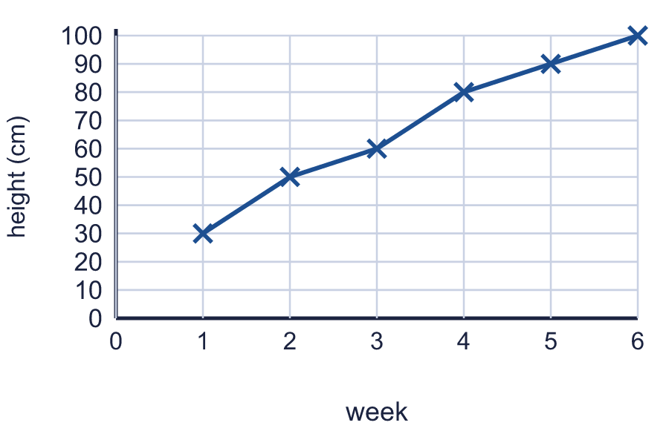  Is Tiara correct? Circle yes or no.  Yes / No  Explain how you know.
     | 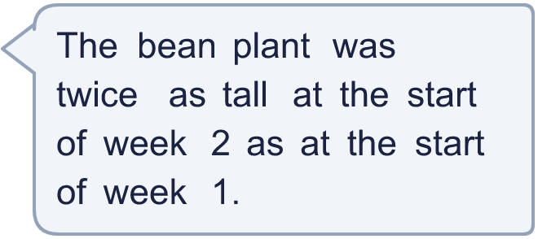
  9 | Is Tiara correct? Circle yes or no.  Yes / No  Explain how you know.
  10 | A class measures a bean plant each week. The table shows the results. Draw a line graph in your book. Use a ruler and put the weeks along the bottom.  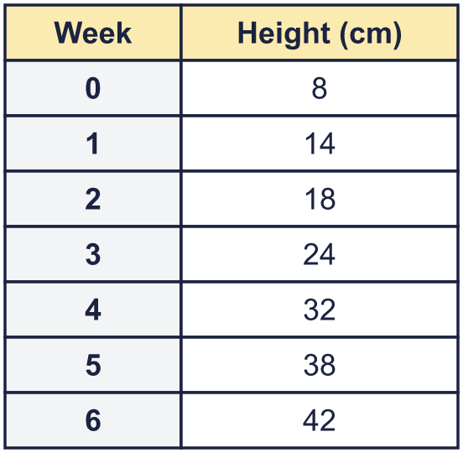
    Use your graph. What was the biggest increase in height in one week?
    cm
    In which week did the plant grow the most? Write the week number.
  10 | A class measures a bean plant each week. The table shows the results. Draw a line graph in your book. Use a ruler and put the weeks along the bottom.
    Use your graph. What was the biggest increase in height in one week?
    cm
    In which week did the plant grow the most? Write the week number.
  11 | The table shows the hour of sunrise and sunset on the first day of four months. Both times use the 24-hour clock. Daylight lasts from sunrise to sunset.  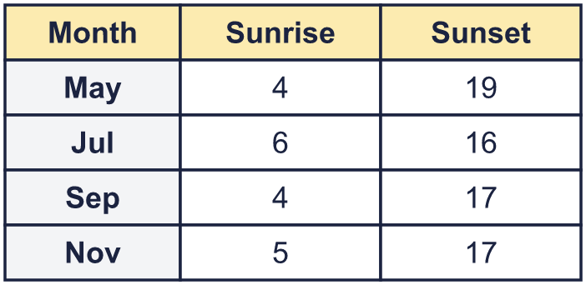
    Which month has the most daylight?
    How many more hours of daylight are there in May than in Jul?
    hours
  11 | The table shows the hour of sunrise and sunset on the first day of four months. Both times use the 24-hour clock. Daylight lasts from sunrise to sunset.
    Which month has the most daylight?
    How many more hours of daylight are there in May than in Jul?
    hours
  12 | The graph shows the height of two plants, A and B, each week.  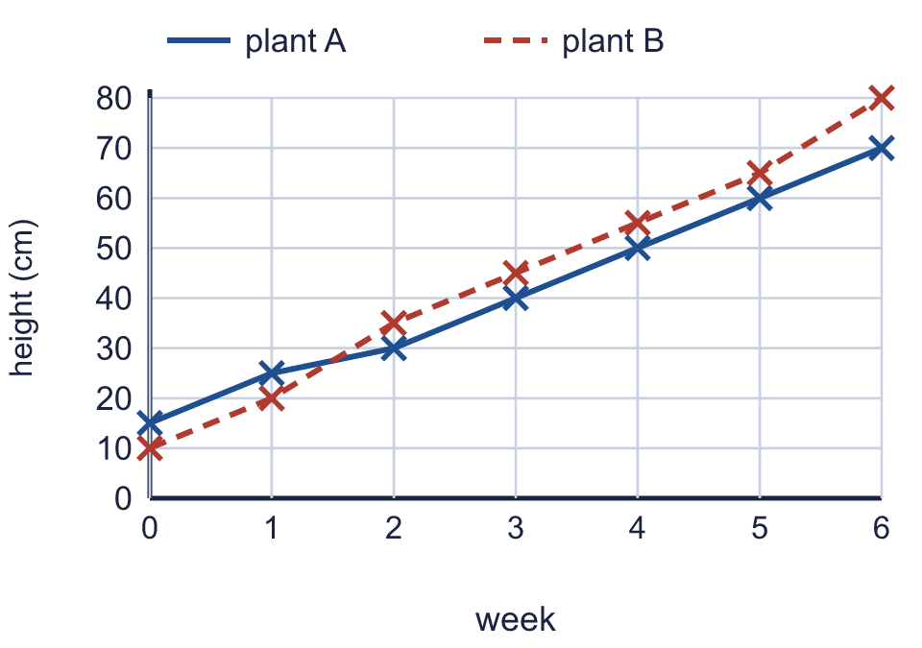  In which weeks was plant B taller than plant A? Write the week numbers.
    How many cm taller was plant B than plant A in week 5?
    cm
  12 | The graph shows the height of two plants, A and B, each week.  In which weeks was plant B taller than plant A? Write the week numbers.
    How many cm taller was plant B than plant A in week 5?
    cm
  13 | 5 miles is the same distance as 8 km, and the points on a graph of miles and kilometres make a straight line through (0, 0). The points are written as (miles, kilometres).  A: (15, 24)  B: (25, 36)  C: (20, 32)  D: (10, 18)  Which points are on the line? Write the letters.
  13 | 5 miles is the same distance as 8 km, and the points on a graph of miles and kilometres make a straight line through (0, 0). The points are written as (miles, kilometres).  A: (15, 24)  B: (25, 36)  C: (20, 32)  D: (10, 18)  Which points are on the line? Write the letters.
  14 | A weather station measures the temperature every hour. The table shows the readings. Draw a line graph in your book. Put the time along the bottom.  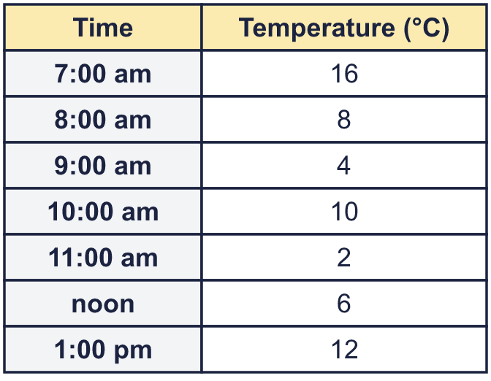
    At what time was it warmest? Write the time.
    At how many of the readings was the temperature higher than 10 °C?
  14 | A weather station measures the temperature every hour. The table shows the readings. Draw a line graph in your book. Put the time along the bottom.
    At what time was it warmest? Write the time.
    At how many of the readings was the temperature higher than 10 °C?

Year 5 · Statistics · Step 1
Draw line graphs
Answers (teacher copy)

  1 | The table shows the mass of a calf at the end of each week. Draw a line graph of the data in your book. Put the weeks along the bottom and the mass up the side.  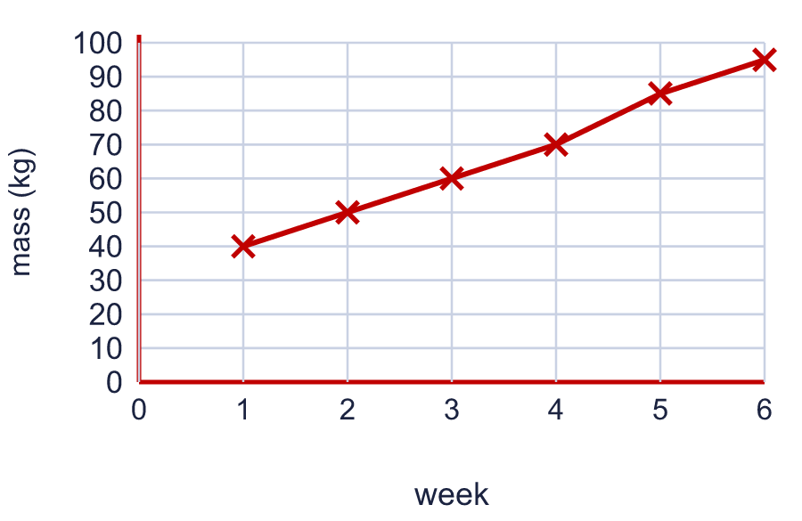  Use your graph. What was the mass at the end of week 5? 85 kg  By how many kg did the mass go up between week 2 and week 6? 45 kg
  2 | The table shows the height of a child at different ages. Draw a line graph of the data in your book.  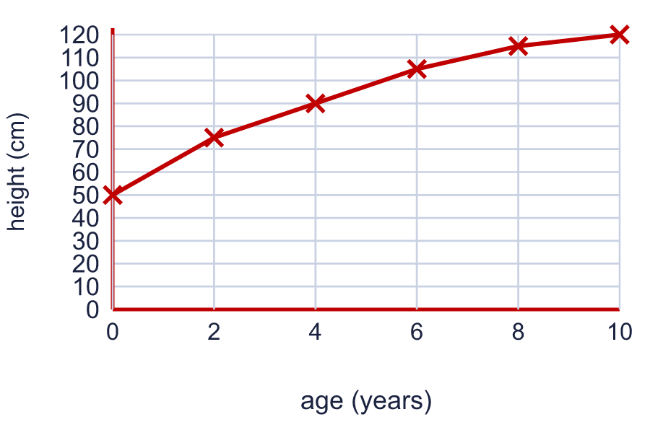  By how many cm did the child grow between age 2 and age 6? 30 cm  At which age did the child's height first reach more than 100 cm? The age was 6 years.
  3 | The graph shows the height of a sunflower at the start of each week.  What was the height at the start of week 2? 90 cm  What was the height at the start of week 6? 30 cm
  4 | The table shows the rainfall on five days. Which graph shows the data correctly? Write the letter.  Graph A  Graph B  Graph C  Correct graph: C
  5 | The greatest value in a table is 167. You draw the vertical axis starting at 0 and going up in 20s.  What is the smallest number the axis must reach? 180  How many gridlines are there above 0? 9
  6 | The table shows that 5 miles is the same distance as 8 km. The points make a straight line, so the same pattern carries on.  How many km is 15 miles? 24 km  How many km is 25 miles? 40 km
  7 | The table shows the hour of sunrise and sunset on the first day of each month. Draw one line graph with two lines in your book. Use a different line for sunrise and sunset.  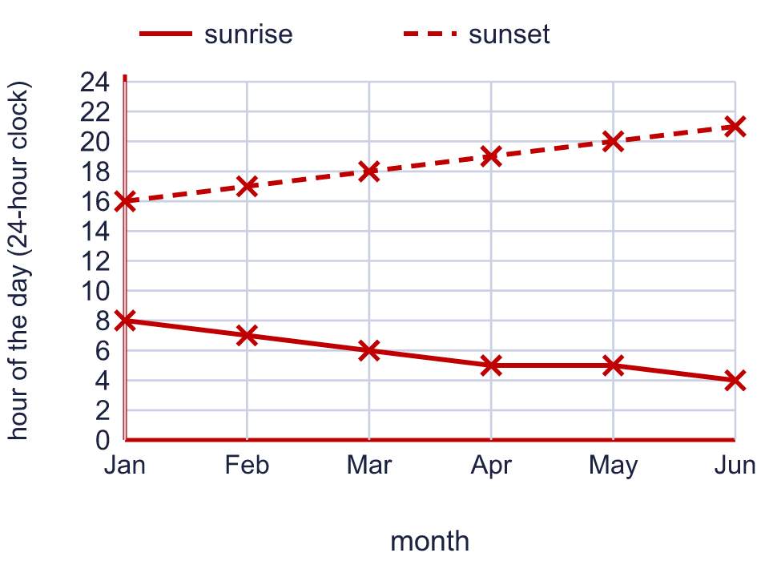  In which month does the sun set latest? Write the month. Jun  How many hours of daylight are there on 1 June? Sunset minus sunrise = 17 hours
  8 | The table shows miles and the same distances in kilometres. Plot the points on a graph in your book and join them with a ruler.  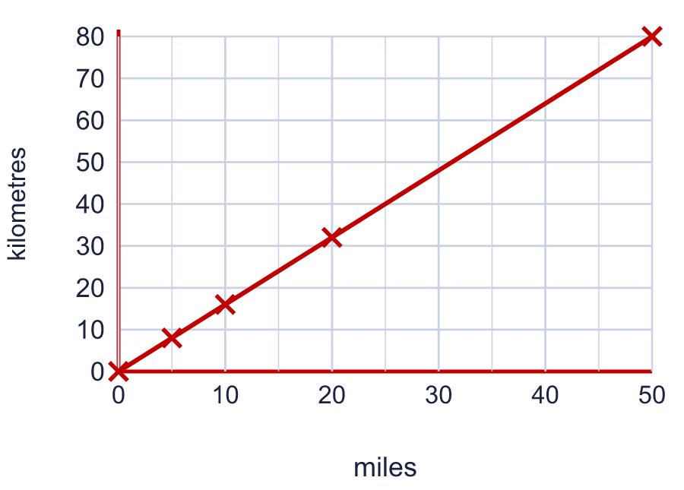  Use your graph. About how many km is 25 miles? 40 km  About how many miles is 64 km? 40 miles
  9 | Is Tiara correct? Circle yes or no.  Yes / No  Explain how you know.  No. Twice 30 cm is 60 cm, but the plant was 50 cm tall in week 2.
  10 | A class measures a bean plant each week. The table shows the results. Draw a line graph in your book. Use a ruler and put the weeks along the bottom.  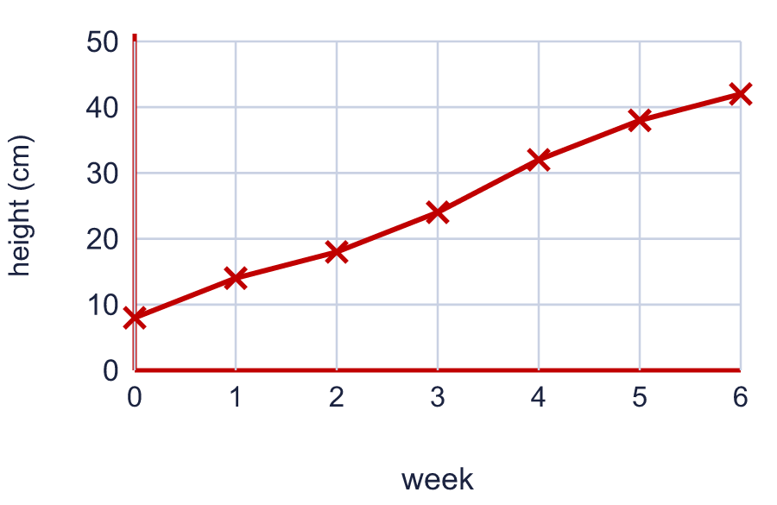  Use your graph. What was the biggest increase in height in one week? 8 cm  In which week did the plant grow the most? Write the week number. 4
  11 | The table shows the hour of sunrise and sunset on the first day of four months. Both times use the 24-hour clock. Daylight lasts from sunrise to sunset.  Which month has the most daylight? May  How many more hours of daylight are there in May than in Jul? 5 hours
  12 | The graph shows the height of two plants, A and B, each week.  In which weeks was plant B taller than plant A? Write the week numbers. 2, 3, 4, 5, 6  How many cm taller was plant B than plant A in week 5? 5 cm
  13 | 5 miles is the same distance as 8 km, and the points on a graph of miles and kilometres make a straight line through (0, 0). The points are written as (miles, kilometres).  A: (15, 24)  B: (25, 36)  C: (20, 32)  D: (10, 18)  Which points are on the line? Write the letters. A, C
  14 | A weather station measures the temperature every hour. The table shows the readings. Draw a line graph in your book. Put the time along the bottom.  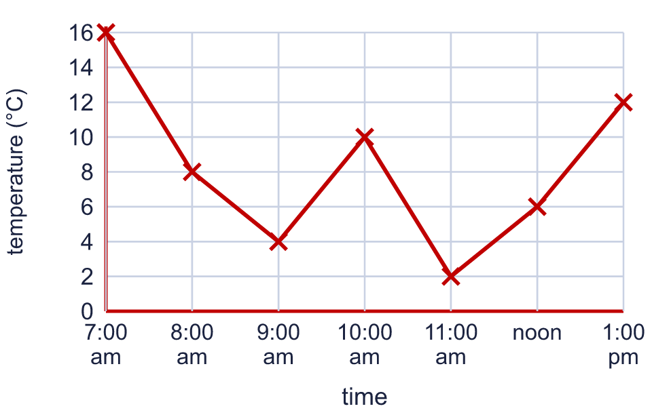  At what time was it warmest? Write the time. 7:00 am  At how many of the readings was the temperature higher than 10 °C? 2

