  Year 5 · Perimeter and area · Step 3  Perimeter of polygons | 
  Year 5 · Perimeter and area · Step 3
  Perimeter of polygons
  1 | Work out the perimeter of the triangle.  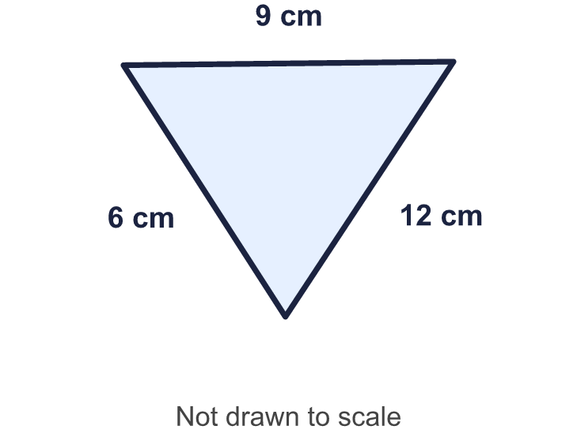
    Perimeter = |  | cm.
  1 | Work out the perimeter of the triangle.
    Perimeter = |  | cm.
  2 | Work out the perimeter of the shape.  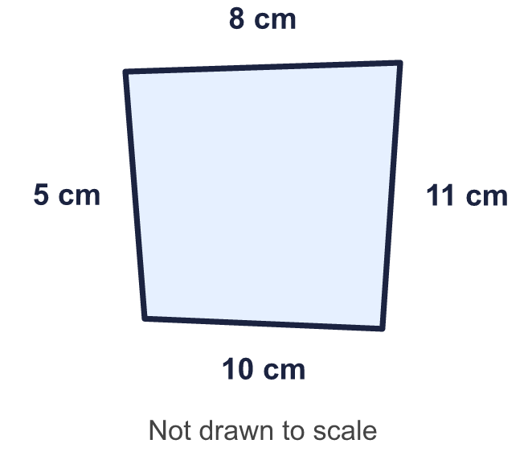
    Perimeter = |  | cm.
  2 | Work out the perimeter of the shape.
    Perimeter = |  | cm.
  3 | Work out the perimeter of the pentagon.  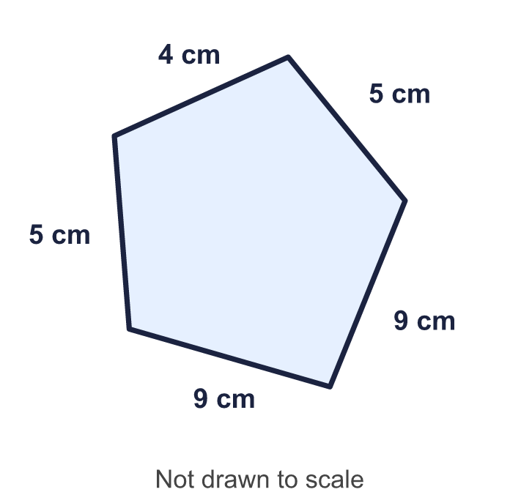
    Perimeter = |  | cm.
  3 | Work out the perimeter of the pentagon.
    Perimeter = |  | cm.
  4 | This is a regular pentagon. All its sides are the same length. Work out the perimeter.  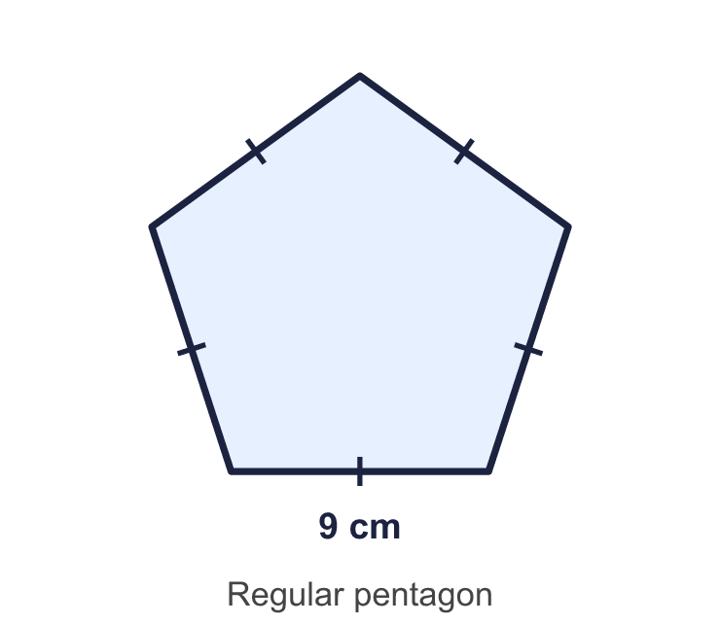
    Perimeter = |  | cm.
  4 | This is a regular pentagon. All its sides are the same length. Work out the perimeter.
    Perimeter = |  | cm.
  5 | Work out the perimeter of the regular hexagon.  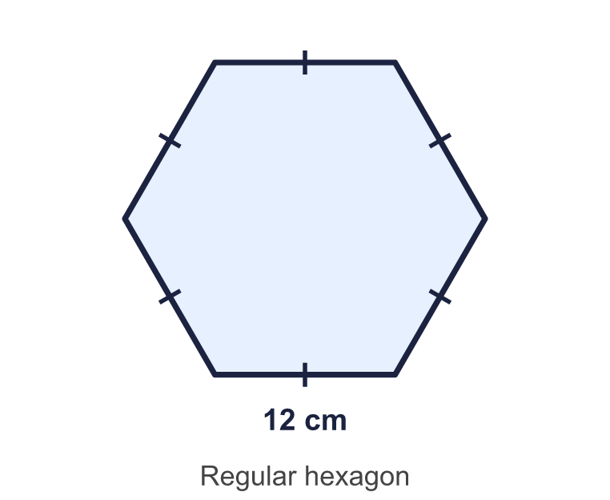
    Perimeter = |  | cm.
  5 | Work out the perimeter of the regular hexagon.
    Perimeter = |  | cm.
  6 | Work out the perimeter of each regular polygon.  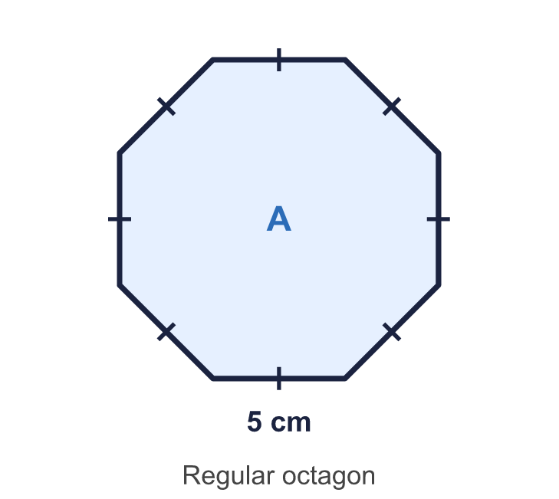  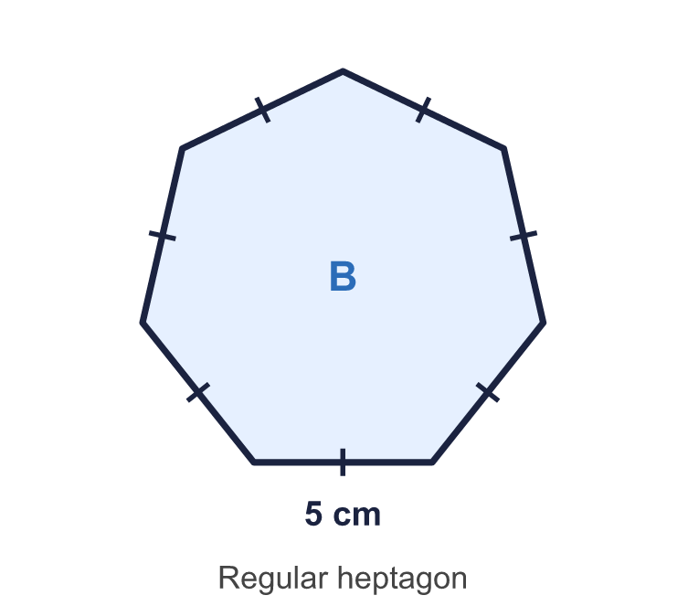
    a) Shape A: |  | cm.
    b) Shape B: |  | cm.
  6 | Work out the perimeter of each regular polygon.
    a) Shape A: |  | cm.
    b) Shape B: |  | cm.
  7 | Work out the perimeter of the shape.  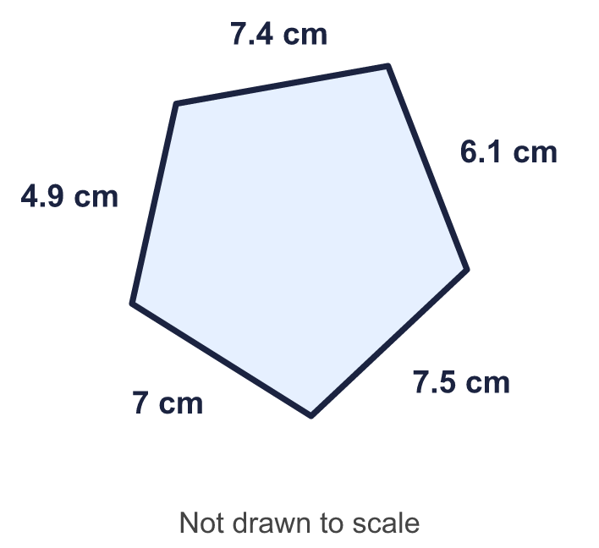
    Perimeter = |  | cm.
  7 | Work out the perimeter of the shape.
    Perimeter = |  | cm.
  8 | A regular pentagon has a perimeter of 30 cm.
    Length of one side = |  | cm.
  8 | A regular pentagon has a perimeter of 30 cm.
    Length of one side = |  | cm.

  9 | Three regular polygons each have a perimeter of 60 cm. Work out the length of one side of each.
    a) a square: |  | cm.
    b) an equilateral triangle:
    cm.
    c) a regular hexagon: |  | cm.
  9 | Three regular polygons each have a perimeter of 60 cm. Work out the length of one side of each.
    a) a square: |  | cm.
    b) an equilateral triangle:
    cm.
    c) a regular hexagon: |  | cm.
  10 | Work out the perimeter of the decagon.
     | 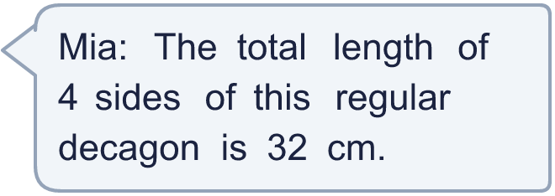
    Perimeter = |  | cm.
  10 | Work out the perimeter of the decagon.
    Perimeter = |  | cm.
  11 | A tennis court is 21 m long and 12 m wide. A football pitch is 92 m long and 59 m wide.  Jo walks round the edge of the tennis court 4 times. Zach walks round the edge of the football pitch once.
    How much further? |  | m.
  11 | A tennis court is 21 m long and 12 m wide. A football pitch is 92 m long and 59 m wide.  Jo walks round the edge of the tennis court 4 times. Zach walks round the edge of the football pitch once.
    How much further? |  | m.
  12 | 4 regular hexagons are joined in a row. Every side is 3 cm long. Work out the perimeter of the whole shape.  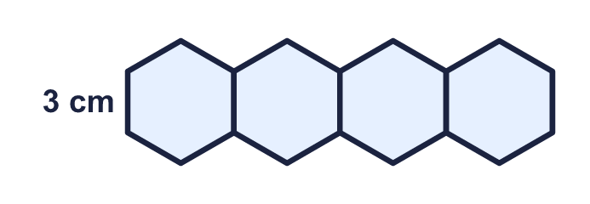
    Perimeter = |  | cm.
  12 | 4 regular hexagons are joined in a row. Every side is 3 cm long. Work out the perimeter of the whole shape.
    Perimeter = |  | cm.
  13 | A square and an equilateral triangle each have a perimeter of 48 cm.  How much longer is a side of the triangle than a side of the square?
    Difference = |  | cm.
  13 | A square and an equilateral triangle each have a perimeter of 48 cm.  How much longer is a side of the triangle than a side of the square?
    Difference = |  | cm.
  14 | Challenge  A regular hexagon has sides of 5 cm. A rectangle has the same perimeter as the hexagon. The length of the rectangle is 4 times its width.
    Width = |  | cm.
    Length = |  | cm.
  14 | Challenge  A regular hexagon has sides of 5 cm. A rectangle has the same perimeter as the hexagon. The length of the rectangle is 4 times its width.
    Width = |  | cm.
    Length = |  | cm.

Year 5 · Perimeter and area · Step 3
Perimeter of polygons
Answers (teacher copy)

  1 | Work out the perimeter of the triangle.  Perimeter = 27 cm.
  2 | Work out the perimeter of the shape.  Perimeter = 34 cm.
  3 | Work out the perimeter of the pentagon.  Perimeter = 32 cm.
  4 | This is a regular pentagon. All its sides are the same length. Work out the perimeter.  Perimeter = 45 cm.
  5 | Work out the perimeter of the regular hexagon.  Perimeter = 72 cm.
  6 | Work out the perimeter of each regular polygon.  a) Shape A: 40 cm.  b) Shape B: 35 cm.
  7 | Work out the perimeter of the shape.  Perimeter = 32.9 cm.
  8 | A regular pentagon has a perimeter of 30 cm.  Length of one side = 6 cm.
  9 | Three regular polygons each have a perimeter of 60 cm. Work out the length of one side of each.  a) a square: 15 cm.  b) an equilateral triangle: 20 cm.  c) a regular hexagon: 10 cm.
  10 | Work out the perimeter of the decagon.  Perimeter = 80 cm.
  11 | A tennis court is 21 m long and 12 m wide. A football pitch is 92 m long and 59 m wide.  Jo walks round the edge of the tennis court 4 times. Zach walks round the edge of the football pitch once.  Who walks further? Zach  How much further? 38 m.
  12 | 4 regular hexagons are joined in a row. Every side is 3 cm long. Work out the perimeter of the whole shape.  Perimeter = 54 cm.
  13 | A square and an equilateral triangle each have a perimeter of 48 cm.  How much longer is a side of the triangle than a side of the square?  Difference = 4 cm.
  14 | Challenge  A regular hexagon has sides of 5 cm. A rectangle has the same perimeter as the hexagon. The length of the rectangle is 4 times its width.  Width = 3 cm.  Length = 12 cm.

