  Year 5 · Perimeter and area · Step 4  Area of rectangles | 
  Year 5 · Perimeter and area · Step 4
  Area of rectangles
  1 | Count the squares to work out the area of the rectangle.  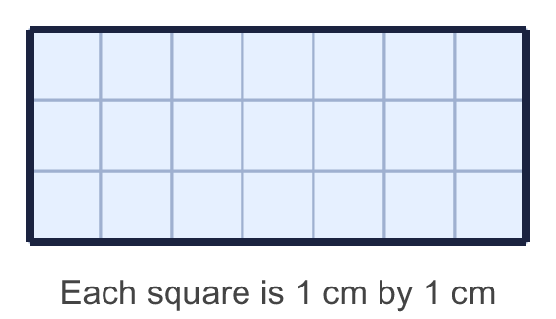
    Area = |  | cm²
  1 | Count the squares to work out the area of the rectangle.
    Area = |  | cm²
  2 | Use the diagram to complete the sentences.  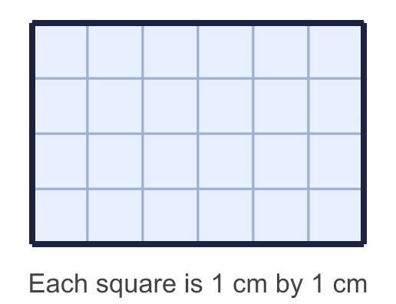
    Each row has |  | squares.
    There are |  | rows.
    There are |  | squares altogether.
    The area is |  | cm²
  2 | Use the diagram to complete the sentences.
    Each row has |  | squares.
    There are |  | rows.
    There are |  | squares altogether.
    The area is |  | cm²
  3 | Work out the area of the rectangle.  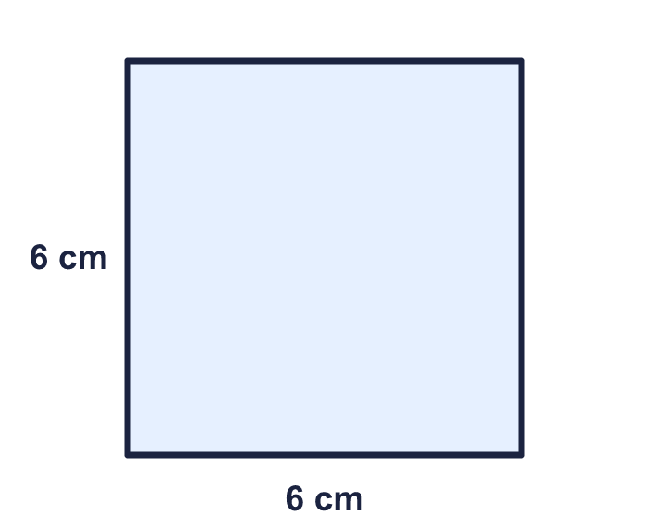
    Area = |  | cm²
  3 | Work out the area of the rectangle.
    Area = |  | cm²
  4 | Work out the area of the square.  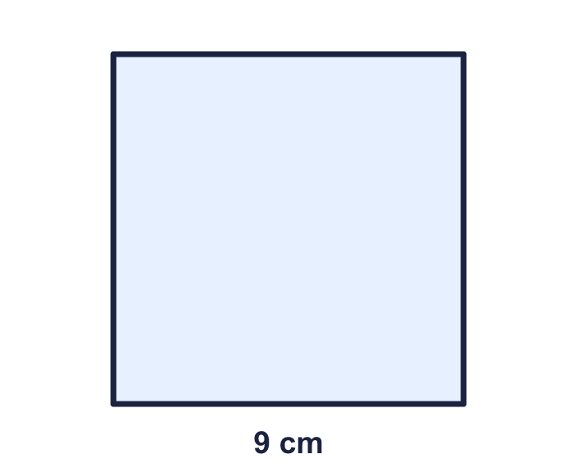
    Area = |  | cm²
  4 | Work out the area of the square.
    Area = |  | cm²
  5 | Work out the area of the playground.  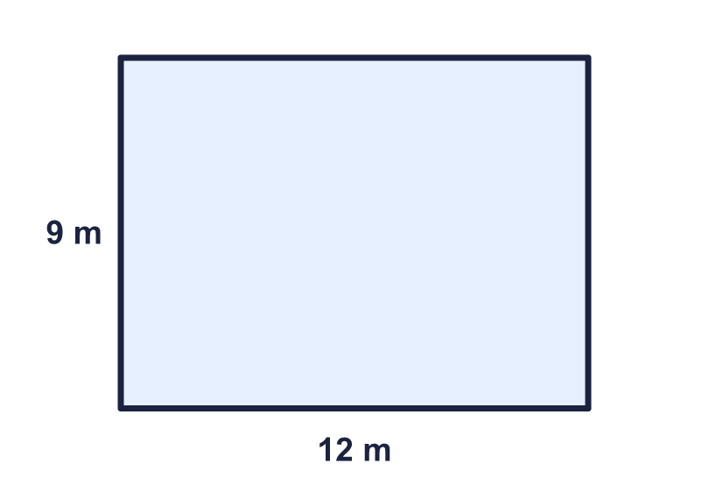
    Area = |  | m²
  5 | Work out the area of the playground.
    Area = |  | m²
  6 | Which rectangles have an area of 18 cm²? Write the letters.  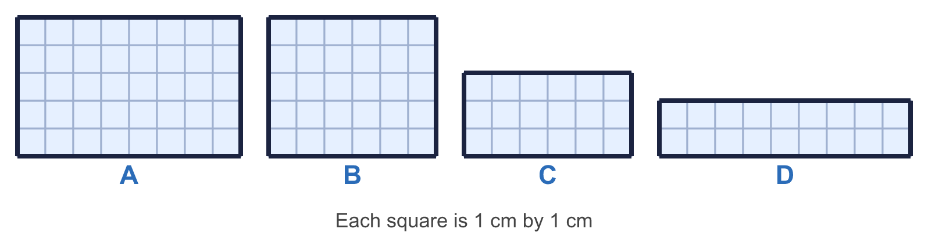
  6 | Which rectangles have an area of 18 cm²? Write the letters.
  7 | This rectangle has an area of 36 cm². Find the missing length.  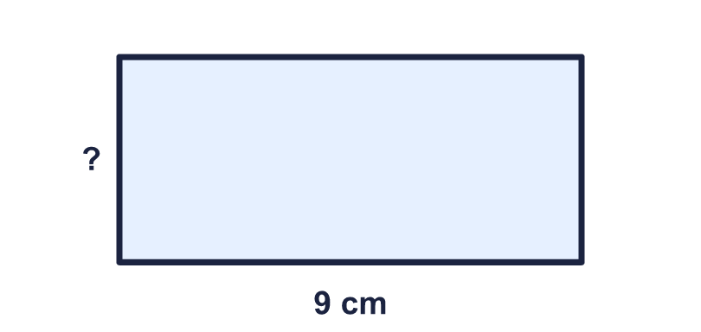
    Missing length in cm:
  7 | This rectangle has an area of 36 cm². Find the missing length.
    Missing length in cm:
  8 | A car park is a rectangle 29 m long and 12 m wide.
    Area of the car park = |  | m²
  8 | A car park is a rectangle 29 m long and 12 m wide.
    Area of the car park = |  | m²

  9 | Rectangles have sides that are whole numbers of centimetres. A 3 cm by 8 cm rectangle is the same as an 8 cm by 3 cm rectangle.  How many different rectangles have an area of 36 cm²?
    rectangles
  9 | Rectangles have sides that are whole numbers of centimetres. A 3 cm by 8 cm rectangle is the same as an 8 cm by 3 cm rectangle.  How many different rectangles have an area of 36 cm²?
    rectangles
  10 | The three rectangles have the same area. Shape A is a square. Work out the missing lengths.  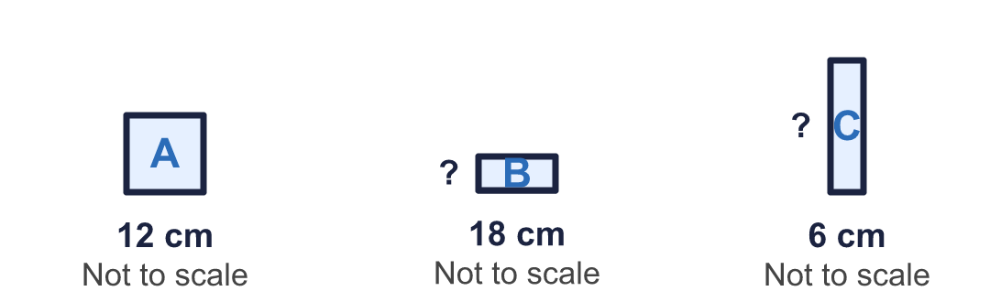
    B: missing length = |  | cm.
    C: missing length = |  | cm.
  10 | The three rectangles have the same area. Shape A is a square. Work out the missing lengths.
    B: missing length = |  | cm.
    C: missing length = |  | cm.
  11 | A rectangle has an area of 165 cm². Its length is 4 cm longer than its width. Both are whole numbers.
    Length = |  | cm.
    Width = |  | cm.
  11 | A rectangle has an area of 165 cm². Its length is 4 cm longer than its width. Both are whole numbers.
    Length = |  | cm.
    Width = |  | cm.
  12 | 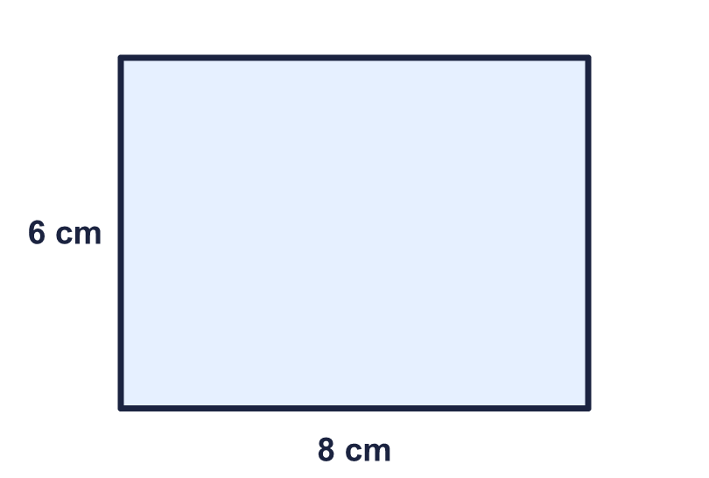  Is Sam correct? Circle yes or no.  Yes / No  Explain how you know.
    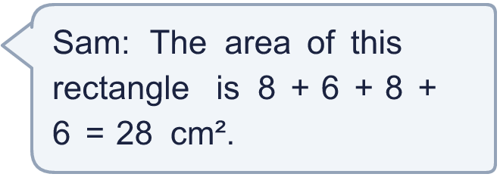
  12 | Is Sam correct? Circle yes or no.  Yes / No  Explain how you know.
  13 | A floor is 24 m long and 8 m wide. It is covered with square tiles. Each tile has sides of 4 m.
    Number of tiles needed =
  13 | A floor is 24 m long and 8 m wide. It is covered with square tiles. Each tile has sides of 4 m.
    Number of tiles needed =
  14 | Challenge  A rectangle has an area of 55 cm² and a perimeter of 32 cm. Its sides are whole numbers of centimetres.
    Length = |  | cm.
    Width = |  | cm.
  14 | Challenge  A rectangle has an area of 55 cm² and a perimeter of 32 cm. Its sides are whole numbers of centimetres.
    Length = |  | cm.
    Width = |  | cm.

Year 5 · Perimeter and area · Step 4
Area of rectangles
Answers (teacher copy)

  1 | Count the squares to work out the area of the rectangle.  Area = 21 cm²
  2 | Use the diagram to complete the sentences.  Each row has 6 squares.  There are 4 rows.  There are 24 squares altogether.  The area is 24 cm²
  3 | Work out the area of the rectangle.  Area = 36 cm²
  4 | Work out the area of the square.  Area = 81 cm²
  5 | Work out the area of the playground.  Area = 108 m²
  6 | Which rectangles have an area of 18 cm²? Write the letters.  C, D
  7 | This rectangle has an area of 36 cm². Find the missing length.  Missing length in cm: 4
  8 | A car park is a rectangle 29 m long and 12 m wide.  Area of the car park = 348 m²
  9 | Rectangles have sides that are whole numbers of centimetres. A 3 cm by 8 cm rectangle is the same as an 8 cm by 3 cm rectangle.  How many different rectangles have an area of 36 cm²?  5 rectangles
  10 | The three rectangles have the same area. Shape A is a square. Work out the missing lengths.  B: missing length = 8 cm.  C: missing length = 24 cm.
  11 | A rectangle has an area of 165 cm². Its length is 4 cm longer than its width. Both are whole numbers.  Length = 15 cm.  Width = 11 cm.
  12 | Is Sam correct? Circle yes or no.  Yes / No  Explain how you know.  No. 8 + 6 + 8 + 6 = 28 is the perimeter. The area is 8 × 6 = 48 cm².
  13 | A floor is 24 m long and 8 m wide. It is covered with square tiles. Each tile has sides of 4 m.  Number of tiles needed = 12
  14 | Challenge  A rectangle has an area of 55 cm² and a perimeter of 32 cm. Its sides are whole numbers of centimetres.  Length = 11 cm.  Width = 5 cm.

