  Year 5 · Perimeter and area · Step 5  Area of compound shapes | 
  Year 5 · Perimeter and area · Step 5
  Area of compound shapes
  1 | Count the squares to work out the area of the shape.  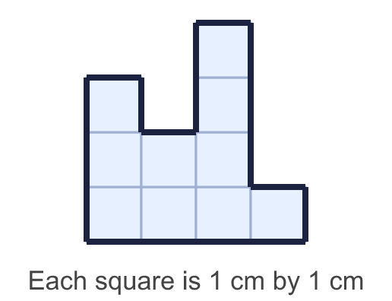
    Area = |  | cm²
  1 | Count the squares to work out the area of the shape.
    Area = |  | cm²
  2 | Work out the area of each shape.  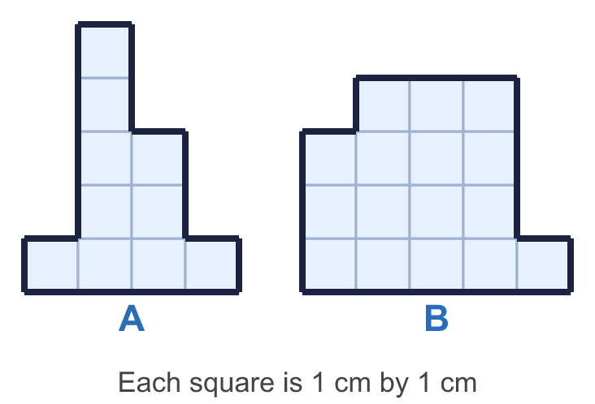
    a) Shape A: |  | cm²
    b) Shape B: |  | cm²
  2 | Work out the area of each shape.
    a) Shape A: |  | cm²
    b) Shape B: |  | cm²
  3 | The shape is made from two rectangles. Rectangle A is below the dashed line and rectangle B is above it.  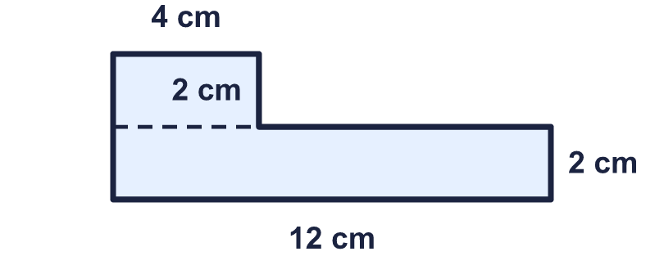
    Area of rectangle A = |  | cm²
    Area of rectangle B = |  | cm²
    Area of the whole shape = |  | cm²
  3 | The shape is made from two rectangles. Rectangle A is below the dashed line and rectangle B is above it.
    Area of rectangle A = |  | cm²
    Area of rectangle B = |  | cm²
    Area of the whole shape = |  | cm²
  4 | Work out the area of the shape.  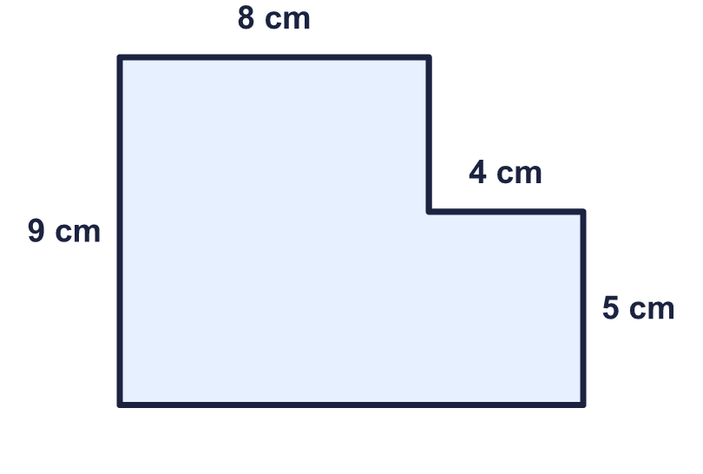
    Area = |  | cm²
  4 | Work out the area of the shape.
    Area = |  | cm²
  5 | Work out the area of the shape.  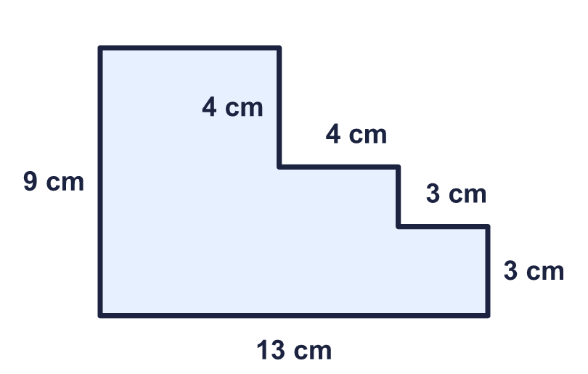
    Area = |  | cm²
  5 | Work out the area of the shape.
    Area = |  | cm²
  6 | Work out the area of the shape.  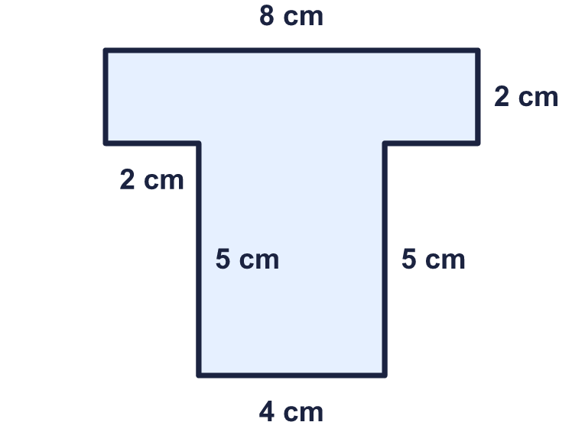
    Area = |  | cm²
  6 | Work out the area of the shape.
    Area = |  | cm²
  7 | Work out the area of the shape.  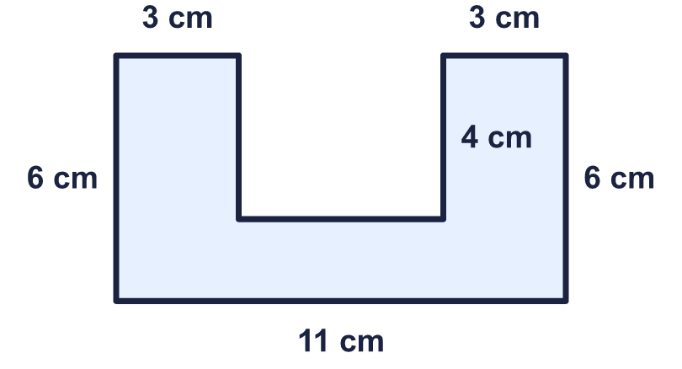
    Area = |  | cm²
  7 | Work out the area of the shape.
    Area = |  | cm²
  8 | Work out the area of the garden.  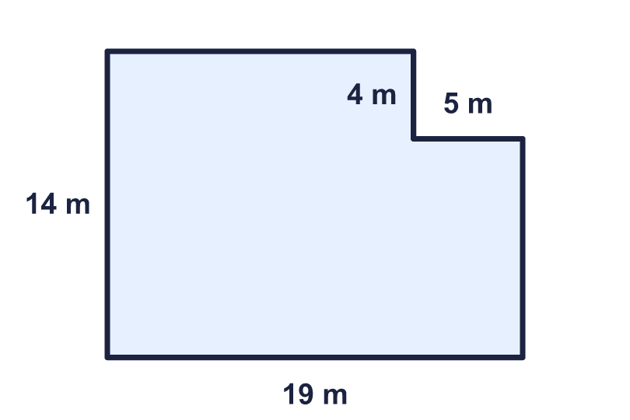
    Area = |  | m²
  8 | Work out the area of the garden.
    Area = |  | m²

  9 | 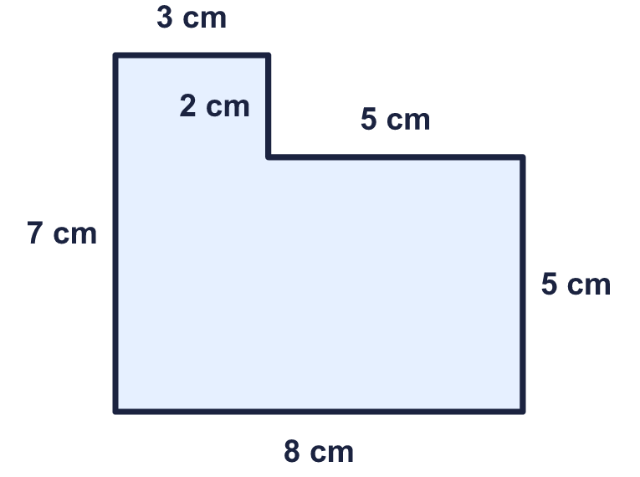  Is Rosie correct? Circle yes or no.  Yes / No  Explain how you know.
     | 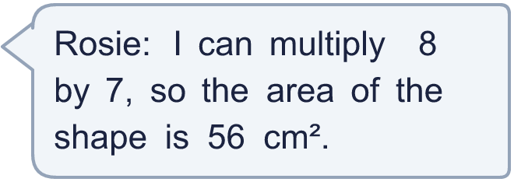
  9 | Is Rosie correct? Circle yes or no.  Yes / No  Explain how you know.
  10 | Which calculations give the area of the shape? Write the letters.  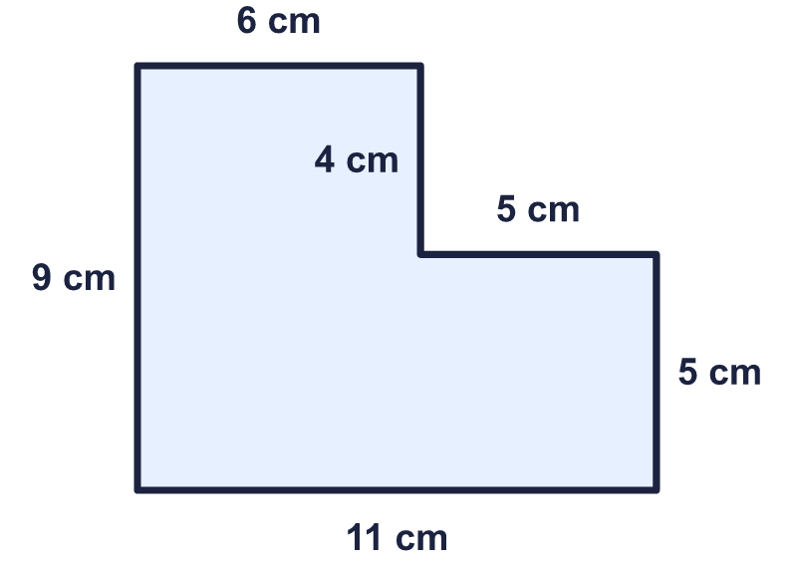  A: 11 + 9 + 5 + 4  B: 6 × 9 + 5 × 5  C: 11 × 9 − 5 × 4  D: 11 × 9 + 5 × 4
  10 | Which calculations give the area of the shape? Write the letters.  A: 11 + 9 + 5 + 4  B: 6 × 9 + 5 × 5  C: 11 × 9 − 5 × 4  D: 11 × 9 + 5 × 4
  11 | The area of the shape is 111 cm². Work out the missing length.  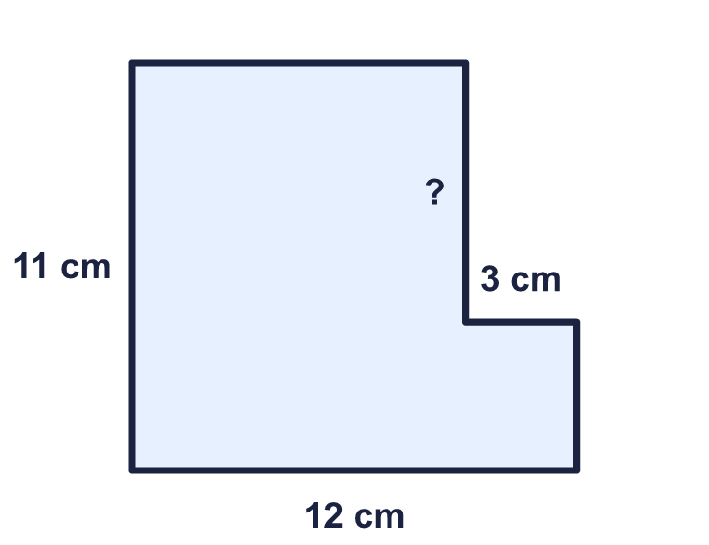
    Missing length = |  | cm.
  11 | The area of the shape is 111 cm². Work out the missing length.
    Missing length = |  | cm.
  12 | A rectangular lawn is 18 m long and 14 m wide. A pond in the lawn is a rectangle 4 m long and 2 m wide. Grass seed is needed for the part of the lawn that is not the pond.
    Area to cover with seed = |  | m²
  12 | A rectangular lawn is 18 m long and 14 m wide. A pond in the lawn is a rectangle 4 m long and 2 m wide. Grass seed is needed for the part of the lawn that is not the pond.
    Area to cover with seed = |  | m²
  13 | Work out the perimeter and the area of the shape.  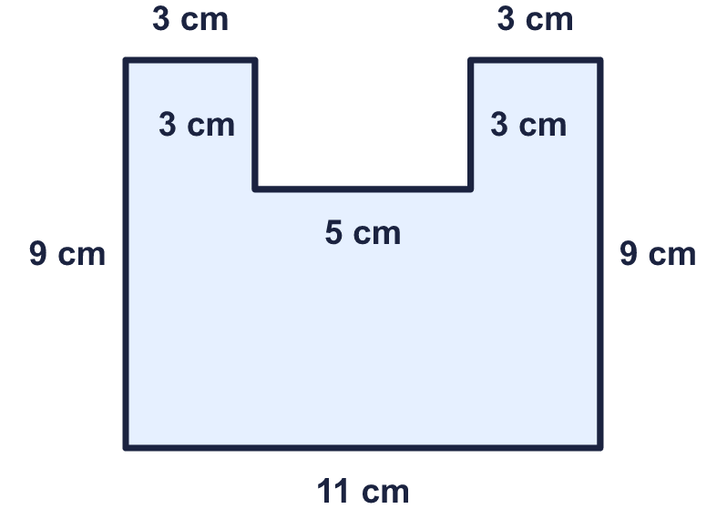
    Perimeter = |  | cm.
    Area = |  | cm²
  13 | Work out the perimeter and the area of the shape.
    Perimeter = |  | cm.
    Area = |  | cm²
  14 | Challenge  Carpet for the floor of this room costs £9 for each square metre.  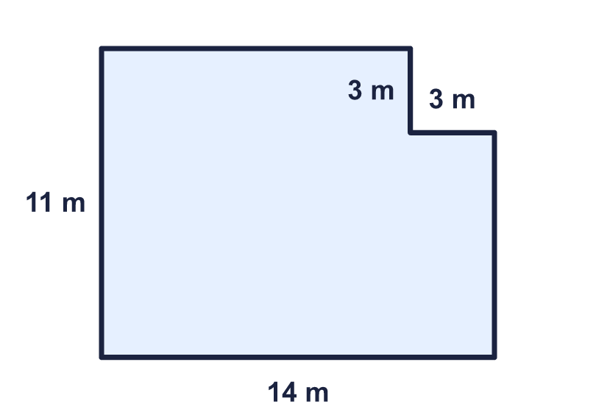
    Cost of the carpet = £
  14 | Challenge  Carpet for the floor of this room costs £9 for each square metre.
    Cost of the carpet = £

Year 5 · Perimeter and area · Step 5
Area of compound shapes
Answers (teacher copy)

  1 | Count the squares to work out the area of the shape.  Area = 10 cm²
  2 | Work out the area of each shape.  a) Shape A: 10 cm²  b) Shape B: 16 cm²
  3 | The shape is made from two rectangles. Rectangle A is below the dashed line and rectangle B is above it.  Area of rectangle A = 24 cm²  Area of rectangle B = 8 cm²  Area of the whole shape = 32 cm²
  4 | Work out the area of the shape.  Area = 92 cm²
  5 | Work out the area of the shape.  Area = 83 cm²
  6 | Work out the area of the shape.  Area = 36 cm²
  7 | Work out the area of the shape.  Area = 46 cm²
  8 | Work out the area of the garden.  Area = 246 m²
  9 | Is Rosie correct? Circle yes or no.  Yes / No  Explain how you know.  No. 8 × 7 = 56 cm² is the area with the missing corner filled in. Take away the corner, 5 × 2 = 10 cm², to get 46 cm².
  10 | Which calculations give the area of the shape? Write the letters.  A: 11 + 9 + 5 + 4  B: 6 × 9 + 5 × 5  C: 11 × 9 − 5 × 4  D: 11 × 9 + 5 × 4  B, C
  11 | The area of the shape is 111 cm². Work out the missing length.  Missing length = 7 cm.
  12 | A rectangular lawn is 18 m long and 14 m wide. A pond in the lawn is a rectangle 4 m long and 2 m wide. Grass seed is needed for the part of the lawn that is not the pond.  Area to cover with seed = 244 m²
  13 | Work out the perimeter and the area of the shape.  Perimeter = 46 cm.  Area = 84 cm²
  14 | Challenge  Carpet for the floor of this room costs £9 for each square metre.  Cost of the carpet = £ 1305

