  Year 5 · Multiply and divide B · Step 10  Efficient division | 
  Year 5 · Multiply and divide B · Step 10
  Efficient division
  1 | Divide in two steps. Write both answers.
    a) | 196 ÷ 2 = |  | then ÷ 2 =
    b) | 1,332 ÷ 2 = |  | then ÷ 3 =
  1 | Divide in two steps. Write both answers.
    a) | 196 ÷ 2 = |  | then ÷ 2 =
    b) | 1,332 ÷ 2 = |  | then ÷ 3 =
  2 | 1,044 ÷ 12 can be worked out in two steps using factors of 12.
    1,044 ÷ 12 = 1,044 ÷ 2 ÷ |  | =
  2 | 1,044 ÷ 12 can be worked out in two steps using factors of 12.
    1,044 ÷ 12 = 1,044 ÷ 2 ÷ |  | =
  3 | Use factors to work out each division. Do not use any factor of 1.  a) 652 ÷ 4 =  b) 330 ÷ 6 =  c) 1,328 ÷ 8 =  d) 864 ÷ 9 =
  3 | Use factors to work out each division. Do not use any factor of 1.  a) 652 ÷ 4 =  b) 330 ÷ 6 =  c) 1,328 ÷ 8 =  d) 864 ÷ 9 =
  4 | Ron is working out 552 ÷ 8. Which methods give the correct answer? Write the letters.  a) 552 ÷ 4 ÷ 4  b) 552 ÷ 2 ÷ 6  c) 552 ÷ 2 ÷ 4
  4 | Ron is working out 552 ÷ 8. Which methods give the correct answer? Write the letters.  a) 552 ÷ 4 ÷ 4  b) 552 ÷ 2 ÷ 6  c) 552 ÷ 2 ÷ 4
  5 | These divisions give the same answer. Write the missing number.
    1,360 ÷ 20 = 1,360 ÷ 5 ÷
  5 | These divisions give the same answer. Write the missing number.
    1,360 ÷ 20 = 1,360 ÷ 5 ÷
  6 | Write which of 2, 3, 5, 6 each number is divisible by. Write none if there are none.  a) 1,230  b) 4,560  c) 366  d) 990
  6 | Write which of 2, 3, 5, 6 each number is divisible by. Write none if there are none.  a) 1,230  b) 4,560  c) 366  d) 990
  7 | Use factors to work out the divisions.  a) 2,652 ÷ 6 =  b) 2,336 ÷ 8 =
  7 | Use factors to work out the divisions.  a) 2,652 ÷ 6 =  b) 2,336 ÷ 8 =
  8 | 9 ÷ 3 = 3. Use this fact to work out the divisions.  a) 900 ÷ 3 =  b) 90 ÷ 3 =  c) 900 ÷ 30 =
  8 | 9 ÷ 3 = 3. Use this fact to work out the divisions.  a) 900 ÷ 3 =  b) 90 ÷ 3 =  c) 900 ÷ 30 =

  9 | a) Jack’s answer:  b) Rosie’s answer:
    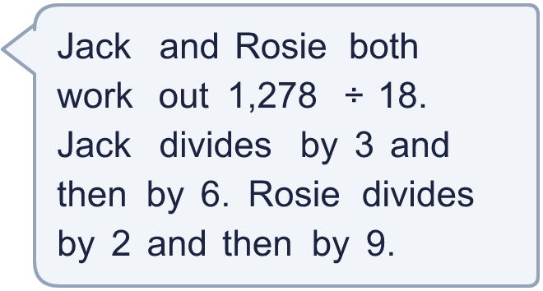
  9 | a) Jack’s answer:  b) Rosie’s answer:
  10 | Is Boba correct? Circle yes or no.  Yes / No  Explain how you know.
     | 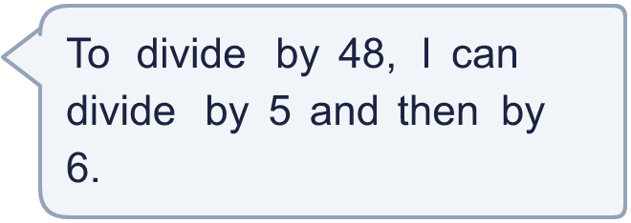
  10 | Is Boba correct? Circle yes or no.  Yes / No  Explain how you know.
  11 | Mo and Dora are working out 1,548 ÷ 18.  Who is correct?
     | 
     | 
  11 | Mo and Dora are working out 1,548 ÷ 18.  Who is correct?
  12 | What number did I start with?
    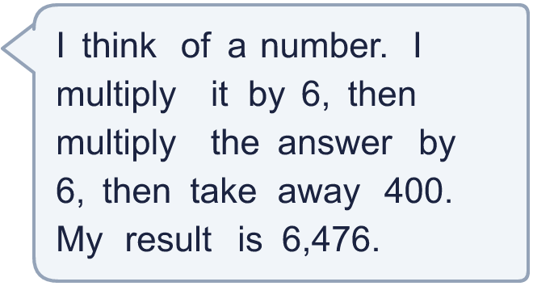
  12 | What number did I start with?
  13 | A school has 696 pencils. They are shared equally between 8 classes.  How many pencils does each class get?
  13 | A school has 696 pencils. They are shared equally between 8 classes.  How many pencils does each class get?
  14 | Write two different ways to divide by 12 in two steps, using two factors.
  14 | Write two different ways to divide by 12 in two steps, using two factors.

Year 5 · Multiply and divide B · Step 10
Efficient division
Answers (teacher copy)

  1 | Divide in two steps. Write both answers.  a) 196 ÷ 2 = 98 then ÷ 2 = 49  b) 1,332 ÷ 2 = 666 then ÷ 3 = 222
  2 | 1,044 ÷ 12 can be worked out in two steps using factors of 12.  1,044 ÷ 12 = 1,044 ÷ 2 ÷ 6 = 87
  3 | Use factors to work out each division. Do not use any factor of 1.  a) 652 ÷ 4 = 163  b) 330 ÷ 6 = 55  c) 1,328 ÷ 8 = 166  d) 864 ÷ 9 = 96
  4 | Ron is working out 552 ÷ 8. Which methods give the correct answer? Write the letters.  a) 552 ÷ 4 ÷ 4  b) 552 ÷ 2 ÷ 6  c) 552 ÷ 2 ÷ 4  c
  5 | These divisions give the same answer. Write the missing number.  1,360 ÷ 20 = 1,360 ÷ 5 ÷ 4
  6 | Write which of 2, 3, 5, 6 each number is divisible by. Write none if there are none.  a) 1,230 2, 3, 5, 6  b) 4,560 2, 3, 5, 6  c) 366 2, 3, 6  d) 990 2, 3, 5, 6
  7 | Use factors to work out the divisions.  a) 2,652 ÷ 6 = 442  b) 2,336 ÷ 8 = 292
  8 | 9 ÷ 3 = 3. Use this fact to work out the divisions.  a) 900 ÷ 3 = 300  b) 90 ÷ 3 = 30  c) 900 ÷ 30 = 30
  9 | a) Jack’s answer: 71  b) Rosie’s answer: 71
  10 | Is Boba correct? Circle yes or no.  Yes / No  Explain how you know.  5 × 6 = 30, not 48. Dividing by 5 and then 6 is the same as dividing by 30.
  11 | Mo and Dora are working out 1,548 ÷ 18.  Who is correct? Dora
  12 | What number did I start with? 191
  13 | A school has 696 pencils. They are shared equally between 8 classes.  How many pencils does each class get? 87
  14 | Write two different ways to divide by 12 in two steps, using two factors.  Any two pairs of factors with a product of 12, for example 3 × 4 or 2 × 6

