  Year 5 · Multiply and divide B · Step 9  Dividing with remainders | 
  Year 5 · Multiply and divide B · Step 9
  Dividing with remainders
  1 | Work out the divisions. Write any remainder like this: 56 r 3.  a) 157 ÷ 2 =  b) 2,431 ÷ 7 =  c) 1,366 ÷ 7 =
  1 | Work out the divisions. Write any remainder like this: 56 r 3.  a) 157 ÷ 2 =  b) 2,431 ÷ 7 =  c) 1,366 ÷ 7 =
  2 | Work out the divisions. Write any remainder.  a) 4,204 ÷ 5 =  b) 9,933 ÷ 5 =  c) 8,810 ÷ 4 =
  2 | Work out the divisions. Write any remainder.  a) 4,204 ÷ 5 =  b) 9,933 ÷ 5 =  c) 8,810 ÷ 4 =
  3 | Write the remainder for each division. You do not need the whole answer.  a) 3,629 ÷ 3: remainder  b) 3,190 ÷ 6: remainder  c) 8,881 ÷ 6: remainder
  3 | Write the remainder for each division. You do not need the whole answer.  a) 3,629 ÷ 3: remainder  b) 3,190 ÷ 6: remainder  c) 8,881 ÷ 6: remainder
  4 | Which is greater: 3,556 ÷ 5 or 6,839 ÷ 3?  Write a or b. (a is the first calculation.)
  4 | Which is greater: 3,556 ÷ 5 or 6,839 ÷ 3?  Write a or b. (a is the first calculation.)
  5 | Pencils are packed in boxes of 8. There are 1,995 pencils.  a) How many full boxes can be made?  b) How many pencils are left over?
  5 | Pencils are packed in boxes of 8. There are 1,995 pencils.  a) How many full boxes can be made?  b) How many pencils are left over?
  6 | Work out the divisions.  a) 1,181 ÷ 9 =  b) 4,097 ÷ 4 =
  6 | Work out the divisions.  a) 1,181 ÷ 9 =  b) 4,097 ÷ 4 =
  7 | Each minibus seats 4 people. 390 people want to go on a trip.  How many minibuses are needed?
  7 | Each minibus seats 4 people. 390 people want to go on a trip.  How many minibuses are needed?
  8 | 40 ÷ 8 = 5. Use this fact to work out the divisions.  a) 400 ÷ 8 =  b) 4,000 ÷ 8 =  c) 4,000 ÷ 80 =
  8 | 40 ÷ 8 = 5. Use this fact to work out the divisions.  a) 400 ÷ 8 =  b) 4,000 ÷ 8 =  c) 4,000 ÷ 80 =

  9 | Is Boba correct? Circle yes or no.  Yes / No  Explain how you know.
     | 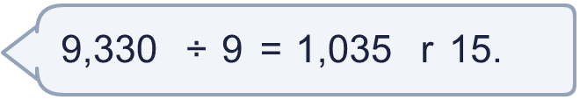
  9 | Is Boba correct? Circle yes or no.  Yes / No  Explain how you know.
  10 | What number did I start with?
     | 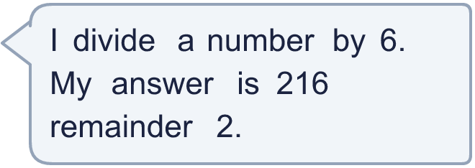
  10 | What number did I start with?
  11 | a) How many times must the ride go round so that everyone rides once?  b) How many people are on the last ride?
     | 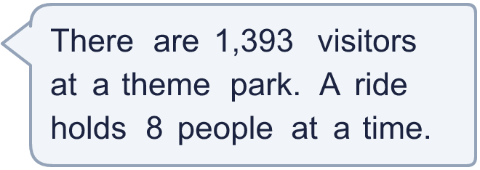
  11 | a) How many times must the ride go round so that everyone rides once?  b) How many people are on the last ride?
  12 | Write the remainder when 1,742 is divided by each number.  ÷ 2, ÷ 3, ÷ 4, ÷ 5, ÷ 6:
  12 | Write the remainder when 1,742 is divided by each number.  ÷ 2, ÷ 3, ÷ 4, ÷ 5, ÷ 6:
  13 | a) How many stickers does each friend get?  b) How many stickers does Dani keep?
    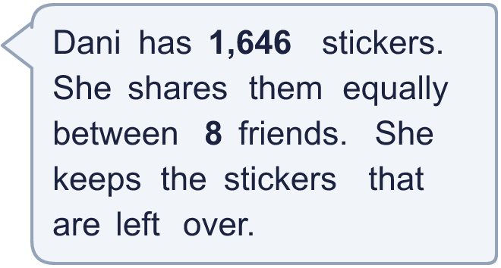
  13 | a) How many stickers does each friend get?  b) How many stickers does Dani keep?
  14 | Write three different 4-digit numbers that leave a remainder of 2 when divided by 6.
  14 | Write three different 4-digit numbers that leave a remainder of 2 when divided by 6.

Year 5 · Multiply and divide B · Step 9
Dividing with remainders
Answers (teacher copy)

  1 | Work out the divisions. Write any remainder like this: 56 r 3.  a) 157 ÷ 2 = 78 r 1  b) 2,431 ÷ 7 = 347 r 2  c) 1,366 ÷ 7 = 195 r 1
  2 | Work out the divisions. Write any remainder.  a) 4,204 ÷ 5 = 840 r 4  b) 9,933 ÷ 5 = 1,986 r 3  c) 8,810 ÷ 4 = 2,202 r 2
  3 | Write the remainder for each division. You do not need the whole answer.  a) 3,629 ÷ 3: remainder 2  b) 3,190 ÷ 6: remainder 4  c) 8,881 ÷ 6: remainder 1
  4 | Which is greater: 3,556 ÷ 5 or 6,839 ÷ 3?  Write a or b. (a is the first calculation.) b
  5 | Pencils are packed in boxes of 8. There are 1,995 pencils.  a) How many full boxes can be made? 249  b) How many pencils are left over? 3
  6 | Work out the divisions.  a) 1,181 ÷ 9 = 131 r 2  b) 4,097 ÷ 4 = 1,024 r 1
  7 | Each minibus seats 4 people. 390 people want to go on a trip.  How many minibuses are needed? 98
  8 | 40 ÷ 8 = 5. Use this fact to work out the divisions.  a) 400 ÷ 8 = 50  b) 4,000 ÷ 8 = 500  c) 4,000 ÷ 80 = 50
  9 | Is Boba correct? Circle yes or no.  Yes / No  Explain how you know.  The remainder 15 is bigger than 9, so another group of 9 can be made. 9,330 ÷ 9 = 1,036 r 6.
  10 | What number did I start with? 1,298
  11 | a) How many times must the ride go round so that everyone rides once? 175  b) How many people are on the last ride? 1
  12 | Write the remainder when 1,742 is divided by each number.  ÷ 2, ÷ 3, ÷ 4, ÷ 5, ÷ 6: 0, 2, 2, 2, 2
  13 | a) How many stickers does each friend get? 205  b) How many stickers does Dani keep? 6
  14 | Write three different 4-digit numbers that leave a remainder of 2 when divided by 6.  Any three 4-digit numbers with remainder 2 when divided by 6, for example 3,248, 5,498, 7,748

