  Year 5 · Fractions B · Step 5  Finding a fraction of an amount | 
  Year 5 · Fractions B · Step 5
  Finding a fraction of an amount
  1 | Work out each fraction of the amount.  a) ¹⁄₄ of 104 =  b) ¹⁄₆ of 210 =  c) ¹⁄₈ of 184 =  d) ¹⁄₉ of 72 =
  1 | Work out each fraction of the amount.  a) ¹⁄₄ of 104 =  b) ¹⁄₆ of 210 =  c) ¹⁄₈ of 184 =  d) ¹⁄₉ of 72 =
  2 | Work out each fraction of the amount.  a) ³⁄₆ of 234 =  b) ²⁄₁₀ of 240 =  c) ²⁄₉ of 261 =  d) ⁴⁄₁₀ of 390 =
  2 | Work out each fraction of the amount.  a) ³⁄₆ of 234 =  b) ²⁄₁₀ of 240 =  c) ²⁄₉ of 261 =  d) ⁴⁄₁₀ of 390 =
  3 | Work out each fraction of 30. What do you notice?  a) ¹⁄₆ of 30 =  b) ²⁄₆ of 30 =  c) ³⁄₆ of 30 =  d) ⁵⁄₆ of 30 =
  3 | Work out each fraction of 30. What do you notice?  a) ¹⁄₆ of 30 =  b) ²⁄₆ of 30 =  c) ³⁄₆ of 30 =  d) ⁵⁄₆ of 30 =
  4 | Write <, > or = in each box.
    a) | ¹⁄₅ of 45 |  | ³⁄₅ of 45
    b) | ⁹⁄₁₀ of 140 |  | ⁶⁄₁₀ of 140
    c) | ²⁄₅ of 45 |  | ⁴⁄₅ of 45
  4 | Write <, > or = in each box.
    a) | ¹⁄₅ of 45 |  | ³⁄₅ of 45
    b) | ⁹⁄₁₀ of 140 |  | ⁶⁄₁₀ of 140
    c) | ²⁄₅ of 45 |  | ⁴⁄₅ of 45
  5 | Tia has 64 sweets. Tia gives ²⁄₄ of them to a friend.  How many sweets does the friend get?
  5 | Tia has 64 sweets. Tia gives ²⁄₄ of them to a friend.  How many sweets does the friend get?
  6 | Work out each amount of money.  a) ⁷⁄₈ of 112 =  b) ²⁄₁₀ of 190 =  c) ²⁄₈ of 96 =
  6 | Work out each amount of money.  a) ⁷⁄₈ of 112 =  b) ²⁄₁₀ of 190 =  c) ²⁄₈ of 96 =
  7 | Three of these amounts are equal to 30. Write the one that is not.  ¹⁄₆ of 180 ¹⁄₅ of 150 ³⁄₈ of 232 ¹⁄₄ of 120
  7 | Three of these amounts are equal to 30. Write the one that is not.  ¹⁄₆ of 180 ¹⁄₅ of 150 ³⁄₈ of 232 ¹⁄₄ of 120
  8 | Work out each fraction of the amount.  a) ⁴⁄₇ of 91 =  b) ³⁄₄ of 124 =  c) ²⁄₅ of 40 =  d) ¹⁄₈ of 200 =
  8 | Work out each fraction of the amount.  a) ⁴⁄₇ of 91 =  b) ³⁄₄ of 124 =  c) ²⁄₅ of 40 =  d) ¹⁄₈ of 200 =

  9 | Is Boba correct? Circle yes or no.  Yes / No  Explain the mistake.
     | 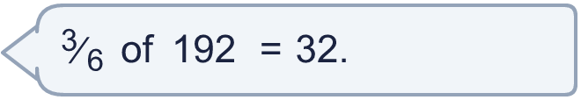
  9 | Is Boba correct? Circle yes or no.  Yes / No  Explain the mistake.
  10 | A box has 64 counters. ²⁄₄ of the counters are red and ¹⁄₄ of the counters are blue. The rest are yellow.  How many counters are yellow?
  10 | A box has 64 counters. ²⁄₄ of the counters are red and ¹⁄₄ of the counters are blue. The rest are yellow.  How many counters are yellow?
  11 | Esther and Scott each have a bag of 200 marbles. Esther takes ¹⁄₈ of her marbles. Scott takes ²⁄₈ of his marbles.
  11 | Esther and Scott each have a bag of 200 marbles. Esther takes ¹⁄₈ of her marbles. Scott takes ²⁄₈ of his marbles.
  12 | How many children come by bus?
     | 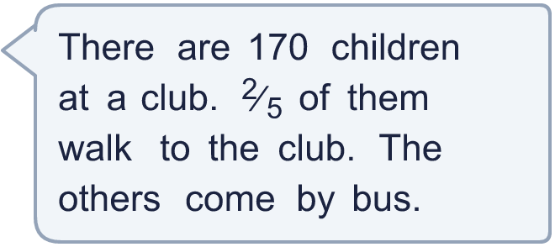
  12 | How many children come by bus?
  13 | A bike costs £200. A shop takes ²⁄₅ off the price in a sale.  How much money is taken off the price?
  13 | A bike costs £200. A shop takes ²⁄₅ off the price in a sale.  How much money is taken off the price?
  14 | 400 people go on a school trip. ²⁄₅ of them are children. ³⁄₄ of the children are boys.  How many boys go on the trip?
  14 | 400 people go on a school trip. ²⁄₅ of them are children. ³⁄₄ of the children are boys.  How many boys go on the trip?

Year 5 · Fractions B · Step 5
Finding a fraction of an amount
Answers (teacher copy)

  1 | Work out each fraction of the amount.  a) ¹⁄₄ of 104 = 26  b) ¹⁄₆ of 210 = 35  c) ¹⁄₈ of 184 = 23  d) ¹⁄₉ of 72 = 8
  2 | Work out each fraction of the amount.  a) ³⁄₆ of 234 = 117  b) ²⁄₁₀ of 240 = 48  c) ²⁄₉ of 261 = 58  d) ⁴⁄₁₀ of 390 = 156
  3 | Work out each fraction of 30. What do you notice?  a) ¹⁄₆ of 30 = 5  b) ²⁄₆ of 30 = 10  c) ³⁄₆ of 30 = 15  d) ⁵⁄₆ of 30 = 25
  4 | Write <, > or = in each box.  a) ¹⁄₅ of 45 < ³⁄₅ of 45  b) ⁹⁄₁₀ of 140 > ⁶⁄₁₀ of 140  c) ²⁄₅ of 45 < ⁴⁄₅ of 45
  5 | Tia has 64 sweets. Tia gives ²⁄₄ of them to a friend.  How many sweets does the friend get? 32
  6 | Work out each amount of money.  a) ⁷⁄₈ of 112 = £98  b) ²⁄₁₀ of 190 = £38  c) ²⁄₈ of 96 = £24
  7 | Three of these amounts are equal to 30. Write the one that is not.  ¹⁄₆ of 180 ¹⁄₅ of 150 ³⁄₈ of 232 ¹⁄₄ of 120  ³⁄₈ of 232
  8 | Work out each fraction of the amount.  a) ⁴⁄₇ of 91 = 52  b) ³⁄₄ of 124 = 93  c) ²⁄₅ of 40 = 16  d) ¹⁄₈ of 200 = 25
  9 | Is Boba correct? Circle yes or no.  Yes / No  Explain the mistake.  No. ¹⁄₆ of 192 = 32. ³⁄₆ of 192 = 3 × 32 = 96.
  10 | A box has 64 counters. ²⁄₄ of the counters are red and ¹⁄₄ of the counters are blue. The rest are yellow.  How many counters are yellow? 16
  11 | Esther and Scott each have a bag of 200 marbles. Esther takes ¹⁄₈ of her marbles. Scott takes ²⁄₈ of his marbles.  Who takes more marbles? Scott
  12 | How many children come by bus? 102
  13 | A bike costs £200. A shop takes ²⁄₅ off the price in a sale.  How much money is taken off the price? £80
  14 | 400 people go on a school trip. ²⁄₅ of them are children. ³⁄₄ of the children are boys.  How many boys go on the trip? 120

