  Year 5 · Fractions B · Step 4  Calculating a fraction of a quantity | 
  Year 5 · Fractions B · Step 4
  Calculating a fraction of a quantity
  1 | Work out each fraction of the amount.  a) ¹⁄₄ of 28 =  b) ¹⁄₃ of 18 =  c) ¹⁄₁₀ of 70 =  d) ¹⁄₈ of 16 =
  1 | Work out each fraction of the amount.  a) ¹⁄₄ of 28 =  b) ¹⁄₃ of 18 =  c) ¹⁄₁₀ of 70 =  d) ¹⁄₈ of 16 =
  2 | Work out each fraction of the amount.  a) ²⁄₄ of 16 =  b) ⁶⁄₁₀ of 30 =  c) ²⁄₂ of 22 =  d) ⁶⁄₈ of 24 =
  2 | Work out each fraction of the amount.  a) ²⁄₄ of 16 =  b) ⁶⁄₁₀ of 30 =  c) ²⁄₂ of 22 =  d) ⁶⁄₈ of 24 =
  3 | Work out each fraction of 24. What do you notice?  a) ¹⁄₆ of 24 =  b) ³⁄₆ of 24 =  c) ⁴⁄₆ of 24 =  d) ⁶⁄₆ of 24 =
  3 | Work out each fraction of 24. What do you notice?  a) ¹⁄₆ of 24 =  b) ³⁄₆ of 24 =  c) ⁴⁄₆ of 24 =  d) ⁶⁄₆ of 24 =
  4 | Write <, > or = in each box.
    a) | ¹⁄₄ of 40 |  | ²⁄₄ of 40
    b) | ¹⁄₅ of 45 |  | ⁴⁄₅ of 45
    c) | ⁷⁄₈ of 40 |  | ⁵⁄₈ of 40
  4 | Write <, > or = in each box.
    a) | ¹⁄₄ of 40 |  | ²⁄₄ of 40
    b) | ¹⁄₅ of 45 |  | ⁴⁄₅ of 45
    c) | ⁷⁄₈ of 40 |  | ⁵⁄₈ of 40
  5 | Tia has 30 sweets. Tia gives ²⁄₅ of them to a friend.  How many sweets does the friend get?
  5 | Tia has 30 sweets. Tia gives ²⁄₅ of them to a friend.  How many sweets does the friend get?
  6 | Work out each amount of money.  a) ⁶⁄₈ of 40 =  b) ³⁄₁₀ of 100 =  c) ²⁄₅ of 60 =
  6 | Work out each amount of money.  a) ⁶⁄₈ of 40 =  b) ³⁄₁₀ of 100 =  c) ²⁄₅ of 60 =
  7 | Three of these amounts are equal to 20. Write the one that is not.  ¹⁄₈ of 160 ²⁄₄ of 92 ¹⁄₅ of 100 ¹⁄₆ of 120
  7 | Three of these amounts are equal to 20. Write the one that is not.  ¹⁄₈ of 160 ²⁄₄ of 92 ¹⁄₅ of 100 ¹⁄₆ of 120
  8 | Work out each fraction of the amount.  a) ⁴⁄₅ of 30 =  b) ²⁄₃ of 30 =  c) ⁷⁄₁₀ of 50 =  d) ²⁄₆ of 66 =
  8 | Work out each fraction of the amount.  a) ⁴⁄₅ of 30 =  b) ²⁄₃ of 30 =  c) ⁷⁄₁₀ of 50 =  d) ²⁄₆ of 66 =

  9 | Is Boba correct? Circle yes or no.  Yes / No  Explain the mistake.
     | 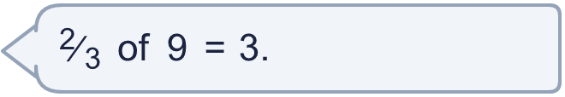
  9 | Is Boba correct? Circle yes or no.  Yes / No  Explain the mistake.
  10 | A box has 28 counters. ¹⁄₄ of the counters are red and ²⁄₄ of the counters are blue. The rest are yellow.  How many counters are yellow?
  10 | A box has 28 counters. ¹⁄₄ of the counters are red and ²⁄₄ of the counters are blue. The rest are yellow.  How many counters are yellow?
  11 | Esther and Scott each have a bag of 240 marbles. Esther takes ⁶⁄₁₀ of her marbles. Scott takes ³⁄₈ of his marbles.
  11 | Esther and Scott each have a bag of 240 marbles. Esther takes ⁶⁄₁₀ of her marbles. Scott takes ³⁄₈ of his marbles.
  12 | How many children come by bus?
     | 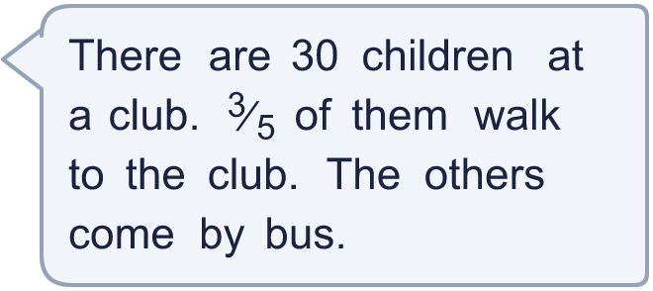
  12 | How many children come by bus?
  13 | A bike costs £56. A shop takes ⁴⁄₈ off the price in a sale.  How much money is taken off the price?
  13 | A bike costs £56. A shop takes ⁴⁄₈ off the price in a sale.  How much money is taken off the price?
  14 | 240 people go on a school trip. ³⁄₈ of them are children. ¹⁄₂ of the children are boys.  How many boys go on the trip?
  14 | 240 people go on a school trip. ³⁄₈ of them are children. ¹⁄₂ of the children are boys.  How many boys go on the trip?

Year 5 · Fractions B · Step 4
Calculating a fraction of a quantity
Answers (teacher copy)

  1 | Work out each fraction of the amount.  a) ¹⁄₄ of 28 = 7  b) ¹⁄₃ of 18 = 6  c) ¹⁄₁₀ of 70 = 7  d) ¹⁄₈ of 16 = 2
  2 | Work out each fraction of the amount.  a) ²⁄₄ of 16 = 8  b) ⁶⁄₁₀ of 30 = 18  c) ²⁄₂ of 22 = 22  d) ⁶⁄₈ of 24 = 18
  3 | Work out each fraction of 24. What do you notice?  a) ¹⁄₆ of 24 = 4  b) ³⁄₆ of 24 = 12  c) ⁴⁄₆ of 24 = 16  d) ⁶⁄₆ of 24 = 24
  4 | Write <, > or = in each box.  a) ¹⁄₄ of 40 < ²⁄₄ of 40  b) ¹⁄₅ of 45 < ⁴⁄₅ of 45  c) ⁷⁄₈ of 40 > ⁵⁄₈ of 40
  5 | Tia has 30 sweets. Tia gives ²⁄₅ of them to a friend.  How many sweets does the friend get? 12
  6 | Work out each amount of money.  a) ⁶⁄₈ of 40 = £30  b) ³⁄₁₀ of 100 = £30  c) ²⁄₅ of 60 = £24
  7 | Three of these amounts are equal to 20. Write the one that is not.  ¹⁄₈ of 160 ²⁄₄ of 92 ¹⁄₅ of 100 ¹⁄₆ of 120  ²⁄₄ of 92
  8 | Work out each fraction of the amount.  a) ⁴⁄₅ of 30 = 24  b) ²⁄₃ of 30 = 20  c) ⁷⁄₁₀ of 50 = 35  d) ²⁄₆ of 66 = 22
  9 | Is Boba correct? Circle yes or no.  Yes / No  Explain the mistake.  No. ¹⁄₃ of 9 = 3. ²⁄₃ of 9 = 2 × 3 = 6.
  10 | A box has 28 counters. ¹⁄₄ of the counters are red and ²⁄₄ of the counters are blue. The rest are yellow.  How many counters are yellow? 7
  11 | Esther and Scott each have a bag of 240 marbles. Esther takes ⁶⁄₁₀ of her marbles. Scott takes ³⁄₈ of his marbles.  Who takes more marbles? Esther
  12 | How many children come by bus? 12
  13 | A bike costs £56. A shop takes ⁴⁄₈ off the price in a sale.  How much money is taken off the price? £28
  14 | 240 people go on a school trip. ³⁄₈ of them are children. ¹⁄₂ of the children are boys.  How many boys go on the trip? 45

