  Year 5 · Decimals and percentages · Step 11  Round to 1 decimal place | 
  Year 5 · Decimals and percentages · Step 11
  Round to 1 decimal place
  1 | Write the two tenths each decimal lies between.
    a) 14.41 is between |  | and
    b) 12.55 is between |  | and
    c) 2.26 is between |  | and
  1 | Write the two tenths each decimal lies between.
    a) 14.41 is between |  | and
    b) 12.55 is between |  | and
    c) 2.26 is between |  | and
  2 | Round each number to 1 decimal place.
    a) 3.66 →
    b) 10.12 →
    c) 11.06 →
    d) 3.65 →
  2 | Round each number to 1 decimal place.
    a) 3.66 →
    b) 10.12 →
    c) 11.06 →
    d) 3.65 →
  3 | Round each number to 1 decimal place. Look at the hundredths digit.
    a) 12.55 →
    b) 3.05 →
    c) 11.05 →
  3 | Round each number to 1 decimal place. Look at the hundredths digit.
    a) 12.55 →
    b) 3.05 →
    c) 11.05 →
  4 | Round each number to 1 decimal place.
    a) 0.77 →
    b) 0.78 →
    c) 0.59 →
  4 | Round each number to 1 decimal place.
    a) 0.77 →
    b) 0.78 →
    c) 0.59 →
  5 | Round each number to the nearest tenth.
    a) 10.34 to the nearest tenth →
    b) 7.87 to the nearest tenth →
  5 | Round each number to the nearest tenth.
    a) 10.34 to the nearest tenth →
    b) 7.87 to the nearest tenth →
  6 | Here are the masses of some parcels. Round each mass to 1 decimal place.
    a) 10.63 kg →
    b) 4.88 kg →
    c) 1.51 kg →
    d) 7.75 kg →
  6 | Here are the masses of some parcels. Round each mass to 1 decimal place.
    a) 10.63 kg →
    b) 4.88 kg →
    c) 1.51 kg →
    d) 7.75 kg →
  7 | Which of these numbers round to 9.1 to 1 decimal place? Write the letters.  A: 8.39  B: 4.87  C: 7.74  D: 9.06
  7 | Which of these numbers round to 9.1 to 1 decimal place? Write the letters.  A: 8.39  B: 4.87  C: 7.74  D: 9.06
  8 | The number line is split into 10 equal steps. Write the number each arrow points to.  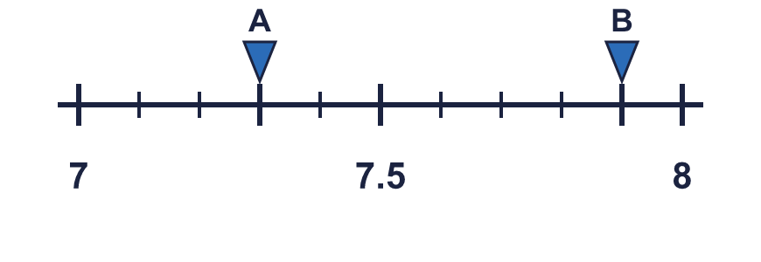
    A = |  | B =
  8 | The number line is split into 10 equal steps. Write the number each arrow points to.
    A = |  | B =

  9 | Is Rosie correct? Circle yes or no.  Yes / No  Explain how you know.
     | 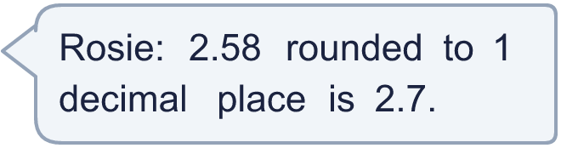
  9 | Is Rosie correct? Circle yes or no.  Yes / No  Explain how you know.
  10 | A number with two decimal places rounds to 2.6 to 1 decimal place.
    The smallest it could be:
    The largest it could be:
  10 | A number with two decimal places rounds to 2.6 to 1 decimal place.
    The smallest it could be:
    The largest it could be:
  11 | How many numbers with two decimal places round to 6.1 to 1 decimal place?
  11 | How many numbers with two decimal places round to 6.1 to 1 decimal place?
  12 | Dora weighs a parcel. Its mass is 3.48 kg. The shop rounds each mass to the nearest 100 g, which is 1 decimal place.  What mass does the shop write? (kg)
  12 | Dora weighs a parcel. Its mass is 3.48 kg. The shop rounds each mass to the nearest 100 g, which is 1 decimal place.  What mass does the shop write? (kg)
  13 | Amir is thinking of a number with 2 decimal places. It rounds to 5.5 to 1 decimal place. Write a number Amir could be thinking of.
  13 | Amir is thinking of a number with 2 decimal places. It rounds to 5.5 to 1 decimal place. Write a number Amir could be thinking of.
  14 | Challenge  A farmer measures the sides of a triangular field. Round each length to 1 decimal place.
    a) 17.22 m → |  | m
    b) 52.67 m → |  | m
    c) 8.41 m → |  | m
  14 | Challenge  A farmer measures the sides of a triangular field. Round each length to 1 decimal place.
    a) 17.22 m → |  | m
    b) 52.67 m → |  | m
    c) 8.41 m → |  | m

Year 5 · Decimals and percentages · Step 11
Round to 1 decimal place
Answers (teacher copy)

  1 | Write the two tenths each decimal lies between.  a) 14.41 is between 14.4 and 14.5  b) 12.55 is between 12.5 and 12.6  c) 2.26 is between 2.2 and 2.3
  2 | Round each number to 1 decimal place.  a) 3.66 → 3.7  b) 10.12 → 10.1  c) 11.06 → 11.1  d) 3.65 → 3.7
  3 | Round each number to 1 decimal place. Look at the hundredths digit.  a) 12.55 → 12.6  b) 3.05 → 3.1  c) 11.05 → 11.1
  4 | Round each number to 1 decimal place.  a) 0.77 → 0.8  b) 0.78 → 0.8  c) 0.59 → 0.6
  5 | Round each number to the nearest tenth.  a) 10.34 to the nearest tenth → 10.3  b) 7.87 to the nearest tenth → 7.9
  6 | Here are the masses of some parcels. Round each mass to 1 decimal place.  a) 10.63 kg → 10.6  b) 4.88 kg → 4.9  c) 1.51 kg → 1.5  d) 7.75 kg → 7.8
  7 | Which of these numbers round to 9.1 to 1 decimal place? Write the letters.  A: 8.39  B: 4.87  C: 7.74  D: 9.06  D
  8 | The number line is split into 10 equal steps. Write the number each arrow points to.  A = 7.3 B = 7.9
  9 | Is Rosie correct? Circle yes or no.  Yes / No  Explain how you know.  No. The hundredths digit of 2.58 is 8, so it rounds to 2.6.
  10 | A number with two decimal places rounds to 2.6 to 1 decimal place.  The smallest it could be: 2.55 The largest it could be: 2.64
  11 | How many numbers with two decimal places round to 6.1 to 1 decimal place?  10
  12 | Dora weighs a parcel. Its mass is 3.48 kg. The shop rounds each mass to the nearest 100 g, which is 1 decimal place.  What mass does the shop write? (kg) 3.5
  13 | Amir is thinking of a number with 2 decimal places. It rounds to 5.5 to 1 decimal place. Write a number Amir could be thinking of.  5.52
  14 | Challenge  A farmer measures the sides of a triangular field. Round each length to 1 decimal place.  a) 17.22 m → 17.2 m  b) 52.67 m → 52.7 m  c) 8.41 m → 8.4 m

