  Year 5 · Decimals and percentages · Step 13  Percentages as fractions | 
  Year 5 · Decimals and percentages · Step 13
  Percentages as fractions
  1 | Write the percentage and the fraction that is shaded in each hundred square.  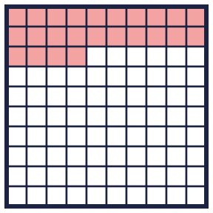  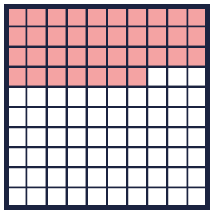
    a) percentage: |  | % fraction:
    b) percentage: |  | % fraction:
  1 | Write the percentage and the fraction that is shaded in each hundred square.
    a) percentage: |  | % fraction:
    b) percentage: |  | % fraction:
  2 | Complete each equal fraction and percentage.
    a) ³⁄₅ = |  | /100 = |  | %
    b) ⁷⁄₁₀ = |  | /100 = |  | %
    c) ¹⁄₂₀ = |  | /100 = |  | %
  2 | Complete each equal fraction and percentage.
    a) ³⁄₅ = |  | /100 = |  | %
    b) ⁷⁄₁₀ = |  | /100 = |  | %
    c) ¹⁄₂₀ = |  | /100 = |  | %
  3 | Write each fraction as a percentage.
    a) ⁹⁄₁₀ = |  | %
    b) ¹⁄₅₀ = |  | %
    c) ²⁄₅ = |  | %
    d) ³⁄₅ = |  | %
  3 | Write each fraction as a percentage.
    a) ⁹⁄₁₀ = |  | %
    b) ¹⁄₅₀ = |  | %
    c) ²⁄₅ = |  | %
    d) ³⁄₅ = |  | %
  4 | Write each percentage as a fraction in its simplest form.
    a) 80% =
    b) 70% =
    c) 20% =
  4 | Write each percentage as a fraction in its simplest form.
    a) 80% =
    b) 70% =
    c) 20% =
  5 | Write <, > or = in each box.
    a) 60% |  | ⁴⁰⁄₁₀₀
    b) 30% |  | ³⁵⁄₁₀₀
    c) 90% |  | ⁴⁰⁄₁₀₀
    d) 75% |  | ⁹⁰⁄₁₀₀
  5 | Write <, > or = in each box.
    a) 60% |  | ⁴⁰⁄₁₀₀
    b) 30% |  | ³⁵⁄₁₀₀
    c) 90% |  | ⁴⁰⁄₁₀₀
    d) 75% |  | ⁹⁰⁄₁₀₀
  6 | Write these in order, starting with the smallest.  ¹⁵⁄₁₀₀ ³⁸⁄₁₀₀ 50% ⁸²⁄₁₀₀
  6 | Write these in order, starting with the smallest.  ¹⁵⁄₁₀₀ ³⁸⁄₁₀₀ 50% ⁸²⁄₁₀₀
  7 | Match each fraction to the equal percentage. Write the letter.  A: 20% B: 12% C: 30% D: 60%
    a) ¹⁄₅ →
    b) ³⁄₅ →
    c) ³⁄₁₀ →
  7 | Match each fraction to the equal percentage. Write the letter.  A: 20% B: 12% C: 30% D: 60%
    a) ¹⁄₅ →
    b) ³⁄₅ →
    c) ³⁄₁₀ →
  8 | Mia spends ²⁄₅ of the money and saves the rest.
    What percentage does she save?
    %
  8 | Mia spends ²⁄₅ of the money and saves the rest.
    What percentage does she save?
    %

  9 | Is Rosie correct? Circle yes or no.  Yes / No  Explain how you know.
     | 
  9 | Is Rosie correct? Circle yes or no.  Yes / No  Explain how you know.
  10 | Jack and Dora go shopping with the same amount of money. Jack spends ¹⁄₅ of his money. Dora spends 35% of her money.  Who spends more? Write the name.
  10 | Jack and Dora go shopping with the same amount of money. Jack spends ¹⁄₅ of his money. Dora spends 35% of her money.  Who spends more? Write the name.
  11 | Which of these are equal to ¹⁄_{5?} Write the letters.  A: ¹⁄₅  B: ²⁰⁄₁₀₀  C: 2%  D: 20%
  11 | Which of these are equal to ¹⁄_{5?} Write the letters.  A: ¹⁄₅  B: ²⁰⁄₁₀₀  C: 2%  D: 20%
  12 | a) How much does Jack spend? (£)  b) How much does Dora spend? (£)
     | 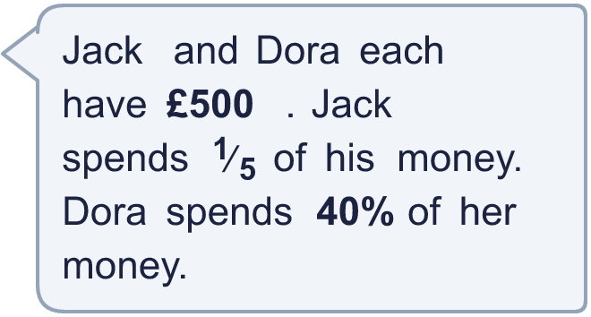
  12 | a) How much does Jack spend? (£)  b) How much does Dora spend? (£)
  13 | In a class, ²⁄₅ of the children have brown hair and 25% have blonde hair. The others have different hair colours.
    What percentage of the children have different hair colours?
    %
  13 | In a class, ²⁄₅ of the children have brown hair and 25% have blonde hair. The others have different hair colours.
    What percentage of the children have different hair colours?
    %
  14 | Challenge  Write 15% as a fraction in its simplest form.
  14 | Challenge  Write 15% as a fraction in its simplest form.

Year 5 · Decimals and percentages · Step 13
Percentages as fractions
Answers (teacher copy)

  1 | Write the percentage and the fraction that is shaded in each hundred square.  a) percentage: 24 % fraction: ²⁴⁄₁₀₀  b) percentage: 37 % fraction: ³⁷⁄₁₀₀
  2 | Complete each equal fraction and percentage.  a) ³⁄₅ = 60 /100 = 60 %  b) ⁷⁄₁₀ = 70 /100 = 70 %  c) ¹⁄₂₀ = 5 /100 = 5 %
  3 | Write each fraction as a percentage.  a) ⁹⁄₁₀ = 90 %  b) ¹⁄₅₀ = 2 %  c) ²⁄₅ = 40 %  d) ³⁄₅ = 60 %
  4 | Write each percentage as a fraction in its simplest form.  a) 80% = ⁴⁄₅  b) 70% = ⁷⁄₁₀  c) 20% = ¹⁄₅
  5 | Write <, > or = in each box.  a) 60% > ⁴⁰⁄₁₀₀  b) 30% < ³⁵⁄₁₀₀  c) 90% > ⁴⁰⁄₁₀₀  d) 75% < ⁹⁰⁄₁₀₀
  6 | Write these in order, starting with the smallest.  ¹⁵⁄₁₀₀ ³⁸⁄₁₀₀ 50% ⁸²⁄₁₀₀  ¹⁵⁄₁₀₀, ³⁸⁄₁₀₀, 50%, ⁸²⁄₁₀₀
  7 | Match each fraction to the equal percentage. Write the letter.  A: 20% B: 12% C: 30% D: 60%  a) ¹⁄₅ → A  b) ³⁄₅ → D  c) ³⁄₁₀ → C
  8 | Mia spends ²⁄₅ of the money and saves the rest.  What percentage does she save? 60 %
  9 | Is Rosie correct? Circle yes or no.  Yes / No  Explain how you know.  No. ¹⁄₄ = ²⁵⁄₁₀₀ = 25%.
  10 | Jack and Dora go shopping with the same amount of money. Jack spends ¹⁄₅ of his money. Dora spends 35% of her money.  Who spends more? Write the name. Dora
  11 | Which of these are equal to ¹⁄_{5?} Write the letters.  A: ¹⁄₅  B: ²⁰⁄₁₀₀  C: 2%  D: 20%  A, B, D
  12 | a) How much does Jack spend? (£) 100  b) How much does Dora spend? (£) 200
  13 | In a class, ²⁄₅ of the children have brown hair and 25% have blonde hair. The others have different hair colours.  What percentage of the children have different hair colours? 35 %
  14 | Challenge  Write 15% as a fraction in its simplest form.  ³⁄₂₀

