  Year 5 · Decimals and percentages · Step 1  Decimals up to 2 decimal places | 
  Year 5 · Decimals and percentages · Step 1
  Decimals up to 2 decimal places
  1 | Write the number shown on each place value chart.  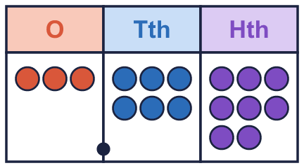  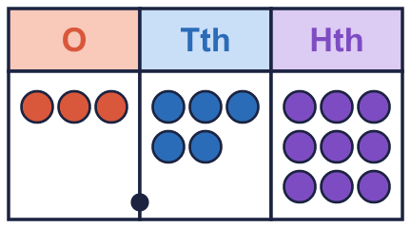
    a) The number is
    b) The number is
  1 | Write the number shown on each place value chart.
    a) The number is
    b) The number is
  2 | Use counters to make each number. Write how many counters go in each column.  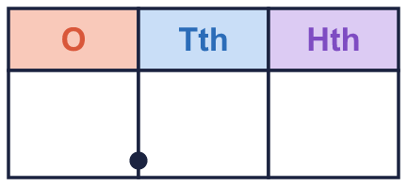
    a) 1.34:
    b) 0.74:
  2 | Use counters to make each number. Write how many counters go in each column.
    a) 1.34:
    b) 0.74:
  3 | What is the value of the digit in each number?
    a) the digit 1 in 449.19:
    b) the digit 8 in 81.4:
    c) the digit 9 in 89.1:
    d) the digit 6 in 63.33:
  3 | What is the value of the digit in each number?
    a) the digit 1 in 449.19:
    b) the digit 8 in 81.4:
    c) the digit 9 in 89.1:
    d) the digit 6 in 63.33:
  4 | Write the missing number.
    a) 0.68 = 0.6 +
    b) 0.31 = 0.3 +
  4 | Write the missing number.
    a) 0.68 = 0.6 +
    b) 0.31 = 0.3 +
  5 | Work out the additions.
    a) 0.3 + 0.05 =
    b) 0.06 + 0.8 =
    c) 0.4 + 0.07 =
  5 | Work out the additions.
    a) 0.3 + 0.05 =
    b) 0.06 + 0.8 =
    c) 0.4 + 0.07 =
  6 | Write each number as a decimal.
    a) 3 ones, 6 tenths and 3 hundredths:
    b) 4 tenths and 6 hundredths:
    c) 4 tenths:
  6 | Write each number as a decimal.
    a) 3 ones, 6 tenths and 3 hundredths:
    b) 4 tenths and 6 hundredths:
    c) 4 tenths:
  7 | How many hundredths (0.01) are in each number?
    a) 0.48:
    b) 1.48:
  7 | How many hundredths (0.01) are in each number?
    a) 0.48:
    b) 1.48:
  8 | Write these decimals in order, starting with the smallest.  1.2 2.5 0.83 0.95
  8 | Write these decimals in order, starting with the smallest.  1.2 2.5 0.83 0.95

  9 | Is Ron correct? Circle yes or no.  Yes / No  Explain how you know.
     | 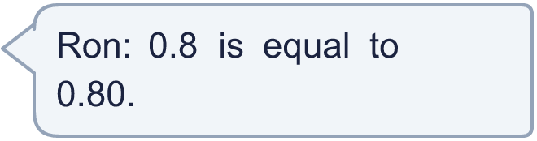
  9 | Is Ron correct? Circle yes or no.  Yes / No  Explain how you know.
  10 | She uses all three cards to make a number with 2 decimal places, like ___.__ Write the largest number she can make.
    
  10 | She uses all three cards to make a number with 2 decimal places, like ___.__ Write the largest number she can make.
  11 | Which of these are equal to 0.2? Write the letters.  A: ²⁄₁₀  B: 0.20  C: 0.02  D: 0.1 + 0.1
  11 | Which of these are equal to 0.2? Write the letters.  A: ²⁄₁₀  B: 0.20  C: 0.02  D: 0.1 + 0.1
  12 | Write the missing number.
    a) 0.4 + |  | + 0.07 = 0.56
  12 | Write the missing number.
    a) 0.4 + |  | + 0.07 = 0.56
  13 | Write a decimal that is between 1.2 and 1.3.
  13 | Write a decimal that is between 1.2 and 1.3.
  14 | Challenge  How many tenths (0.1) make 1.3?
  14 | Challenge  How many tenths (0.1) make 1.3?

Year 5 · Decimals and percentages · Step 1
Decimals up to 2 decimal places
Answers (teacher copy)

  1 | Write the number shown on each place value chart.  a) The number is 3.68  b) The number is 3.59
  2 | Use counters to make each number. Write how many counters go in each column.  a) 1.34: 1 3 4  b) 0.74: 0 7 4
  3 | What is the value of the digit in each number?  a) the digit 1 in 449.19: 0.1  b) the digit 8 in 81.4: 80  c) the digit 9 in 89.1: 9  d) the digit 6 in 63.33: 60
  4 | Write the missing number.  a) 0.68 = 0.6 + 0.08  b) 0.31 = 0.3 + 0.01
  5 | Work out the additions.  a) 0.3 + 0.05 = 0.35  b) 0.06 + 0.8 = 0.86  c) 0.4 + 0.07 = 0.47
  6 | Write each number as a decimal.  a) 3 ones, 6 tenths and 3 hundredths: 3.63  b) 4 tenths and 6 hundredths: 0.46  c) 4 tenths: 0.4
  7 | How many hundredths (0.01) are in each number?  a) 0.48: 48  b) 1.48: 148
  8 | Write these decimals in order, starting with the smallest.  1.2 2.5 0.83 0.95  0.83, 0.95, 1.2, 2.5
  9 | Is Ron correct? Circle yes or no.  Yes / No  Explain how you know.  Yes. 0.8 = 0.8 and 0.80 = 0.8, so they are equal.
  10 | She uses all three cards to make a number with 2 decimal places, like ___.__ Write the largest number she can make.  8.73
  11 | Which of these are equal to 0.2? Write the letters.  A: ²⁄₁₀  B: 0.20  C: 0.02  D: 0.1 + 0.1  A, B, D
  12 | Write the missing number.  a) 0.4 + 0.09 + 0.07 = 0.56
  13 | Write a decimal that is between 1.2 and 1.3.  1.25
  14 | Challenge  How many tenths (0.1) make 1.3?  13

