  Year 5 · Place value · Step 4  Numbers up to 1,000,000 | 
  Year 5 · Place value · Step 4
  Numbers up to 1,000,000
  1 | What number is shown in the place value chart?
    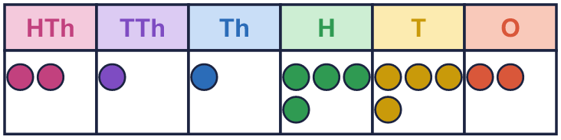
  1 | What number is shown in the place value chart?
  2 | What number is shown in the place value chart?
    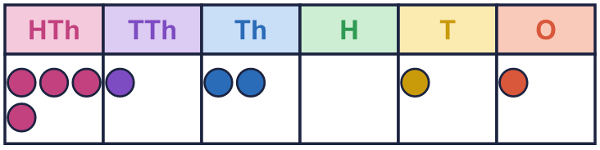
  2 | What number is shown in the place value chart?
  3 | What number is shown in the place value chart?
    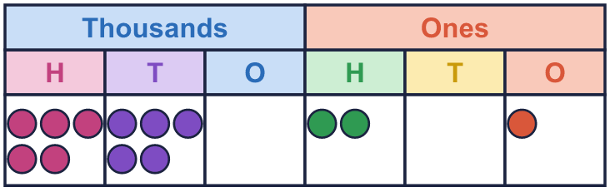
  3 | What number is shown in the place value chart?
  4 | Draw counters to show 330,142 in a place value chart.  Draw your counters here:  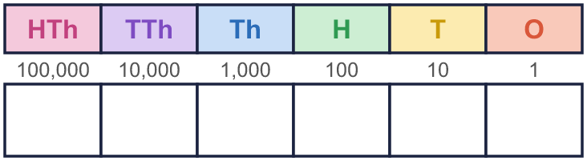
  4 | Draw counters to show 330,142 in a place value chart.  Draw your counters here:
  5 | Write the value of the digit in the box.  a) 78,499 =  b) 865,559 =
  5 | Write the value of the digit in the box.  a) 78,499 =  b) 865,559 =
  6 | What is the value of the 9 in each number?  a) 198,628 =  b) 2,978 =  c) 751,967 =  d) 953,670 =  e) 197 =  f) 6,695 =
  6 | What is the value of the 9 in each number?  a) 198,628 =  b) 2,978 =  c) 751,967 =  d) 953,670 =  e) 197 =  f) 6,695 =
  7 | Partition the number. Fill in the missing parts.
    220,871 =
    200,000 | + | 20,000 | + |  | +
     | + | 1
  7 | Partition the number. Fill in the missing parts.
    220,871 =
    200,000 | + | 20,000 | + |  | +
     | + | 1
  8 | Complete the part-whole models.
    a)  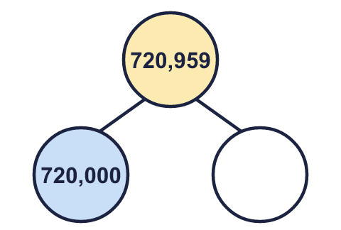 | b)  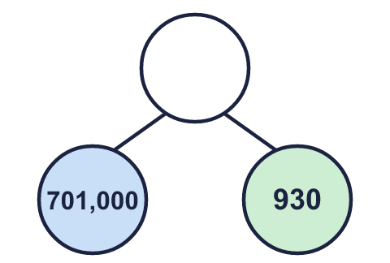 | c)  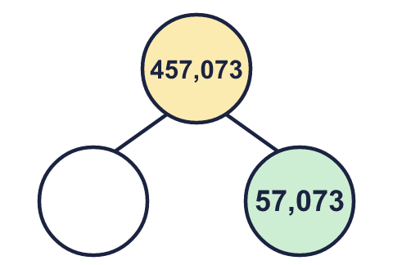
  8 | Complete the part-whole models.
    a) | b) | c)

  9 | Circle the numbers that have a 7 in the thousands column. Write their letters.  a) 8,567  b) 577,689  c) 7,741  d) 965,427  Answer:
     | 
  9 | Circle the numbers that have a 7 in the thousands column. Write their letters.  a) 8,567  b) 577,689  c) 7,741  d) 965,427  Answer:
  10 | Is Boba correct? Circle yes or no.  Yes / No  Explain how you know.
    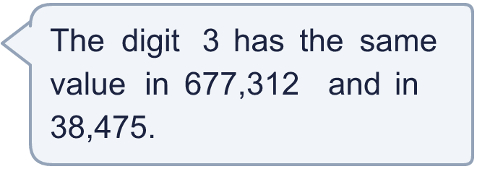
  10 | Is Boba correct? Circle yes or no.  Yes / No  Explain how you know.
  11 | 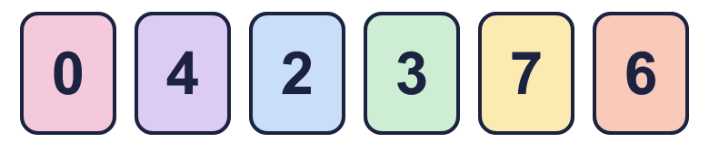  a) Make the smallest number.  b) Make the largest even number.  c) Make the number closest to 500,000.
     | 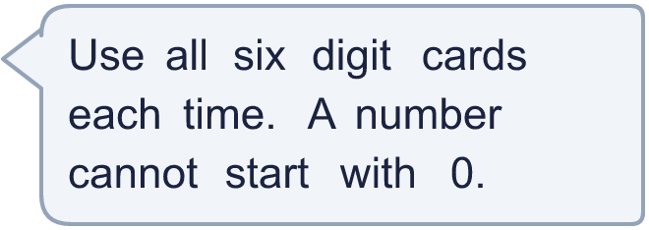
  11 | a) Make the smallest number.  b) Make the largest even number.  c) Make the number closest to 500,000.
  12 | 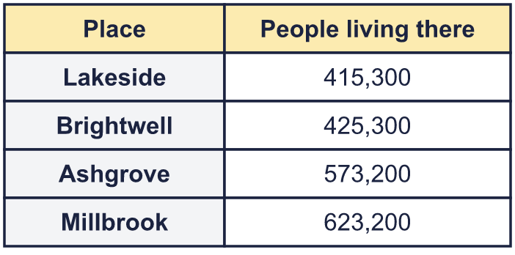  a) Write the towns in order, smallest number of people first.  b) Which town has 10,000 more people than Lakeside?  c) What is the value of the digit in the box in the Brightwell number: 425,300?
     | 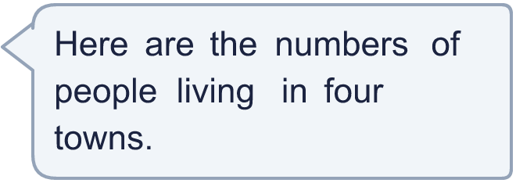
  12 | a) Write the towns in order, smallest number of people first.  b) Which town has 10,000 more people than Lakeside?  c) What is the value of the digit in the box in the Brightwell number: 425,300?
  13 | • The ones digit is 0.  • The ten thousands digit is 4.  • The thousands digit is 8.  • The hundreds digit is 3.  • The tens digit is double the hundreds digit.  • The tens digit is double the hundred thousands digit.  What is my number?
    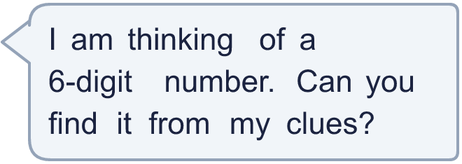
  13 | • The ones digit is 0.  • The ten thousands digit is 4.  • The thousands digit is 8.  • The hundreds digit is 3.  • The tens digit is double the hundreds digit.  • The tens digit is double the hundred thousands digit.  What is my number?
  14 | Write three different 6-digit numbers in which the digit 4 is worth 40,000.
  14 | Write three different 6-digit numbers in which the digit 4 is worth 40,000.

Year 5 · Place value · Step 4
Numbers up to 1,000,000
Answers (teacher copy)

  1 | What number is shown in the place value chart?
    211,442
  2 | What number is shown in the place value chart?
    412,011
  3 | What number is shown in the place value chart?
    550,201
  4 | Draw counters to show 330,142 in a place value chart.  Draw your counters here:  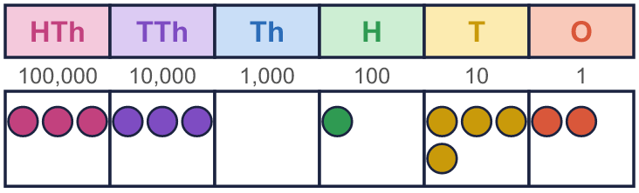
  5 | Write the value of the digit in the box.  a) 78,499 = 400  b) 865,559 = 9
  6 | What is the value of the 9 in each number?  a) 198,628 = 90,000  b) 2,978 = 900  c) 751,967 = 900  d) 953,670 = 900,000  e) 197 = 90  f) 6,695 = 90
  7 | Partition the number. Fill in the missing parts.  220,871 = 200,000 + 20,000 + 800 + 70 + 1
  8 | Complete the part-whole models.  a) 959 b) 701,930 c) 400,000
    a)  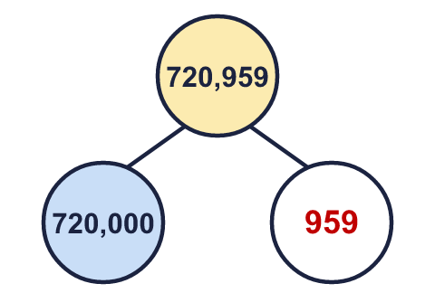 | b)  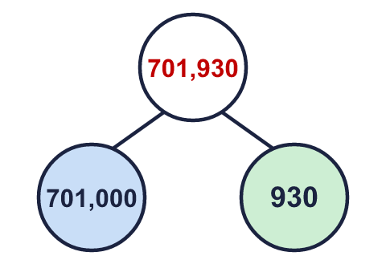 | c)  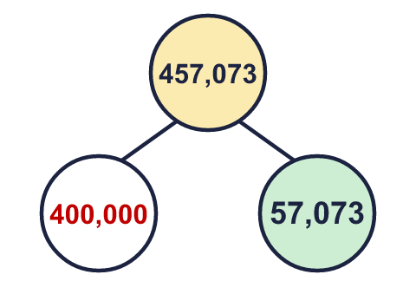
  9 | Circle the numbers that have a 7 in the thousands column. Write their letters.  a) 8,567  b) 577,689  c) 7,741  d) 965,427  Answer: b and c
  10 | Is Boba correct? Circle yes or no.  Yes / No  Explain how you know.  In 677,312 the 3 is worth 300. In 38,475 it is worth 30,000. The columns are different, so the values are different.
  11 | a) Make the smallest number. 203,467  b) Make the largest even number. 764,320  c) Make the number closest to 500,000. 476,320
  12 | a) Write the towns in order, smallest number of people first. Lakeside, Brightwell, Ashgrove, Millbrook  b) Which town has 10,000 more people than Lakeside? Brightwell  c) What is the value of the digit in the box in the Brightwell number: 425,300? 20,000
  13 | • The ones digit is 0.  • The ten thousands digit is 4.  • The thousands digit is 8.  • The hundreds digit is 3.  • The tens digit is double the hundreds digit.  • The tens digit is double the hundred thousands digit.  What is my number?  348,360
  14 | Write three different 6-digit numbers in which the digit 4 is worth 40,000.  Any numbers with the 4 in the ten thousands column, for example 245,457, 145,091, 649,200

